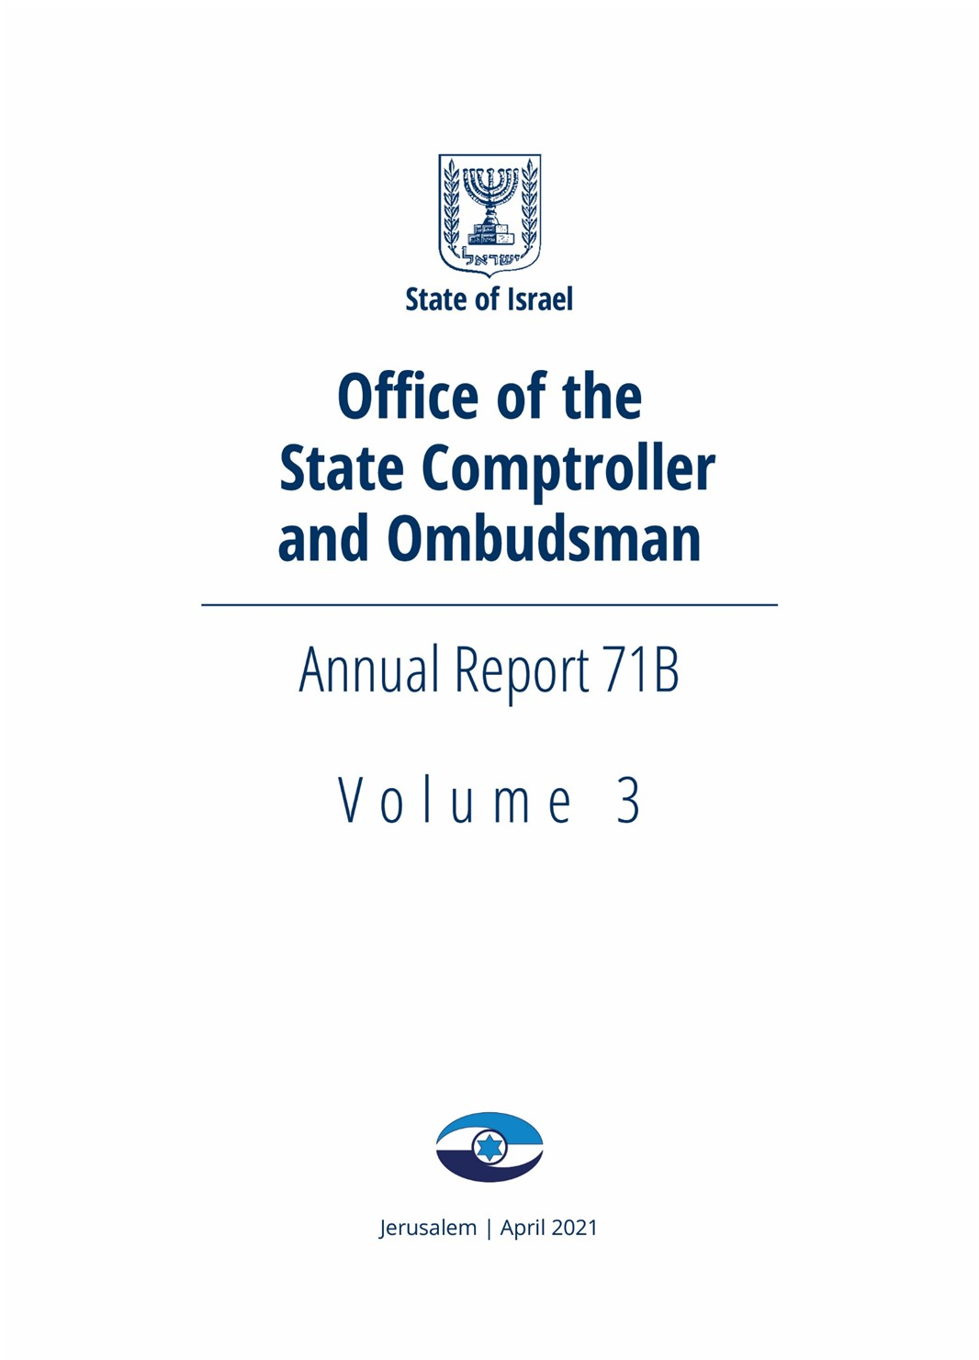

Foreword
Annual Audit Report 71B is the second part of the State Comptroller’s annual report on the results of the audit of the audited bodies in 2020. This volume is dedicated to issues related to the Defense Establishment, which is responsible for the safety of the State of Israel. Following is a review of the issues included in it:
The audit regarding the relocation of the Intelligence Directorate and the Computer and IT Directorate to the Negev found that the disputes and disagreements between the Defense Establishment and the Ministry of Finance and the Ministry of Transport and Road Safety, are a barrier to the process of the relocation of the Intelligence and IT directorates to the Negev. In view of the fact that the relocation of these units to the Negev is part of a wide-ranging national initiative, embodies a meeting of political, defense and economic interests, it is important that the parties reach the necessary understandings, with assistance from the National Security Council, and make decisions on the fulfillment of these understandings, In order to pave the way to successful relocation of the units to the Negev.
In order to maintain the preparedness and competency for war or operational activity, the IDF closes areas for training purposes. In the audit regarding the IDF land training areas, it has been stated that the training areas are closed areas spread over one third of Israel's land area, and some of them include nature reserves, antiquities and agricultural areas. In view of the shortage of land in Israel, there is an inherent tension between the various national needs, including defense needs. The audit found that at the audit completion date, approximately 73% of the training areas that have been designated for repurposing to civilian needs in 2015 have still not been repurposed. It is recommended that the National Council for Planning and Construction, and the IDF, conduct a methodological examination of the IDF’s processes for closing the training areas in view of the planning processes of land purposes as carried out by the Planning Administration, taking into account the various national development needs, including defense needs. It is also recommended that these two bodies coordinate between these two processes, which currently take place under separate sets of laws, draw conclusions and recommend to the Government accordingly.
The Israel Aerospace Industries Ltd. (IAI) is a Government company, and is one of Israel’s largest companies. In 2019 its sales totaled approximately 1.4 billion dollars, and it employed approximately 15,000 employees. From January 2017 to January 2019, 29 senior executives were appointed in the IAI, accounting for 46% of the Company’s senior executives.
The audit regarding the appointment of senior executives in the Israel Aerospace Industries LTD. found deficiencies regarding the processes of recruiting and appointing certain senior executives, appointing temporary and acting executives and executives transfer. Consequently, principles of equality and competition in these areas were not fully complied. The IAI is a government company obligated to comply with norms of good governance, equality and competitiveness, including in all matters concerning the appointment of its senior executives, as required by law. It is appropriate that the Company's management and Board of Directors draw the necessary conclusions and take measures to prevent such deficiencies in the future.
According to the policy of the State Comptroller's Office, special emphasis is placed on monitoring the rectification of deficiencies that was raised in previous reports. This volume includes two follow-up audits as follows:
In November 2017, the State Comptroller’s office published a special report on the National Preparedness for Defense Against the Drone Threat, and from October 2019 to June 2020, conducted an extended follow-up audit regarding this matter. It is estimated that in June 2020 there were 30,000 drones in Israel. The audit found that the audited bodies had not yet completed their operational preparedness for dealing with this threat, and that the areas of responsibility between the audited bodies were not fully defined. These bodies have to take measures to optimally complete the preparedness for dealing with the drone threat, covering all aspects, within a short period of time.
It should be noted that alongside s the threats derives from use of drones, this use can contribute to the development of Israel's transport and economy in many aspects. Regulating the operation of drones in Israel’s airspace is vital for maximizing the benefits that can be gained from using them.
In May 2017 an audit regarding the IDF's Mental Health array was published. From November 2019 to May 2020, a follow-up audit regarding the rectification of the deficiencies that was raised in the previous audit was conducted.
The Mental Health Services are a significant component in the IDF’s medical services. In light of the fact that the purpose of these services is to ensure the mental health and resiliency of the IDF soldiers, the value of their quality and availability are of the highest importance. Therefore, the IDF needs to focus on the aspects in need of improvement as presented in this chapter, addressing in particularly the matter of the increase in the number of exemptions from military service in the IDF on grounds of the mental status of its candidates. This increase has national and strategic implications since it affects the building of the IDF’s forces
The sections in this report were conducted by the Defense Establishment Division in the State Comptroller's office. I wish to thank the employees of this Division and all employees of the State Comptroller's Office for their professional, thorough and objective work, especially in light of the challenges, during the COVID-19 pandemic.
The audited bodies must act quickly and efficiently to rectify the deficiencies that have not yet been rectified, as required by law. The Office of the State Comptroller will continue to monitor and ensure the rectification of the deficiencies.
I wish we all return to routine life soon.

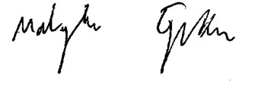
Matanyahu Englman
State Comptroller
and Ombudsman

Jerusalem, April 2021

