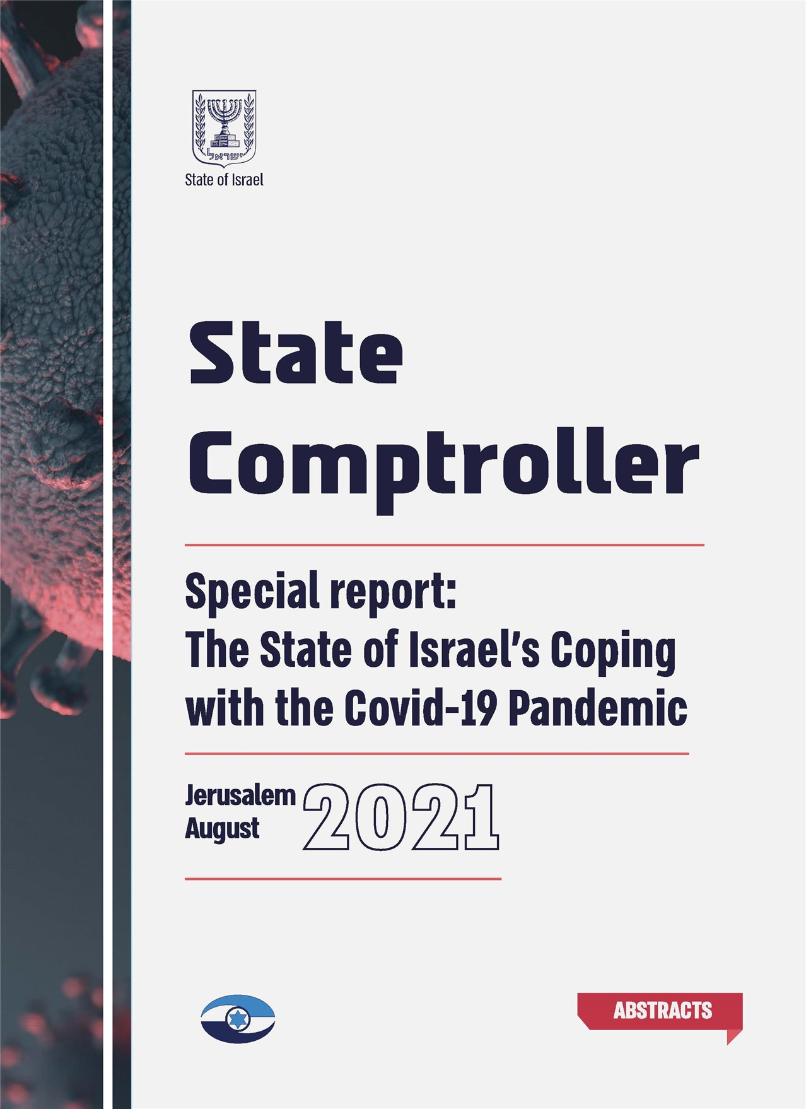



State of Israel

State Comptroller

Special Report: The State of Israel's Coping with the Covid-19 Pandemic

Abstracts



August 2021 | Jerusalem

Catalogue Number 2021-003
ISSN 0793-1948
www.mevaker.gov.il

Graphic Design: ER Design Team

Table of contents

Abstracts

5 |  | Foreword
11 |  | Introduction
 |  | Chapter One
 |  | National Level Issues
27 |  | Managing Covid-19 Pandemic at the National Level – Decisions making Process and Implementation
39 |  | Managing the Covid-19 Pandemic at the National Level – Handling of the Pandemic in Local Authorities with High Infection
49 |  | Public Information Campaign during the Covid-19 Pandemic
63 |  | The Covid-19 Pandemic – The IT Perspective
 |  | Chapter Two
 |  | Economic and Budget Topics
75 |  | Budgeting Management during the Covid-19 Pandemic - Handling the Crisis and Preparing for the Future
87 |  | Municipal Property Tax Discounts for Businesses during the Covid-19 Pandemic Period
99 |  | Financial Services, Credit and Stability of Financial Institutions during the Covid-19 Pandemic

 |  | Chapter Three
 |  | Welfare, Education, Health and Employment Topics
111 |  | Government Handling of the Unemployed during the Covid-19 Pandemic
125 |  | Caring for Senior Citizens during the Covid-19 Pandemic
137 |  | Aspects of Regular Medical Activity during the Covid-19 Pandemic
147 |  | Sampling and Lab Testing Setup for Diagnosing Covid-19
157 |  | Distance Teaching and Learning during the Covid-19 Pandemic Period
169 |  | Epidemiological Investigations to Break the Covid-19 Infection Chains

Foreword
We are in the midst of the fourth wave of the Covid-19 pandemic, which is shaking countries all over the world, including Israel. This pandemic influenced our lives significantly, and the situation is testing our personal and national resilience. In such a reality it is highly important for the government to act properly, efficiently and economically. I therefore see it essential for the State Comptroller's Office to continue its activity, subject to the challenges of this time, in order to improve the conduct of the government bodies.
Our office monitored the government actions during the first wave of the pandemic, and began auditing several matters regarding the handling of the Covid-19 pandemic and its effects. Given the importance of the interim findings in that audit and the added value of rectifying the deficiencies as quickly as possible, I found it appropriate to submit the interim findings to the Knesset, and to publish them in October 2020.
This report contains chapters on various topics regarding the management of the crisis on the national level, and to economic and budgetary matters. The following is a summary of the deficiencies and the recommendations raised in this report:
The report contains an audit regarding the Managing the Covid-19 Pandemic at the National Level – Decisions Making Process and Implementation. The audit found deficiencies, inter alia in the following areas:
The 34th government's decision-making process during the Covid-19 pandemic;
Establishment of a Covid-19 cabinet and decision-making in this matter by the 35th government;
Activity of the government and the Covid-19 cabinet during the second wave of the pandemic;
The Ministry of Health's operational capacities for managing the crisis;
The role and conduct of the National Security Council in assisting the government's management of the crisis, and in drawing conclusions and monitoring the implementation of the decisions during the crisis;
Establishing a reference scenario;
Setting a strategy for exiting the first wave of the pandemic and preparing for the second wave;
Handling passengers arriving in Israel;
Establishing an investigative epidemiological array.
The local authorities, who have managerial and operational ability and experience, have a main role in handling and providing services to residents in both routine and in emergencies. The Covid-19 pandemic emphasized the importance of an optimal interaction between the central and the local government. The audit regarding the Managing of the Covid-19 pandemic at the National Level – Decisions Making Process and Implementation raised that the policy for dealing with areas with a high rate of infection in order to halt outbreaks of infection from spreading was not implemented, and areas where the infection spread were not handled effectively according to the established criteria. These deficiencies may have contributed to the increase in the infection rate and the decision to impose a second general lockdown, and may have also had a negative impact on the public's willingness to cooperate in combating the Covid-19 pandemic. In order to make optimal use of the local authorities' relative advantage in dealing with residents and achieving the national objectives, it is recommended that the relevant government ministries – the Ministry of Health, the Ministry of Interior, the Ministry of Public Security, and the Ministry of Justice – include the local authorities in the national effort to reduce infection and consider expanding their authority in this matter.
The audit regarding the Public Information Campaign during the Covid-19 pandemic raised that government spending on communication during the Covid-19 pandemic totaled NIS 311 million. There were 53 million visits to the Ministry of Health website in March–October 2020, and 73% of the calls to the Ministry of Health call center in September 2020 were not answered by a receptionist (most of these calls were cut off). It was also raised that the government response to the need for providing information regarding the Covid-19 pandemic and ways of dealing with it differed from the plan for national communication in a civilian emergency, which had been the subject of a drill 18 months before the outbreak of the pandemic. Furthermore, important positions in the communication array established in the Prime Minister's Office according to a 2007 Government Resolution were not filled at the time of the outbreak, and therefore the array did not operate as planned. In addition, the Ministry of Health, which was required to lead the government communication efforts, lacked the required functional infrastructure and professional tools. These were supplemented during the crisis, at a time of rising infection rates, causing the allocation of state resources, without taking into account the preparations made and resources invested in the years preceding the crisis. In view of the findings raised in this audit, and in order to ensure the government communication departments preparedness for emergencies, it is recommended to Formulate a binding plan for dividing responsibility among the various communication bodies and adapting the organizational and professional infrastructure of each one to the responsibility assigned to it according to this plan; Set principles and effective communication methods based on population research, including mapping and specification of various target population groups; and establish consolidated information databases for public use in emergencies.
Another challenge facing communication bodies is combating false information, widely distributed, inter alia through social networks. The communication array in the Prime Minister's Office is responsible for ensuring other government communication departments preparedness for emergencies. The findings and recommendations in this chapter should be the basis for drawing conclusions process regarding this matter.
Besides massive infection, the Covid-19 pandemic caused one of the worst employment crises in Israel's history. The audit regarding the Government Handling of the Unemployed during the Covid-19 pandemic found that 880,000 people received unemployment benefits in April 2020, more than 11 times in comparison to January 2020. Unemployment benefits paid in 2020 totaled NIS 26.3 billion, more than six times the total in 2019. The total cumulative debt of Israeli citizen from the beginning of the crisis until January 2021 due to overpayment of unemployment benefits was NIS 923 million. In practice, the Covid-19 pandemic was a test case under pressure. As such, it exposed deficiencies in the quality of service for those claiming unemployment compensation from the National Insurance Institute (NII), and in the government actions to reintegrate unemployed in the labor market, with an emphasis on cooperation and regular data sharing among three key bodies: the NII, the Israeli Employment Service, and the Labor Branch in the Ministry of Labor, Social Affairs, and Social Services. It is recommended to consider uniting the resources of the bodies handling the employment market in a single organizational agency. This will reduce the organizational division that can reduce the effectiveness of the government's activity. In addition the relevant bodies should increase, the cooperation between them. Improving the cooperation is important in light of the reduction in the scope of the activity of the Labor Branch and the Employment Service in 2020, and given the negative incentive of some of the unemployed to return to the labor market, or at least to improve professional skills due to the extension of eligibility for unemployment compensation during the audited period.
The Covid-19 pandemic sharply reduced global economic activity and caused an economic crisis in Israel. This crisis featured a severe liquidity problem in many households and businesses. For example, the total loans requested from all of the state guarantee loan funds was NIS 73.6 billion. The audit regarding Financial Services, Credit and Stability of Financial institutions during the Covid-19 pandemic raised that the financial regulators in Israel had made rapid preparations for providing assistance to the economy and maintaining its resilience. Among other things, they adapted the financial services provided to the public to the circumstances of the crisis, expanded the supply of credit, and monitored the risks incurrent in financial activity in the economy. At the same time, deficiencies were found, inter alia in the cooperation between all of the relevant bodies regarding the definition of essential activity of financial regulatory bodies in emergency, dealing with the high exposure of financial institutions to derivatives abroad, establishing measurable criteria for granting loans, and setting timeframes for handling loan requests. Furthermore, it was found that the rate of guarantees in the portfolio of state-guaranteed loans was lower in comparison with similar programs in other countries. It is therefore recommended to examine the proposed assistance mechanisms for the purpose of increasing the efficiency the credit granted to businesses, with the aim of bridging the cash flow gap caused by the crisis and enabling businesses to resume their activity and grow when the crisis ends.
This report contains a chapter regarding Municipal Property Tax Discounts for Businesses during the Covid-19 pandemic. The government provided aid for businesses through a discount on municipal property taxes in two rounds. The estimated total of the discounts in the first round in April 2020 was NIS 2.8 billion. In the second round in september 2020 a discount approved for the time period between June 2020 and June 2021 was NIS 3.5 billion. The audit raised that in the payment mechanism of the second round, the bureaucratic burden on businesses was greater, the duration of handling the requests was longer, and when the mechanism was first put into practice, delays were created in handling the requests submitted. During the audit, the Small and Medium Business Agency (SBA) and the Israel Tax Authority improved the procedure for submitting and handling requests. Bureaucracy was reduced, and businesses are now contacting the SBA online, without having to provide approval from the Israel Tax Authority. It is recommended that the Ministry of Interior and the Ministry of Finance continue their cooperation, analyze the needs of businesses and local authorities, and take necessary steps in order to enable exhaustion of rights. It is also recommended that the Ministries rectify the deficiencies found in the audit and determine guidelines for future assistance programs, if necessary.
This special report also contains chapters regarding education, welfare, health, and employment matters, including:
Caring for senior citizens during the Covid-19 pandemic;
Aspects of regular medical activity during the Covid-19 pandemic;
Taking samples and laboratory testing for diagnosing Covid-19;
Distances teaching and learning during the Covid-19 pandemic;
Epidemiological investigations to break the Covid-19 infection chains;
Remote work of government ministries in the Covid-19 pandemic – The IT perspective;
Budgeting management during the covid-19 pandemic – handling the crisis and preparing for the future.
This report reflects the State Comptroller's vision and goals, including conducting an innovative, social, motivate, relevant, objective, and respectful audit, that is oriented to the future challenges, improving the activity of the audited bodies, promoting the fulfillment of their objectives, and increasing the benefit the public can gain from their activity. On the one hand, the state's audit focuses on social matters, among them the service provided to the public, and the substantial risks affecting the activity of the audited bodies. On the other hand, it acts to implement norms of good governance in the actions of the government and public administration.
This report was carried out by the Social and Welfare Division the Economic a departments Division, the Government Ministries and Institutions Division and the Defense Establishment Division in the State Comptroller's Office. I thank the employees of these divisions and the Office staff involved in writing the report for their professional, thorough, efficient, and challenging work, especially in the circumstances created by the Covid-19 pandemic.
The audited bodies should act quickly and efficiently to rectify the deficiencies that have not yet been rectified in order to improve future handling of the Covid-19 pandemic.
I wish all of us an optimal handling of the Covid-19 pandemic and a safe return to our life routine.

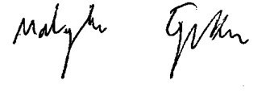
Matanyahu Englman
State Comptroller and
Ombudsman of Israel

Jerusalem, August 2021

