
Engagements Exempted from Tender in the ICT Sector

Systemic Topics
State Comptroller's Report – Cyber and Information Systems | May 2023

Engagements Exempted from Tender in the ICT Sector

Government procurement is a central pillar in the activity of government bodies since most government activity depends on the procurement of goods or services. An efficient government procurement system ensures proper conduct and optimal utilization of public funds. Streamlining ICT procurement, based on technology that changes frequently, is essential for promoting ICT and technological innovation in government bodies. The transparency of procurement procedures in the government is of great importance, both from a Moral Perception of responsibility for public funds and from a professional aspect, according to which a transparent and competitive procurement process will bring better results for the government bodies. In June 2022, a draft was published for public comments regarding the amendment to the Mandatory Tenders Regulations, 1993.
The scope of ICT procurement in 2019$-$2021 was about NIS 14.4 billion, about 15.6% of the total government procurement in these years. The scope of ICT procurement carried out through exempt from the tender in 2019$-$2021 was about NIS 1.79 billion, about 14.2% of total ICT procurement in those years.


NIS 14.4 billion |  | NIS 4.2 billion |  | NIS 1.79 billion |  | 717
the scope of ICT procurement in 2019$-$2021 |  | the gap between the procurement scope in 2020 presented in Merkava system and the scope published by the Government Procurement Administration |  | the total ICT procurement exempt from the tender in 2019$-$2021 (14.2% of the total ICT procurement in those years) |  | the number of ICT purchase orders in the range of NIS 47,500$-$50,000 through an exemption from the tender on the grounds of "purchases up to NIS 50,000"
25% |  | 40% |  | 61% |  | Six-fold
of the government bodies did not submit the required reports for 2021 to the Government Freedom of Information Unit |  | of the contracts exempt from tender publicized, lack essential information required by law |  | of the ICT engagements exempt from tender on the grounds of a "sole source purchase" (NIS 1.1 billion) |  | the government bodies' use rate of the "sole source purchase " exempt in ICT procurement (61%) is six-fold than the one in non-ICT government procurement (9.72%)
Audit Actions

From April to October 2022, the State Comptroller's Office examined government bodies' ICT engagements through an exemption from a tender. The audit was conducted in the Accountant General's Division of the Ministry of Finance (the Accountant General). It was based on data retrieved by the State Comptroller's Office from the Merkava (Comprehensive Lateral System in Government Ministries) system, the website of the Procurement Administration at the Ministry of Finance, and the Government Freedom of Information Unit website. Completion examinations were conducted at the Ministry of Welfare and Social Security, Construction and Housing, the National Digital Agency at the Ministry of Economy and Industry (the National Digital Agency), the Israel Mapping Center, and the Competition Authority.
Key Findings


ICT Engagements Through an Exempt from Tender on the Grounds of a "Sole Source Purchase " – ICT procurement through an exempt from tender on the grounds of a sole source purchase in 2019$-$2021 was NIS 1.1 billion – about 61% of the total ICT procurement through an exempt from tender, this compared to a corresponding rate of 9.7% in general procurement (without ICT).
  - It was found that the use of the sole source purchase exemption by the government bodies in ICT procurement (61%) was over six-fold than in non-ICT government procurement (9.72%).
  - It was found that the government procurement system has eight suppliers when two-thirds and more of the ICT procurement orders (in monetary terms) issued to them, at about NIS 130 million, were exempted from the tender on the grounds of a sole source purchase. Furthermore, six suppliers with which the sum of the engagements, exempt from the tender on the grounds of a sole source purchase, was the largest – about NIS 467 million. It should be noted that engagements were also made with those suppliers through tender procedures. This may raise concerns regarding the lack of perfect competition and the violation of the principle of equality under the principles established by law, as well as the non-exhaustion of the examination of the alternatives by the government body before the decision to use the exemption on the grounds of a sole source purchase.
  - It was found that in four government bodies – the Ministry of Transport and Road Safety (Ministry of Transport), the Ministry of Agriculture and Rural Development, the Labor Division of the Ministry of Economy and Industry, and the Israel Tax Authority (the Tax Authority) – the average rate of ICT procurement through an exempt from tender on the grounds of a sole source purchase in 2019$-$2021 is almost double to more than double the average rate of ICT procurement that is carried out without a tender in all government ministries (14%) (Ministry of Transport – 31%; Ministry of Agriculture and Rural Development – 31%; Labor Division of the Ministry of Economy and Industry – 27%; Tax Authority – 26%). The total of the ICT procurement through an exemption from the tender on the grounds of a sole source purchase in the four entities was about NIS 627.7 million.
  - In an examination of 65 minutes of ministerial committees convened in 2019$-$2021, it was raised that in the vast majority (97%) of the professional opinions submitted to the tender committees, the measures taken to locate additional suppliers were not detailed as required under the provisions of the Directives on Regulation, Finance, and Economy (TAKAM Directives). Without this information, the committee's ability to reach the certainty required to approve the request is significantly impaired.
  - The audit raised that the Procurement Administration does not have comprehensive information on the objections to engage through an exemption from the tender on the grounds of a sole source purchase, and in practice, each government body handles separately the objections submitted to it on its intentions to engage on these grounds. The presence of comprehensive information on the objections submitted to the government bodies on the engagement exempt from tender at the government body in charge of government procurement – will improve its decisions regarding optimizing the government procurement processes.

ICT Engagements Through an Exempt from Tender due to a Contract Sum of up to NIS 50,000 – in 2019$-$2021, ICT procurement orders through an exempt from tender due to an engagement of up to NIS 50,000 (Regulation 3(1)) were NIS 161 million, about 9.1% of the total ICT procurement orders through an exempt from tender in these years, compared to a corresponding rate of 2.8% in general procurement (without ICT).
  - Nine cases were found, at NIS 898,000, in which several procurement orders from the same supplier for the same service were made within up to 14 days, each in less than NIS 50,000, but cumulatively they were over this sum. Artificial splitting of engagements, if done, violates the principle of equality based on the tender laws. The obligation to carry out the procurement through a tender is circumvented through it. Furthermore, due to fragmentation, public funds may be overused due to the non-utilization of the size advantage.
  - Regarding procurement orders classified as engagements exempt from tender under Regulation 3(1) made in the range of NIS 25,000$-$50,000, it was found that in 2019$-$2021 717 procurement orders were made in the range of NIS 47,500$-$50,000 – the most significant number of procurement orders from all the sum tiers included in the range of NIS 25,000$-$50,000. The number of procurement orders in the second largest sum tier was 202. That is, the number of ICT procurement orders classified as engagements exempt from tender under Regulation 3(1) and carried out in sums close to the exemption cap set in the regulations is three-fold than the number of procurement orders in any other sum tier.
  - Moreover, it was found that the Prime Minister's Office executed about 22% (156) of the 717 procurement orders, the Central Bureau of Statistics executed about 7.5% (53), the Ministry of Justice executed about 7.3% (52), and the Ministry of Health executed about 5.9% (42). It was also found that there are three suppliers with whom the number of engagements made by the government bodies in this price range constituted over 40% of all engagements with them in 2019$-$2021. This raises the concern that government bodies sometimes adjust procurement orders to the sum exempted from the tender. Due to the reduction of the quality or quantity of the procurement to avoid a tender, a waiver of requirements necessary for the activity of the governmental body is possible. Furthermore, the ability to plan the procurement may be adversely affected due to the absence of a complete situation report of the government body's procurement needs.

Publication of Government Engagements
  - It was found that in about 40% (about 7,000) of the publications of engagements through an exempt from the tender in 2019$-$2021, the government bodies did not publicize all of the information (the name of the supplier, The value of the engagement or an estimate thereof; The dates of the start and end of the engagement) in contravention of the legal requirements when engaging with suppliers through an exempt from the tender. This affected the transparency to the public and the Procurement Administration's control ability.
  - Regarding the completeness and reliability of the data published in the engagements report, it was raised that in hundreds of cases, material errors were found in the details of the engagements: in six cases, the engagements were categorized as exempted on the grounds of being up to NIS 50,000, even though the scope was over this sum; In 822 cases the engagements were categorized as exempted when the required approving party according to this ground for exemption is different than the party specified as the approving party; In 585 cases the engagements were categorized as exempted on the grounds of a sole source purchase, while the relative professional opinion was not attached, as required under the provisions of the Directives on Regulation, Finance, and Economy (TAKAM). These could have been avoided if there were basic controls in the publication module alerting the government bodies of errors or deficiencies in the data entry.
  - It was found that in 2019$-$2021, the government bodies submitted an average of 62.5% of the reports on the date set by the directives of the Freedom of Information Unit. In contrast, over a third of the bodies (37.5%) did not submit a report or submitted it late. The delay ranged from a few days to a few months. This is in contravention of the Unit's directives and the government's resolution to promote transparency and expand the proactive dissemination of information for the benefit of the public.
  - Regarding 70 ICT procurement orders by the Ministry of Transport in 2019$-$2020, 9 (13%) of them, for about NIS 3.3 million, were not published on the Freedom of Information Unit website. Regarding 135 ICT procurement orders executed by the Ministry the Health in 2019$-$2020, 7 (5%) of them, at about NIS 5.2 million, were not published on the Freedom of Information Unit website.

Information Published by the Procurement Administration in the Annual Government Procurement Reports – the Procurement Administration presents, in its annual report, the comparative data of the previous year based on the data published in the previous year and not based on a new retrieval intended to obtain current data. As a result, updates made by the government bodies to procurement orders created in subsequent years do not appear in the Procurement Administration data. It was found that there are gaps of NIS 1.2–4.2 billion between the scope of procurement presented in the Procurement Administration's report for 2019$-$2020 (NIS 27.3 billion and NIS 30.5 billion, respectively) and the scope of procurement for these years in the data of the Merkava (Comprehensive Lateral System in Government Ministries) system as of June 2022 (NIS 28.5 billion and NIS 34.7 billion, respectively).

Categorization of ICT Procurement in the Merkava (Comprehensive Lateral System in Government Ministries) System – Merkava does not have defined rules or a binding government directive for the use of SKUs or specific groups of material enabling to identify all or some of the ICT procurement operations. It was also raised that Merkava does not have a compensatory control, such as a computerized control mechanism to warn of using SKUs that do not match the procurement group or to prevent this use. Therefore, government bodies cannot obtain a current and accurate ICT procurement situation report through computerized means. In addition, the supervisory and control bodies – the Accountant General, the Procurement Administration, and the National Digital Agency – cannot receive comprehensive information on ICT procurement in all government bodies. For example, the Central Election Committee entered into the Merkava system in 2019$-$2021 procurement orders at NIS 227 million for payments to the Knesset factions for their representatives' attendance at the polling stations. These orders were categorized by Merkava as "computer services," even though they are payments to factions. In other words, the ICT procurement analysis, including the "computer services" category, would have created a significant bias in the data.

Built-in Controls in the Merkava System – Merkava lacks some built-in controls that could have prevented errors made as part of the execution of a procurement order through an exempt from tender, or that could have alerted such errors, such as classifying procurement orders as exempt from tender due to an engagement with a government company, even though the engagement is with a private company; Classification of procurement orders as exempt from the tender on the grounds of engagement of up to NIS 50,000, even though the order sum is more significant. It even reaches hundreds of thousands and millions of NIS.

National Digital Agency Information on the Scope of ICT Procurement – the managers of digital and information technology departments manually enter into the Agency's dedicated system the data on which the National Digital Agency bases the report. These data are not linked to the Merkava data, and in practice, there are gaps between the information reported by the Agency and the data in the Merkava system. The sums reported in the Agency may be larger or smaller than the data in the Merkava system. The audit raised gaps of NIS 1.2–1.4 billion per year between the sums published by the National Digital Agency each year, and the sums in Merkava, defined as ICT procurement by the State Comptroller's Office.

Classification of Engagements as Sensitive – the State Comptroller's Office sampled 25 procurement orders from among the ICT engagements of government bodies in 2019$-$2021 through an exemption from tender and classified as sensitive. It was found that 5 (20%) of them, at NIS 390,000, were unnecessarily classified as sensitive and were not published on the government Freedom of Information Unit website.

The Procurement Administration's Activities to Strengthen Transparency – the State Comptroller's Office commends the Procurement Administration website strengthening the transparency of various aspects of government procurement, including the engagements through an exemption from a tender. Such as, the publication of general information on the Procurement Administration's activities, the publication of reports, and the creation of a dashboard and a database of questions and answers.

Key Recommendations

The Procurement Administration should examine the gaps between the procurement data in its publications and the data on procurement carried out in practice in a particular year as presented in the Merkava (Comprehensive Lateral System in Government Ministries) system. It is also appropriate to examine whether the Procurement Administration presents a complete and updated situation report of the procurement carried out in practice each year, and not rely on data entered in previous years that, as stated, do not reflect the actual procurement.
Due to the procurement scope in general, and the ICT procurement scope in particular, the Procurement Administration and the Merkava unit, in cooperation with the National Digital Agency, should establish an outline computer classifing the ICT ministerial and the governmental expenditure. Establishing a computerized reporting mechanism to receive reliable information from various governmental bodies is also appropriate. Thus, the situation report of the governmental ICT activity will reflect the actual procurement and will be compatible with the procurement data in the Merkava system.
It is recommended that the Procurement Administration and the Merkava unit implement structured controls in the Merkava system and appropriate compensatory controls to prevent and detect errors in the entry of procurement data to the Merkava system, reliably presenting the data to the public and in the analysis of the data by the government bodies and the Procurement Administration.
It is recommended that the Accountant General examine individually the engagements of the government bodies with the suppliers, most of which through exemption from the tender on the grounds of a sole source purchase, and the engagements with the suppliers whose scope of the exemption from tendering, for this reason, reaches tens and hundreds of millions of NIS. It is further recommended that the Accountant General employ digital tools for continuously monitoring multiple purchase orders from the same supplier with an exemption on the grounds of a sole source purchase and consider intervention in the appropriate cases. It is also recommended that the Procurement Administration consult, to the extent necessary, with the Competition Authority regarding examining the findings raised and improving perfect competition.
It is recommended that the Accountant General control the implementation of the guidelines among all government bodies in these matters: (a) The level of detail required in the professional opinion from each ordering unit, including the attachment of documents on the examinations, carried out and their results; (b) The degree of certainty required from the ministerial committees before approving engagements on the grounds of a single supplier. It is appropriate that according to the outcome of the control, the Accountant General will consider refining its guidelines. It is also appropriate that the Accountant General characterize a digital tool compiling all the objections received in the various procurement procedures in the ministries and present to the Procurement Administration cases of multiple objections to a particular supplier, of numerous objections on a specific object of an engagement or of multiple objections on the intentions of a particular body of government so that the Administration can use the tools at its disposal according to the need regarding the decision on exemption from tendering for the government ministries, the creation of agreed terms and prices, passing on dedicated instructions to the tender committees and more.
It is recommended that the government bodies ensure that the procurement requirements are not reduced in quantity or quality and do not try to circumvent tendering in this way. It is also appropriate that the Ministry of Finance complete the amendment to the regulations, including raising the threshold requiring the execution of procurement through a tender, which at the audit completion was NIS 50,000. It is further recommended that the Procurement Administration consider additional controls on engagements made in sums close to the exemption cap to ensure no reduction in quantity or quality and examine the need for holding a central tender for computer products purchased in sums close to the exemption cap.
The governmental bodies should ensure complete and accurate publication of the data of the engagements under the provisions of the TAKAM Directives. The Freedom of Information Unit, in cooperation with the Accountant General, should enforce the publication of the engagements of all entities within the stipulations set in the Freedom of Information Law. It is also recommended that all the parties involved – the Procurement Administration, the Merkava (Comprehensive Lateral System in Government Ministries) Unit, and the Freedom of Information Unit – consider establishing computerized interfaces between the systems to ensure an accurate presentation of the government engagements.


The Frequency of ICT Purchase Orders Through Exempt Under Regulation 3(1) at NIS 40,000–50,000 NIS, in Increments of NIS 1,000, 2019–2021

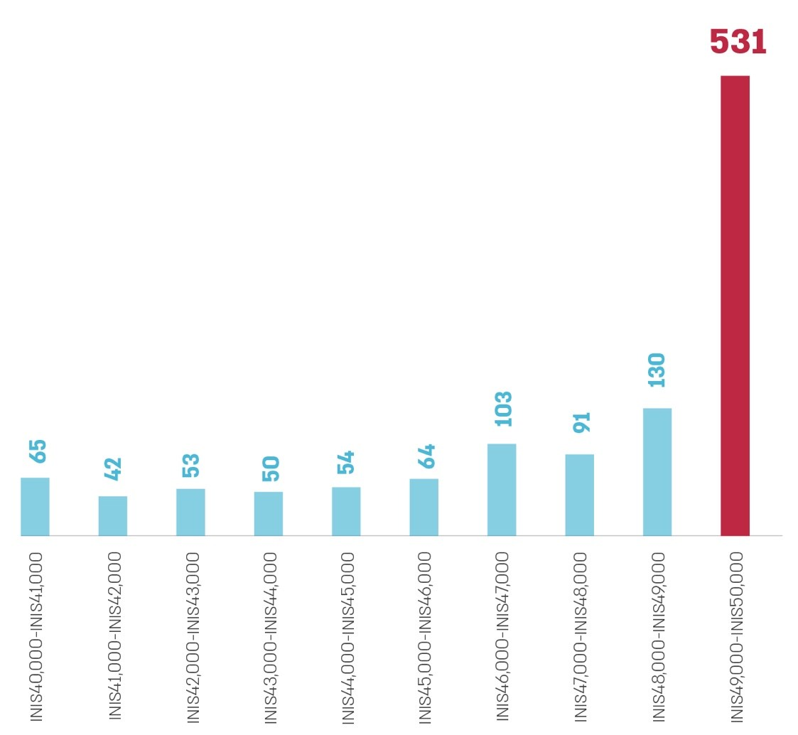
According to the Merkava data processed by the State Comptroller's Office.
The Scope and Number of ICT Purchase Orders Through Exempt Under Regulation 3(1) at NIS 47,500–50,000 by Government Bodies that Made at Least 30 Orders, 2019–2021
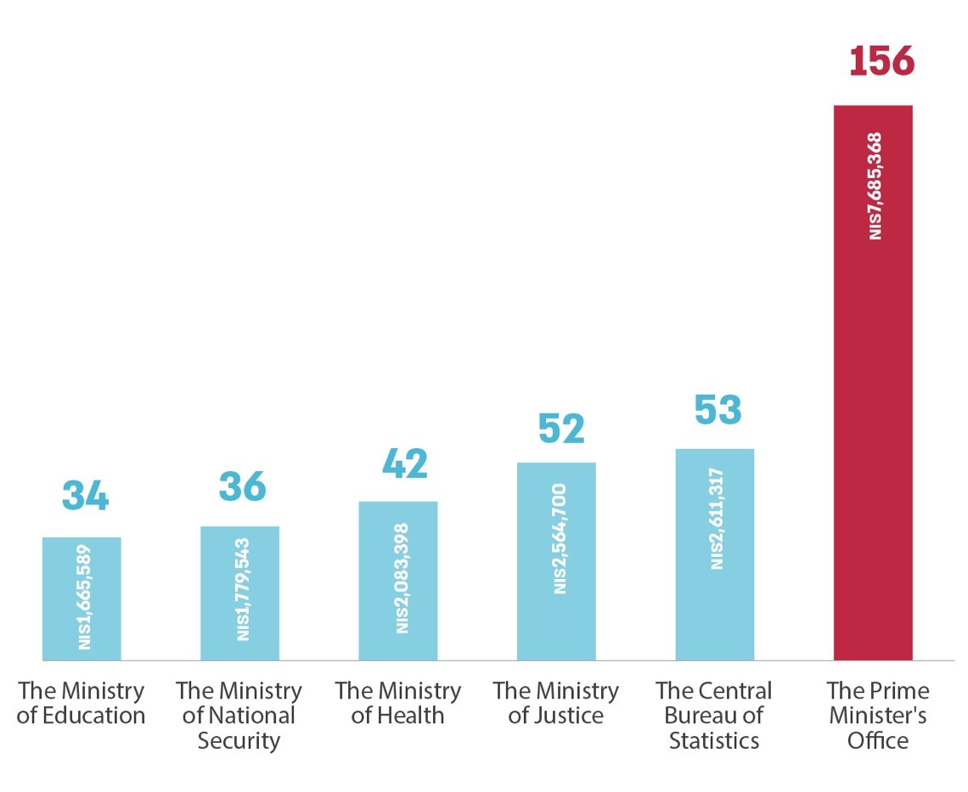
According to the Merkava data processed by the State Comptroller's Office.

Summary
The rapid development of the ICT field means that government bodies should implement innovation quickly and efficiently to prevent the relevant technology from becoming obsolete until the procurement process is completed. At the same time, the public interest requires that the procurement procedures be conducted in a fair, equitable, and transparent consistent with the provisions of the law and lead to business results and economic efficiency.
The findings of this report indicate a series of deficiencies in procurement, with an emphasis on ICT engagements exempt from tender. The following are the main deficiencies: the information published by the Procurement Administration and the National Digital Agency in procurement does not match the information in the Merkava system, thereby compromising the transparency to the public and the control capabilities of government procurement activity; Hundreds of percent higher use of government bodies of the exempt from tender on the grounds of a sole source purchase and on the grounds of engagements in sums up to NIS 50,000 in ICT procurement, compared to general procurement; And non-compliance with the provisions of the law concerning the publication of engagements.
The government bodies should adhere to the provisions of the law and the government procurement provisions of the TAKAM Directives. It is recommended that the Procurement Administration improve the procurement process in the Merkava system, including implementing computerized controls and compensatory controls, to verify the information's completeness and reliability and improve the ongoing supervision and control and the decision-making processes. The Accountant General and the Freedom of Information Unit should enforce the publication of the engagements of all entities under the provisions of the law while ensuring the reliability of the information made available to the public.

