­­



**The Ministry of Welfare's Treatment of Adults with Disabilities**

Ministry of Welfare and Social Affairs

Report of the State Comptroller of Israel | July 2024

The Ministry of Welfare's Treatment of Adults with Disabilities



The rights of people with disabilities are based on the principle of equality and the recognition of the value of the human being created in the image of God, and they are entitled to equal treatment and enjoy human rights and fundamental freedoms. A person with a disability is defined as an individual whose functioning is significantly limited in key life areas due to a physical, mental, or cognitive impairment. This report focuses on about 44,500, adults with disabilities aged 18 to 40, eligible to receive services from the Ministry of Welfare and Social Affairs (the Ministry of Welfare). Upon completing their high school education, young adults with disabilities may need support to facilitate their integration as equal members of society. To this end, the Ministry of Welfare offers services encompassing support in essential life spheres: housing, employment, leisure, family, and community.

The main services the Ministry of Welfare provides for people with disabilities include housing and employment assistance. The Ministry's policy is to offer comprehensive services to enable People with disabilities to reside within their families and communities before considering options outside their community. Housing services are designed to support individuals living at home through guidance that promotes optimal functioning – community living or in residential frameworks ran by the Ministry of Welfare for people who cannot live in their home – out-of-home housing frameworks. Regarding employment, the Ministry's policy aims for an independent employment of a person with disabilities as much as possible. Employment services encompass support for those working in the open market and programs within the Ministry for those who cannot secure employment outside of protected settings.

According to the Ministry of Welfare's policy, person-centered service is a cornerstone of providing services to people with disabilities, including tailoring services to individual needs, involving individuals in decision-making processes, ensuring freedom of choice, and fostering a sense of purpose and self-worth.

The Welfare Services for People with Disabilities Law, 2022, regulated and anchored the right of people with disabilities to receive social services supporting independent and autonomous living. As of 2022, the Ministry of Welfare has allocated about NIS 2.9 billion for these services. To implement the law, the government allocated an additional NIS 2 billion to the Ministry of Social Affairs for five years, beginning in 2024.



|  |  |  |  |  |  |  |
| --- | --- | --- | --- | --- | --- | --- |
| **about NIS 2 billion** |  | **37%** |  | **5% only** |  | **4% only** |
| to implement the law, the additional budget the government allocated to the Ministry of Social Affairs for five years, beginning in 2024, is a 14% increase in the annual budget of NIS 2.9 billion (as of 2022) |  | of the special education system graduates (about 3,700 people) recognized by the Ministry of Welfare and entitled to receive its services – do not receive any services from the Ministry of Welfare |  | of the special education system graduates participate in the Ministry of Welfare's adult life preparation programs (about 2,100 people) |  | of people with disabilities in the Ministry of Welfare's housing frameworks live in the community, compared to an average of 71% living in the community in selected countries |
|  |  |  |  |  |  |  |
| **less than 1%** |  | **41%** |  | **100%** |  | **8% only** |
| of people with disabilities placed in out-of-home housing frameworks move to more community-based housing settings (about 600 people) |  | of people living in the Ministry of Welfare apartments are transferred to another apartment or room on weekends and holidays, according to their reports in the State Comptroller's Office questionnaire |  | of the people with disabilities living in a protected residence reported in the State Comptroller's Office questionnaire that intimacy between partners is impossible |  | people with disabilities (about 1,050) advanced to more independent employment with an average payment (adjusted wage) of NIS 17 per hour compared to (compensation) NIS 0–3 per hour in protected employment |



**Audit Actions**

From January to October 2023, the State Comptroller's Office audited the Ministry of Welfare's treatment of adults with disabilities, including key components necessary for implementing the Welfare Services Law and utilizing the allocated budget. Key areas examined included the implementation of the Ministry of Welfare's policy for people with disabilities; The integration of young adults with disabilities into society post-graduation; Housing services and employment services for people with disabilities; And the oversight of these services. The audit was conducted at the Disability Administration and the Welfare Employment Division within the Administration of Personal and Social Services at the Ministry of Welfare and the Special Education Department at the Ministry of Education. Completion examinations were conducted at the National Insurance Institute and various housing and employment settings, at the Ministry of Health, and in local authorities.

The audit included: (a) Analysis of data regarding eligibility and placements in housing and employment for people with disabilities aged 18 to 40 at the time of the audit, regarding all of the Disability Administration's settings operating from 2013 to 2023 or during part of said period, regarding all supervision visits conducted in settings of the Disability Administration from 2018 to 2022, and regarding students who completed their studies in special education frameworks and were aged 19 to 28 at the time of the audit; (b) The State Comptroller's Office questionnaires: to people with disabilities residing in housing facilities managed by the Ministry of Welfare; to professionals in the field of disabilities at the Ministry's headquarters; to districts and local authorities, and housing inspectors within the Disability Administration; (c) Focus groups with people with disabilities, their parents, and social workers at local authorities.



**Key Findings**



**The Ministry of Welfare's Policy Regarding Adults with Disabilities Treatment –** most of the components in the Ministry of Welfare's policy on the treatment of people with disabilities are lacking, including critical components such as the definitions of fundamental concepts related to community and community housing, the establishment of a multi-year work plan for policy implementation, the identification of priorities, the setting of measurable objectives, the development of standardized measurement tools, and the leadership of an inter-ministerial process involving relevant government offices involved in the provision of services for people with disabilities to enable them to reside within the community, and for development of services offered by the Ministry of Welfare. Despite the Ministry asserting that "community" and "housing in the community" are core concepts to its policy and the implementation of the Welfare Services for People with Disabilities Law, it has failed to provide definitive descriptions of these terms. Additionally, the status update compiled by the Ministry of Welfare lacks data concerning the service recipients and the quality of services available to people with disabilities, as well as their alignment with individual needs. The significance of defining "housing in the community" is underscored by the Ministry's data indicating that the average monthly cost for community housing services is about NIS 1,700, compared to about NIS 13,000 for out-of-home housing frameworks.

**The Integration of Young People with Disabilities into Adult Life Post-Education**

* + **Receipt of Services from the Ministry of Welfare –** over a third of special education graduates recognized by the Ministry of Welfare (about 3,700 people, equal to 37%) do not receive any services from the Ministry. Of those recognized as eligible, around 20% (about 530 people) are graduates of special education with intellectual developmental l disability, and about 32% (about 820 people) with autism are similarly unserved by the Ministry of Welfare. Furthermore, about half of the special education graduates (about 3,200 people) who access welfare services in adulthood get these services only a year or more after graduation. Such delays impede the ability of young people with disabilities to foster independence, with some remaining idle in their parents' homes and potentially losing the advancements gained during their education due to a lack of meaningful engagement.
  + **The Exhaustion of Rights –** the Ministry of Welfare supervises service processes for people with disabilities and their families. It was found that these processes are deficient in key components: receipt of information is challenging (only 20% of respondents indicated that they could access a designated website or representative for understanding their rights during transition or crisis periods), a bureaucratic burden (75% of professionals believe that the guidelines published by the Ministry of Welfare provide limited assistance), an absence of care management and initiative (only 11% of professionals reported proactively reaching out to the people with disabilities in their care), lack of available professionals, and no transfer of data. These barriers may significantly hinder access to necessary services for people with disabilities and their families, ultimately leading to the non-recognition of eligible people by the Ministry of Welfare.
  + **Participants in Preparation Programs –** only about 6% of special education graduates (about 2,400 people) participated in the adult life preparation initiatives jointly offered by the Ministry of Education and the Ministry of Welfare. The overwhelming majority (94% at about 41,000 people) did not systematically receive opportunities from the Ministry of Welfare and the Ministry of Education to develop life skills and social and occupational competencies necessary for integration into military or national service, further education, or employment in the open market following graduation.

**The placement of People with Disabilities Within Housing Frameworks –** the monthly rates for housing frameworks are higher for more institutional framework. Specifically, the cost of residing in a sheltered residence is about NIS 14,600 per month per person, which is about NIS 2,000 (16%) higher than the rate for a hostel (about NIS 12,600). Furthermore, the hostel rate exceeds that of an apartment (around NIS 11,500) by about NIS 1,200 (10%), while the rate for an apartment is about NIS 9,700 higher (about six times) than that of a supportive environment, which costs about NIS 1,700. The placement committees under the Ministry of Welfare review requests for out-of-home housing frameworks for people with disabilities, often proposing three potential residential settings such as sheltered residence. However, these committees do not meet the people with a disability before determining their housing framework, and they do not involve the person himself or their family members in the decision-making process. The placement committees at the Ministry of Welfare determine the course of a person's life with limited participation on said person's part in such a fateful decision, which affects them for many years and gives them a limited right to choose their place of residence. Making fundamental decisions regarding a person in their absence undermines the person's dignity and reflects a failure to consider their preferences and desires.

**Community Living for People with Disabilities –** the Ministry of Welfare prioritizes community-based settings over institutional ones. Despite this policy, data from the Ministry indicates that from 2020 to 2022, 96% (about 11,300 people on average) of those receiving housing services from the Ministry lived in out-of-home settings, with a similar figure of 95% (around 8,700 people) in 2018–2019. In practical terms, only a tiny fraction (4%, about 500 people) of those receiving housing services live in community settings. Moreover, less than one percent (1%) of all people with disabilities transitioned to more community-oriented environments, with 90% remaining in their initial placement settings. Comparatively, the rate of people with disabilities living in out-of-home settings in Israel is notably high, at 96%, compared to an international average of 29%. In the USA and France, only 3% and 8% reside in such environments, respectively.

**Employment of People with Disabilities in Hostels and Apartments –** integrating people with disabilities into the workforce enhances their potential for independent and meaningful living, enabling them to engage actively in community life. However, the audit raised that about 24% (about 600 people) living in hostels and apartments were not employed at all during 2022, and were idle.

**Employment of People with Disabilities –** the average tariff in protected employment settings (day centers and rehabilitative work enterprises) is around NIS 3,800, with hourly wages ranging from NIS 0 to 3. In contrast, the average tariff in independent employment settings (work groups and individual market integration) is about NIS 1,900, with an average wage of NIS 17 per hour. In 2022, the Ministry of Welfare employed only about 10,000 people with disabilities across various employment frameworks out of about 37,000 people eligible for Ministry services. The Ministry of Welfare's policy promotes independent employment over protected employment and encourages a transition from protected to less protected frameworks, ultimately reaching an independent framework. However, the audit raised that most people with disabilities (70%, about 7,200 people) are engaged in protected employment. Only 8% (around 1,050 people) of those with disabilities who received employment services from the Ministry advanced to more independent employment. Furthermore, about one-third (35%) have remained in protected employment for over five years, indicating a lack of progression to more independent roles that offer higher income potential (an average of NIS 17 per hour compared to NIS 0–3). Additionally, 62% of respondents in protected employment believe they could secure more independent employment, suggesting that about two-thirds of those in protected employment do not feel they are realizing their full employment potential.

**The Provision of Service and Treatment of People with Disabilities in Housing and Employment Frameworks –** one of the fundamental principles of the Ministry of Welfare's policy is a person-centered service. Key principles include tailoring services to each person's individual needs and ensuring the freedom to choose. Despite the long-term residency of people with disabilities in these frameworks, many report a lack of autonomy regarding daily activities. In a questionnaire evaluating their experiences, average scores were remarkably low: the questionnaire assessed welfare frameworks on a scale of 0–10, and an average score of 1.4 was given for daycare centers, 3.8 for hostels, and 4.5 for apartments provided by the Ministry of Welfare, contrasted with a score of 8.8 for private homes of a person with welfare assistance on the Freedom to Decide Index. Individuals expressed being deprived of privacy, intimacy, and the potential for personal relationships (the questionnaire awarded an average score of zero for daycare centers, 2.8 for hostels, and 5 for Ministry apartments, against a score of 10 for those living in private homes with welfare assistance). Additionally, it was noted that about 27% of individuals are relocated to other apartments during weekends and holidays. Those in protected employment reported feelings of disrespect and a sense of purposelessness compared to individuals in independent employment frameworks. Notably, most people with disabilities reside in northern regions of the country, where the concentration of those receiving employment and housing services is lower. Conversely, a more balanced distribution is observed in central areas.

**Monitoring the Situation of People in the Housing and Employment Frameworks –** to determine the transitions of a person with disabilities to more communal living arrangements, their state must be assessed. The audit raised that individuals in less communal and more institutional settings have limited interactions with community professionals who could provide holistic assessments, including the person's family and the resources available in the community, and who can assess their situation and assist in developing the person's abilities for returning to the community, through an appropriate tailored plan. While 5% of professionals indicated they do not meet with people residing in their homes, 52% reported the same regarding those in institutional settings. Regarding employment, 42% of social workers in local authorities admitted to being uninformed or only partially informed about the status of people with disabilities within their first year in an employment setting. This figure doubled to 78% after the first year.

**Supervision by the Ministry of Welfare of the Housing and Employment Frameworks –** under the regulatory guidelines established by the government team to enhance the provision of outsourced social services and approved by the government in 2016, inspectors are required to conduct inspections of each housing framework between 13 and 18 times annually and each employment framework 6.5 times per year. The audit raised that inspections in the employment frameworks are performed only once every 3.5 years on average, and in the housing frameworks, about once every 18 months, constituting about 4% of the mandated inspection frequency. Despite person-centered service being a core component of the Ministry's policy and an area of expertise for inspectors, only about 5% of inspection inquiries pertain to this topic.



**The Impact of the Ministry of Welfare's Preparation Programs on Societal Integration –** a clear positive correlation exists between participation in the Ministry of Welfare's preparation programs for military service (an improvement of 22 percentage points) and national service (an improvement of 20 percentage points), as well as transitioning to community residence (an improvement of 22 to 35 percentage points), and securing employment in the free market (an improvement of 18 to 30 percentage points), and the length of employment in the free market (an improvement of about three months.



**Key Recommendations**

**The Ministry of Welfare's Policy Regarding the Treatment of Adults with Disabilities –** it is recommended that the Ministry address the gaps in the policy formulation by establishing a comprehensive situational analysis based on systematic data evaluation, setting clear priorities for policy implementation, defining measurable objectives, particularly in housing and employment, and developing a reliable measurement tool for consistent monitoring of these objectives.

**The Integration of Young People with Disabilities into Adult Life Post-Education –** the Ministry of Welfare should analyze the causes for the discrepancies between the number of special educations graduates eligible for services, in all aspects, and those recognized, as well as the factors contributing to the partial realization of their rights to services. Furthermore, the Ministry should monitor the rights to services, publish monitoring outcomes, identify barriers to these rights, and eliminate them. Additionally, the Ministry of Welfare should review the service processes it supervises for people with disabilities and their families, map the "customer journey," and identify unique needs at each stage to implement a quality service concept. It is also recommended that the Ministry expand transitional and preparatory programs to encompass all special education graduates.

**Housing Placement for People with Disabilities –** the Ministry of Welfare should involve people with disabilities in the decision-making process concerning their residence. Updates to the procedures should mandate that placement committees consult with the person and engage their family members in decisions, depending on need.

**Community Living and Independent Employment** **–** it is recommended that the Ministry of Welfare develop a strategic work plan to define community living and establish multi-year objectives for transitioning people with disabilities into such frameworks. Additionally, the Ministry should collaborate with professionals in examining the barriers to community living and adapt the range of services and the scope of support and guidance it provides to people with disabilities living in the community to their needs, thus enabling the expansion of community living. It is further recommended that the Ministry facilitate independent employment opportunities for people with disabilities through regular occupational ability assessments, monitor the duration of their employment, investigate the reasons for extended stays in employment settings, and ensure the implementation and updating of treatment plans designed to support individuals in these frameworks.

**The Service and Treatment of People with Disabilities Within Housing and Employment Frameworks –** it is recommended that the Ministry of Welfare clearly define what constitutes a person-centered service. This definition should be reflected in the services provided within the housing frameworks under its jurisdiction. Additionally, the Ministry should delineate the parameters that classify community residences based on the services offered. Continuous monitoring of the quality of service in these frameworks is recommended. Furthermore, the Ministry should instruct the operators of employment frameworks to provide training for staff members regarding respectful interactions with people with disabilities. Generally, the sense of belonging within employment frameworks and, specifically, within protected employment frameworks should be enhanced. The Ministry should guide these frameworks through tenders and supervision to foster diversity, engagement, and meaningful employment opportunities. Improvement of person-centered services across all operational frameworks is also recommended. Lastly, the Ministry of Welfare should ensure that all individuals residing in apartments and hostels have access to employment that aligns with their needs and aspirations.

**Monitoring the State of Individuals in Housing and Employment Settings –** it is recommended that the Ministry of Welfare supervise social workers in local authorities, ensuring they conduct independent, objective assessments annually for people with disabilities living in out-of-home settings and those in employment environments. These assessments should yield reliable progress evaluations and the potential for transitioning to community-based and more independent living arrangements.

**Supervision by the Ministry of Welfare over Housing and Employment Frameworks –** it is recommended that the Ministry of Welfare enforces compliance with the required scope of inspection visits and that it expands the inspection components focusing on person-centered services by clearly defining the service components to be evaluated, outlining the methods for assessing these elements and specifying the pertinent questions to be addressed by the inspector.

**Drawing of the Experience of Service for People with   
Disabilities from a Parents' Group**

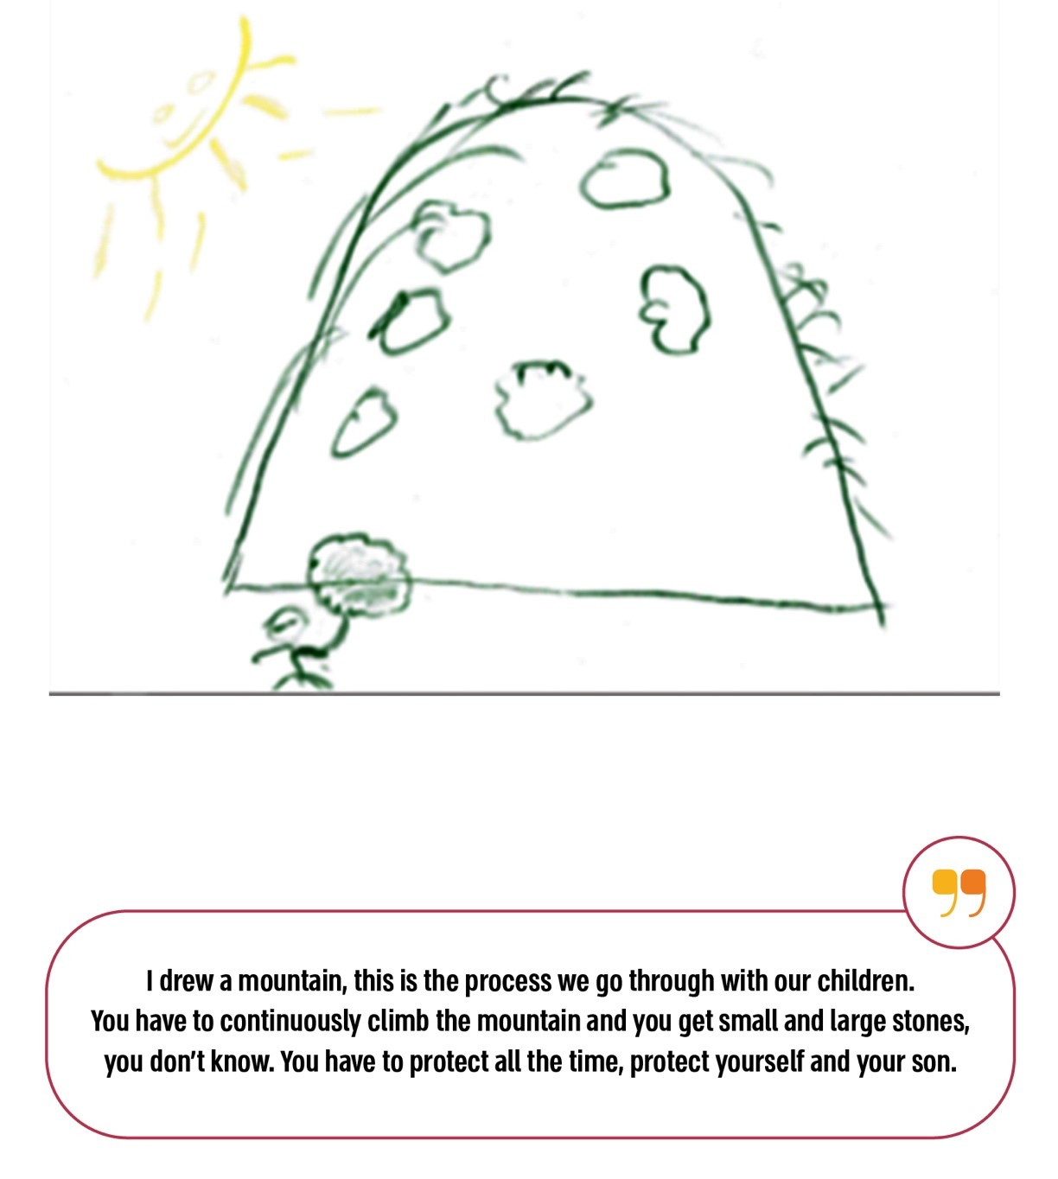

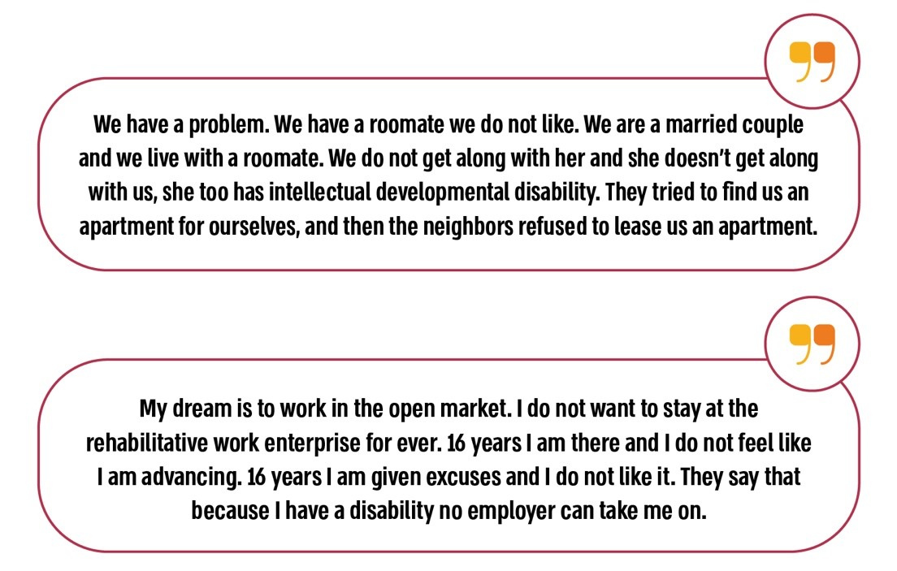

The diagram below presents a comparative analysis of the rate of people with disabilities residing in the community in Israel versus that in 18 selected countries. The data indicates that the rate of people with disabilities living in the community in Israel is the lowest at 4%, in contrast to an average of 71% in other countries. Conversely, the rate of people with disabilities residing in out-of-home housing frameworks in Israel is higher than the norm observed in other countries, recorded at 96% compared to an average of 29%.

**Rates of People Living in the Community and in Out-of-Home Settings in Selected Countries, 2021**

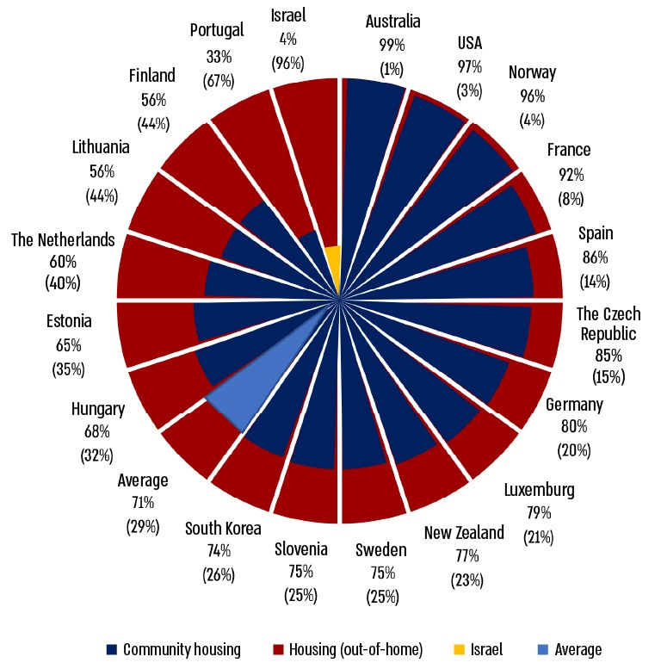

According to data collected during the audit.



**Summary**

About one million people in Israel live with a disability. In 2022, around 44,000 were eligible to receive services from the Ministry of Welfare, with about 57% (about 25,500) receiving those services. People with disabilities are, first and foremost, human beings; hence, the Ministry of Welfare is committed to providing services that respect them and enable them to live as equals within society, with freedom and independence. Implementing the Welfare Services for People with Disabilities Law at the beginning of 2024, accompanied by a budget increase, presents a significant opportunity for the Ministry of Welfare to fulfill this commitment.

Although the vision outlined by the Social Services Law and the policy of the Ministry of Social Affairs can be realized immediately among those who join the Ministry’s services, many adults with disabilities are left without adequate support. A substantial rate (37%) of young adults with disabilities do not receive any services from the Ministry. Additionally, despite the Ministry's emphasis on independent living in the community, the audit raised that most people with disabilities do not reside in community settings (96%) or engage in independent employment (60%). Moreover, although the housing frameworks operated by the Ministry have housed people with disabilities for many years, the main principles of community living and person-centered services do not exist in them, nor do they exist in employment frameworks, particularly in the protected frameworks.

To effectively realize its commitment to people with disabilities, it is recommended that the Ministry of Welfare develop housing services that enable residents to lead meaningful lives within the community, with respect and freedom of choice in their lifestyles. In addition, employment services should provide meaning and self-fulfillment, facilitating independent employment to the greatest extent possible. The necessary changes within the Ministry of Welfare are extensive and challenging. Therefore, it is recommended that the Ministry focus on removing barriers and enhancing the services provided, particularly for people with disabilities entering the services for the first time, including graduates of the special education system, and ensure a continuum of services throughout various life stages.