­­



**Information Security in the Conversion Authority at the Prime Minister's Office – Results of Resilience Test**

Prime Minister's Office

Report of the State Comptroller of Israel | July 2024

Information Security in the Conversion Authority at the Prime Minister's Office – Results of Resilience Test



Conversion refers to the process by which an individual joins Judaism. The Conversion Authority within the Prime Minister's Office was established by government resolution in February 2008 and is responsible for all processes related to the State of Israel conversion. This Authority supervises the special conversion courts, facilitates the instruction of converts prior to conversion, provides them support throughout the process, and implements the conversion procedures leading to the issuance of the "certificate of conversion", which serves as a civil-legal confirmation of religious conversion and is recognized in all relevant contexts within Israel.

The Conversion Authority handles over 5,000 conversion processes annually across various demographics, employing about 70 staff members, including rabbinical judges. The processes are administered via the "Maor" system, a computerized application developed by the Prime Minister's Office. The information and documents stored within this system are sensitive; any breach in regard to the confidentiality, integrity, or availability of said information could result in significant financial and reputational harm to both the State of Israel and the converts.



|  |  |  |  |
| --- | --- | --- | --- |
| **3** |  | **6 deficiencies** |  |
| types of breaches were raised by the audit, through which the audit team was able to generate false conversion certificates |  | were found in the resilience test and defined as "critical" or "high" level risks |  |
|  |  |  |  |



**Audit Actions**

In August 2023, the State Comptroller's Office conducted a resilience test for the Maor system used by the Conversion Authority operating within the Prime Minister's Office.

For the protection of state security, the sub-committee of the Knesset State Audit Committee decided not to bring this report before the Knesset in its entirety, but to publish only parts thereof, under Section 17 of the State Comptroller’s Law, 1958. The confidentiality of this data does not prevent the understanding of the nature of the audit.



**Key Findings**



**Critical Risk Level Deficiency – Circumvention of Established Business Logic Within the System, Enabling the Issuance of a Fraudulent Conversion Certificate –** the audit was able to circumvent existing work processes and control measures within the system and generate a fake conversion certificate, which would allow its holder to falsely represent themselves as Jewish, thereby misleading individuals and state institutions that view such a certificate as official certification of a religious conversion.

**Five High-Risk Deficiencies Were Identified**, including the susceptibility to an anonymous attacker overwhelming the system by automated submission of forms for the mass opening of files.

**Five Moderate-Risk Deficiencies Were Identified.**

**Ten Low-Risk Deficiencies Were Identified.**

It should be noted that the majority of the identified deficiencies pertain to an "internal threat", indicating a potential risk from users with access to the Maor system, as opposed to an "external threat" from unauthorized parties.



In its response dated March 2024, the Prime Minister's Office outlined its initiatives to address the deficiencies identified during the penetration test, including rectification of the critical deficiency soon after the test was conducted. The State Comptroller's Office commends the actions taken by the Prime Minister's Office to rectify these deficiencies prior to the compilation of the final audit report.



**Key Recommendations**

It is recommended that the Prime Minister's Office address the deficiencies identified during the test.

1. It is recommended that the Prime Minister's Office, the Cyber Defense Unit (Yahav), and the "e-gov" Unit rectify the online form for the "Request to open a conversion file".

**The Number of Deficiencies Found in the Resilience Test Conducted on the "Maor" System in August 2023, Broken Down Into Risk Levels**

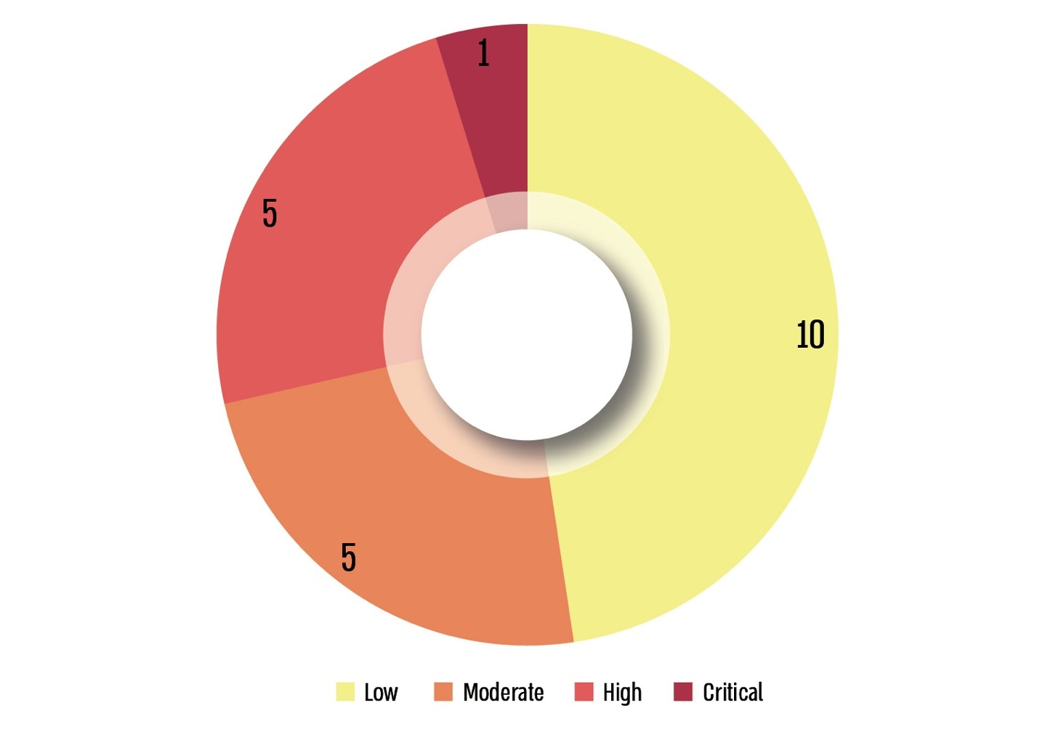

**Example of Fake Conversion Certificate Generated by the Audit**

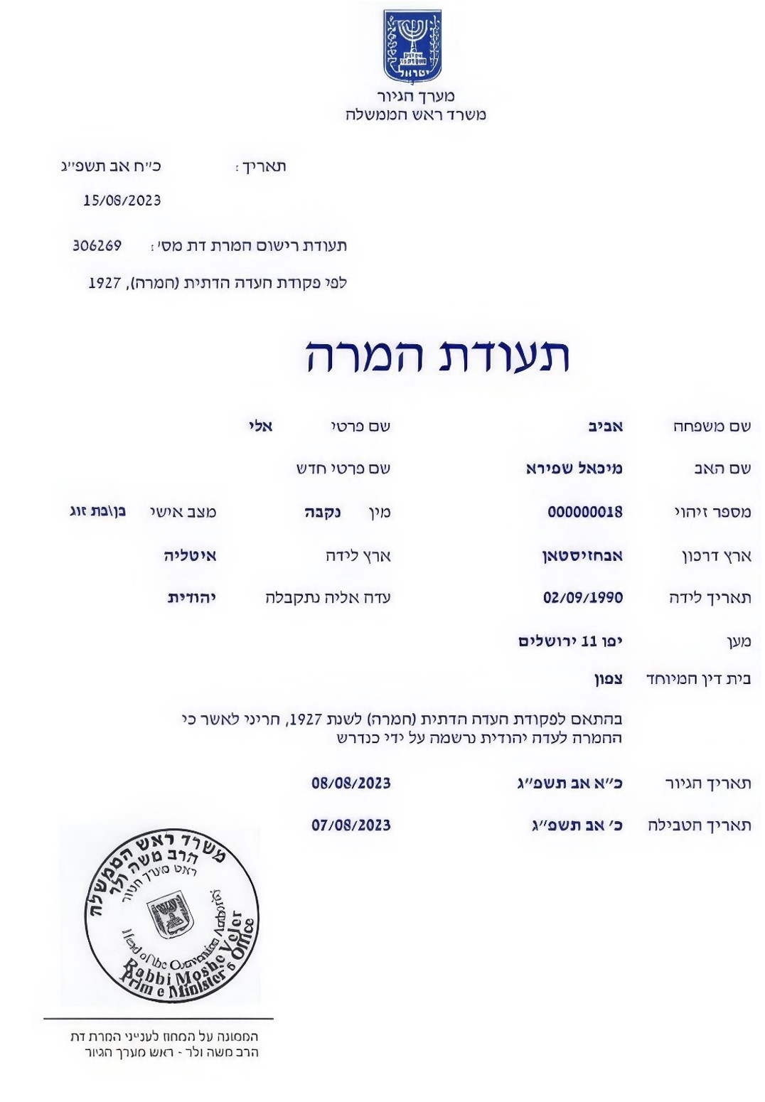



**Summary**

Conversion refers to the process by which an individual joins Judaism. The Conversion Authority within the Prime Minister's Office is responsible for all processes related to state conversion in the State of Israel. This Authority supervises the special conversion courts, facilitates the instruction of converts prior to conversion, provides them support throughout the process, and implements the conversion procedures leading to the issuance of the "certificate of conversion", which serves as a civil-legal confirmation of religious conversion and is recognized in all relevant contexts within Israel.

The State Comptroller's Office assessed the integrity of the computerized system utilized by the Conversion Authority. The information and documents stored within this system are sensitive; any breach in regard to the confidentiality, integrity, or availability of said information could result in significant financial and reputational harm to both the State of Israel and the converts. The audit uncovered a critical vulnerability within the "business process" of the Conversion Authority, specifically, the potential for the generation of fake conversion certificates, which would enable their holders to falsely represent themselves as Jewish, thereby misleading individuals and state institutions that recognize this certificate as official certification of religious conversion.

In its response dated March 2024, the Prime Minister's Office outlined its initiatives to address the deficiencies found during the penetration test, including rectification of the critical deficiency soon after the test was conducted. The State Comptroller Office commends the actions taken by the Prime Minister's Office to rectify these deficiencies prior to the compilation of the final audit report.

The Prime Minister's Office is urged to address the deficiencies highlighted in this audit, as detailed in the report. Additionally, it is recommended that the National Digital Agency and e-gov Unit evaluate whether the deficiencies identified are applicable to other computerized government services involved in the issuance of official certificates to the public.