­­



**Agricultural Production Boards – Functional and Financial Aspects**

Agricultural Production Boards

Report of the State Comptroller of Israel | July 2024

Agricultural Production Boards – Functional and Financial Aspects



The Agricultural Production Boards in Israel are associations of farmers originating in the 1940s, to regulate agricultural production and marketing across various sectors and to address the unique agriculture challenges. These boards ensure a consistent supply of food and agricultural products at fair prices for consumers while safeguarding equitable pricing for producers. In recent decades, the roles of the production boards have evolved, and most now focus on providing services to farmers, including training, research, information collection and distribution, and insurance. In Israel, various production boards operate in conjunction with the Ministry of Agriculture and Food Safety and the Ministry of Economy and Industry. This report examines the activities of five production boards: The Plants Production and Marketing Board, the Honey Production and Marketing Board, the Ground Nuts Production and Marketing Board, the Wine Grapes Board, and the Fruit and Vegetable Products Board.



|  |  |  |  |  |  |  |
| --- | --- | --- | --- | --- | --- | --- |
| **about 2.8 million tons** |  | **25% and 24%** |  | **NIS 518 million** |  | **32%** |
| of plant products were produced and marketed in Israel in 2022, of which about 1.5 million tons of vegetables, about 428,000 tons of citrus fruits, and about 917,000 tons of other fruits |  | the increase rate in vegetable and in fruit prices respectively between 2014–2023, compared to a 10% rise in the general consumer price index |  | the Ministry of Finance allocation by to the Ministry of Agriculture for direct subsidies in the crop sector within the state budget for 2023–2024, and whose manner of disbursement has not yet been agreed upon |  | the gap between the higher vegetable prices cited in the survey conducted by the Plants Board and their prices in the survey conducted by the Ministry of Agriculture |
|  |  |  |  |  |  |  |
| **NIS 8.5 million** |  | **0%**–**247%** |  | **13 years** |  | **0 representatives** |
| the levies that farmers have not yet paid to the Plants Board for 2020–2022, of which about NIS 1.6 million is for unpaid levies in the olive industry |  | the range of deviation rates of administrative and general expenses in production boards in 2022 from their maximum ratio according to the Ministry of Finance procedure for subsidies |  | average tenure of gatekeepers in production boards (auditing accountant, legal advisor, and internal auditor), without rotation |  | appointed by the government to the plenum of the Fruit and Vegetable Products Board |



**Audit Actions**

From February to December 2023, the State Comptroller's Office audited various aspects of the operations of five production boards: the Plants Board, the Honey Board, the Ground Nuts Board, the Wine Grapes Board, and the Fruit and Vegetable Products Board. Supplementary examinations were carried out in April and May 2024. The audit addressed multiple facets of the production boards, including financial statements, corporate governance, the relevance of the normative framework, the organizational structure of the boards, and their indirect impacts on the cost of living. It should be noted that the activities of the Egg and Poultry Board and the Dairy Board were not included in this audit, as they were reviewed in State Comptroller's reports published in May 2022 and May 2023, respectively.

The audit encompassed both the production boards and the Ministry of Agriculture, while supplementary examinations were conducted at the Ministry of Finance and the Ministry of Economy.



**Key Findings**



**The Ratio of Administrative and General Expenses –** across all production boards, with the exception of the Ground Nuts Board, expenses for administrative and general components out of the revenue exceed the ratios stipulated by the Ministry of Finance's procedures for subsidies related to these expenditures. Specifically, the administrative and general expenses in the Plants Board exceed the guideline by 57% (about NIS 5.8 million); in the Wine Grapes Board, by 71.6% (about NIS 310,000); in the Honey Board, by 27.9% (about NIS 153,000); and in the Fruit and Vegetable Products Board, by 247% (about NIS 252,000).

**Accumulated Surpluses and Unused Resources –** the Honey Board reported a profit surplus of about NIS 5.3 million at the beginning of 2022, which exceeds the Board's annual budget for that year (about NIS 4.5 million) by around NIS 800,000. The Board maintains high rates of return on its cash balance, investing in securities about NIS 3.1 million (about 61%), NIS 3.3 million (about 64%), and NIS 3.2 million (about 70%) in the years 2020, 2021, and 2022, respectively. However, it has not fully utilized its operational capabilities within the honey and pollination industry, including control and enforcement measures and research and development initiatives. The surplus of the Wine Grapes Board increased each year from 2018 to 2021, accumulating an amount exceeding the sum required to finance its subsequent year’s activities and its activities during Shmita years (the seventh year of the seven-year agricultural cycle when the land is left to lie fallow).

**The Plants Board Revenue from Levies –** although the unification of several production boards into the Plants Board in 2003 was to streamline operations and decrease overhead costs, the Plants Board currently employs four distinct collection teams that operate independently. Furthermore, the levies are collected in accordance with a procedure established about 15 years ago, which has not been updated as of the audit date. This procedure specifies separate collection processes for each of the Board's three segments – fruits, vegetables, and citrus fruits – but fails to include collection procedures for the olive sector, which was integrated into the Board in 2010. The fragmentation of collection mechanisms results in economic inefficiencies, including duplicated salary expenditures for collection staff across sectors and continued procedural actions against debtors, which may have been mitigated by establishing a single collection team for the entire Board. The outstanding levies owed to the Plants Board for 2020–2022 was about NIS 8.5 million.

**Fruit and Vegetable Prices –** consumer prices for fresh fruits have risen by about 24% over the past ten years (from November 2013 to October 2023), while prices for fresh vegetables have increased by about 25%. This compared with a 10% rise in overall food prices excluding fruits and vegetables, and a similar increase in the general consumer price index. In its consistent survey reporting for growers, the Plants Board presents produce prices that are higher than those published by the Ministry of Agriculture. The average price for vegetables sampled during the audit within the quality group type A in the Plants Board's survey was about 32% higher than the corresponding prices in the Ministry of Agriculture survey. Notably, prices for eggplant and zucchini in the Plants Board survey were about 70% and 60% higher, respectively. Such discrepancies may contribute to increased prices shifted to consumers, suggesting that the Board may not be fulfilling its responsibility to ensure an adequate supply of plants at reasonable prices for the population.

**The Customs Tariff Reduction Rate on Fruits and Vegetables –** a significant disparity of 68% on average was found between the government's resolution from August 2021 and the Board's proposal from November 2021, specifically concerning 16 out of the 28 species cited in the Board's proposals. The Board opted to negate any reductions in protective customs tariffs. Therefore, the Plants Board endeavored to persuade decision-makers to limit reforms on indirect subsidies in agriculture. The ongoing provision of indirect subsidies benefits farmers by potentially increasing the cost of competing imported products, thereby maximizing their returns. However, the Plants Board did not consider the implications of this approach on consumer prices, despite its obligation to ensure suitable pricing for the general population.

**Direct and Indirect Subsidies –** OECD data from 2020 raised that Israel's import goods as a percentage of GDP was about 17.1%, ranking fifth lowest among the 34 examined OECD countries. As of this year, private consumption of imported fresh fruits and vegetables accounted for around 9% of total expenditure on such items. OECD estimates indicate that in 2021, the share of indirect subsidies constituted 90.7% of total assistance to farmers in Israel, significantly surpassing the OECD average of 23.1%. The OECD recommended a simultaneous reduction of indirect subsidies alongside the provision of direct subsidies to farmers. The process of reducing indirect subsidies commenced in 2022–2023, with the initial two phases of customs reductions implemented. However, in 2023, the Ministry of Agriculture and the Ministry of Finance opted to halt the progression of the established reduction plan due to a lack of consensus on the allocation of direct subsidies among farmers. Consequently, by December 2023, about NIS 518 million in direct subsidies budgets for the plant sector remained unutilized (about NIS 270 million for 2023 and NIS 248 million for 2024).

**Appointment of Government Representatives to the Boards –** in all boards examined, only 12 out of a potential 24 representatives were duly appointed, from the Ministry of Agriculture, the Ministry of Economy, and the Ministry of Finance, despite legal requirements in the law establishing these boards and in their articles of incorporation. In all boards, with the exception of the Ground Nuts Board, the records of the appointments of government representatives to the board of directors are absent. In total, 5 out of 12 government representatives on the boards of directors of these boards are missing. The Fruit and Vegetable Products Board has not appointed a chairman from the Ministry of Economy, as mandated. Furthermore, with the exception of the Wine Grapes Board, where state representatives attend plenary meetings, the participation rate of government representatives in plenary board meetings and board meetings of the rest of the production boards varies between 40% and 60%. This limited representation potentially undermines the influence of government ministries on board decisions and may also diminish the public oversight enshrined in the boards' incorporation documents.

**Length of Time in Office of the Gatekeepers in the Boards –** as of the audit date, the gatekeepers in the agricultural production boards (legal advisor, auditing accountant, and internal auditor) have served as external service providers for an average of about 13 years, without rotation. Furthermore, it was noted that, contrary to the provisions outlined in Government Companies Regulations and the Civil Service Commission's directives to government ministries, there is no stipulation limiting the term of office for these gatekeepers in the production boards, allowing their tenure to extend over decades, with one gatekeeper's term reaching 19 years. Such prolonged service may lead to a dependency of the production boards on these service providers. Additionally, extended periods of service raise concerns about potential excessive identification between the gatekeepers and the boards, which may jeopardize their professional independence.

**Transparency and Publication of Information to the Public –** the Ground Nuts Board and the Fruit and Vegetable Products Board do not disclose financial and performance information on their websites, nor do they issue an annual report to the public as mandated by the Freedom of Information Law. Similarly, the Wine Grapes Board and the Honey Board, while not subject to the Freedom of Information Law, also refrain from publishing such data. The Ministry of Agriculture similarly does not make available the financial statements of all agricultural production boards or budget reports with respect to each board's performance. It should be noted that general background information on the production boards was published on the Ministry's website during the audit period. The Fruit and Vegetable Products Board lacks a dedicated website, making it impossible to access information through the Ministry of Economy or the unified government website (gov.il). Furthermore, as of the audit date, the Accountant General has not published the financial statements of the Fruit and Vegetable Products Board for 2022 on the Ministry of Finance's website, which contravenes the Budget Foundations Law. In the absence of information regarding the boards' performance and current activities, the public is deprived of the opportunity for oversight that is afforded by transparency of information.

**Outdatedness of the Normative Base –** the legislation governing the operation of production boards was established in the mid-twentieth century and relies on outlooks that are now outdated. The incompatibility of regulations with the realities of life in the current era in Israel may render certain regulations ineffective. For instance, the Fruit and Vegetable Products Board does not engage in the purchase and sale of citrus fruits for industry purposes as stipulated in the regulations, and its management is unaware of, and fails to enforce, the Purchase of Citrus Fruits for Industry Purposes Regulations. Additionally, the powers granted to the Plants Board upon its inception as the Fruit Board in 1973 – to establish rules on regulatory issues – have become obsolete and do not align with the Boards' current role or conduct. The presence of such powers in the statute book contributes to ambiguity regarding the Plants Board's contemporary function.

**Regulation of the Honey Industry in Judea and Samaria –** the lack of enforcement of the Honey Order and the Bee Regulations in Judea and Samaria may result in overcrowding of beehives in the region and neighboring areas, ultimately diminishing bee resilience and their ability to combat diseases and pests. This could lead to a reduced honey harvest and adversely affect the pollination capacity of bees. Additionally, in the absence of appropriate regulations, beekeepers with hives in Judea and Samaria are not eligible for inclusion in the registry of beekeepers that are members of the Board, and thus cannot access services provided by the board, such as research and development, insurance, pest management, and technological advancements.

**The Institutional Structure of the Agricultural Production Boards –** there is a trend in the Western world towards predominantly voluntary agricultural production boards or statutory boards with membership contingent upon the consent of the majority of growers within each sector. The following findings pertain to the structure of the production boards in Israel:

* **The Plants Production and Marketing Board –** as of October 2023, over 5 years have elapsed since the withdrawal of 11 fruit species from the Plants Board, yet the Ministry of Agriculture has not assessed the consequences of this withdrawal. The decision to withdraw these species was based on low levy collection rates, leading the Ministry to infer that growers did not wish to remain members of the Board. It should be noted that the Plants Board's levy collection varies by sector: in the fruit sector, levies are collected from growers; in the vegetable and citrus sectors, levies are collected from marketers; and in the olive sector, growers choose their collection method. Therefore, evaluating growers' opposition to board membership based solely on levy collection rates does not provide an equitable opportunity to examine this benchmark among vegetable and citrus growers, who lack the option to withhold payment.
* **The Honey Board –** despite an estimated agricultural output of about NIS 3 billion reliant on bee pollination services, the board of directors of the Honey Board lacks representation from the farmers requiring pollination services. Furthermore, the board of directors of the Honey Board includes 23% representation from the business sector (marketers) and 62% from beekeepers, resulting in 85% of management being comprised of stakeholders' representatives. Honey Board directors have not been required to disclose their affiliations or sign arrangements to mitigate potential conflicts of interest as appropriate.
* **The Ground Nuts Board –** the marketing procedures for ground nuts conducted by the Ground Nuts Board are similar to those of the Cotton Board, which is voluntary. While all cotton crops, akin to ground nuts, are marketed abroad solely through the Cotton Board, association with the Cotton Board is not legally mandated and depends on its economic viability for growers. This comparison indicates that voluntary association, if economically beneficial to growers, could meet the objectives of the ground nuts export industry, similar to the current circumstances wherein membership in the Ground Nuts Board is compulsory.
* **The Fruit and Vegetable Products Board –** no activities of the Fruit and Vegetable Products Board were identified necessitating its statutory status. Aside from participation in international conferences as Israel's official representative and the collection of information regarding volumes of fruit processed by member enterprises, no additional activities carried out by this board have been observed over the past decade. The Board's incurred expenses were found to be purely administrative and general. Additionally, the law by virtue of which it operates is outdated, with provisions related to production planning, quality improvement, research activities, export promotion, and advising the Minister of Economy remaining unimplemented. The Board also fails to adhere to standards of proper corporate governance.
* **The Wine Grapes Board –** membership in the Wine Grapes Board is voluntary and lacks regulatory authority; however, the Ministry of Agriculture is involved in the Board's management.



In the past decade, the Ministry of Agriculture has advocated for the regulation of the honey industry independent of emergency situations. An updated government bill prepared by the Ministry was presented to the Knesset in 2023. The Ministry of Agriculture should incorporate provisions for the regulation of the honey industry into primary legislation that is not contingent upon the declaration of an emergency.



**Key Recommendations**

It is recommended that the Ministry of Agriculture and the Ministry of Economy, in coordination with the production boards, comprehensively examine and analyze agricultural production boards. The Minister of Agriculture and the Minister of Economy, along with the aforementioned parties, should decide regarding the initiation of new regulations for these corporations and any necessary changes.

The Ministry of Finance, the Ministry of Economy, the Ministry of Agriculture, the Ministry of Justice, and the production boards should assess the current situation and promote legislative amendments to ensure that production boards are empowered to address the needs of Israeli agriculture. This must be balanced with the necessity of ensuring competition and a free market to reduce the cost of living in Israel, while considering the characteristics of the agricultural sector.

It is recommended that the Executive Committee of the Plants Board, the Plenum of the Fruit and Vegetable Products Board, the Board of Directors of the Honey Board, and the Board of Directors of the Wine Grapes Board evaluate the administrative and general expenses of the boards for which they are responsible. Additionally, it is recommended that the Ministry of Agriculture and the Ministry of Economy ensure that all production boards operate efficiently to fulfill their mandates, acknowledging the unique characteristics of each board's responsibilities, and guide their management accordingly. The Ministries of Agriculture and Economy should consider establishing a cap on administrative and general expenses for agricultural production boards, similar to the Ministry of Finance procedures for subsidies.

The Ministries of Agriculture, Economy, and Finance, as well as the responsible ministers, should fully staff and participate as government representatives in the boards of directors and plenary sessions of the boards, as mandated by the establishing laws. Moreover, the production boards, particularly the Honey Board, must ensure that meeting notifications for the boards of directors and plenary sessions are distributed to all government representatives involved in their management, thus ensuring ongoing functionality of the production boards and uphold public oversight of their activities.

To enhance the activities of the boards and ensure the independence of the gatekeepers, it is recommended that the boards consider limiting the term of office for the gatekeepers. Additionally, the Ministry of Agriculture and the Ministry of Economy, which supervise the boards' operations, should review the establishment of rules regarding these terms.

The production boards, subject to the Freedom of Information Law and the Budget Foundations Law, should publish their financial statements in compliance with applicable regulations and proper governance. It is further recommended that all production boards, along with the respective ministries responsible for supervising their operations – namely the Ministries of Agriculture and Economy – disseminate as much information as possible concerning the boards' performance and activities.

The Ministry of Agriculture, the Ministry of Finance, and the Plants Board should assess the structure and functions of the Plants Board, considering the advantages and disadvantages of operating as a statutory corporation that collects mandatory payments from growers in certain sectors versus functioning as a voluntary organization focused solely on protecting the interests of growers.

The Plants Board should consider conducting a separate survey on behalf of the Board regarding fresh vegetable prices in wholesale markets, rather than relying on data published by the Ministry of Agriculture or collected by other objective entities. Should it be deemed essential, the survey should be conducted in a manner that guarantees the reliability of its results.

It is recommended that the Ministry of Agriculture and the Plants Board analyze the implications of the withdrawal of 11 species from the Plants Board, including an examination of the potential cancellation of mandatory payments to the Board and its subsequent effects on the Board's structure and functions. This analysis should encompass the changes in crop sectors that have been withdrawn and the impact of these changes on plant produce.

The Ministry of Agriculture, in coordination with the Ministry of Defense and in consultation with the Ministry of Justice, should examine the implementation of the Honey Order and Bee Regulations within security legislation, as well as assess the applicability of policies related to the honey industry in Israel to the Judea and Samaria territories.

The Honey Board should assess the source of its substantial profit balance and, based on the findings, develop a strategic work plan to implement initiatives and investments to enhance the industry's efficiency. Additionally, it is recommended that the Board explore options for revisiting previously rejected initiatives due to cost constraints.

The Ministry of Agriculture should evaluate the potential for including representatives from farmers utilizing pollination services on the Honey Board's board of directors, given their direct relevance to the Board's operations. Furthermore, the Ministry should investigate the implications of abolishing the mandatory participation in the Ground Nuts Board, transitioning it to a voluntary structure similar to that of the Cotton Board.

The Ministry of Economy should determine the rationale for amending the legal framework to enable the Fruit and Vegetable Products Board to function as a representative body of stakeholders, without regulatory authority or government involvement in its operation.

The Wine Grapes Board should collect membership fees sufficient to generate a surplus that can support activities during Shmita years, while ensuring this surplus does not significantly exceed the anticipated deficit from such years. Additionally, the Board should formulate a multi-year plan to increase investments to enhance industry operations and efficiency, utilizing a portion of its accumulated surplus, and adjusting membership fees accordingly. The Ministry of Agriculture should consider altering the composition of the Wine Grapes Board's management, to allow for a private entity to promote the interests of the wine sector without government interference, particularly considering that membership is voluntary and does not entail regulatory authority.

**Mandatory Incorporation and the Framework for the Establishment of the Production Councils**

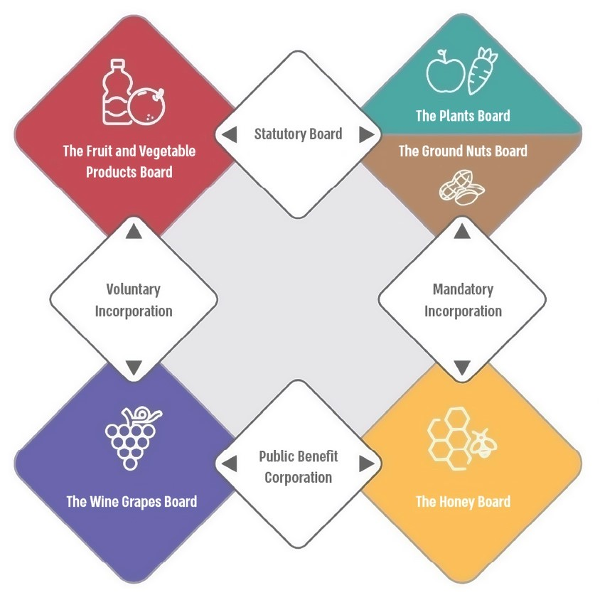

According to the incorporation documents and Boards related legislation, processed by the Office of the State Comptroller.

**Board Revenues, the Maximum Ratio of Administrative and General Expenses Set in the Ministry of Finance's Procedure for Subsidies and Their Actual Ratio (in thousands of NIS), 2022**

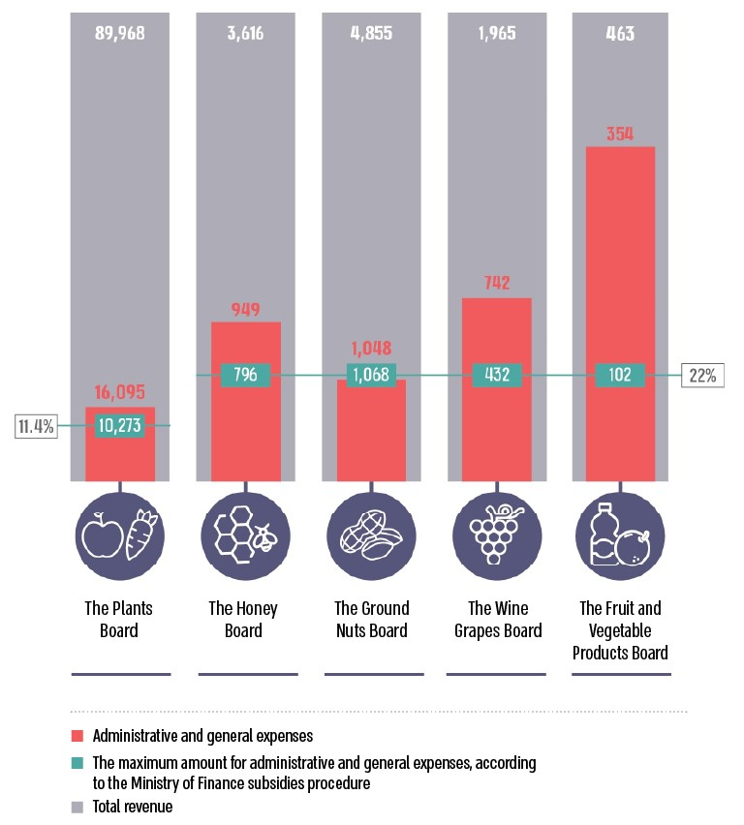

According to data from the financial statements of the production boards, processed by the Office of the State Comptroller.

* The amounts of administrative expenses and general expenses were calculated in accordance with the maximum marginal rate of these expenses from the revenue cycle, as determined in the Ministry of Finance procedure concerning state budget subsidies for public institutions.



**Summary**

Beginning in the 1940s, agricultural production boards were established in Israel to address the agricultural sector challenges by regulating the market, promoting exports of agricultural products, and ensuring essential infrastructure for production and marketing, including research and development, training, knowledge dissemination, insurance against natural damages, pest control, and sales promotion. In recent decades, the number of active production boards in Israel has decreased. This report raised functional and financial deficiencies in the operations of the production boards, which are reflected in five aspects:

1. **Financial Aspect –** the audit raised that, with the exception of the Ground Nuts Board, the boards' administrative expenses are excessively high compared to those deemed reasonable for public corporations and non-profit organizations with similar characteristics. Additionally, the Wine Grapes Board has accumulated a surplus balance exceeding requirements for its current activities as well as for the Shmita year, while as of 2022, the Honey Board has accumulated surpluses totaling approximately NIS 5.3 million (about 156% of its revenue).
2. **Indirect Effects on the Cost of Living –** the audit examined the indirect effects of the Plants Board on the cost of living in Israel and found that levies collected from growers had a minimal impact on fruit and vegetable prices in the past decade. However, actions taken by the Board, in representing plant sectors vis-à-vis the executive authority and providing price information, have indirect effects on consumer prices. The Board's responsibilities enshrined in law, including its responsibilities and obligations towards growers, may conflict with its responsibilities to the public. Survey results indicated that the Board consistently published produce rates at prices higher than those published by the Ministry of Agriculture, potentially contributing to increased consumer prices. Furthermore, the Board advocated for decisions favoring farmers, prioritizing price guarantees for growers over ensuring an adequate supply of plants at fair prices for the general population.
3. **Corporate Governance –** the audit raised issues in corporate governance, such as failure to appoint governmental representatives to the boards, extended tenures for gatekeepers (auditing accountant, legal advisor, internal auditor), delays in financial statement approvals, and insufficient public transparency regarding board activities and performance.
4. **Legal Foundation –** the findings indicate that the normative framework governing the boards is outdated, largely enacted between the 1950s and 1970s, with some provisions rendered ineffective and others lacking clarity. The audit uncovered inconsistencies between various norms and legislation governing production boards and the boards' current operational environment.
5. **Organizational Structure and Powers –** the audit raised inconsistencies in the organizational structure and powers assigned to different production boards, raising questions about the rationale behind these differences. Notably, there is a trend in Western countries towards primarily voluntary agricultural production boards or to statutory boards whose membership is conditional on referenda and majority consent from growers in each sector, in contrast to prevailing practices in Israel.

The audit highlighted disparities among production boards regarding their organizational structures and powers. The operations of certain boards do not warrant the organizational framework and authority they possess. This necessitates a comprehensive examination by the Ministry of Agriculture, in conjunction with the Plants Board, Honey Board, Ground Nuts Board, Wine Grapes Board, and the Ministry of Economy, alongside the Fruit and Vegetable Products Board, to assess the need for structural changes within these entities. It is recommended that this examination include an evaluation of the financial performance of production boards as presented in their financial statements, necessary adjustments to the legal framework governing each board, their structural organization, and their current roles.

Given the Iron Swords War outbreak in October 2023, the imperative for establishing agricultural sustainability in Israel during both normal and emergency situations was underscored. The production boards significantly contribute to supporting farmers and supplying agricultural produce to the population. Consequently, the findings of this examination will assist the Minister of Agriculture, the Minister of Economy, and other involved parties in formulating regulatory initiatives concerning these organizations and implementing necessary changes.