­­



**The Protection of the Traffic Routes in Judea and Samaria**

The Defense System

Report of the State Comptroller of Israel | July 2024

The Protection of the Traffic Routes in Judea and Samaria



In the Central Command Area, encompassing Judea and Samaria, there are numerous traffic routes traversing areas A[1], B[2], and C[3]. The cumulative length of these routes utilized by both Israelis and Palestinians is about 1,600 km. Prominent routes include main roads 60 and 90 (which run north-south) and 1, 443, and 5 (which run east-west).

The Israeli population residing in Judea and Samaria is about 503,000, in about 150 local authorities. The Palestinian population in Judea and Samaria is about 3 million, inhabiting roughly 450 cities and villages.

The Israeli populace utilizing the main roads in Judea and Samaria face persistent terror attacks, including stone-throwing, Molotov cocktail attacks, the deployment of explosive devices against vehicles, use of vehicles to run people down at bus stops, and gunfire from ambushes or from moving vehicles.

The Israel Defense Forces (IDF), by the Central Command, who is the commander of the IDF operations in Judea and Samaria, is responsible for overall security and military duties, as well as maintaining law and public order in the area. The Judea and Samaria Division constitutes the primary military force operating in Judea and Samaria, supported by six regional brigades.

According to the Central Command data in 2022, there were about 3,780 non-shooting terror attacks in Judea and Samaria, (averaging 315 incidents per month), of which 646 (17%) involved the laying of IEDs or throwing of Molotov cocktails. Several of these attacks occurred on the main roads used by many Israeli residents. Furthermore, Central Command data raises a 4-fold increase in shooting incidents in Judea and Samaria from 2021 to 2022, (167 incidents compared to 41), with 143 incidents occurring in the first half of 2023. As a consequence, 19 Israeli citizens lost their lives due to terror attacks targeting routes in Judea and Samaria from the beginning of 2022 through the end of the first half of 2023, with 13 fatalities in the first half of 2023.

**This audit was conducted before the onset of the "Iron Swords" War; however, its findings and recommendations have become increasingly more relevant in the current context, particularly from a forward-looking perspective.**



|  |  |  |  |  |  |  |
| --- | --- | --- | --- | --- | --- | --- |
| **1,600 km** |  | **330% increase** |  | **3,780** |  | **over 5-fold increase** |
| of routes used by Israelis in Judea and Samaria (most of them in Area C) |  | in the number of shooting incidents in Judea and Samaria at routes and local authorities from January 2022 to June 2023 (310 incidents) compared to 2019–2021 (71 incidents) |  | number of non-shooting terror attacks in Judea and Samaria in 2022 |  | in the number of shooting incidents against IDF forces that entered Palestinian cities in 2022 (138 shooting incidents) compared to 2021 (25 shooting incidents) |
|  |  |  |  |  |  |  |
| **number of battalions** |  | **14%–57%** |  | **significant proportion of the checkpoints** |  | **3,322** |
| reinforced the IDF's order of battle in Judea and Samaria as of July 2023, compared to a reinforcement of double the number of battalions in July 2022, during Operation "Breakwater" |  | of the defense assignments in the three regional brigades that were examined (Samaria, Binyamin, and Etzion) were not according to plan, including the placement of observation posts, foot and mounted patrols, setting up ambushes, placing temporary checkpoints on the roads, and securing pick-up stations |  | in Judea and Samaria are open and not used as permanent checkpoints |  | the number of counterterrorism activities and arrests carried out by the IDF in Judea and Samaria in 2022 |
|  |  |  |  |  |  |  |

|  |  |  |  |  |  |  |
| --- | --- | --- | --- | --- | --- | --- |
| **NIS576 million** |  | **in at least 75%** |  | **32 years** |  | **only 14 out of 19** |
| allocated for the construction of bypass roads in Judea and Samaria in the last 7 years |  | of the incidents recorded in the call log of the Samaria and Judea District Police, the response times of the district police officers were either not recorded or the records were untrustworthy |  | the time period from the initiation of the Huwara bypass road in 1992 to its completion in 2024. From January 2022 to June 2023, 246 attacks occurred on the route passing through the village of Huwara |  | relay sites included in the three-year plan to improve cellular coverage in Judea and Samaria have actually been established, as of December 2023 (74%), six years after the planned date for completing the plan's implementation |
|  |  |  |  |  |  |  |
| **60%** |  | **64%** |  | **81%** |  | **only 24%** |
| of residents of Judea and Samaria who responded to the State Comptroller's Office questionnaire reported that their sense of security on Judea and Samaria traffic routes is low |  | of residents of Judea and Samaria who responded to the State Comptroller's Office questionnaire indicated low levels of satisfaction with the arrival times of the Israel Police to security incidents on the traffic routes |  | of residents of Judea and Samaria who responded to the State Comptroller's Office questionnaire reported that cellular coverage on the traffic routes in their routine travel area is insufficient to moderately sufficient |  | of the respondents to the State Comptroller's Office questionnaire who experienced a security incident on the traffic routes, reported it to the police hotline (100). 75% reported it to the local authorities' emergency hotline (1208) |



**Audit Actions**

From December 2022 to September 2023, the State Comptroller's Office audited the protection of traffic routes in Judea and Samaria and the response to residents during security incidents along these routes. This included an evaluation of the operational activities of the bodies jointly responsible for security on the routes, efforts related to the construction of bypass roads, the civil communication response through cellphone companies, and the intelligence response in the region via the "Smart Region" program.

The audit was carried out at the Ministry of Defense (MoD), the National Security Council (NSC), the IDF (including the Central Command, the Civil Administration, the Operations Directorate, the Planning Directorate, and the Ground Forces), at the Israel Security Agency (ISA), the Ministry of Transport and the Israel National Roads Company, the Ministry of Communications, the Ministry of Finance, the Israel Police (Judea and Samaria District), and at the emergency hotlines in local authorities in Judea and Samaria. Supplementary examinations were conducted at the Ministry of Justice, the Ministry of Construction and Housing, and at Mekorot.

The audit included public participation tools: meetings were held between the chief security officers (CSOs) and Civilian Security Coordinators with the IDF (CSCs) from local authorities in Judea and Samaria; a questionnaire, was distributed Israeli resident in Judea and Samaria to which 5,236 residents responded; in collaboration with the Central Command Intelligence and the Centre for the Survey of Israel, a GIS system was used to analyze data on the number of attacks along all Judea and Samaria traffic routes in 2022–2023.

For protection of state security, the sub-committee of the Knesset State Audit Committee decided not to bring this report before the Knesset in its entirety, but to publish only parts thereof, under Section 17 of the State Comptroller’s Law, 1958.



Section One: **The Operational Response for the Protection of Traffic Routes in Judea and Samaria**



**Key Findings**



**The Central Command's Order of Battle –** disparities have emerged in the allocation of the order of battle within the Central Command area during specific periods.

**Fulfilment of Defense Assignments in the Shomron, Binyamin, and Etzion Regional Brigades in the Judea and Samaria Division –** the audit raised that, despite reinforcement efforts per the "Breakwater" Ordinance, the escalating threats in these routes do not receive the necessary operational response, as reflected by the challenges faced by the three regional brigades examined in the Judea and Samaria Division (Samaria, Binyamin, and Etzion) in fulfilling the defense assignments approved weekly at the division level. For instance, on selected dates in 2022 and 2023, about 14% to 57% of the defense assignments assigned to these units were not executed. These encompass assignments such as placement of observation posts, foot and mounted patrols, setting up ambushes, placing temporary checkpoints on the roads, and securing Pick-up stations. The failure to complete these assignments undermines the forces' ability to safeguard the residents in the Judea and Samaria sector against threats.

**IDF's Permanent Checkpoints Policy in Judea and Samaria –** most assailants shooting incidents from 2019 to 2023 came from the cities of Jenin (145 attackers), Nablus (104 attackers), and Ramallah (72 attackers). Notably, there was an increase in attacks from Jenin in 2023, while incidents from other cities decreased. Currently, there are no permanent checkpoints at the exits from these cities. The audit found that the IDF's policy regarding the effectiveness of permanent checkpoints as a protective measure involves coordination between the division, command, and General Staff (via the Operations Division). The IDF Operations Division Head has stated that this policy consists of providing operational responses through temporary checkpoints and the removal of existing ones, and it undergoes regular evaluations in situational assessments. However, it remains unclear whether the General Staff and the Ministerial Committee on National Security Affairs (the State Security Cabinet) are aware of the significant number of open checkpoints in Judea and Samaria.

Furthermore, the audit found that the IDF's policy regarding the establishment of permanent checkpoints in Judea and Samaria, as denoted by the positions of the Central Command and the Operations Directorate, is predicated on past experiences and an operational outlook that incorporates, amongst other things, intelligence and warnings. Nonetheless, risks may emerge from this policy due to potential intelligence failures and the following events and findings:

* + The events of October 7th, 2023, which precipitated the "Iron Swords" War.
  + The implementation of the "Smart Regional Brigade" project remains incomplete.
  + It is unclear if the General Staff is aware of the significant number of open checkpoints in Judea and Samaria.
  + Most shooters involved in incidents between 2019 and 2023 have come from Jenin (145), Nablus (104), and Ramallah (72), where there are no fixed checkpoints at their exits.

**The Drivers' Order of Battle Within the Judea and Samaria Division for Route Protection Assignments –** the audit raised that the staffing of active workforce for drivers within the Judea and Samaria Division (excluding the Menashe Regional Brigade) operates at only about 80% of the required ratio of filled positions, before accounting for drivers engaged in unforeseen assignments such as arrests. Moreover, the established workforce does not accurately reflect the division's real needs following the reinforcement of the order of battle in Judea and Samaria, which has nearly doubled. The driver shortfall negatively impacts the execution of defense assignments and hinders the effective utilization of the reinforcements invested in Judea and Samaria by the IDF.



**Key Recommendations**

The defense mission is ongoing, influenced by a threat that has a reasonable likelihood of realization. Given the threats that have emerged within Judea and Samaria in 2022–2023, it is recommended that the IDF assess the scope of the order of battle required for long-term protection across all areas in Judea and Samaria, with particular emphasis on defense operations in traffic routes, and based on the findings of this assessment and its estimations, allocate the necessary order of battle.

The Central Command evaluates whether the order of battle in the command can adequately meet the assigned defense assignments. Similarly, the Judea and Samaria Division, along with the Shomron, Binyamin, and Etzion regional brigades, should review the planning processes for initiated missions and identify root causes for failures to execute them. A response to the issue should involve the Command and the Operations Directorate, so as to enhance defensive responses along key routes, including improvements in field visibility, thereby bolstering residents' sense of security.

The border protection system in the Ground Forces, in partnership with the Central Command, should increase the necessary staffing levels in accordance with the drivers' workforce for the operational areas within the Central Command to ensure the regional brigades can effectively carry out their assignments to protect traffic routes, including monitoring and strictly observing driving safety rules. Additionally, it is recommended that they conclude the examination of updating staffing allocation in alignment with operational needs and changes to the order of battle in Judea and Samaria, and staff them.

The IDF (the Operations Directorate and Central Command) should reassess the permanent checkpoints policy within Judea and Samaria as part of the overarching defense strategy. Furthermore, the Prime Minister and the State Security Cabinet should decide regarding the Judea and Samaria defense strategy, including the policy on the placement of permanent checkpoints within Judea and Samaria.



Section Two: **Israel Police Activity in Judea and Samaria as Part of the Protection of Routes**



**Key Findings**



**The Order of Battle of the Israel Police's Judea and Samaria District –** the order of battle of the Judea and Samaria District comprises 1,174 police officers, of whom 302 are patrol officers. They serve an area encompassing 5,670 square kilometers, with about half a million Israeli residents and about half a million Palestinians traveling on the traffic routes. Data from Police Headquarters indicates that the manner in which the population-to-police ratio in the Judea and Samaria District is measured does not accurately reflect reality, in view of the district's responsibility to address the movement of Palestinians within Judea and Samaria, especially concerning criminal offenses on the routes and traffic accidents involving Palestinians (in Area C). In terms of area-to-officer ratio, the Judea and Samaria District ranks sixth among seven districts, with each police officer in Judea and Samaria District managing an average area of 4.8 square kilometers (only the southern police district has a slightly higher ratio). In contrast, other districts have a much lower ratio ranging from 0.07 to 1.61 square kilometers per officer. This disparity directly impacts incident response times within the district. This state of affairs, both in terms of the size of the population and the size of the area under the responsibility of the Judea and Samaria District, compared to the number of police officers in the district, hinders the Judea and Samaria District from fulfilling its mission and enforcing law and order in the area under its responsibility.

**Protected Vehicles in the Judea and Samaria District of the Israel Police –** 48% of the protected vehicles allocated to the Judea and Samaria District, which constitutes 27% of the district's entire vehicle fleet, were in substandard condition. This may pose risks to police forces' prompt response in threatened areas.

**The Response Times of the Judea and Samaria District to Incidents on the Judea and Samaria Roads –** the audit raised that, contrary to the protocols established by the Operations Division of the Israel Police, systematic measurements of incident response times for district officers are not conducted. In at least 75% of recorded incidents in the Judea and Samaria District's call log, response times were either unmeasured (462 cases, representing 45% of the incidents) or showed unreliable records, such as identical timestamps for arrival and departure of a police squad car (310 cases, equating to 30% of the recorded incidents). This raises concerns with respect to data accuracy (25% of incidents). Inadequate recording and absence of response time measurements inhibits the police's capacity for incident control and performance improvement. Public participation data indicates that 64% of respondents expressed low satisfaction with the Israel Police's response times to security incidents, in contrast to 32% and 26% dissatisfaction rates regarding Magen David Adom (Israel's medical emergency services) and IDF forces, respectively. Furthermore, police data raised that Judea and Samaria District officers arrived late to 28.2% of life-threatening incidents and to 19.35% of events categorized as high severity. Continuation of this trend may jeopardize public safety.

**The 1208 Emergency Hotline[4] in Local Authorities and the Israel Police 100 Hotline –** the audit raised that the 1208 hotline is regarded by the IDF as more professional compared to the Police 100 hotline, providing superior responses to citizens due to its familiarity with local areas, which enhances the direction given to the security forces. This is further supported by the results of the public participation questionnaire, showing that among respondents who experienced terrorism incidents in the routes in the past two years, 75% reported to the 1208 hotline, while about 24% contacted the 100 hotline. Moreover, despite an instruction issued in 2019 by the Central Command's Chief to establish a standardized operational concept for cooperation between the emergency hotlines, the 100 hotline, and the regional brigades, such a concept remains undeveloped. The lack of such framework causes the military and civilian systems to continue operating independently during security incidents, potentially compromising response quality during emergencies.

**Tow Trucks in the Judea and Samaria District –** the audit raised that over the course of 18 months spanning 2022 and 2023, the police carried out 161 tows of vehicles obstructing traffic. In 42% of these cases, there was no orderly record of the towing vehicles' arrival times following calls for service, nor was there any follow up of the matter. The lack of proper record-keeping undermines the assessment of compliance with the agreement terms by the towing service contractor providing services to the Police regarding vehicle removal and towing timelines on the Judea and Samaria roads. This can result in extended obstruction on traffic routes, which may pose risks to individuals on the road due to impeded movement. This concern regarding prolonged traffic disruptions was echoed by the head of the Samaria Regional Council, who pointed out that vehicle towing from the routes is occasionally undertaken at the council's request due to police tow truck delays.



**Key Recommendations**

It is recommended that the National Headquarters of the Israel Police assess the actual population size, including the Palestinian population within the Judea and Samaria District, and evaluate whether the workforce and resources align with the district's needs, considering its geographical territory, to enhance the district's capacity to fulfill its responsibilities.

The National Headquarters of the Israel Police, in collaboration with the Judea and Samaria District, should ensure adherence to the required response times for patrol officers and maintain accurate records and measurements of these response times to bolster security and public confidence in the police.

It is recommended that the Central Command develop an inter-organizational operational concept for the 100 hotline, 1208 hotline, and the regional brigades, under the directives of the Command's Chief instructions, to regulate the connections among these three entities in a manner that optimizes emergency response in Judea and Samaria.

It is recommended that the Israel Police monitor the towing and removal times of vehicles across Judea and Samaria, improve the arrival times of towing vehicles, and ensure that the service provider complies with the terms of the agreement with the Police to prevent traffic congestion that could pose security risks to passengers on the routes.



Section Three: **The "Smart Regional Brigade" Project as Part of the "Smart Region" – Integration, Realization, and Maintenance**

**"Smart Region" –** the operational framework of the "Smart Region" concept is founded on the extraction of comprehensive information gathered from diverse sources within Judea and Samaria. The implementation of the "Smart Region" concept in the regional brigades is referred to as "Smart Regional Brigade".



**Key Findings**



**Transfer of Information Between Bodies –** the audit raised gaps in the transfer of information between certain bodies involved in the project, which contradicts the operational concept of the "Smart Region" concept, based on information extraction.

**Implementation of the "Smart Region" Project –** the audit raised that the implementation of the "Smart Region" project remains incomplete.

**Maintenance of Various Measures –** the audit noted that the resolution of malfunctions in certain measures, requiring action from civil companies (Tier B handling), may extend beyond the timeframe stipulated in the maintenance contract until repairs are completed. Malfunctions over time hinder the capacity to prevent attacks and to investigate incidents post-occurrence, as reflected by the shooting attack in Samaria, during which a specific measure at a particular intersection was non-operational for an extended period due to non-arrival of a response team from the company to handle the problem.



**Key Recommendations**

The bodies involved in the project must assess methods and means to enhance information transfer between them in line with the "Smart Region" concept.

Given the ongoing reliance on civilian companies, the IDF, through Central Command and a specific body, should update service norms of the maintenance and response contract for civilian companies under the operational concepts and field needs, minimizing the maintenance response duration for certain measures.



Section Four: **Transportation Infrastructure in Judea and Samaria**



**Key Findings**



**Bypass Roads in Judea and Samaria –** as of the audit end date, the Judea and Samaria Division identified 12 routes within the examined brigades (Binyamin, Etzion, and Samaria) as "red routes" due to repeated terror attacks. The last government resolution since 2015 provided a response through bypass roads for 2 of these 12 routes.

The audit presented a concerning state of affairs highlighting the prolongation of processes leading to the commencement of construction on sections of bypass roads traversing Palestinian communities, where numerous assaults took place. Specifically, the construction of the 7 km long Huwara bypass road, the 7.5 km long Al-Arroub bypass road, and the completion of the Beit Aryeh Road which is 11 km long.

* **The Construction of the Huwara bypass Road (7 km) –** the construction of the Huwara bypass road, initiated in 1992, and the city building plans that included it, which were approved in 1993 and again in 1999, were completed 32 years later in 2024, for a financial investment of NIS 387 million. In June 2018, the Ministry of Defense finalized the road planning. The significant delay in the budget allocation by the Ministry of Finance, coupled with various factors, including the absence of an approved state budget in early 2020, the transfer of the responsibility for the construction of the road from the Ministry of Defense to the Ministry of Transport, as requested by the Ministry of Transport, the Ministry of Defense's agreement to said request and the transfer of responsibility to the Ministry of Transport in February 2020, all led to another postponement of the start of construction work to February 2021, more than two and a half years after the Ministry of Defense was already prepared from a planning perspective to issue a tender. Earlier completion of the construction may have mitigated the frequency and impact of attacks on this route in recent years.
* **The Construction of the Al-Arroub Bypass Road (7.5 km) –** between January 2022 and June 2023, 481 attacks were recorded on this road, including 392 incidents of stone-throwing, 39 of Molotov cocktails, 6 of tire-burning, and 44 other incidents. Despite clear security needs, about nine years passed from the Minister of Defense’s directive to initiate detailed planning of the Al-Arroub bypass road in 2014 until the road opened in 2023. Planning by the Ministry of Transport through the Israel National Roads Company was completed in June 2020, about 4.5 years after the Ministry of Defense allocated a NIS 10 million budget for planning (December 2015). This while, according to the determination of the Israel National Roads Company Director General, the planning of a 7 km long road was supposed to take about a year and a half. Moreover, the Israel National Roads Company was also aware that the budget of NIS 10 million made available to it for planning would be insufficient to complete the planning of the project. Only more than a year after the budget was allocated and the planning began, did Israel National Roads Company apply in February 2017 to supplement the additional budget required, and even after securing a supplemental budget of NIS 29 million, another two and a half years elapsed before planning was finalized.
* **The Completion of Constructing the Beit Aryeh Road (11 km) –** the audit raised that as of August 2023 no significant progress had been made in constructing the Beit Aryeh Road since the Ministry of Defense's decision in 2014, despite the recognized civil and security necessity for construction of the road. The Prime Minister and Minister of Finance's decision from 2017 to allocate NIS 76 million towards road construction in Judea and Samaria was not implemented by the Ministry of Finance until two years later and in a manner that prevented the Ministry of Defense from utilizing the budget. Ongoing delays in the project and non-adherence to schedules have compromised the safety of residents using this route. Failure of the Ministry of Finance to provide the supplemental budget to meet the total budget of NIS 76 million, combined with the Israel National Roads Company's demand to change the design's speed and the dispute between the Ministry of Defense and the Ministry of Transport regarding the executing entity – all of these resulted in the failure to publish a construction tender as of November 2023, despite the completion of detailed planning in 2020.

**Road Lighting –** the Israel National Roads Company is responsible for the planning, development, and maintenance of Israel's intercity road network, including in Judea and Samaria. The maintenance works encompass various areas, including carriageway[5] upkeep, safety rail maintenance, road markings, and the upkeep of lighting and signage essential for safety. In its commitment to maintaining intercity roads, the Israel National Roads Company has installed over 20,000 lighting fixtures on the Judea and Samaria roads.

* The audit raised that, despite Israel National Roads Company's emphasis on the prompt repair of lighting faults (within 24 hours) and recognizing the importance of rapid resolution for maintaining optimal lighting serviceability on the Judea and Samaria roads under its responsibility, the Israel National Roads Company lacks real-time measurement capabilities for said serviceability, and it relies on patrols carried out by the Israel National Roads Company to that end, and on reports of lighting malfunctions made by users of the roads, potentially leading to untreated lighting failures along the Judea and Samaria roads.
* The audit found that from June 2022 to May 2023, 1,053 complaints concerning lighting on Judea and Samaria roads were recorded at the Israel National Roads Company call center. The audit also found that responses to these complaints were often delayed, which may result in safety and security risks.
* During the public participation procedure, civilian security coordinators with the IDF expressed concerns regarding road lighting in Judea and Samaria, emphasizing that the lighting serves not only as a safety measure but also as a critical security component.



**Key Recommendations**

Should the government proceed with the execution of transportation infrastructure projects in Judea and Samaria that necessitate long-term commitment and substantial funding, the Ministry of Finance, the Ministry of Transport, and the Ministry of Defense and should establish this within a budgeted multi-year plan with supervision, to guarantee the plan's implementation over time. Furthermore, it is recommended that the Minister of Defense and the Israel Defense Forces examine, in collaboration with the Minister of Transport, an ongoing plan to provide infrastructural solutions to enhance the safety of passengers on the routes, including the construction of additional bypass roads. This initiative must be supported by a budget anchored within the budget of the ministry responsible for its implementation, to ensure optimal completion of the necessary infrastructure.

It is recommended that the Chief Executive Officers of the Ministry of Defense and Ministry of Transport, in conjunction with the Ministry of Finance, ensure that the budget allocation for each transportation project of security significance is aligned with the approved planning and execution stages. In the event of failure by the aforementioned ministries, the matter should be presented to the Minister of Defense and the Minister of Transport, particularly when concerning bypass routes to red routes whose construction has received government approval in individual resolutions. Delays in budget allocation pose risks to passenger safety on these routes.

It is recommended that the Ministry of Finance, the Ministry of Defense and the Ministry of Transport, thoroughly investigate to gain insights and optimize construction of roads, particularly in Judea and Samaria, required for the protection of road users and for safeguarding their lives. To mitigate potential disputes that may hinder road construction in Judea and Samaria and the integration of security components therein, the Ministry of Defense and the Ministry of Transport must promptly resolve the matter of the body responsible for the execution and financing of these projects based on each party's relative advantages. Such actions will enhance road construction efficiency and reduce risks to human life.

It is recommended that the National Security Council monitor, regulate, and report to the government on the execution of its resolutions regarding traffic safety on routes in Judea and Samaria. If delays arise from unresolved disputes among relevant ministers, the Prime Minister should intervene to settle these disputes.

It is recommended that the Ministry of Transport, through the Israel National Roads Company, due to its comparative advantage in executing transportation infrastructure projects, be designated the responsible body for the construction of bypass roads in Judea and Samaria that are utilized by the general public, and that the Ministry of Defense, through the IDF, by virtue of its responsibility for the safety of residents and travelers along Judea and Samaria roads and its authority to approve civilian plans and infrastructure in Judea and Samaria, promptly establish security requirements, enabling the Ministry of Transport and the Israel National Roads Company to incorporate these into the overall plans for pricing and execution of projects.

Given the significant delay in completing the Beit Aryeh Road and the urgent security concerns highlighted by the Commander of the Central Command in February 2023, the Ministry of Transport and the Israel National Roads Company should ensure that the construction of this road is finalized as swiftly as possible.

It is recommended that the Ministry of Transport facilitate the ongoing budgeting of the Israel National Roads Company in alignment with plans, to permit the completion of installing smart switchboards to alert when lighting faults occur along Judea and Samaria roads, as well as the transition of streetlights to smart lighting. Following the installation of this system, it is recommended that the Ministry of Transport set standards for lighting serviceability on Judea and Samaria roads and continuously monitor the Israel National Roads Company compliance therewith.

The deployment of lighting fixtures along Judea and Samaria routes is critical for safety and security. Therefore, the responsiveness of the Israel National Roads Company is vital, as it contributes to the sense of security for road users and helps mitigate safety risks. The lack of ongoing information regarding lighting fixture functionality delays maintenance responses, putting road users at risk and undermining their sense of security. The Israel National Roads Company must improve its responsiveness to complaints received through various channels, ensuring prompt and effective resolution while communicating this to the public to bolster the overall sense of security.



Section Five: **Cell Coverage**



**Key Findings**



**Gaps in Cell Coverage –** twenty-two years after the Ministry of Defense's Director General highlighted (in 2001) the need to address gaps in cell coverage in Judea and Samaria and directed to complete the deployment of the cell system due to the security situation, significant coverage gaps persist as of August 2023. The current level of cell coverage in Judea and Samaria is about 70%.

**Plans to Improve Cell Coverage in Judea and Samaria –** the audit raised that the three-year plan for establishing communication sites, intended for completion in 2018, remains unfinished, nine years after its approval by the Ministry of Communications and the cell companies in 2015, and six years following renewed approval of this plan by the Directors General of the MoD and the Ministry of Communications in 2018. Furthermore, the plan, which encompassed only 19 (68%) of the 28 sites required for bridging the gaps in cell coverage in Judea and Samaria at that time, as defined the Communications Staff Officer at the Civil Administration, was partial. The delayed establishment of 14 sites, as of December 2023 (74% of the sites included in the three-year plan and 50% of the required sites), could potentially impair citizens’ ability to receive timely responses to security incidents on Judea and Samaria traffic routes, thereby disrupting operational and medical responses.

**Integration of Cell Companies into Military Relay Sites to Improve Cell Coverage in Judea and Samaria –** the audit raised discrepancies in the response received by Companies B and C to requests to integrate the construction of antennas into IDF facilities and the response received by Company A to integration requests: requests from Companies B and C (6 and 18 requests, respectively) were reviewed by the IDF and approved in full during the period examined, whereas Company A's requests were not properly transferred to the IDF by the Communications Staff Officer, resulting in them not being examined. 5 years later, Company A has not integrated in any of the 23 military relay sites requested between 2018 and 2023 for the improvement of cell coverage in Judea and Samaria. Company A provided alternative solutions for three out of the 23 sites. This situation reflects inadequate management by the Communications Staff Officer and a failure to address cell coverage needs in Judea and Samaria, which has been identified as a critical security issue by the Central Command Commander. Moreover, the Communications Staff Officer lacks procedures or instructions for integrating cell companies at military relay sites in Judea and Samaria.

**In Response to the State Comptroller's Office Public Participation Questionnaire** in April and May 2023, 4,314 respondents (82%) out of 5,236 rated their cell coverage in their routine travelling area as moderate or poor. This suggests significant difficulties in making calls from mobile phones, with many experiencing garbled or fragmented connections.

**Supervision and Enforcement Over Cell Companies –** the audit found that it was not until six and a half years after the Deputy Advisor to the Minister of Defense underscored the need for sanctions against cell companies for non-compliance with license conditions, and about four and a half years after the Communications Staff Officer, the Judea and Samaria Legal Advisor and the Ministry of Justice began their strategic work, that measures to impose sanctions on cell companies in Judea and Samaria were developed. This lack of enforcement perpetuates gaps in cell coverage in Judea and Samaria, posing security risks to travelers in the area.

**Future Plans for Frequency Allocation –** the allocation of frequencies in Judea and Samaria to Palestinian operators may adversely affect the coverage and quality of communication services that Company C could provide there.

**The Authority's 1208 Emergency Hotline – Roaming Option –** the regional councils in Judea and Samaria operate a regional emergency hotline, providing rapid assistance to citizens in distress (safety or security) while traveling on Judea and Samaria routes. These call centers, recognized as the 1208 hotline, are connected to all emergency agencies including the IDF, Israel Police, Magen David Adom, and the Search and Rescue. The audit found that the Central Command Commander's decision in May 2019 to stop the activity for examining "roaming of emergency calls" to the 1208 hotline, which could have improved the call center's availability to residents experiencing emergencies on the routes in Judea and Samaria, was not accompanied by a supplemental effort to address difficulties in making calls and improving public responses. This may leave road users on Judea and Samaria without effective communication capabilities to reach rescue agencie.



**Key Recommendations**

It is recommended that Communications Staff Officer eliminate barriers that impede cell companies from finalizing the establishment of all designated communication sites, thereby enhancing cell coverage in Judea and Samaria, and mitigating risks during security or medical incidents. Should the Communications Staff Officer encounter further challenges, it is imperative to present these issues to relevant stakeholders: the Director General of the Ministry of Communications, the Director General of the Ministry of Defense and the Coordinator of Government Activities in the Territories, to facilitate prompt improvements in cell coverage.

The head of the Civil Administration and Communications Staff Officer should collaborate promote the integration of all cell companies at military relay sites to enhance cell coverage in the Judea and Samaria. In this regard, the Communications Staff Officer, in conjunction with the IT Directorate and the Planning Directorate of the IDF, must establish a clear procedure for submitting requests for integration into military relay sites, ensure its publication, and adhere to the established guidelines. This process should incorporate measurable indicators and timelines for processing requests, which the head of the Civil Administration should review regularly. Until the procedure is finalized, the Communications Staff Officer must proceed according to the operational protocols of the Planning Directorate, Administration and Assets Division, and the IT Directorate, without necessitating a preliminary agreement for application transfers. Furthermore, the Planning Directorate, Central Command, and the Administration and Assets Division should promptly integrate procedure for cell companies at military sites, ensuring timely responses to requests from all cell companies within a specified uniform timeframe, and communicate this to the cell companies and the Communications Staff Officer.

It is recommended that the head of the Civil Administration, via the Communications Staff Officer, facilitate the efforts of cell companies to enhance coverage in the Judea and Samaria, and if necessary, implement sanctions against any companies that fail to comply with the conditions of their Judea and Samaria licenses upon the enforcement of the sanctions order.

It is recommended that the Ministry of Communications finalize its inspections to ensure that cell coverage along Judea and Samaria routes is not compromised by frequency allocations to Palestinian operators, which could hinder communication and jeopardize passenger safety.

It is recommended that the Central Command, in collaboration with the Israel Police, finalize the formulation of the operational concept for the 1208 hotline, including establishing a regulatory framework for its relationship with the 100 hotline, in coordination with the Ministry of Communications.

It is recommended that as long as significant cell coverage gaps persist in Judea and Samaria in general and in high-risk centers specifically, and while the 1208 hotline remains the hotline for residents, the Communications Staff Officer should collaborate with the Ministry of Communications and cell companies to implement "call roaming" to the 1208 hotline. This will enable residents whose mobile devices fall outside the coverage area of their SIM card’s network to connect to the 1208 hotline via any accessible network, thereby reducing risks associated with cell coverage deficiencies.



**The "Smart Region" Initiative –** the audit raised that the "Smart Region" concept, including the "Smart Regional Brigade," integrates advanced technological capabilities to enhance counter-terrorism efforts in the Judea and Samaria area. This concept has resulted in improved operational effectiveness in the Central Command area, particularly within brigades where it has been executed; however, the project has not yet been completed.

**The 1208 Hotline –** the audit found that the IDF regards the 1208 hotline as a professional resource providing superior responses to citizens compared to the 100 hotline, due to its superior familiarity with the area, which enhances the direction given to security forces. This finding is corroborated by a public participation survey, presenting that 75% of respondents who experienced terror attacks in the past two years, contacted the 1208 hotline, while about 24% contacted the 100 hotline.

**The Sense of Personal Security of Judea and Samaria Residents on Traffic Routes**

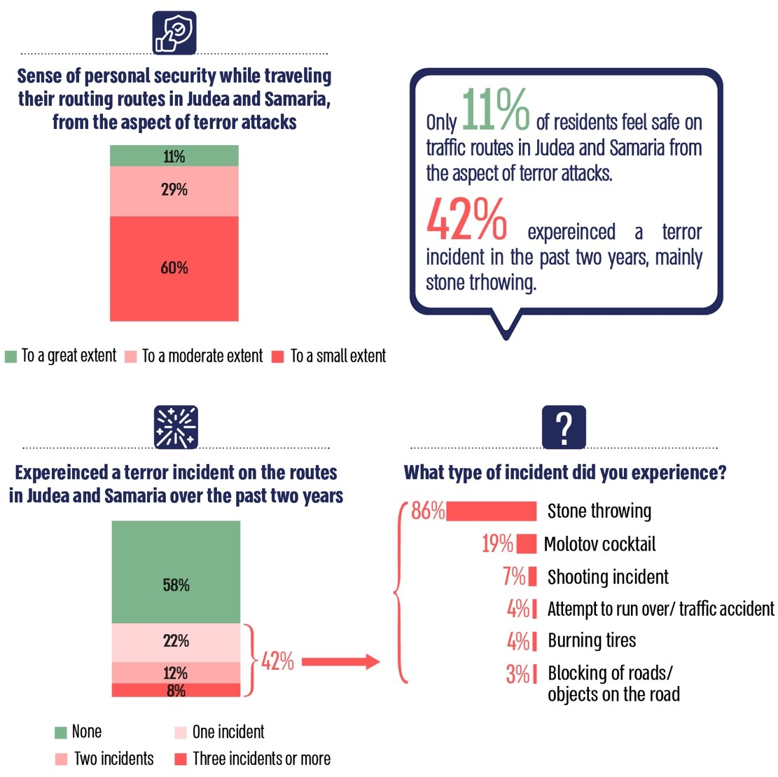

Source: Survey conducted by the Ci Institute for the Office of the State Comptroller, May 2023.

**Sampling the Execution Rate of Initiated Defense Assignments in the Samaria Regional Brigade at Various Times in 2022–2023**

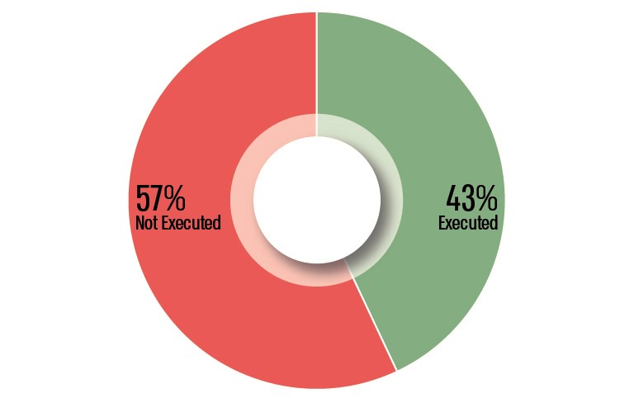



**Summary**

The Israeli population of 503,000 residents in Judea and Samaria has endured years of terror attacks on traffic routes. Since the beginning of 2022, there has been a notable increase in these incidents on traffic routes in Judea and Samaria, resulting in the deaths of 19 citizens, including 13 in the first half of 2023.

The audit raised that, despite the reinforcement of forces in Judea and Samaria, the IDF has not fully met its defense objectives. Furthermore, the additional reinforcements deployed after terrorist attacks have not effectively ensured the necessary security in a consistent and systematic manner. It was also noted that the "Smart Region" project has not yet reached its full potential. Additionally, the audit raised that the Israel Police, through the Judea and Samaria District, has not provided a timely and effective response to citizens, while local authorities' emergency call centers have managed to gain greater public trust by addressing the gaps.

The findings indicated a dire situation, highlighting the prolonged processes until the construction of bypass roads for routes going through Palestinian communities, where hundreds of security incidents occur. Furthermore, the audit raised inadequate cell coverage along Judea and Samaria routes, particularly in areas frequently targeted by attacks. Various plans from previous years have not come to fruition, and regulatory bodies have not effectively enforced compliance from cell companies to achieve complete coverage.

The national headquarters of the Israel Police, in collaboration with the Judea and Samaria District, must ensure compliance with required response times to public calls and assess the available manpower in the district to fulfill its responsibilities, ultimately improving public trust in law enforcement. Additionally, given the prolonged timeline for constructing the bypass roads, the Ministry of Transport, in conjunction with the Israel National Roads Company, should comprehensively investigate the root causes of these delays and develop solutions for expedited road construction in the future. It is also recommended that the IDF and the Ministry of Defense, in collaboration with the Ministry of Transport, form an ongoing plan to provide infrastructural support to enhance traveler safety on these routes, including the construction of additional bypass roads. Concurrently, the Ministry of Communications, together with the Civil Administration, must immediately ensure complete cell coverage on Judea and Samaria routes, particularly in high-risk areas according to the licenses granted for operating cell networks in Judea and Samaria.

To enhance the defensive response along these routes and improve residents' sense of security, the IDF should evaluate the readiness of the order of battle in the command area to meet its defense assignments and reassess the policy regarding the placement of permanent checkpoints in Judea and Samaria. Additionally, the Judea and Samaria Division should analyze the planning processes for initiated assignments and identify the root causes for non-compliance, providing a comprehensive response in collaboration with the Central Command and the Operations Directorate.

In the April 2024 response by the National Security Council to the draft audit report, it was noted that the defense strategy for Judea and Samaria was discussed in the State Security Cabinet following the outbreak of the "Iron Swords" war, as well as in the war management cabinet. The Prime Minister and the State Security Cabinet should subsequently reach a decision regarding the defense strategy in Judea and Samaria, including the policy on the placement of fixed checkpoints.

**Although this audit was conducted before the "Iron Swords" war, its findings and recommendations are particularly pertinent and relevant, especially from a forward-looking perspective.**

1. Area A – Areas in Judea and Samaria, according to the Interim Agreement with the Palestinians, in which responsibility for internal security and public order was transferred to the Palestinian Authority. Movement of Israelis is prohibited in these areas.
2. Area B – Areas in Judea and Samaria in which security control is in the hands of Israel while civil administration powers, including responsibility for public order, are in the hands of the Palestinian Authority. This area includes Palestinian rural communities, open areas and nature reserves.
3. Area C – Areas in Judea and Samaria in which the IDF, through the Central Command, bears full security responsibility, including aspects of internal security and public order. Area C is about 60% of the territory of Judea and Samaria. All Israeli local authorities in Judea and Samaria are located in Area C.
4. 1208 Hotline – The regional councils in Judea and Samaria operate a regional emergency hotline, among other things, to provide a rapid response to citizens who encounter distress (safety or security) while traveling on Judea and Samaria traffic routes.
5. Carriageway – a section of road or path used for the passage of wheeled vehicles, especially motor vehicles.