­­



**Activity of the Ministry for Regional Cooperation**

The Ministry of Regional Cooperation

Report of the State Comptroller of Israel | November 2024

Activity of the Ministry for Regional Cooperation



The Ministry for Regional Cooperation (MRC or the Ministry) was established in 1999 by a government decision but ceased operations in 2003. In 2009, the Ministry was re-established by another government decision (the establishment decision), which outlined its areas of responsibility. These include promoting economic cooperation with countries in the region and the Palestinian Authority, as well as implementing joint economic projects to foster economic welfare and stability in the region. Additionally, it was determined that the Ministry would collaborate with entities involved in regional development to mobilize resources and encourage investments aimed at fostering cooperation. The Ministry was also tasked with coordinating efforts among relevant government ministries in these areas.

Shortly after the 2009 establishment decision, the government decided to transfer certain responsibilities of the Israeli-Palestinian Joint Economic Committee (JEC) from the Ministry of Finance to the MRC. It was further decided that the Minister for Regional Cooperation would chair the JEC.

The MRC furthers its objectives through several mechanisms: issuing calls for proposals, inviting local authorities and higher education institutions to undertake activity related to regional cooperation; providing grants to public institutions (such as non-profit organizations) under Section 3A of the Budget Foundations Law; engaging in tenders; and fostering inter-ministerial collaboration.



|  |  |  |  |  |  |  |
| --- | --- | --- | --- | --- | --- | --- |
| **NIS  39–74  million** |  | **38%– 49% Executed Budget** |  | **58%  of the Ministry's resources** |  | **40%  of the success indicators** |
| The Ministry's annual budget in the years 2018–2023 |  | Of the Ministry's budget in the years 2018–2023 |  | in the years 2018–2023 (approximately NIS 91 million out of NIS 156 million) were spent on salaries and operational expenses |  | in the work plans for 2019 and 2022 were not fully achieved |
|  |  |  |  |  |  |  |
| **NIS 8.3 million** |  | **NIS 60 million** |  | **26 years** |  | **15 years** |
| were invested in the business lounges at Sha'ar Efraim and Gilboa. However, activity in the Sha'ar Efraim lounge is minimal, and the establishment of the Gilboa lounge has not yet been completed |  | were invested in bridge construction as part of the Jordan Gateway project |  | have passed since the signing of the agreement with the Kingdom of Jordan to establish the Jordan Gateway project. In practice, its construction has been halted |  | have passed since the government decision to establish a Ministerial Committee for Regional Cooperation, but the committee has not been formed |



**Audit Actions**

From August 2023 to January 2024, the State Comptroller's Office examined aspects of the Ministry for Regional Cooperation's activities. The audit was conducted primarily within the Ministry for Regional Cooperation, with additional examintions carried out in the Budget Department of the Ministry of Finance and in the Ministry of Environmental Protection. In addition, information was sought from nonprofit organizations involved in promoting regional cooperation projects. These NPOs are not subject to oversight under the State Comptroller Law, 1958 (Consolidated Version).



**Key Findings**



**Government Decision to Establish the Ministry for Regional Cooperation –** In the June 2009 government decision to establish the Ministry for Regional Cooperation (MRC), the Ministry's function was defined, but its authority was not. This contrasts with the Ministry for the Development of the Negev and Galilee, for which specific areas of authority were outlined in the relevant government decision, as well as the decision establishing the Authority for Economic and Social Development of the Druze and Circassian Sectors. The audit revealed that neither the government decision nor any other binding source clearly defined the responsibilities of the MRC. In order to advance and implement its key projects, the Ministry depends on the cooperation and goodwill of other government ministries and agencies. As a result, most of the Ministry's projects have been delayed for many years and have yet to materialize. For example, the completion of the Jordan Gateway project has been significantly delayed, despite 26 years having passed since the agreement to establish it was signed, and 12 years since the first government decision addressing the project.

**The Ministerial Committee for Regional Cooperation –** The June 2009 government decision regarding the establishment of the Ministry for Regional Cooperation (MRC) stipulated that a Ministerial Committee for Regional Cooperation would be established, to be chaired by the Minister for Regional Cooperation. The decision also stated that the committee's composition and authority would be determined in a separate government decision. However, despite the 2009 government decision, the Ministerial Committee for Regional Cooperation was never established or convened.

**The Organizational Structure of the Ministry for Regional Cooperation –** During the audited years, the Ministry's staffing level averaged 84% of its authorized positions, with 29 positions filled out of an average of 34.5 authorized positions. Furthermore, the audit revealed that approximately 20 positions (out of an average of 34.5) were designated for political appointees in the offices of the Minister and the Director-General, leaving professional roles in the Ministry understaffed. As a result, the Ministry became heavily reliant on a single official: the Director of the Economics Division, who has served in the role since July 2017. Among the professional staff, he is one of the few who has remained with the Ministry for an extended period.

**Internal Auditing in the Ministry for Regional Cooperation –** Despite the significant importance of the Jordan Gateway and Red Sea–Dead Sea Canal projects, the activities carried out under the Ministry for Regional Cooperation's calls for proposals, and the grants provided under Section 3A of the Budget Law, no internal audits have been conducted to examine these projects and activities. The absence of internal audits to review the projects that the Ministry for Regional Cooperation is in charge of (as well as its activity related to calls for proposals, grants, and various financial operations) hinders the ability to present the Ministry's leadership and relevant stakeholders with insights into the significant delays in implementing these projects. Furthermore, it prevents the drawing of lessons learned that could benefit other projects.

**The Jordan Gateway Project –** The Jordan Gateway Project is an initiative for a joint industrial park between Israel and the Kingdom of Jordan. The Jordanian side of the project was intended to house Israeli and Jordanian factories, while the Israeli side was planned to serve as a logistics hub and a base for transporting goods to Israeli ports. Despite over NIS 60 million having been invested in the project and the approximately 26 years passed since the agreement to establish it was signed (along with 12 years since the first government decision addressing the project in practical terms), as of the conclusion of this audit construction of the Jordan Gateway project has been halted. In fact, since the bridge's construction in 2019, no further actions have been taken to build or establish additional infrastructure on the Israeli side to advance the project. The continued delay of the Jordan Gateway project jeopardizes the originally envisioned economic benefits and the investment exceeding NIS 60 million. Furthermore, it could undermine the trust between the Kingdom of Jordan and the State of Israel.

**Implementation of the Ministry's Work Plan Projects –** 45% of the success indicators and approximately 40% of the Ministry's key indicators for 2019 and 2022, cumulatively, were not fully achieved. For example, it was found that the Ministry for Regional Cooperation failed to fully achieve 80% of the key indicators set in 2022 for the goals of "promoting economic and civil cooperation between Israelis and Palestinians for the mutual benefit of both societies and economies" and "establishing the Ministry as a knowledge hub for regional cooperation." The failure to achieve most of the Ministry's success indicators – among them the key indicators – may indicate poor planning of the annual work plan, as well as deficiencies in the formulation of the Ministry's goals and objectives. It also suggests inefficient and ineffective use of resources and difficulty adapting to changes and unforeseen events in its environment.

**Budget Execution Rates of the Ministry –** In the years 2018–2023, the Ministry was allocated an annual budget ranging from approximately NIS 39.3 million to NIS 73.7 million. Of this amount, the Ministry utilized up to 49% of its total approved budget, with only 12% to 41% of the budget designated for initiating projects and implementing its programs being executed. Additionally, on a cumulative basis in the years 2018–2023, the Ministry spent approximately 40% more on its operational costs than on activities aimed at fulfilling its mission. In the years 2018–2019, approximately 85% of the Ministry’s financial resources were spent on salaries and operational expenses.

**Business Lounge Projects at Land Crossings from the Palestinian Authority –** Over the years, there has been a downward trend in business activity at the Sha'ar Efraim business lounge, which was constructed at a cost of approximately NIS 4 million. This decline is reflected both in the number of participants in business activity – which decreased from 609 in 2018 to 405 in 2023 and in the proportion of business activity for which the lounge was originally intended, dropping from 88% in 2018 to 60% in 2023. Although the lounge was initially designed to facilitate meetings between businesspeople, it lacks common support tools for such interactions, such as wireless internet access, printers, and computer stations. Additionally, the construction of the business lounge at the Gilboa Crossing, for which the Ministry for Regional Cooperation allocated NIS 3 million for planning and construction, remains incomplete and has yet to fulfill its original purpose.

**The Joint Economic Committee (JEC) for Israel and the Palestinians –** Despite the importance attributed to the convening of the Joint Economic Committee (JEC) for Israel and the Palestinians, and despite its inclusion as one of the primary tasks in the Ministry's work plan, as of the conclusion of this audit the JEC has convened only once under the MRC, on September 2, 2009. It should be noted that a meeting of the JEC was scheduled for June 2023 but was postponed by the Palestinians. Another meeting was planned for September 13, 2023, but the Palestinians requested another postponement to October 26, 2023. However, due to the outbreak of the Swords of Iron War on October 7, 2023, the committee did not convene as planned, and at this stage, no future date has been set for its meeting.

**Implementation of the Strategic Work Recommendations –** It was found that although the MRC recognizes the strategic needs for regional development, it has not advanced the recommendations of its 2021 strategic work plan. These recommendations included exploring alternatives for improving food security, protection of the seas, and fostering collaboration among specialized entities to provide long-term direction for achieving the Ministry's goals.



**Enhancing Cooperation with Morocco –** The State Comptroller's Office commends the projects and various collaborations initiated by the Ministry with entities in Morocco. These initiatives include organizing delegations to Morocco, convening conferences on culture, sports, and academia, and hosting a delegation of influencers from Morocco in November 2022. Notably, the Ministry facilitated the signing of a memorandum of understanding between the bar associations of both countries in May 2022 and hosted a delegation of Moroccan business leaders in Israel in March 2022 as part of a joint initiative. At a total investment of approximately NIS 4 million, these activities have played a key role in strengthening ties, promoting mutual understanding, and deepening collaboration between the nations.

**Investment in Innovation Centers and the MEHAMEM Project** **–** The State Comptroller's Office also highlights the Ministry's commitment, in late 2023, to invest in innovation centers and initiate the MEHAMEM project[1] (Training, Information, and Research Center).



**Key Recommendations**

In light of the findings in this audit report, it is recommended that the Prime Minister and the Minister for Regional Cooperation evaluate the need for the continued existence of the Ministry for Regional Cooperation as an independent entity. If it is determined that the Ministry’s activity is essential, a strategic plan should be promptly formulated, including tasks and objectives for the Ministry’s operations, and steps should be taken to implement it. Additionally, there should be a review to decide the necessary authority and resources for the Ministry, in order to enhance its functionality and enable the execution of large-scale infrastructure projects.

It is further recommended that the Ministry, in collaboration with the Government Secretariat, define the responsibilities and authority of the Ministry for Regional Cooperation and align them with the roles assigned to it by the government. The Ministry should also work to establish the Ministerial Committee for Regional Cooperation, as stipulated in the 2009 government decision, and the Minister for Regional Cooperation should ensure that the committee convenes with the necessary frequency.

The Ministry for Regional Cooperation should adapt to geopolitical developments and initiate cooperation projects in areas that are becoming increasingly critical to the region, such as food security and advanced agriculture, water desalination, green energy, and the creation of new and attractive trade routes. Additionally, it is recommended that the Ministry complete the strategic review process initiated in 2021 to develop actionable decisions for more effectively advancing various regional development projects and work towards their implementation.

****The Ministry should implement a planning and resource allocation process for its various tasks and programs to ensure more efficient planning and execution of its work plans. It should also establish guidelines for adjusting work plans in response to unforeseen changes.

**The Ratio Between the Ministry's Operational Budget Execution and Activity Budget Execution (Allocated for Projects and Programs) 2018–2023 (in NIS Thousands)**



According to data from the Accountant General, as processed by the State Comptroller's Office.

**The Jordan Gateway Project – the Bridge Connecting the Israeli and Jordanian Sides\***

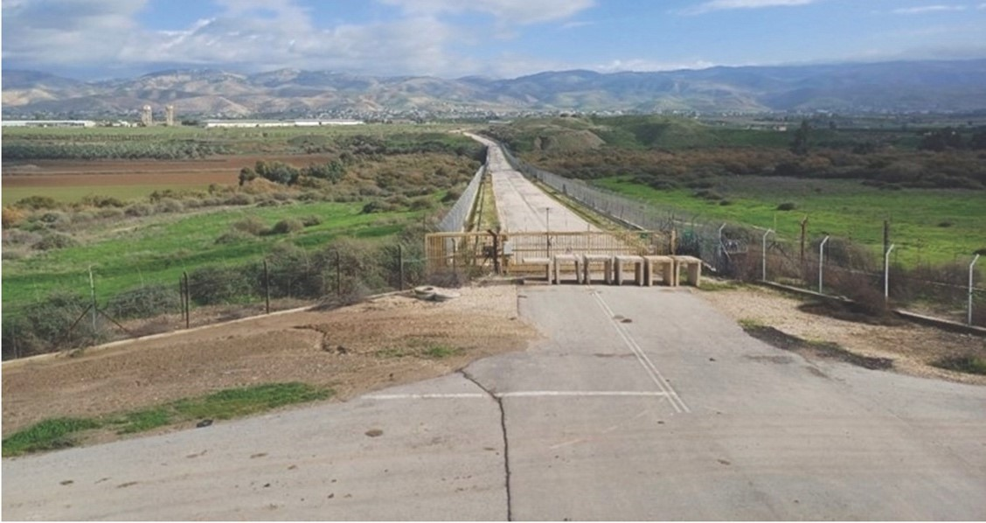

Photographed by representatives of the State Comptroller's Office, December 2023.

* Approximately NIS 60 million from the Ministry of Transport's budget was invested in the construction of the bridge; it has never been opened and remains non-operational.



**Summary**

Upon its establishment, the Ministry for Regional Cooperation was intended to play a substantive role, recognizing that activities in the realm of inter-state cooperation and the initiation of regional projects involving Israel and neighboring countries could significantly advance shared interests. Such activities were envisioned to naturally strengthen political, economic, and cultural ties with the citizens of these countries.

The Abraham Accords, signed in 2020 with several Gulf states, and the growing regional need for meaningful solutions in the fields of water, energy, food security, advanced agriculture, and medicine, further underscore the potential of fostering collaboration in these critical areas between Israel and neighboring countries. These solutions have the potential to become key drivers of Israel's growth, both economically and diplomatically.

The audit report reveals that the Ministry for Regional Cooperation has neither adapted to the needs and changes occurring in the geographical region nor succeeded in capitalizing on the significant potential for cooperation with neighboring countries in relevant areas in recent years. Over a multi-year perspective, the ministry's outputs have been minimal, consistently showing budget execution rates below 41% for the allocated activity budget. In addition, deficiencies were identified in the Ministry’s operations and its management of the various projects under its responsibility over the years. The Ministry’s flagship project, the Jordan Gateway, has failed to materialize despite the many years since the Israeli government decided to launch it. Part of the Ministry's weakness can be attributed to its lack of authority vis-a-vis other government ministries and agencies.

The findings in the audit report raise serious doubts about the Ministry’s ability to fulfill its mission, its effectiveness as a driving force for advancing regional cooperation, and the justification for its continued operation.

In light of the findings in this audit report, is recommended that the Prime Minister and the Minister for Regional Cooperation evaluate the need for the continued existence of the Ministry for Regional Cooperation as an independent entity. Should it be determined that the Ministry’s independent operation is indeed necessary, its areas of responsibility and authority must be clearly defined, and a strategic plan outlining tasks and objectives for its activity should be promptly developed and implemented.

1. MEHAMEM – Training, Information, and Research Center. The purpose of the MEHAMEM Project is to consolidate existing knowledge in the field by establishing an online portal, developing metrics for successful cooperation, and conducting training sessions, written tutorials, etc.