­­



**The Ministry of Justice's Handling of Insolvency and Financial Rehabilitation Proceedings**

Special Reports

Report of the State Comptroller of Israel | November 2024

The Ministry of Justice's Handling of Insolvency and Financial Rehabilitation Proceedings



Insolvency proceedings provide a framework for addressing situations where debtors are unable to meet their financial obligations. In September 2019, the Insolvency and Financial Rehabilitation Law, 2018, came into effect, encompassing all legal provisions related to insolvency proceedings. The law has three main objectives: (1) to achieve the financial rehabilitation of the debtor; (2) to maximize the repayment rate to creditors; and (3) to enhance legal certainty and stability, shorten proceedings, and reduce the bureaucratic burden. The Commissioner of Insolvency and Financial Rehabilitation Proceedings, operating within a division of the Ministry of Justice, is in charge of handling insolvency cases. These include insolvency proceedings for individuals and corporations, company liquidations, corporate restructuring, and creditor arrangements. The Commissioner's authority over cases of individuals applies to insolvency proceedings where the debt exceeds NIS 150,000[1], while cases involving smaller debts are managed by the Enforcement and Collection Authority. Each year, more than 20,000 applications for receivership orders or initiation of proceedings are filed in the field of insolvency for individuals; approximately 15,000 orders are issued, and over 60,000 active cases are managed. In 2022, the courts issued orders to operate corporations for financial rehabilitation in 20 cases; issued liquidation orders for 953 corporations; and approved 20 financial rehabilitation plans. The total claims filed in insolvency proceedings in 2021 amounted to over NIS 60 billion (approximately NIS 43.7 billion in individual cases and NIS 16.7 billion in corporate cases). The average repayment rate in insolvency cases of individuals handled by the Commissioner was approximately 7% in 2021 and 13% in 2022.



|  |  |  |  |  |  |  |
| --- | --- | --- | --- | --- | --- | --- |
| **NIS 786 billion** |  | **Over NIS 60 billion** |  | **Only approximately 7%  repayment** |  | **Only 7 employees** |
| The scope of household debts. Approximately 70% of these are for housing, and approximately 30% are consumer debts. As of 2019, 9% of the adult population in Israel had cases opened against them in the Enforcement and Collection Authority |  | The total claims in 2021; each year, more than 20,000 applications for receivership orders or initiation of proceedings are filed |  | The average repayment rate in insolvency cases for individuals handled by the Commissioner in 2021 (13% in 2022) Total annual bad debts are approximately NIS 49.5 billion |  | supervising approx. 450 trustees managing  approx. 60,000 debt collection cases, involving debts totaling approx. NIS 60 billion |
|  |  |  |  |  |  |  |
| **Increase of  approx. 60%** |  | **Only approx. 20  investigation cases** |  | **Only approx 850 Debtors** |  | **8** |
| in complaints filed against trustees in 2021 (3,496 complaints) compared to 2020 (2,148 complaints) |  | handled by the Investigations Unit each year, although the Administrator estimates that violations occur in over 2,000 insolvency proceedings each year |  | Out of an estimated 37,500 debtors for whom financial education is relevant, according to estimates, less than 3% had completed a program for proper financial management by June 2023 |  | The number of databases within separate unsynchronized computing systems used by the Administrator |



**Audit Actions**

From January to June 2023, the State Comptroller's Office examined the Ministry of Justice's handling of insolvency and financial rehabilitation proceedings[2]. The audit focused, among other topics, on the following areas: determining monthly payments for debtors; training in financial rehabilitation; guidance and oversight of trustees; enforcement activities; computing systems; data analysis and research; the allocation of authorities in handling insolvency proceedings; engagement with external parties (representatives) to carry out the Commissioner's duties; and the splitting of the General Guardian’s Division, the Registrar of Inheritance Affairs, and the Commissioner of Insolvency into two distinct entities. The audit was conducted in the Commissioner of Insolvency Proceedings Division within the Ministry of Justice, including its headquarters and regional offices. Additional examinations were carried out in other units within the Ministry of Justice, the Enforcement and Collection Authority, and the Budget Division of the Ministry of Finance. Meetings were also held with former senior managers in the Commissioner's office, attorneys specializing in insolvency from the private sector and the Israel Bar Association, academics researching insolvency, and representatives from third-sector organizations.



**Key Findings**



**Determining Monthly Payments for Debtors –** as of the audit completion date, September 2023, the Minister of Justice had not issued subsistence allowance regulations, contrary to the provisions of the Insolvency and Financial Rehabilitation Law. These regulations are necessary for establishing a basis for calculating the monthly payment required from debtors within the insolvency process.

**Providing Information on the Calculation of Monthly Payments –** the Commissioner does not provide debtors with the information used to determine the interim periodic payment amount. This includes the data taken into account and the method of calculation for the periodic payment amount.

**Oversight and Supervision of Trustees –** the Trustee Supervision Unit within the Commisiioner of Insolvency Proceedings (established to fulfill the Commissioner's legal responsibility for ensuring the integrity, fairness, and efficiency of insolvency proceedings) does not conduct proactive reviews or in-depth investigations into the conduct of the approximately 450 trustees under its supervision, who handle approximately 20,000 cases annually. This includes oversight of their interactions with debtors and the courts, the quality of their work, the distribution of funds to creditors, and the scope of fees paid to trustees, often from the trustee's escrow account. In the absence of such reviews and investigations, no sanctions have been imposed on trustees who failed to properly perform their duties. Regarding trustee conduct, the unit focuses on technical monitoring, such as verifying the physical presence of trustees in court proceedings and the actual submission of reports.

**Handling Complaints Against Trustees –** over the years, there has been a 60% increase in the number of complaints against trustees received by the Commissioner (2,148 in 2020, 3,496 in 2021). The Commissioner has not established a structured mechanism for handling complaints against trustees. Among other shortcomings, no mandatory timeline has been set for processing complaints; no criteria have been defined for categorizing complaints; no guidelines have been issued for handling complaints based on their classification until their resolution; and no mechanism exists for providing updates or information to complainants and trustees (or respondents). Additionally, there are no established rules for appeals, sanctions against trustees for substantiated complaints, or criteria for imposing such sanctions.

**Computerized Complaint Management System –** the Commissioner lacks adequate and efficient computerized tools for managing, monitoring, and documenting complaints. As of the audit completion date, the Commissioner manually managed approximately 200 complaints, deemed significant, out of thousands. An effective computerized system is particularly essential given the high volume of complaints (over 3,400 in 2021).

**Service Surveys Among Debtors** **–** service surveys conducted by the Commissioner reveal that more than half of the debtors surveyed expressed dissatisfaction with the trustees' handling of their inquiries (56%) and their availability (55%). Additionally, 70% of respondents stated that they did not receive a full and clear response from the trustee. Despite these findings, the Commissioner has neither intensified its oversight of trustees nor analyzed the survey results, conducted a lessons-learned process, or taken deignated actions to address the deficiencies identified in the surveys.

**Scope of Activity of the Investigations Unit –** the Commissioner's Investigations Unit operates on a limited scale, handling only about 20 cases annually during the audit period. From 2015 to mid-2023, the unit dealt with a total of approximately 80 cases. This is despite the Commissioner's estimate that insolvency-related offenses occur in approximately 10% of ongoing proceedings – more than 2,000 cases annually – with bad debts resulting from these offenses amounting to approximately NIS 5 billion per year. The investigations unit's activity in corporate cases only began in 2023, four years after the law granted its investigators criminal enforcement authority in this area. Under these circumstances, concerns arise that the lack of broad and effective activity by the Commissioner through the Investigations Unit undermines both deterrence against abuse of insolvency proceedings and enforcement capabilities regarding criminal activities in the field, particularly the concealment or diversion of assets that could increase the repayment rate for creditors.

**The Investigations Unit Faces a Manpower Shortage –** with only 12 investigator positions filled out of 25 authorized positions, as per the staffing standards established when the unit was created nearly thirty years ago. This is despite the fact that, during this period, the number of insolvency cases has increased by thousands of percent, requireing additional resources and tools to fulfill the unit’s functions and objectives. The Commissioner is constrained in the scope of investigations it can conduct and is forced to act only in cases where cooperation agreements have been reached with a specific police unit. Under these circumstances, all 80 cases handled by the unit from 2015 until the end of the audit were investigated in collaboration with the police.

**Intelligence Gathering and Focusing Investigation Efforts –** The Commissioner's activity in the field of intelligence is extremely limited, and the Intelligence Unit lacks the tools and technological systems necessary for collecting and analyzing intelligence to support its operations. Under these circumstances, the Administrator’s capcity to focus investigative activities based on intelligence is significantly limited.

**Scope of the Proper Financial Management Training Program –** as of June 2023, nearly four years after the Insolvency and Financial Rehabilitation Law came into effect, only about 850 debtors – less than 3% of the estimated 37,500 debtors for whom the training was relevant – had completed the financial management training program. These figures indicate that financial rehabilitation programs, including the training program for proper financial management, which began operations in March 2021 (a year and a half after the law came into effect, making debtor rehabilitation a central objective), have been operating on a limited scale with insufficient resource allocation. These factors have directly contributed to the low implementation rate of the training programs.

**The Commissioner's Computing System –** the Commissioner's operations rely on outdated operational computing systems based on Magic technology, which are among 40 such Magic-based systems used by the Ministry of Justice. These systems have been in operation for about 30 years and require extensive maintenance. Despite improvements made over time, they continue to experience frequent malfunctions. The computing systems are not suited to the organization's needs, forcing the Commissioner's staff to work manually. This manual work is time-consuming, inefficient, and prone to human errors in data entry and retrieval of outdated information, failing to provide adequate and comprehensive support for organizational requirements. As a result, there is a risk of disruption or even paralysis of the Commissioner’s ability to manage approximately 60,000 cases, which could, in the Commissioner's assessment, negatively impact Israel’s business and economic sectors. Despite the 2017 decision by the Ministry of Justice and the Commissioner to develop a new computing system, no progress has yet been made on the project.

The Commissioner's computing systems include eight separate databases that are not continuously synchronized. This lack of integration prevents the transfer and sharing of information between systems, complicates the formation of a nationwide snapshot report, increases the risk of data distortion, heightens maintenance complexity, and could result in inefficient case management. It should be noted that the need to reform the department's computing systems was first raised in the 1996 Avrahami Committee Report.

**Collection of Information and Data and Research for Implementing the Insolvency and Financial Rehabilitation Law –** contrary to the requirements of the Insolvency and Financial Rehabilitation Law, the Commissionerdoes not conduct proactive research in the field of insolvency proceedings, particularly in core areas of its operations – such as financial rehabilitation, payment orders, and guidance and supervision of trustees. Furthermore, the Commissioner's office lacks designated staff with the necessary research expertise relevant to these matters. Additionally, the Ministry of Justice has not conducted research to support the implementation of the Insolvency Law. While the Ministry initiated the research process and engaged an external research team for this purpose, the project was not completed due to the research team's concerns regarding methodological challenges. These gaps are inconsistent with the obligations imposed on the Ministry of Justice and the Commissioner under the law.

**Division of Powers in Handling Insolvency Proceedings –** The Ministry of Justice decided to examine, as part of a policy review, and approximately three years after the Insolvency and Financial Rehabilitation Law came into effect, the need to improve the efficiency of the existing model for managing insolvency cases. This review includes assessing the model that determines the divison of powers between the Commissionerand the Enforcement and Collection Authority. However, the audit found that this decision, made in May 2022, has not yet been advanced by the Ministry of Justice in practice.

**Splitting of the General Guardian's Division, the Commissioner of Insolvency, and the Registrar of Inheritance Affairs –** the process of examining the possibility of splitting a large and complex division (which included three entities, employed over 500 staff members and approximately 150 representatives in headquarters and regional units) was conducted over an exceptionally short period of less than two months (from March 3, 2022, to April 28, 2022). During this period, and even before an informed decision was made on the matter, practical steps already had been taken toward splitting the division. This process was carried out without decision-makers having access to a complete status report of the situation (required for making an informed decision about the split) and without addressing the logistical needs necessary for the decision's full implementation. In light of the above, the reasons underlying the decision to split the division and the nature of the process undertaken do not provide sufficient grounds for implementing such a significant and extensive organizational change. Additionally, this process involves appointing additional senior officials while balancing other priorities and projects under consideration by the Ministry of Justice.



**Professional Training Program –** as of December 2022, more than 600 professionals have completed specific training designed for those involved in roles that promote financial rehabilitation and poverty awareness.



**Key Recommendations**

The Minister of Justice, with the approval of the Constitution, Law and Justice Committee, should complete the enactment of regulations for the calculation of subsistence allowances, and the method for determining an individual's earning capacity.

The Commissioner should supervise the conduct of approximately 450 trustees managing approximately 60,000 cases annually. To achieve this, it is recommended that the Commissioner develop a comprehensive and detailed work framework to ensure effective supervision of trustees. He should define the required supervisory actions, criteria for evaluating the quality of trustees' work, and methods for addressing irregularities found during supervisory activity. Additionally, it is recommended that the Administrator establish an effective mechanism for ensuring professional handling of complaints against trustees.

It is recommended that the Commissioner expand the Investigations Unit's scope of activity, both for individual cases and corporate cases, in alignment with the number of insolvency proceedings. This activity should be based on defined goals designed to support the unit in fulfilling its purpose through enforcement and creating deterrence against abuse of insolvency proceedings. It is recommended that the Commissioner, in collaboration with the Ministry of Justice's management, the Civil Service Commission, and the Ministry of Finance, conduct a comprehensive assessment of the resources necessary to the Investigations Unit. The Commissioner should formulate an appropriate response to maximize the unit’s activity and achieve its objectives.

It is recommended that the Commissioner and the police establish work interfaces to ensure effective collaboration, maximizing their mutual capabilities to enhance enforcement in the field of insolvency.

The Commissioner should assess the alignment between the rate of recommendations for referral to training programs and the proportion of cases where such referrals are deemed necessary. Additionally, the Commissioner should take all necessary steps to expand the scope of training programs, in order to match the potential number of debtors that need such training. It is proposed that the Ministry of Justice and the Commissioner implement an appropriate organizational framework for financial rehabilitation activity. This framework should include the formation of an operational structure to expedite the development and implementation of financial rehabilitation programs and processes, with particular emphasis on training for proper financial conduct.

It is proposed that the Ministry of Justice, in collaboration with the Commissioner, promptly develop a structured work plan regarding the Commissioner's computing systems. This plan should ensure that insolvency proceedings are conducted with computing systems that enable the Commissioner to perform his duties efficiently, provide adequate service levels, and comply with legal requirements.

It is proposed that the Commissioner and the Enforcement and Collection Authority conduct an assessment regarding the need to establish a joint information system for handling insolvency proceedings. This assessment should consider the advantages and disadvantages of such a system, its associated costs, and the efficiency of its use.

It is recommended that the Ministry of Justice promote a policy review to evaluate an appropriate and efficient organizational structure for insolvency-related activity, focusing on the division of powers between the Commissioner and the Enforcement and Collection Authority. This is intended to optimize resource utilization, maximize operational outcomes, improve public service in general, and enhance and improve the efficiency of insolvency proceedings in particular. Based on the findings of this policy review, it is further proposed to examine the potential need for legislative amendments to allow for necessary adjustments in accordance with the developed framework.

When making decisions regarding the organizational structure, which have a broad impact on the organization's operations, the Ministry of Justice, and particularly the Director-General of the Ministry, should base such decisions on a thorough preliminary examination. This examination should include consideration of all relevant data, factors, and alternatives, and should allocate sufficient time to conduct the evaluation process.

**Insolvency Proceedings - Key Figures**

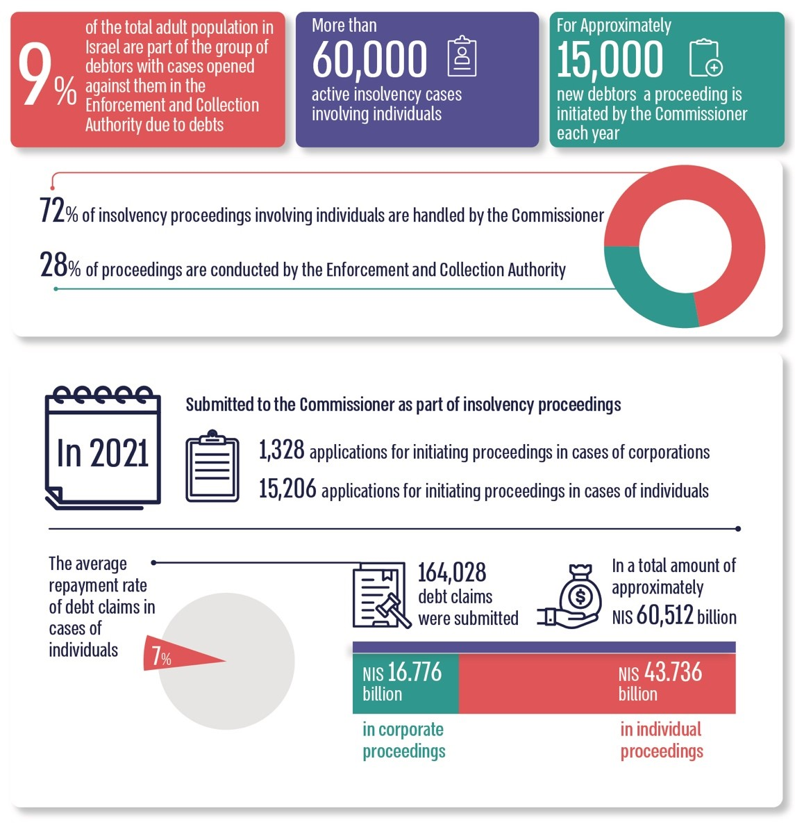

According to data from the Commissioner and the Enforcement and Collection Authority, as processed by the State Comptroller's Office.



**Summary**

The handling of insolvency proceedings has a profound impact on hundreds of thousands of debtors and creditors, as well as on numerous corporations, and it can also have broader financial and social impacts on the economic sector and at the national level.

The findings of this audit indicate significant deficiencies in the Ministry of Justice's handling of insolvency proceedings, as well as gaps in the Commissioner's ability to address the challenges it faces, with a particular emphasis on the management of insolvency cases of individuals. Notably, deficiencies were identified in three core areas of the Commissioner's operations: Financial Rehabilitation – Only a small portion of debtors for whom training for proper financial management is relevant actually participate in such programs. Supervision of Trustees – The Trustee Supervision Unit does not conduct proactive reviews or in-depth investigations into the conduct of trustees. Investigations – The Investigations Unit operates on a limited scale, handling only a small number of cases, raising concerns about the potential erosion of deterrence and the ability to enforce the law effectively.

The findings of this report, addressing various operational and organizational aspects, necessitate broad rectification action to enable effective operations in achieving the goals outlined in the Insolvency and Financial Rehabilitation Law. Strengthening the Commissioner's activities in the core areas mentioned requires addressing the gaps highlighted in the report across organizational, operational, and supportive dimensions. These include advancing measures to ensure the functionality of the computing system, collecting data for analysis and research purposes, and addressing structural and organizational gaps identified across all core areas. Additionally, it is proposed that the Ministry of Justice, responsible for the two operational branches managing insolvency (the Commissioner and the Enforcement and Collection Authority), conduct a policy review to evaluate the existing organizational structure. This policy review should assess the need for changes designed to optimize resource utilization, improve and increase the efficiency of insolvency proceedings, and enhance public service. When making decisions regarding the organizational structure, which have wide-ranging implications, the Ministry of Justice – and particularly its Director-General – should base such decisions on a thorough and comprehensive preliminary examination. This process should allow sufficient time for evaluation and consider all relevant data, considerations, and alternatives. Additionally, the organizational change implemented in 2022, which divided the department into two branches, should be analyzed and studied as part of a lessons-learned process to guide the Ministry of Justice in future organizational initiatives.

The Ministry of Justice and the Commissioner must work to address the deficiencies raised in this report.

1. Section 104 of the Insolvency and Financial Rehabilitation Law. The updated amount for this matter, according to Notice No. 2 (2023), Official Gazette 5783 11052, 3076, is NIS 161,236.45.
2. This audit report was originally supposed to be included in the State Comptroller's annual report and published in May 2024. However, due to the outbreak of the Swords of Iron War, the completion of the audit report was delayed. It is now being published, reflecting the data available during the audit process.