­­



Systemic Audits

**Ask Once Policy – Follow-up Audit**

Report of the State Comptroller of Israel – Cyber and Information Systems | November 2024

Ask Once Policy – Follow-up Audit



The executive authority, through its various branches, provides many services to the public. One of the ways to streamline the services provided by government ministries and auxiliary units to the public is the provision of services in a wholly digital format from end to end in one place in a friendly and accessible manner while implementing the "**Ask Once Policy**," which means **receiving information[1] from the citizen only once and sharing it between government bodies to facilitate the provision of various services without the need for repeated submissions by citizens.**

In 2016, the government adopted the Ask Once Policy across ministries and auxiliary units to enhance public service delivery and reduce bureaucratic burdens (Resolution 1933[2]). This resolution mandates that government ministries share necessary information to improve public services, adhering to restrictions and guidelines outlined in the resolution and applicable laws. For instance, the guidelines balance information sharing for optimized service delivery and the obligation to maintain privacy under the Protection of Privacy Law, 1981, mindful of the sensitivity, scope of information, and the public benefit derived from such sharing. In 2020, amid the Covid-19 pandemic, the government initiated a plan to accelerate digital services to the public (Resolution 260[3]). This plan involved the then-Ministry of Cyber and National Digital Matters and about 40 additional ministries and public bodies in driving significant reforms in bureaucratic processes through advanced digital solutions and wide technological platforms, including alleviating bureaucratic burdens via the Ask Once Policy.

To successfully implement the Ask Once Policy on a large scale within government services, it is imperative to identify and map the services offered by each ministry, validate these services by analyzing their characteristics, including required references and agencies involved, incorporate them into a comprehensive database cataloging all government services; connect them to the government's technological infrastructure that enables information sharing and approve the transfer of information between the bodies in the Information Transfer Committees[4]. In line with Resolution 1933, the National Digital Agency[5] established the Information Highway, a secure infrastructure for information transfers between government ministries and public bodies, along with a "committee system" (Moed system) to facilitate the management and authorization of these processes.

This report was written in light of the "Iron Swords" War and the civilian response given to the population during the months of conflict since October 7. The significance of providing digital services to citizens is amplified during emergencies. Information transfer between public bodies is crucial for effective government operations and public service provision during emergencies, particularly regarding critical and life-saving services. Throughout the Iron Sword War, numerous citizens and businesses required various government services, including support for families of the hostages, the missing, and the fallen, assistance for those whose property suffered damage, aid for evacuees, services for individuals whose livelihoods were impacted, and firearms licensing. Efficient online services can alleviate the emotional distress of those affected and optimize the time and resources involved in submitting applications and exercising rights within various government ministries.

**Illustration of the Ask Once Policy**

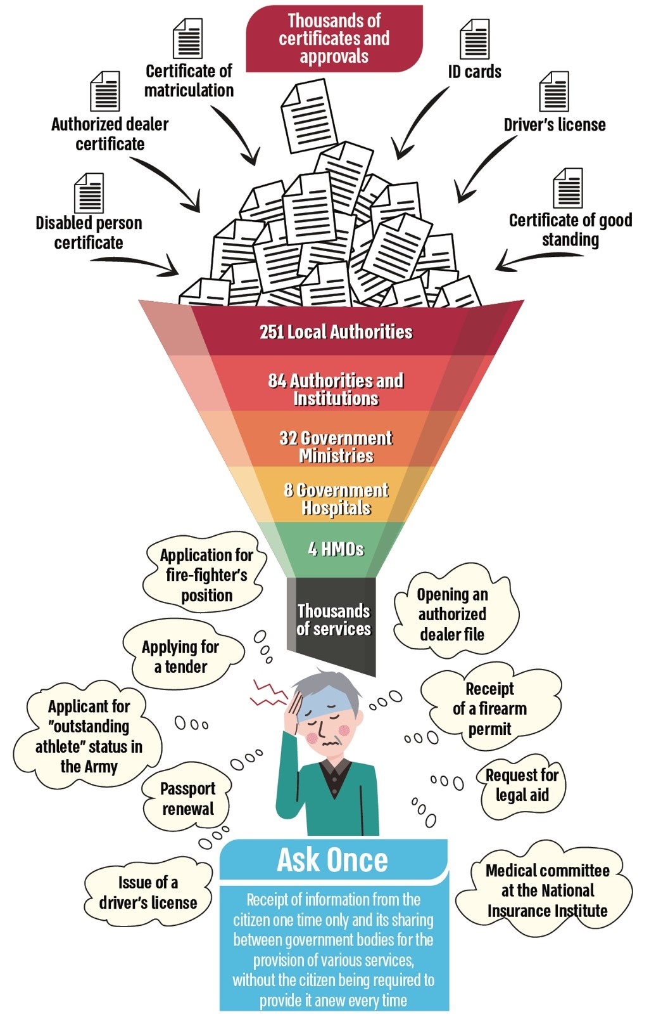



|  |  |  |  |  |  |  |
| --- | --- | --- | --- | --- | --- | --- |
| **?** |  | **in only 9%** |  | **342 days** |  | **240,000** |
| about eight years after the implementation of the Ask Once Policy in the government and the auxiliary units, the National Digital Agency still does not have data regarding the scope of services in which this policy is implemented |  | of the government services (350 out of 3,888), the Information Highway[6] is used for information transfers between government ministries and public bodies |  | on average, in 2023, were required to approve or deny a request to transfer information between public bodies. Almost six times longer (570%) than the time set in the government resolution – 60 days |  | firearms licensing applications were awaiting review by the Ministry of National Security during the war (as of December 2023). Still, only in April 2024, a digital interface was established between the IDF and the Ministry of National Security to transfer the information required between them to advance the review of applications |
|  |  |  |  |  |  |  |
| **0** |  | **0** |  | **0** |  | **only 20%** |
| of the 480 services provided by the Ministry of Education have been validated; hence, it is impossible to know which ones are suitable for implementing the Ask Once Policy |  | meetings of the Steering Committee on Information Transfers between Public Bodies were convened in  2021–2023 |  | of the Ministry of Defense services relevant to bereaved families and disabled IDF personnel are implemented through the Information Highway |  | of requests (209 out of over 1,000) for information transfers submitted by bodies to the Population Authority are managed in the designated system (Moed), which is supposed to manage the information transfer processes between bodies |



**Audit Actions**

In 2021, the State Comptroller's Office audited the implementation of the Ask Once Policy (the Previous Report or Audit[7]). The primary issues addressed in the Previous Audit included the process of mapping government services, establishing objectives for minimizing the information and approvals necessary for the public to access services, developing a system for managing the operations of information transfer committees (the Moed system), and establishing the government Information Highway (the Information Highway or Highway).

From June to December 2023, the State Comptroller's Office conducted a focused follow-up audit on significant findings from the Previous Audit, including the implementation of the Ask Once Policy by National Digital Agency the and promoting the supporting infrastructures and the Moed system. It should be noted that this audit examined additional aspects not addressed by the Previous Audit, raised findings from these examinations, and included them in the follow-up report.



**Key Findings**



**Mapping and Validation of Services –** **the** **follow-up audit** raised that twelve bodies failed to validate their services, encompassing 480 services at the Ministry of Education and 129 at the Rabbinical Courts. Furthermore, despite a government resolution adopted eight years ago, the National Digital Agency has yet to establish a comprehensive policy for the mapping and validation of services, including updating and enhancing the service database. Consequently, the Agency lacks a complete and current situation report of all government services and the necessary information and approvals for their delivery.

**Expanding the Mapped Bodies –** **the Previous Audit** recommended that the ICT Authority and Israel Digital assess the feasibility of incorporating additional public bodies that offer numerous services to the public, such as local authorities, hospitals, and HMOs, into the mapping process. **The follow-up audit found that this deficiency has not been rectified** and that despite the State Comptroller's earlier recommendations, the examination has not been conducted, and services provided by public bodies that are not government bodies have yet to be mapped and validated. This adversely affects the efforts to enhance public service and mitigate the bureaucratic burden, deviating from the government's 2020 plan to expedite digital services for the public.

**Government Ministries' Use of the Information Highway –** the Previous Audit raised that three bodies (the IDF, the Tax Authority, and the National Insurance Institute) required to implement the Information Highway for information sharing by April 2021 had not complied. **The follow-up audit found that this deficiency has not been rectified** and that these bodies are still not connected to the Information Highway, failing to adhere to the government's resolution, the State Comptroller's recommendations in the Previous Audit, and the ICT Authority's plan for connection to the Information Highway. **Additionally, the follow-up found** that three other bodies – namely, the Ministry of Defense, the Ministry of Energy and Infrastructure, and the Israel Antiquities Authority – have also not established connections to the Information Highway, contrary to the government resolution and ICT Authority deployment plans. **Moreover,** about eight years following the government's mandate for ministries and auxiliary units to utilize the government's technological infrastructure for information sharing (the Information Highway), this infrastructure has been employed for less than one-third of all services (1,178 out of 3,888). Consequently, for most services (70%), government ministries rely on local infrastructures, email, or require citizens to provide the necessary information independently. The insufficient utilization of the Information Highway undermines the intended benefits, hindering the enhancement of public service and the implementation of the Ask Once Policy, which minimizes the inconvenience for citizens due to repetitive information requests by multiple government bodies.

**The Ministry of Defense's Use of the Information Highway –** it was found that the Ministry of Defense does not obtain various approvals from government ministries directly via the Information Highway; instead, it requests approvals from bereaved families and IDF-disabled members. The State Comptroller's Office has commented to the Ministry of Defense that, in its civilian operations, it must provide services to the public through the secure digital platform provided by the National Digital Agency, just like all other government ministries. There was an expectation that during the Iron Swords War, with an increase in bereaved families and disabled individuals, the Ministry would enhance its service delivery to these populations by utilizing the Information Highway and implementing the Ask Once Policy, thereby alleviating the need for these populations to obtain approvals and certifications from multiple ministries unnecessarily.

**Implementation of the Ask Once Policy** **–** the Previous Audit raised a lack of a comprehensive and detailed situation report regarding implementing the Ask Once Policy within government ministries. It was recommended that the ICT Authority and Israel Digital establish specific targets at both the ministry and service levels, along with a multi-year timetable for progress, to ensure the achievement of the targets outlined in the government resolution. **The follow-up audit has found that this deficiency has not been rectified.** Eight years after the government resolution and four years after the Previous Audit, the National Digital Agency still lacks information or data concerning the scope of government services implementing the Ask Once Policy and the potential services that could adopt this policy. Furthermore, the National Digital Agency does not possess mechanisms for monitoring the implementation of the Ask Once Policy within government ministries or supervising the matter. Additionally, no specific targets have been established at the ministry and service levels for integrating government services under the Information Highway or implementing the Ask Once Policy from 2021 to 2023. A multi-year timetable for progress has also not been set to ensure the achievement of the objectives established in government resolutions 1933 and 260, regarding the implementation of the Ask Once Policy and expanding digital services to the public. There is no process for monitoring and publicizing compliance with these resolutions.

**Transfer of Information Between Bodies and the Implementation of a "Committee System" for Managing Information Transfer (Moed system)**

* **In the Previous Audit,** it was recommended that the ICT Authority annually submit a report to the government regarding the work of the committees for information transfer, including data on processing times for requests at each stage, particularly regarding significant bottlenecks and reasons for delays. **The follow-up audit found that this deficiency has not been rectified** and that since 2020, the National Digital Agency has not prepared or submitted any annual reports to the government. Furthermore, the steering committee, established under the government resolution to supervise the implementation of the resolution regarding information transfers between ministries to promote the ask once policy, did not convene at all in 2021–2023, effectively ceasing operations. This is despite the government's mandate for the steering committee, chaired by the Agency, to provide annual updates on the implementation status. The absence of steering committee meetings and lack of public information publication has undermined control over the implementation of the resolution. This lack of supervision is particularly evident in light of audit findings regarding using the Moed system and extended processing times for information transfers between ministries.
* **The Previous Audit** raised that only about 9% of all requests processed by committees for information transfers between public entities in 2019 were managed via the Moed system. **The follow-up audit found that this deficiency had not been rectified.** The National Digital Agency lacks data on the volume of information transfer requests not processed through the Moed system, indicating that many requests are not handled through said system. Specifically, it was found that in 2021–2023, only 209 requests were submitted to the Population Authority via the Moed system, representing about 20% of all information transfer requests submitted during that period.
* **The Follow-up audit** found that in 2018–2023, the average processing time for a request by the body holding the information was 277 days, exceeding the 60-day timeframe set in the government resolution. Thus, the processing time for information transfer requests extended four times longer than mandated. The lengthy processing duration – about nine months or more from the submission of a request to its approval – impairs public service delivery, reflects inefficiency, imposes bureaucratic burdens, and waste of resources and managerial attention to the ongoing process. It should be noted that the extended processing time undermines the implementation of the Ask Once Policy based on information transfer between ministries.

**Transfer of Information Between Ministries During the "Iron Swords" War – Firearms Licensing** negotiations between the Israel Defense Forces and the Ministry of National Security to develop an online interface for transferring data between the two bodies have been going on for years. However, as of April 2024, this interface had yet to be established, including through the Information Highway. Consequently, citizens applying for a firearms license must apply to the IDF for confirmation of military service (Form 830) concurrently with their license application. Upon receiving confirmation from the IDF, the applicant must then forward this confirmation to the Ministry of National Security. **The follow-up audit found** that due to the significant increase in firearms license applications following the onset of the war, the Ministry of National Security reached out to the IDF in October 2023 to expedite the establishment of the interface. In November and December 2023, official requests were submitted to obtain the necessary information for the committee's decision on data transfer, adhering to privacy protection regulations. It was not until April 2024, six months after the war began, that the IDF's online interface for firearms licensing with the Ministry of National Security was finally launched. This delay occurred despite a substantial backlog, which reached about 240,000 unprocessed applications by December 2023, highlighting the urgent need for efficient data transfer from the IDF to the Ministry of National Security to facilitate timely reviews of firearms license applications during the conflict. This situation underscores the detrimental effects of non-compliance with government resolutions regarding utilizing the Information Highway and implementing the Ask Once Policy.



**Mapping and Validation of Services – the Previous Audit** raised that only 933 (26%) of the 3,545 public services mapped had undergone the necessary analysis and validation of service characteristics, including required references and involved bodies, by the service-providing ministries in collaboration with the National Digital Agency. The lack of analysis and validation impedes the identification of services suitable for implementing the Ask Once Policy or those that effectively implement it and achieve significant bureaucratic alleviation, making it challenging to engage with the relevant ministries to enforce government resolutions. Moreover, it was recommended that timetables and targets for progress in creating a service database and validating it with ministries be established, adherence must be monitored and reported to the government, and ways for timely and effective information updates and improvements must be considered. **The follow-up audit found that the deficiency has been largely rectified,** with 2,742 out of 3,888 mapped services (70%) validated by the National Digital Agency in collaboration with government ministries.

**Transfer of Information Between Bodies – the Previous Audit** recommended the development of an online form facilitating efficient interaction within the Moed system and external public bodies. **The follow-up audit found that the recommendation was implemented.** The National Digital Agency now provides external public bodies, which are not connected to the Moed system, with an online form linked to the Moed system.



**Key Recommendations**

The National Digital Agency should develop a comprehensive work plan for advancing the Ask Once Policy, including timelines mandating all government ministries, auxiliary units, and public bodies that have not yet mapped and validated their services or those not connected to the government Information Highway, to establish a suitable infrastructure to implement the Ask Once Policy. Should the National Digital Agency lack sufficient authority to promote necessary actions by these bodies as stipulated in the government resolution, it should expand its directive authority through a government resolution or other designated means. Furthermore, the Agency should consider anchoring all timetables in a binding government resolution.

The Ministry of Education, the Ministry of Environmental Protection, the Rabbinical Courts, the Israel Tax Authority, the Employment Service, the Ministry of Interior, and the Ministry of Culture and Sports, in collaboration with the National Digital Agency, should map and validate the services they provide to the public.

The IDF, the Tax Authority, the National Insurance Institute, the Ministry of Defense, Energy and Infrastructure, the Antiquities Authority, and the Central Bureau of Statistics should connect to the Information Highway. They should facilitate information transfers to and from them via the Highway, leveraging its advantages to realize the Ask Once Policy in public service provision, particularly regarding life events specified in government resolutions: birth, relocation, job transitions, disability, nursing care needs, death, business initiation, and commercial import.

The Ministry of Defense should promptly implement the government resolution and adhere to the State Comptroller's recommendations in the Previous Report regarding its connection to the Information Highway, thereby ensuring compliance with the Ask Once Policy in service delivery.

The National Digital Agency should ensure that all government bodies that have yet to fulfill their obligations comply with government resolution regarding connection to and utilization of the Information Highway and update the Information Highway deployment plan accordingly. This plan must include mandatory timelines for connecting the relevant bodies to the Information Highway in alignment with the government resolution. Moreover, the Agency should define success metrics and supervise their implementation. Additionally, all relevant ministries and public bodies should connect to the Information Highway and deliver their services accordingly. Government ministries' success indicators and compliance with these objectives should be reported to the government and the public as part of the Agency's annual report.

The head of the National Digital Agency should reinstate the steering committee on information transfers and convene it to supervise the operations of government ministries and public bodies in achieving the Ask Once Policy goal while also monitoring failures in implementing the stated policy. Thus, enhancing governmental service to the public and alleviating bureaucratic burdens. Moreover, the committee should report to the government on the execution of the resolution, particularly concerning the actual timelines for information transfers between bodies. It should also clarify to all public bodies their responsibility to manage the approval processes for information transfers and to execute them effectively and efficiently through the infrastructure provided, including the Information Highway and the Moed system, thereby streamlining and improving public service.

The Ministry of Justice should finalize the work of the inter-ministerial team focused on enhancing the information transfer domain, instituting significant reforms to the overall process in line with government resolutions, and ensuring substantial reductions in both approval timelines and information transfer durations among bodies. The National Digital Agency should improve the information transfer processes within the ministerial committees, involving automation and digital management processes in the new Cheeta system[8]. This reduces the processing time from application submission to final decision to under 60 days, as mandated by the government resolution.

**Number of Services Implementing the Ask Once Policy, Eight Years After the Government's Resolution**

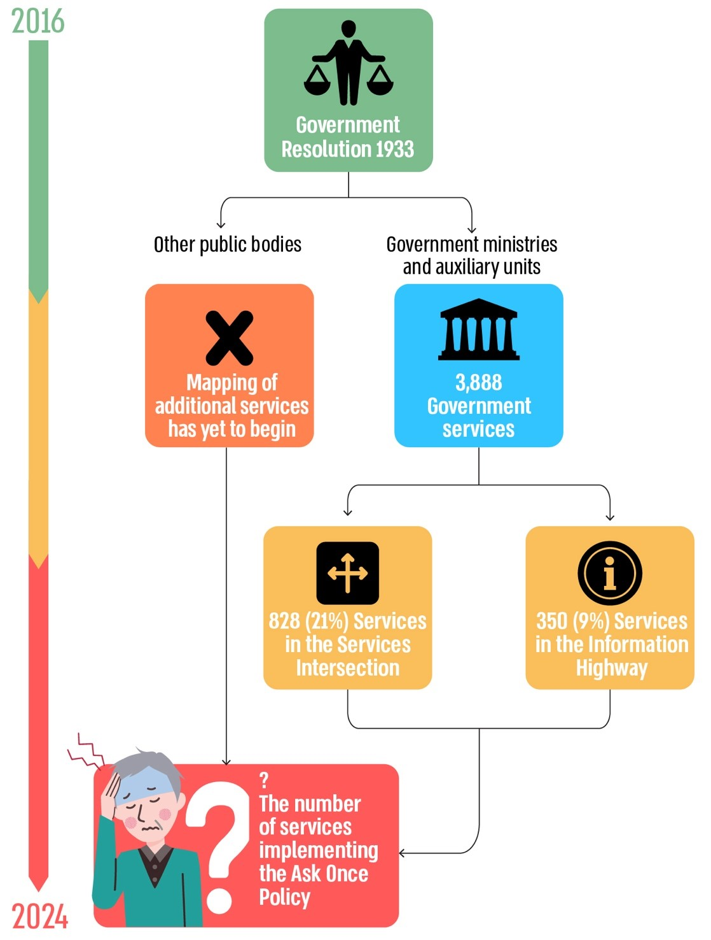

According to data from the National Digital Agency, processed by the Office of the State Comptroller.



**Summary**

To reduce the bureaucratic burden and enhance public service, the government decided to implement the Ask Once Policy in 2016. This policy stipulates that if a public body requires information to provide a service, it should not request this information from the citizen or business if another public body already possesses it. Instead, the information should be directly obtained from the holding body. In 2020, the government accelerated the adoption of digital services by advancing the Ask Once Policy. The Iron Swords War demonstrated and even highlighted the importance of providing digital services to the public while implementing the Ask Once Policy.

In 2021, the State Comptroller's Office published the Previous Report, which showed significant progress was still needed before achieving the 2021 mandate prohibiting ministries from requesting certificates from the public that are available through other ministries. Four years after the resolution, a clear picture of the implementation status of the Ask Once Policy was still lacking, hindering goal-setting for ongoing policy enforcement, including establishing milestones and monitoring.

The follow-up audit, conducted eight years after the initial government resolution, examined the rectification of the key deficiencies found in the Previous Audit and raised significant progress in the preliminary actions required to implement the Ask Once Policy, particularly concerning the mapping of government services provided to the public and the analysis of their characteristics. However, most deficiencies noted in the Previous Report were not addressed. The utilization of the Information Highway – a technological infrastructure designed to facilitate secure, cross-ministerial information transfer between all government ministries – currently encompasses only 9% of government services. Additionally, the objectives set in government resolutions are not being met. The National Digital Agency lacks data concerning the scope of actual and potential services for implementing the Ask Once Policy, and it fails to submit timely reports on compliance with governmental resolutions to the government. Additionally, the inter-ministerial steering committee established to monitor the implementation of these resolutions has not convened.

Efficient inter-ministerial information transfer is critical for the Ask Once Policy. The follow-up findings indicate that ministries are not adhering to government resolutions or the guidelines of the National Digital Agency. Processing times for inter-ministerial information transfer exceeded designated limits by over 300%, with an average transfer time of about nine months, compared to the 60-day target. This illustrates a low level of commitment from ministries and auxiliary units to fulfill government resolutions.

During the Iron Swords War, in light of the excessive scope of about 240,000 new firearm license applications pending with the Ministry of National Security as of December 2023, a request for information transfer via an online interface was made to the IDF. However, this interface was not operational until April 2024, nearly six months following the onset of the war, despite the urgent need for rapid information exchange.

The government plan established in 2016 has yet to be effectively implemented after eight years, and the completion of the process does not seem foreseeable. The fundamental issue appears to be the limitations of the National Digital Agency’s capabilities to enforce the plan, as its interactions with government bodies do not compel government ministries to take actual action. This deficiency, combined with a lack of commitment from government and public bodies to adhere to the resolution and the National Digital Agency’s directives, has resulted in inadequate execution of the Ask Once Policy.

To expedite policy implementation, the National Digital Agency should adopt a comprehensive strategic approach addressing all contributory factors, requiring a commitment from all government ministries and auxiliary units. Including mapping and validating public services, connecting ministries to the Information Highway, establishing supporting portals, and improving inter-ministerial information transfer processes, including coordination through the Moed system. It is recommended that local government and the health sector be included in advancing government policy. Addressing the deficiencies in the Previous Audit will enhance public service delivery and governmental efficiency. Should the National Digital Agency require additional authority to implement these measures, it must engage with the government to secure such powers.

The National Digital Agency should transparently report the extent of implementation of the Ask Once Policy concerning information transfers in its annual reports. Without significant progress, the National Digital Agency should bring the matter to the government, advocating for updated resolutions that impose binding timelines on government ministries and public bodies.

The Minister of Economy, responsible for the National Digital Agency, should supervise the enforcement of government resolutions and periodically report to the government on the policy progress. The inter-ministerial team, led by the Ministry of Justice, should finalize discussions and present the government with a proposal to eliminate barriers and promote effective and rapid information transfer between ministries and public bodies, thus supporting improved public service and reduced bureaucracy.

**The Rectification Extent of the Key Deficiencies Noted in the Previous Report**

| **The Rectification Extent of the Deficiency Noted in the Follow-up Audit** | | | | **The Deficiency in the Previous Audit Report** | **The Audited Body** | **The Audit Chapter** |
| --- | --- | --- | --- | --- | --- | --- |
| **Fully Rectified** | **Significantly Rectified** | **Slightly Rectified** | **Not Rectified** |
|  |  |  |  | The ICT Authority should develop an online form for an efficient working interface on the Moed system with external public bodies. | ICT Authority | Transfer of information between bodies and the Moed system |
|  |  |  |  | Government ministries and auxiliary units, in collaboration with the National Digital Agency, validated only about 26% of all services mapped (933 out of 3,545). Without full validation of the mapped services, the ICT Authority and Israel Digital did not have a complete and reliable situation report of each ministry's total services to the public, the information and authorizations required to receive each service, and the originating body issuing each authorization. | ICT Authority, Israel Digital, government ministries, and auxiliary units | Mapping and validation of services provided to the public |
|  |  |  |  | It was recommended that the ICT Authority and Israel Digital consider incorporating additional public bodies that provide many services to the public, such as local authorities, hospitals, and HMOs, into the mapping to consider the implementation of the Ask Once Policy. | ICT Authority and Israel Digital | Mapping and validation of services provided to the public |
|  |  |  |  | Three bodies that Government Resolution 260 of 2020 required to externalize information on the Information Avenue by April 2021 have not yet implemented the system – the Tax Authority, the National Insurance Institute, and the Ministry of Defense. | Tax Authority, National Insurance Institute, Ministry of Defense | Government ministries' use of the Information Highway |
|  |  |  |  | In August 2020, the ICT Authority did not have a complete and detailed picture of the rate of implementation of the Ask Once Policy in the ministries at all levels, and it was also impossible to maintain an optimal process of setting goals for implementing the policy, including setting milestones for progress and monitoring their implementation. | The ICT Authority | Implementation of the Ask Once Policy |
|  |  |  |  | It was recommended that the annual report that the ICT Authority submits to the government regarding the work of the committees include data regarding the processing times for requests at each stage, significant bottlenecks in the request approval process, and the reasons for delays. Thus, a complete situation report of the information transfer process on both the requesting and the holding side of the information will be provided, as well as the stages in the process that require improvement. | The ICT Authority | Transfer of information between entities and the Moed system |
|  |  |  |  | Only 9% of all requests processed by committees for information transfers between public bodies in 2019 were processed through the Moed system. The ICT Authority and bodies not yet connected to the Moed system should do so. | The ICT Authority and relevant government ministries | Transfer of information between entities and the Moed system |

1. Data stored on a government database or confirmation issued by a government ministry.
2. Government Resolution 1933, "Improving the transfer of government information and making government databases accessible to the public" (August 30, 2016).
3. Government Resolution 260, "Plan to accelerate digital services for the public and promote digital literacy and amend a government resolution" (July 26, 2020).
4. According to Regulation 3A of the Protection of Privacy (Information Security) Regulations, 2017, every public body that provides or receives information is required to appoint a committee whose duty is to discuss requests for the provision of information from the ministry to public bodies or requests by the ministry to receive information from another public body and to consider whether to approve these requests.
5. The National Digital Agency was established in 2021 in the course of the merger of the Government ICT Authority and the Headquarters of the Israel Digital National Initiative.
6. The Information Highway is a central infrastructure that provides a uniform, organization-wide solution based on the development of standard interfaces for the secure transfer of information between government ministries and public bodies.
7. Annual Audit Report 72A (2021) "Ask Once Policy' to Improve the Governmental Digital Service to the Public".
8. A new information system established by the National Digital Agency to manage information transfer procedures between ministries.