­­



The National Insurance Institute

**The Tevel Project for Upgrading the Computing Systems in the National Insurance Institute – Follow-up Audit**

Report of the State Comptroller of Israel – Cyber and Information Systems | November 2024

The Tevel Project for Upgrading the Computing Systems in the National Insurance Institute – Follow-up Audit



In 2009, the National Insurance Institute (NII) initiated the "Tevel" Project to upgrade the computer system (Tevel or the Project), whose main goal is the realization of the principle of "the insured at the center," which focuses on the exhaustion of his rights. The Project is indented to progressively enhance the core and main headquarters systems of the NII, encompassing 48[1] systems and subsystems, and establish a modern technological infrastructure. The planned duration of the Project was 11 years, from early 2010 to the end of 2020, and its total budget was planned to be about NIS 477 million.

In 2015, the State Comptroller published a report addressing phase A[2] of the Project (the State Comptroller's Report from 2015), which noted, inter alia, that given the deviations from the project's budget and schedule, it is necessary to rectify the deficiencies to ensure that in the coming years, the implementation will continue in alignment with approved plans and content in subsequent years. The report underscored the importance of completing the Project without further delays, given that one of its primary objectives is to place the insured's needs at the center and the exhaustion of his rights. In 2017, a report from NII's consultants decided that the chosen implementation approach was flawed, compounded by an overall failure in program management. Their principal recommendation was to continue executing the Project plan while limiting it to partial content relative to the original plan.

In 2020, the State Comptroller's Office published another report on the "Tevel" Project[3] (the Previous Report or the Previous Audit), criticizing the management of the Project's content, budget, and work plan, including the necessary rectification of deficiencies highlighted in the State Comptroller's Report from 2015. The said Report concluded that although the NII had implemented several essential and advanced systems contributing to enhanced work processes and improved service for the insured, these systems constituted only a tiny fraction of those planned in 2009. The pathway to fully realizing the project's main objective – the implementation of the "insured at the center" concept – remained distant. The primary recommendation was for the National Insurance Institute to reassess the evaluation and planning procedures within the Project thoroughly and to closely monitor progress toward meeting milestones at each stage to mitigate further delays in its implementation.

In 2021, a decision was made to reduce the Project scope further, focusing specifically on the domain of pensions – specifically, types of pensions requiring the convening of medical committees for their approval, while suspending the addressing of other core systems. Later that year, the NII sought the expertise of an additional consultant to evaluate the Project's continuation. The consultant identified significant delays in schedules and substantial cost overruns compared to initial plans; However, he also noted improvements in the Project's management. The consultant recommended continuing the Project, emphasizing the necessity of strengthening budgetary control processes.



|  |  |  |  |  |  |  |
| --- | --- | --- | --- | --- | --- | --- |
| **14 years** |  | **NIS 1 billion** |  | **200%** |  | **50%** |
| since the beginning of the project in 2010, planned to be completed in 2020. By the end of the current multi-year plan (in 2025), the Project will be five years behind schedule with no expected completion date |  | the expected cost overrun of the Project by the end of the current multi-year plan. This overrun is expected to increase by hundreds of millions of NIS by the time the Project is completed |  | the expected increase in the Project cost compared to its original budget until the end of the current multi-year plan. From a planned NIS 477 million to an expected NIS 1.5 billion |  | of the core systems (19 out of 38) were removed from the Project, and their implementation was suspended, such as the systems that handle old-age and survivors' pensions, reservists, and children |
|  |  |  |  |  |  |  |
| **51 years** |  | **270,000** |  | **only 10 systems** |  | **NIS 116 million** |
| the age of the information system that handles old-age and survivors' pensions. This system and other systems developed decades ago were removed from the Project |  | insured individuals were treated through the "Tevel" system in 2022, 140,000 claims were filed, and 50,000 medical committees were held through the system |  | of the 38 core systems originally planned to be completed in 2020 were implemented by the follow-up audit time (26%) |  | the average annual budget of the "Tevel" Project in 2019–2023 |
|  |  |  |  |  |  |  |



**Audit Actions**

From June to September 2023, the State Comptroller's Office followed up on the key deficiencies of the Previous Audit concerning the "Tevel" Project. This follow-up audit was carried out at the National Insurance Institute (NII), and focused on the project budget, implementation timelines, and contents. Additionally, the audit included an assessment of the multi-year and annual work plans, their supervision, and the Project's budgetary control.



**Key Findings**



**The Delineation of the Project and the Contents that were Implemented –** the Previous Audit noted that the NII had only executed a small portion of the systems initially planned for inclusion in the Project in 2009. **The follow-up audit found that the deficiency was slightly rectified.** NII has decided to detract 19 (50%) of the 38 core systems from the Project, with 6 systems removed since the Previous Audit. Nine additional systems (about 24%) remain unrealized. Seven systems have been fully implemented, comprising 3 new systems and 4 that were partially operational during the Previous Audit. Only 10 of the core systems (about 26%) were fully implemented under the Project. Moreover, six out of ten modules within the ERP project have not been implemented, and the NII does not plan to complete the additional systems outlined in the Project beyond 2025.

**The Project Timelines –** as of the audit end date, fourteen years since the beginning of its execution, despite a significant reduction in Project content to about half of the original plan, the substantial delay in timelines and persistent decrease in content reflect a consistent, multi-year process of distancing from the original planning of the Project to the point of relinquishing entire layers of it. This trend, which has been ongoing for several years, has not resulted in adherence to deadlines for implementation even after content reduction. As of the follow-up audit date, the completion of the multi-year plan approved for implementation until 2025 (which includes 15 of the 38 [40%] core systems initially planned) will be five years (about 45%) behind the original schedule. Moreover, the NII lacks a strategy to complete the approved limited content, leading to expectations of further schedule deviations.

The NII decided to exclude from the "Tevel" Project and not upgrade nearly 50% of the planned core systems without an alternative technological response for these systems. The systems detracted from the Project encompass areas such as old-age and survivors', reserve, unemployment, children's, and survivors' benefits, facilitating the disbursement of tens of billions of NIS to over one million insured individuals annually. These systems developed decades ago (the old-age and survivors' system was developed in the 1970s) on outdated infrastructures and technologies, face diminishing technological capabilities, and the availability of professionals to continue to maintain them is decreasing. This decision effectively alters the Project's original objective to modernize the NII's information system, eliminate technological and process barriers, enhance management and control, and improve agility in adapting information systems and processes to legislation, regulation, and NII policy changes.

**The Project Budgeting –** the Previous Audit raised that, despite partial implementation of the Project contents compared to the original plan, the budget execution rate by July 2019 was about 58% over the original budget allocation. **The follow-up audit found that this deficiency was not rectified as of the audit date;** even with significant content reduction (by about half), expenditures reached about NIS 1.2 billion, roughly 260% of the initially approved budget of NIS 477 million. It is estimated that by completing the current multi-year plan in 2025, the Project costs may exceed 200% of the original budget, resulting in an excess of over one billion NIS. Notably, the NII lacks an estimate for the anticipated costs associated with the subsequent multi-year plan, thereby failing to estimate the total Project cost upon completion.

**Inclusion of the Cost of NII's Standard Workforce Employees in the Project Budget –** the Previous Audit raised that the Project budget data does not include the employment costs of the NII's standard workforce employees incorporated in the Project, and it recommended that such expenses be incorporated. **The follow-up audit found that this deficiency was not rectified.** Despite the NII's management stating it would implement the recommendation, the personnel costs for these standard workforce employees were not included in the Project budget. These costs are about NIS 5 million annually, representing about 4% of the annual Project budget.

**Project Planning vs. Execution and Budget Control –** the Previous Audit raised that the NII's budget supervision team faced difficulties to comprehensively control over the Project budget compared to the planned one, mainly due to insufficient detailed, complete, and current planning data. **The follow-up audit found that the deficiency in the budgetary control procedures was slightly rectified.** During this audit, it was noted that in the task status control process, the NII retroactively updates the planned hours for the execution of each completed task so that these align with the actual execution hours. This practice of retroactive updating effectively nullifies the hours budget allocated for the planned execution hours within the Project, which involves the management of hundreds of tasks. Consequently, upon completing the update of performance data for the task, the planning data regarding resource allocation (number of development hours) is presented as equal to the actual performance data.

Disregarding planning data highlights a significant deficiency that significantly affects the overall Project supervision and control. The lack of continual monitoring of discrepancies between planning and actual execution hampers the effective management of resource allocation in the Project, which involves hundreds of thousands of development hours with a financial cost of tens of millions of NIS per year. Furthermore, the quarterly budget control report submitted to the accountant relies on planning data from the Project management system, which is retrospectively updated according to actual execution. Consequently, this report does not accurately reflect the original planning and cannot be relied upon for control or decision-making. Effective budgetary and process control is unattainable without dependable reporting on planning data, leading to potential inaccuracies in decision-making based on these reports.

**Conducting Research at the End of Each Version –** after each version or development cycle is completed, comprehensive investigations and lessons-learned processes are not undertaken routinely. The NII is satisfied with performing spot investigations into specific events; However, this approach fails to address the necessity for a thorough lesson-learned process that examines the entire version lifecycle. This examination should encompass the requirements gathering stage, characterization and development processes, change management, testing, and the go-live stage. Lessons are essential for change, improvement, and preservation purposes, even when a version is successfully launched, to replicate future successes. The absence of these processes undermines the NII's capacity to enhance development processes systematically and continuously.



**The Governance Mechanisms in the Project –** the State Comptroller's Office commends the NII for the ongoing efforts of the Steering Committee and the Finance Committee, as well as the periodic meetings conducted by the accountant and ICT VP, noting that the plan has received unanimous approval from all parties involved in its execution.



**Key Recommendations**

The NII should develop a comprehensive plan, including a finalized schedule for the Project completion, with all components duly approved. Additionally, periodic control mechanisms must be established to ensure the effective implementation of the plan. All of this is to achieve the main goal of the Project – placing the insured and fulfilling their rights at the center.

The NII should assess the future of the systems excluded from the Project, considering the quality of current solutions and their technological viability for sustained operation within the existing technological framework. Based on this assessment, a multi-year upgrade plan must be formulated to achieve the principal aim of the "insured at the center" while concurrently advancing the existing systems within the "Tevel" Project.

Due to significant and ongoing budgetary deviations, the NII should conduct a thorough investigation to identify and analyze the causes of these deviations. It must also prevent future deviations in this and another IT Projects it manages. Following this investigation, a final budget for the Project completion must be established, along with the designation of accountability for budget adherence.

The NII should include in the Project budget all associated expenses, including the costs related to the employment of standard workforce employees.

The NII should implement Standard control processes, wherein original planning is compared against actual execution. This includes an analysis of both overestimations and underestimations to facilitate the extraction of reliable lessons regarding actual costs and the efficiency of the characterization, development, and testing teams’ efforts.

****The Project's management should adopt a structured and systematic approach for lessons learning after each Project version.

**The Reduction in the Contents of the "Tevel" Project Compared to the Rising Costs**

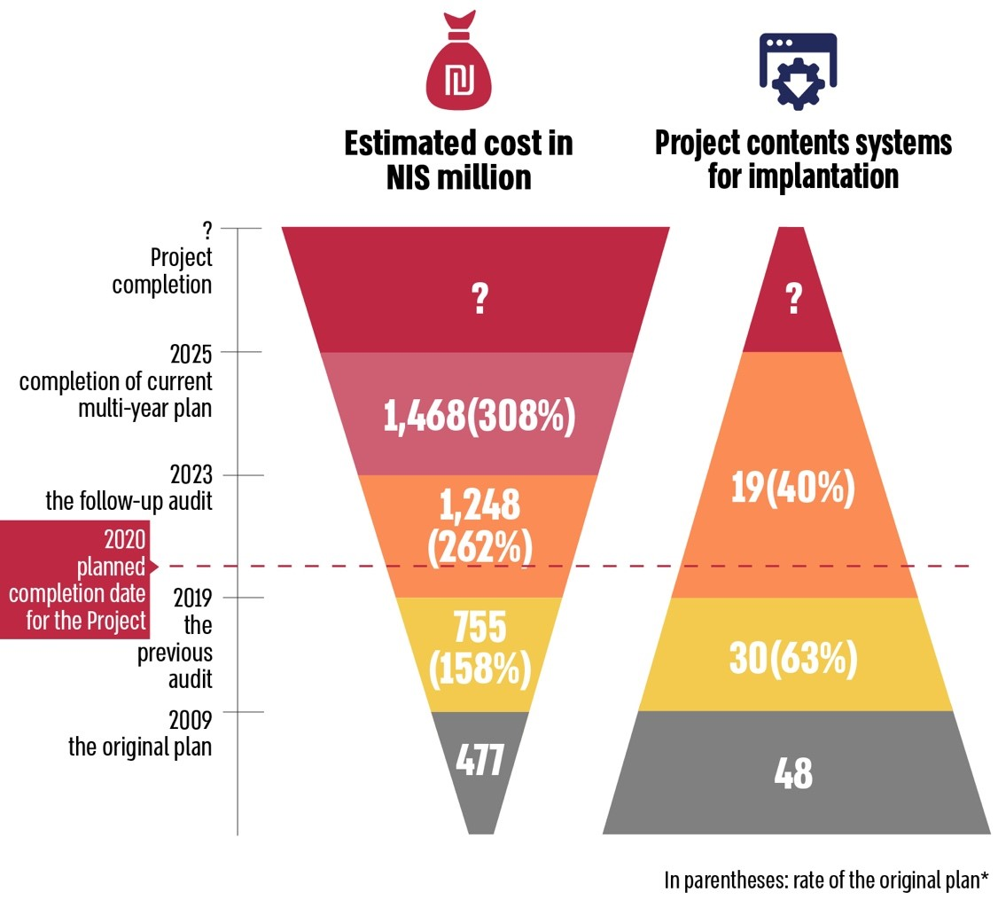



**Summary**

The "Tevel" Project, NII's leading digital initiative, was initiated over a decade ago to eliminate technological and procedural barriers and implement the vision of the NII to provide comprehensive access to its services for the public and promote data transparency. This initiative aligns with its principle of placing the insured at the center and maximizing their entitlements. As of the audit date, the NII has invested about NIS 1.2 billion into the Project, completing ten (a quarter) of the planned 38 core systems.

The State Comptroller's Office has published two audit reports regarding the Project’s implementation: one in 2015 and another in 2020. This follow-up report examines the rectification of the key deficiencies noted in the Previous Audit.

The follow-up audit raised that most of the key deficiencies noted in the Previous Report remain unaddressed or have been slightly rectified. Schedule deviations persist, and the NII has no estimated completion date for the Project. Concurrently, while the NII reduced the Project contents by half, the current estimated cost is about NIS 1.5 billion, representing a deviation of about NIS 1 billion from the original budget of NIS 477 million (an increase of about 200%). This deviation is expected to rise by several hundred million NIS more by the Project’s completion. Continuous discrepancies in Project timelines and costs adversely affect the provision of optimal services to the insured populace. The report also notes a practice of retroactively amending planning data, which significantly undermines effective supervision and budget control and examines allocated versus planned initially resources. Regarding the engagement of relevant stakeholders, the NII has addressed the deficiencies noted in the Previous Report by initiating steering committee meetings and periodic control meetings involving its management representatives.

Despite the investment of over NIS 1 billion of public funds into the "Tevel" Project – over double the initial overall planning – the objective of enhancing public services and assisting individuals in exhausting their rights has been partially realized, partly due to the Project's reduced contents.

The significant deviations in the Project necessitate the NII's administration to monitor the factors contributing to these discrepancies, establish mechanisms to mitigate them, and definitively determine the Project’s completion date and budget. The management of the NII is responsible for effectively utilizing public funds invested in the Project. It is therefore recommended that the NII implement the insights gained from addressing the deficiencies outlined in this report across all Projects under its supervision. Moreover, the management should assess, given the progress of system development over the past 14 years, the expectation of achieving an improvement in the ICT response in all the systems across all of the NII's systems, particularly those excluded from the Project, and convene a thorough and strategic discussion based on examination results.

**The Rectification Extent of the Key Deficiencies Noted in the Previous Report**

| **The Rectification Extent of the Key Deficiency Noted in the Follow-up Audit** | | | |  |  |  |
| --- | --- | --- | --- | --- | --- | --- |
| **Fully Rectified** | **Significantly Rectified** | **Slightly Rectified** | **Not Rectified** | **The Deficiency in the Previous Audit Report** | **The Audited Body** | **The Audit Chapter** |
|  |  |  |  | In the first half of 2019, the NII advanced the implantation of the Project without reaching an agreement among the parties involved regarding the existence of a detailed annual work plan. | NII | Managing the Project's annual work plan |
|  |  |  |  | Only five of the 38 core systems included in the original 2009 Project contents had been implemented by August 2019, and even then, only partially compared to the original plan. Of the 10 modules in the headquarters (ERP system), only two were fully implemented, and one was partially implemented. | NII | The Project scope |
|  |  |  |  | Although the NII established a budget supervision team in 2018 which met regularly, the team had difficulty thoroughly monitoring the Project budget in 2019 compared to the planned contents due to the lack of detailed, complete, and updated planning data. | NII | The Project budget |
|  |  |  |  | Despite partially implementing the Project's contents compared to the original plan, budget execution by July 2019 was about 58% over the original budget approved for the Project in 2009 (about NIS 755 million compared to the original budget of NIS 477 million). | NII | The Project budget |
|  |  |  |  | The Project budget execution data does not include all direct costs, such as salaries for 15 ICT and information systems administration employees employed on the Project. | National Insurance Institute | The Project budget |

1. In the previous audit 31 core systems were noted. Given their size and scope of modules of the Medical Committees System (Such as the system of work injury or general disability committees) they are regarded in the follow-up audit as separate systems, therefore there are 38 core systems. Moreover, the project included ERP system with ten modules in the headquarters. Thus, in total 48 systems and subsystems.
2. See the State Comptroller, Annual Report 65C (2015), "The Tevel Project for Upgrading the Computing Systems in the National Insurance Institute", pp. 1289 $-$ 1331.
3. See the State Comptroller, Annual Report 70C (2020), "The Tevel Project for Upgrading the Computing Systems in the National Insurance Institute".