­­



Special Report

**Artificial Intelligence – National Preparedness**

Report of the State Comptroller of Israel – Cyber and Information Systems | November 2024

Artificial Intelligence – National Preparedness



Artificial intelligence (AI) is an overarching term for technologies developed to enable machines to execute tasks that necessitate human intelligence. The ongoing AI revolution is recognized as a "disruptive innovation" poised to alter various aspects of life and numerous industries significantly. The Ministry of Innovation[1], Science and Technology (the Ministry of Innovation) defines AI as "the capability of a machine to learn to perform human actions and enhance its performance, relying on data, examples, and operational experience, and, in a broader context, all technological operations extracting information and insights from databases."

Academic research in artificial intelligence dates back to the 1950s. However, in recent years, particularly following the introduction of various tools and applications (apps) available in the market for diverse fields, there has been a marked advancement in the integration capabilities between man and machines, which some characterize as a genuine revolution. AI is employed in various sectors, including the development of autonomous vehicles, analysis of X-ray images, assessment of credit risks, securities trading, and candidate evaluation for employment. Furthermore, AI systems play integral roles in interactions between consumers and businesses, businesses and other businesses, professionals and clients, labor relations, public sector entities, and the public and general public.

AI was also widely used during the "Iron Swords" War; apart from its operational use, it contributed to the identification and location of hostages and fatalities. In advocacy, AI facilitates the creation of multilingual videos, enhancing accessibility to diverse populations worldwide through voice reproduction, animation, dubbing, subtitles, and translation. Additionally, the war highlighted the use of "deepfake" technology – a form of AI utilized by various parties for propaganda and the dissemination of misinformation.

In May 2018, the Chief of Staff for the National Security Council at the time, following the Prime Minister's directive, appointed project leaders to formulate a national plan to bolster scientific-technological resilience as a critical component of Israel's national security ("the National Initiative"). Thus positioning Israel globally among the top five countries in core technological domains, including artificial intelligence and data science. The Initiative's report was presented to the Prime Minister and published in September 2020.

Artificial Intelligence in Israel – Milestones in 2018–2023



In February 2020, the Chairman of the National Research Infrastructures Forum (Telem Forum[2]) appointed a professional review committee led by Dr. Orna Berry to assess the necessity for government intervention to accelerate advancements in artificial intelligence and data science (Telem Committee). The Committee's directive, outlined in the appointment letter, emphasized the importance of focusing on the following aspects: human capital, physical infrastructure, access to databases, and knowledge transfer from academia to industry. The Committee's findings were published in December 2020. In August 2021, following Government Resolution 212, the government approved the Telem Committee's recommendations, initiating the first implementation phase with a budget of about NIS 550 million from 2021 to 2023.

In July 2022, the then-Minister of Innovation launched a "National Program for Artificial Intelligence". This program, crafted by an inter-ministerial team, was officially published by her ministry in January 2023 (the Ministry of Innovation's National Program).

In February 2023, Government Resolution 173 approved an extension to the first phase, approved in August 2021 (the second phase). This resolution included a directive to the Ministry of Finance to allocate a budget not exceeding NIS 500 million, which will be utilized by Telem Forum entities from 2023 to 2026.

This audit report evaluates the national preparedness in artificial intelligence, examines how the Israeli government formulates and enacts a national strategy to position Israel among the leading countries globally, and assesses whether its actions in artificial intelligence will establish a robust foundation for Israel's development and prominence as a scientific and technological power. The preparedness, decision-making, and implementation processes for the government program in artificial intelligence commenced in 2018 and continued throughout the audit period.



|  |  |  |  |  |  |  |
| --- | --- | --- | --- | --- | --- | --- |
| **0** |  | **only 1 NIS billion** |  | **drop from 5th place to 9th place** |  | **drop from 20th place to 30th place** |
| Israel has no **long-term national strategy** in artificial intelligence. The government did not approve a **comprehensive and individual master plan for the implementation.** Instead, over the years, it has approved programs in phases implemented slow, lacking, and does not meet the set schedules |  | was approved by the government in two phases. most of the amount had not yet been realized. The approved budget is about a fifth of the recommended one by the Telem Committee in December 2020 and about a tenth of the "National Initiative" recommendation from September 2020 |  | in the Tortoise index out of 83 countries in 2019–2024. This is an international artificial intelligence, index whose ranking is based on – investment, innovation, and application |  | in the Oxford index out of 193 countries in 2020–2023. This is an international artificial intelligence index regarding governmental readiness for artificial intelligence. In a sub-index measuring the government's artificial intelligence strategy and its digital capabilities, Israel dropped 33 places (from 35th to 68th) in these years |
|  |  |  |  |  |  |  |
| **only 40%** |  | **only 11%** |  | **55%** |  | **76%** |
| was realized of the first phase budget, the government approved for 2021–2023 (NIS 220 million out of about NIS 550 million). The realization rate refers to agreements that have been signed, of which tens of millions of NIS have not yet been executed or completed |  | the realization rate of the first phase in high-performance computing (supercomputer), which is about NIS 30 million out of the NIS 270 million approved |  | of the budget allocated in the first phase for human capital was realized (about NIS 34 million out of NIS 62 million), focusing on the needs of academia but not to the industry needs |  | the budget realization rate in natural language processing in Hebrew and Arabic. However, the realization rate includes an agreement for a language module for which there is a budgetary commitment that has not yet been realized |



**Audit Actions**

From June 2023 to March 2024, the State Comptroller's Office examined the national preparedness in artificial intelligence, assessing Israel's international ranking and the government and relevant ministries' actions to advance a national program for artificial intelligence. The audit was performed in the Ministry of Innovation, the Innovation Authority, the Ministry of Defense, the Planning and Budgeting Committee, the Ministry of Finance, and the National Security Council in the Prime Minister's Office. Supplementary examinations were conducted within the National Digital Agency at the Ministry of Economy and Industry.



**Key Findings**



**The Absence of an Integrating Government Body Supervising Artificial Intelligence National Program –** under the government's resolution and the agreement reached between the Minister of Innovation and the head of the National Security Council in July 2022, the Ministry of Innovation, under the then minister's leadership, formulated a national program for artificial intelligence. However, after the change in government in January 2023, the Ministry of Innovation did not comply with the government’s resolution to promote and lead in artificial intelligence. The program initiated by the Ministry did not progress to the implementation phase after establishing the 37th Knesset, leading to stagnation on the established milestones. Since the change in government, the Ministry has limited its focus to specific issues within Israel's artificial intelligence sector and has not led to advancement at the national level.

Six years after the Prime Minister decided to promote artificial intelligence and submit it as a program for government approval, an overall national program to advance it has yet to receive government endorsement. Aside from the two phases of the Telem program, the national program introduced by the then-Minister of Innovation in July 2022 remains ineffective when it has not been implemented following the change in government. The necessity for the government’s approach to artificial intelligence to be guided by an integrating government body responsible for the execution of the government program is underscored by several factors: the significance of this sector to the national economy and its resilience; The myriad of government ministries and public agencies engaged in the advancement and integration of artificial intelligence technology within the governmental framework; The critical importance of Israel’s standing as a global leader in this technological revolution; And the mandate assigned to the Ministry of Innovation to supervise the government’s strategy. As of the audit date, there is no integrating government entity that holds overall responsibility for formulating and leading a national program, pooling budgets, and controlling and supervising the program's implementation and progress.

**The Drop-in Israel's Ranking in Artificial Intelligence –** Israel aspires to be a leading technological and high-tech player .The audit raised that in 2019–2024, Israel's position in global rankings for activity and investment in artificial intelligence declined. The Tortoise Index dropped from 5th place out of 62 countries to 9th place out of 83 countries. The Oxford Index's ranking dropped from 20th to 30th place out of 193 countries. Additionally, in the Innovation Index, Israel's ranking dropped from 10th place to 15th place out of 133 countries. This decline is attributed, in part, to the findings detailed in this report regarding the government's approval, leadership, and execution of a broad national program in artificial intelligence. Tortoise sub-index data for 2024 indicate that while Israel excels in human capital, research, and development, it lags in government strategy (32nd place), infrastructure (26th place), and operational environment (65th place). The decline in Israel's international rankings in 2019–2024 highlights the urgent need for the government to reassess its policy regarding artificial intelligence.

**Government Discussion on the "National Initiative" Recommendations –** the "National Initiative" was established at the appointment of the National Security Council per the Prime Minister's directive. Its draft report was presented to the Prime Minister in May 2019, and the final draft was submitted to the head of the National Security Council in December of the same year. Following the changes in government that year, the final report, which included a comprehensive plan for formulating a strategic national response to artificial intelligence and associated projects with a budget of NIS 10 billion, was distributed to all government ministries and made public in September 2020. The report, compiled with input from hundreds of knowledge experts who volunteered their expertise for about two years, identified the promotion of artificial intelligence as critical for Israel's resilience across various sectors, including science, economy, security, and health. The audit found that the Initiative's recommendations were neither presented to the government nor discussed within any authorized government forum, nor were they budgeted or matured for implementation, despite the National Security Council being required to review the "National Initiative" following its completion and implementation for the review of the authorized body which approved the designation. Additionally, according to the agreement with the Legal Counsel to the Prime Minister's Office, the National Security Council was to establish the inter-ministerial team and submit its recommendations to the Prime Minister and government shortly after the "National Initiative" work was concluded, not about a year and a half later.

Once the Prime Minister, the government, or any other governmental body tasked professional parties to conduct staff work and submit a report based on the recommendations of 14 professional teams and hundreds of knowledge experts, which was to serve as a basis for making an operative decision on a specific issue, the head of the National Security Council should have completed the process until the government discussed the recommendations following the teams' work and the submission of the report summarizing their findings; However, this did not occur. The failure to forward to the government the conclusions of the "National Initiative" report, which remained unaddressed for two years due to administrative delays unrelated to the Initiative's work, adversely impacted the government's ability to capitalize on the contributions of the exceptional knowledge experts appointed under the Prime Minister's decision.

**Government Discussion of the Recommendations of the Artificial Intelligence and Data Science Committee (Telem Committee) –** the chairman of the Telem Forum appointed the Telem Committee to assess the necessity for government intervention to expedite the development of artificial intelligence and data science. It was determined that akin to the "National Initiative" recommendations intended to serve as a basis for a government decision, this program, which was completed in December 2020, was not thoroughly discussed within the government but rather in a limited manner under two phases, which were budgeted at around one-fifth of the Committee’s recommended budget, at about NIS 1 billion. Consequently, it was not endorsed as a comprehensive master plan nor budgeted with a long-term vision.

**Regulation –** despite the inherent risks associated with artificial intelligence technology and the imperative to regulate its usage responsibly while upholding fundamental rights, it has been determined that as of the audit end date, the collaborative efforts between the Ministry of Innovation and the Ministry of Justice to advance regulation in artificial intelligence and the principles outlined in the Policy Principles document have not yet received government approval. Israel currently lags behind the European Union, which has already enacted legislation regulating artificial intelligence use based on risk levels. The absence of regulation in Israel presents various risks that generate new legal and regulatory challenges. It is essential to ensure that, irrespective of technological advancements, human beings remain central to decision-making and that the development and application of artificial intelligence are conducted responsibly, safeguarding fundamental rights and public interests, including human dignity, privacy, equality, non-discrimination, and complete transparency.

**High-Performance Computing (HPC) –** although the necessity for supercomputing infrastructure was identified in 2020 as fundamental for positioning Israel as a leading nation in artificial intelligence, five years later, existing computing infrastructures remain limited and inadequate for advancing research and industry in Israel. This deficiency in computing infrastructure hinders the public sector, academia, and industry’s capacity to foster and develop artificial intelligence.

**Infrastructure for Training Large Models –** it was found that by the end of December 2023, as the first phase concluded, the Directorate of Defense, Research, & Development (DDR&D) did not fulfill its obligations within the partners’ agreement to establish an infrastructure for training large models. The Innovation Authority has not yet regulated a complex calculation infrastructure for scientific use, essential for furthering artificial intelligence technology. Thus, the implementation rate of the first phase for advancing artificial intelligence stood at merely 11%, with about NIS 30 million disbursed out of a total approved budget of NIS 270 million.

**Natural Language Processing (NLP) –** the Telem Committee highlighted the importance of advancing natural language processing, deeming it essential for employing artificial intelligence capabilities in government ministries and various industries. Therefore, the Program's primary objective is to bridge the significant technological divide between existing capabilities in English and other Latin languages and those in Hebrew and Arabic, the following findings were found:

* + Only on December 31, 2023, the final day designated for the implementation of the initial phase, the DDR&D entered into an agreement of NIS 37 million for developing a Hebrew and Arabic language model project in collaboration with an international company. The first model is anticipated to be implemented by mid-2025, a year and a half after the conclusion of the initial phase. Notably, this financial commitment constitutes about a quarter of the allocated resources for language processing within the first phase. The substantial delay by the DDR&D in advancing the large language model (LLM) for Hebrew and Arabic may severely impede governmental responses to citizens, as the anticipated model is intended to catalyze the digital transformation of the Israeli economy, particularly within the public sector, through artificial intelligence tools.
  + By the end of the first phase, Israel lacked a language model in Hebrew and Arabic for government use and citizen interaction. The total budget realization for developing language processing capabilities for Hebrew and Arabic, necessary to reduce the considerable technological gap compared to English and other Latin languages, reached 76% of the approved budget for this component (NIS 138 million out of NIS 180 million). This realization rate includes the language model agreement, which has only a budgetary commitment of NIS 37 million and has yet to be realized.

**Human Capital –** it was found that in human capital investment for artificial intelligence advancement, implementing the Telem Committee’s program within the first phase approved by the government was partial. As of the end of 2023, only NIS 34 million out of NIS 62 million was realized, about 55% of the allocated budget, mainly addressing academic needs while neglecting industry requirements.

**Employment of Researchers and Senior Faculty in Academia –** it was found that, although the partner agreement for the first phase allocated about NIS 24 million for faculty admission in academia and around NIS 20 million for dedicated research grants in AI CORE fields, these elements were not executed, by the end of the first phase, by the Planning and Budgeting Committee. Moreover, the Planning and Budgeting Committee and the Innovation Authority lack up-to-date and accurate information on the existing number of researchers. This deficiency underscores a lack of attention to the necessary training and development of human capital in artificial intelligence, which is critical for realizing the defined objectives.

**Scope of Scholarships –** it was found that in 2021–2023, the Planning and Budgeting Committee awarded about 50 scholarships, representing 5% of the roughly 1,000 scholarships recommended by the Telem Committee, as part of the implementation of the first phase budget approved by the government. The average annual financial scope was about NIS 10 million, significantly lower than the NIS 100 million per year recommended by the Committee. Thus, the scope of scholarships awarded during the first phase was about 10% of the suggested budget. Furthermore, the Innovation Authority and the Planning and Budgeting Committee lack information regarding the impact of these scholarship distributions on the advancement of human capital in academia in artificial intelligence.

**Budget Realization of the First Phase –** as of the conclusion of the first phase in December 2023, the budgetary realization was only about 40% of what was approved by the government, which was NIS 220 million out of a projected NIS 550 million. This reflects the implementation of only about 5% of the Telem Committee comprehensive program, which has not been deliberated in full within the government or adequately budgeted. It should be noted that this implementation rate pertains to signed agreements, yet tens of millions of NIS remain unimplemented or incomplete.

**The Second Phase –** the audit raised that in February 2023, the government endorsed a budget for the second phase in implementing the Telem program, at NIS 500 million, to be executed from 2023 to 2026. However, only in September 2024, over a year and a half after the government’s resolution, was the Telem Forum partners agreement signed for implementation from 2024 to 2027. This state of affairs, where the signed partner agreement mandates that the second phase is to commence about one year after the designated implementation date, signifies a substantial gap in adhering to the government’s resolution regarding the second phase. This, among other things, given the assessment that in the first and second year out of the four that the government decided upon, only about 10% of the total budget stipulated in the government's resolution will be realized within the framework of the agreement.

It should be noted that the total budget approved for both the first and second phases was about NIS 1 billion, about one-fifth of the budget recommended by the Telem Committee in December 2020.

**Data Literacy –** the findings indicate that, although data literacy is a crucial skill anticipated to be necessary across various fields and sectors, neither the first phase approved by the government nor the partners' agreement for the second phase addressed this area. Furthermore, the Ministry of Education was not included in the partner agreements promoting artificial intelligence. This omission of data literacy education at an early age could hinder the readiness and integration of the next generation into the technological landscape, as artificial intelligence increasingly concerns all aspects of life and is expected to be utilized daily by the general public.



**Establishment of a Knowledge Center in the Ministry of Innovation –** the State Comptroller's Office commends the Ministry of Innovation for engaging various entities to promote regulatory principles and establishing a knowledge center focused on the regulation and ethics of artificial intelligence.



**Key Recommendations**

The Ministry of Innovation should adhere to the government's resolutions and the conclusions reached with the then-Minister regarding collaboration with the National Security Council, thereby leading the government's policy on artificial intelligence. Within this framework, finalizing the national strategic program initiated in 2022 is essential. This program should encompass, among other elements, a vision, milestones, a comprehensive action plan detailing the government bodies responsible for each action direction, timelines for implementation, and a corresponding budget plan. Additionally, it should establish a framework for the periodic evaluation of the state's adherence to the objectives outlined in the plan, as well as mechanisms for individual evaluations of the defined action directions, including updates as necessary. The Ministry of Innovation, Science and Technology is currently tasked with fulfilling its responsibilities, thereby upholding the government's resolution. Strong leadership of a significant national initiative is essential to sustain technological capabilities and relative advantages over other countries. Any deviation from the established implementation path will necessitate a government update to assess the situation and provide a response to advance the government's objective of promoting artificial intelligence. It is recommended that the Prime Minister, who initiated the national program for artificial intelligence in 2018 as a basis for this decision, supervise the government's engagement through the National Security Council to ensure the effective implementation of the national program.

The Ministry of Innovation should collaborate with the Innovation Authority to facilitate the signing of necessary agreements that advance the computing infrastructure essential for advancing artificial intelligence in Israel.

Given the importance of developing large language models in Hebrew and Arabic, it is recommended that the Ministry of Innovation work jointly with the Innovation Authority, the Directorate of Defense, Research, & Development, and the National Digital Agency to advance this project and integrate it into government ministries and the public sector.

Given concerns regarding the insufficiency of the grants program to address the recruitment challenges for new faculty in artificial intelligence, the required number of researchers should be determined, and the Planning and Budgeting Committee should explore alternative solutions for faculty recruitment, implementing them, according to the examination findings, in the future phases.

The Innovation Authority and the Planning and Budgeting Committee should establish control mechanisms focusing on data collection and analysis to assess the impact and effectiveness of scholarship distribution on enhancing and expanding human capital in artificial intelligence.

The Ministry of Innovation should investigate the reasons behind the limited execution of components from the initial phase of the human capital program and ensure comprehensive implementation in subsequent phases. Recognizing that the primary barrier to leveraging capabilities in artificial intelligence is human capital, the Ministry of Innovation, in collaboration with the Planning and Budgeting Committee, should develop a comprehensive strategy for increasing the scope of research and the number of faculty and researchers in artificial intelligence.

The Ministry of Innovation and the Ministry of Justice should cooperate to update regulatory principles in line with technological advancements and the standards established in the signed international treaty and bring them for government approval. They should also assess the necessity of promoting legislation akin to the practices in the European Union or advancing sector-specific regulation based on concrete risk, as is customary in the United States, United Kingdom, and Australia. In any case, regulatory frameworks are imperative to safeguard state and citizen security against the misuse of artificial intelligence capabilities.

Having received the mandate from the government to lead and advance the artificial intelligence sector in Israel, the Ministry of Innovation should implement the second phase as outlined in the government resolution, monitor the timelines and content of its execution in collaboration with the Telem Forum and other relevant government ministries and bodies engaged in the promotion and integration of this field in Israel.

It is recommended that the Ministry of Innovation, with the Ministry of Education, incorporate educational initiatives into the national artificial intelligence program by developing curricula that enhance data literacy. Moreover, following the completion of the subcommittee's work established by the Director General of the Ministry of Education to advance artificial intelligence, the Ministry of Education should formalize its integration into all educational institutions' curricula through a circular from the Director General, formulating a multi-year implementation plan.

**The Implementation Status of the First Phase Main Projects**

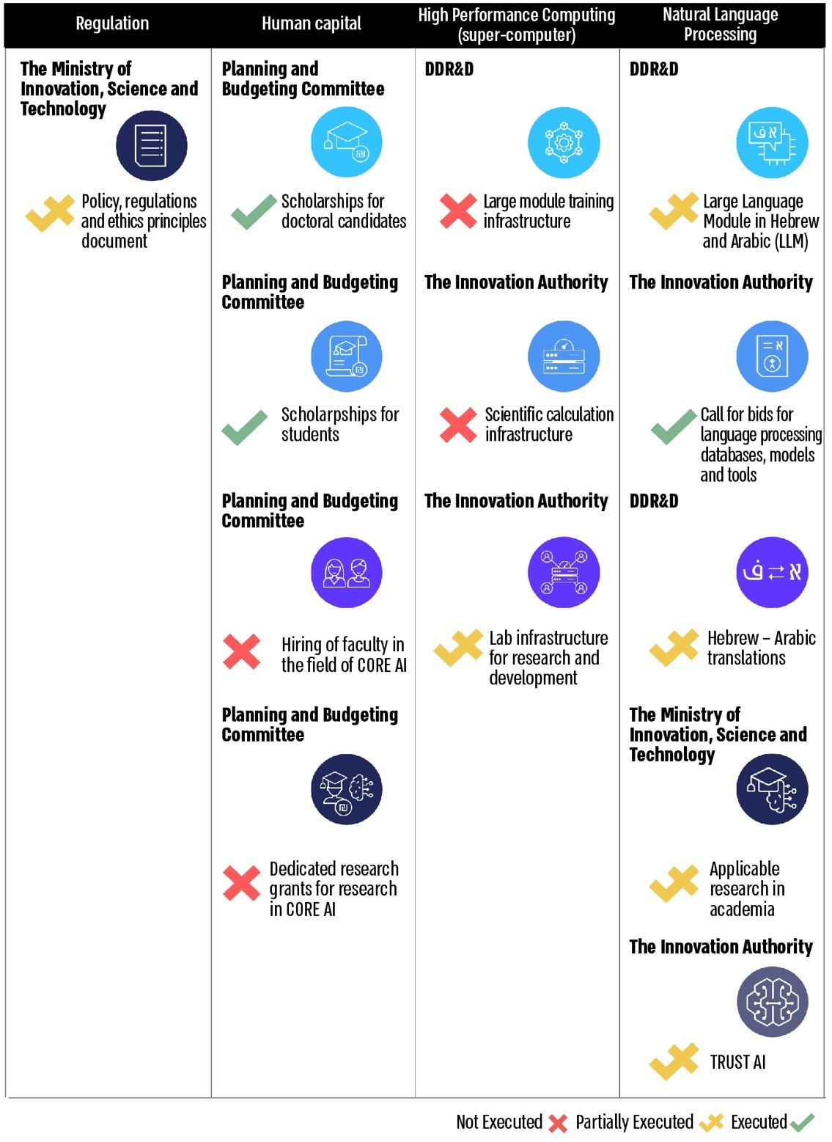

**The Budgetary and Substantial Development of the National Program for Artificial Intelligence**

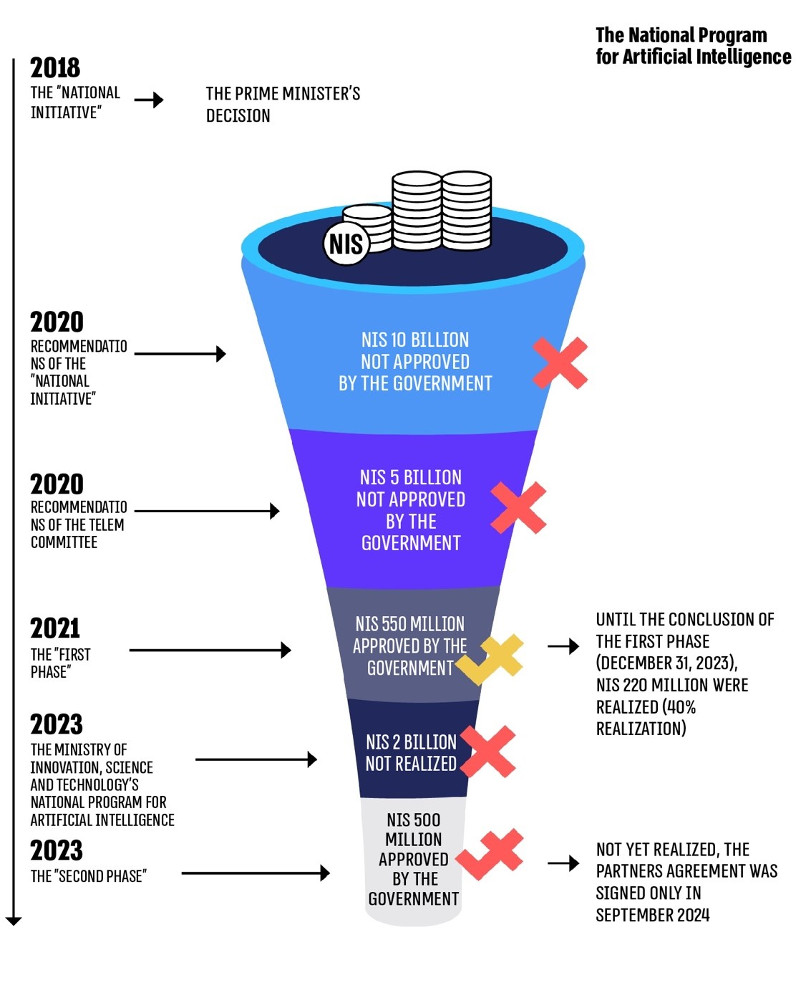



**Summary**

The scientific and technological leadership of the State of Israel is a fundamental pillar of its national security, economic resilience, and the well-being of its citizens. Israel’s leadership in these domains strategically compensates for its lack of natural resources and limited human capital compared to other nations. The artificial intelligence revolution has transitioned from a futuristic concept to a core innovative technology impacting numerous facets of contemporary life, serving as a central focal point for international competition across various fields, including science, economics, industry, security, health, education, and employment.

According to the report, while Israel recognized already in 2018 that the technological sector was on the brink of a significant revolution, and the Prime Minister acknowledged the necessity of preparing and implementing a comprehensive national plan on the subject, since that time, the government has failed to lead and implement strategies for approving a broad, long-term national plan and has not initiated its implementation, nor continuously supervised to ensure the necessary progress. Consequently, Israel's standing in the international arena has begun to erode.

Despite the Prime Minister's 2018 decision to establish the "National Initiative" and despite the Telem Committee, a professional review committee appointed to examine the acceleration required for the development of artificial intelligence, having determined in 2020 that a national program in artificial intelligence and data science is critical for the resilience of the State of Israel, there remains no national program approved and budgeted by the government as of 2024. In 2018-2023, two significant plans were developed to advance the field of artificial intelligence at the national level: "National Initiative" and the Telem Committee program; However, these initiatives have either been abandoned or progressed minimally. The audit indicated that the 2021 agreement between the head of the National Security Council and the then-Minister of Innovation that her ministry shall be given overall responsibility and powers for managing the national program and coordinating the government's actions, as supported by the government's resolution, has not been implemented. Furthermore, the National Program formulated by the Ministry of Innovation has not been advanced, and since the change in government in December 2022, the Ministry of Innovation has focused solely on specific areas.

Consequently, about six years after the Prime Minister's decision, and given the accelerated development of artificial intelligence technology globally, Israel lacks a comprehensive long-term national strategy, and the government has not approved a comprehensive and specific master plan for implementation. The government's endorsement of programs has been sporadic, slow implementation, and has not adhered to established timelines. Additionally, the government did not approve the principles of policy, regulation, and ethics regarding artificial intelligence developed by the Ministry of Innovation and the Ministry of Justice, leaving crucial elements unanchored in legislation or sectoral regulation.

It is evident that while the state identified and analyzed the need promptly, it has struggled for several years to make effective decisions corresponding to that need and to implement them accordingly.

To uphold Israel's technological and scientific superiority in artificial intelligence, deemed a national priority, the Ministry of Innovation should lead the government policy, aligning its actions with the government's previous resolutions and the agreement between the then-Minister and the National Security Council. This entails finalizing the national strategic program initiated in 2022, which should encompass a clear vision, milestones, a detailed action plan specifying governmental responsibility for each action direction, implementation timelines, and an aligned budget. Additionally, the Ministry should establish a framework for a periodic assessment of the program's compliance with the outlined objectives and an individual evaluation of the defined actions, including necessary updates. In this context, it must review, among other factors, the current administrative structure responsible for implementing the initiatives approved by government resolutions, which, as of the audit end date, operates voluntarily and without budgetary authority.

The Ministry of Innovation, Science, and Technology should fulfill its responsibility by upholding the government's resolutions. Strong leadership of a significant national program is essential for sustaining Israel's technological capabilities and relative advantage over other nations. Any deviation from the established implementation course necessitates a governmental update to assess the situation and respond accordingly to promote artificial intelligence initiatives further.

It is recommended that the Prime Minister, who initiated the move to advance the national program in artificial intelligence in 2018, monitor the progress of governmental actions in this regard through the National Security Council, guaranteeing the practical implementation of a significant national plan.

1. Breakthrough innovation that brings about a fundamental change and often threatens the existing one.
2. A voluntary action framework designed to coordinate and pool resources among all national bodies that may benefit from a large research infrastructure (the Directorate of Defense, Research, & Development (DDR&D), the Planning and Budgeting Committee, the Ministry of Finance, the Innovation Authority, and the Ministry of Innovation).