­­



Social Audit

**Promoting Gender Equality in Local Government**

State Comptroller of Israel | Local Government Audit Report | July 2024

Promoting Gender Equality in Local Government

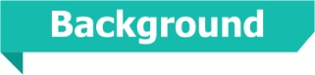

The principle of gender equality, which prohibits discrimination between women and men, is a cornerstone of the principle of equality recognized as a supreme principle in Israeli law when a violation thereof may be deemed a constitutional infringement on human dignity. The realization of this principle is closely tied to the democratic integrity of the local authority. Ensuring gender equality across all sectors, particularly in decision-making centers, is vital during national crisis and emergencies, as already existing gaps in positions of power between women and men may intensify in such times, when women might also face heightened risks to their personal security and employment conditions during such times. Local authorities, both as employers and as governmental athoritires, are responsible for promoting gender equality among their employees and integrating gender perspectives into decision-making processes affecting their residents. Under the law, local authorities' initiatives to promote gender equality must be accompanied by the Consultant for the Advancement of Women's Status within that authority (the Consultant). This Consultant, among other things, should be involved in shaping the local authority's policy, advocating for an assessment of the gender implications of its decisions, and gathering pertinent information and data relevant to her role.

Alongside the local authorities, governmental regulatory bodies are accountable for promoting gender equality in local government. This includes the Administration of Local Government within the Ministry of Interior, the Authority for the Advancement of the Status of Women[1], and the Equal Employment Opportunities Commission. Each of these bodies ensures local government bodies comply with legal obligations and effectively promote gender equality. The promotion of gender equality and the integration of gender perspectives hold significant importance regarding the local authority employees (intra-organizational aspects) and the residents of these local authorities (extra-organizational aspects). This report will mainly focus on the intra-organizational aspects.



|  |  |  |  |  |  |  |
| --- | --- | --- | --- | --- | --- | --- |
| **83 out  of 146** |  | **about 69%** |  | **about 20% only** |  | **about 45% only** |
| Israel's ranking in the global gender gap index in 2023, a drop of 23 places compared to 2022, which was 60th place (the country ranked 1st is the closest to achieving gender equality)[2] |  | the average monthly gross salary of female employees compared to male employees across all local government bodies in 2021 |  | women rate among elected officials in all local authorities (724 out of 3,647) following the 2024 local authority elections |  | municipal corporations rate with adequate representation of both male and female members, including elected officials, regarding Appointments made between January 2022 and June 2023 |
|  |  |  |  |  |  |  |
| **about 74%** |  | **about 26% only** |  | **24 out  of 257** |  | **about 80%** |
| the women rate employed by local authorities in 2020 (about 123,000 out of 166,000) |  | the women's rate in 2022 amongst senior officials in local authorities (379 out of 1,431) |  | the number of local authorities in September 2023 with no Consultant for the Advancement of Women's Status (about 9%)[3] |  | the rate of Women Consultants for the Advancement whose scope of role was not defined (148 out of 184), according to their responses to the questionnaires |
|  |  |  |  |  |  |  |



**Audit Actions**

From May to November 2023, the State Comptroller's Office audited the local authorities and governmental regulatory bodies' actions to promote gender equality and the integration of gender considerations in local government. The in-depth audit was conducted in the municipalities of **Beer Sheva**, **Beit Shemesh**, **Kfar Sava**, **Nahariya**, and **Rahat**, as well as in the **Gan Yavne** Local Authority and the **Gezer** Regional Council (the examined authorities). The audit was also conducted at the Administration of Local Government within the Ministry of Interior, the Authority for the Advancement of the Status of Women, the Equal Employment Opportunities Commission, and the Commissioner of Wages and Labor Agreements at the Ministry of Finance.

The in-depth examination included an assessment of the implementation of legal provisions by these local authorities regarding the gender pay gap among their employees, an analysis of the gender wage disparity and it's influencing factors conducted with the assistance of an external economic consultant, and an evaluation of the representation of both genders among elected officials, senior management, and members of municipal governing bodies. Additionally, the enforcement of legal provisions to promote gender equality within procurement and contracting procedures of local authorities, appointment procedures, employment terms, and the main functions of the Consultants for the Advancement of Women's Status within these authorities.

The audit also included questionnaires concerning implementing the Male and Female Workers Equal Pay Law, 1996, and the position and performance of the Consultant for the Advancement of Women's Status in local authorities, responded by 194 local authorities. Additionally, some findings were based on data collected from all local government bodies. The data analysis also included an evaluation of the distribution of audit findings according to various characteristics of local authorities, utilizing data from the Central Bureau of Statistics for the end of 2022 and the classifications of the local authorities according to data from the Ministry of Interior.



**Key Findings**



**The Normative Aspect –** it was found that the general and individual arrangements for promoting gender equality within local government bodies, which have evolved into legislation or regulatory instructions, exhibit limited scope compared to the corresponding arrangements in government ministries, government auxiliary units, and government companies. This limitation is mainly presented in the mechanisms for monitoring, supervision, and enforcement of the arrangements applied to local government bodies and in collecting and analyzing information and statistical data on gender distribution for conducting gender analysis of these budgets.

**Self-Assessment of the Gender Wage Gap –** Israel was ranked 83rd out of 146 countries in the global gender gap index in 2023, reflecting a drop of 23 places since 2022 (when the country ranked 60th) (the country ranked 1st is the closest to achieving gender equality). Israel's low ranking in the index can be attributed, in part, to its poor performance in the category assessing gender inequality within the economy, especially the gender wage gap. In 2022, the average monthly salary of female employees in local government bodies was about 69% of their male counterparts (gross salary before tax). Despite the evident gender pay disparities among the examined local authorities' employees, around 48% of authorities that responded to the questionnaire (92 out of 194), including **Rahat**, did not conduct internal assessments of gender pay gaps under the Equal Pay Law in 2021 and 2022. The audit further raised that most of the local authorities whose internal reports were examined (49 out of 60), including **Beer Sheva**, **Beit Shemesh**, **Nahariya**, and **Gan Yavne**, failed to fully implement the provisions of the law and the directives issued by the Equal Employment Opportunities Commission concerning internal report preparation. Furthermore, most did not adhere to the Commission's recommendations on how the internal report is edited and what data will be displayed.

**Monitoring the Fulfillment of Employers' Obligations Under the Equal Pay Law and Their Enforcement –** it was found that since the law has been applied to specific employers, including local government bodies, of the obligation to compile an internal report on the gender wage gap and since the publication of the Commission's instructions regarding the manner of compiling the internal report, the delivery of the notice to employees and the publication of the report based thereon, no systematic control has been carried out by the Equal Employment Opportunities Commission or by another regulatory body on the compliance with the provisions of the law and the instructions above. Additionally, no organized enforcement actions were undertaken against employers who did not meet their obligations in this regard, even though the audit found that about 48% of local authorities responding to the questionnaires (92 out of 194) did not prepare internal reports on gender pay disparity for 2021 and 2022, and among those that did prepare a report for 2022, about 23% (22 out of 97) failed to notify their employees of the gaps raised by their analyses for that year.

**The Gender Pay Gaps in the Examined Local Authorities –** the State Comptroller's Office analysis of the gender pay gaps, with the assistance of an external economic consultant, found a disparity in average gross salaries between male and female employees of about 24% (NIS 18.7 per hour) in **Beer Sheva**; Of about 20% (NIS 12 perhour) in **Beit Shemesh**; Of about 22% (NIS 14.9 per hour) in **Gezer**; Of about 42% (NIS 33.9 per hour) in **Gan Yavne**; Of about 23% (NIS 13.6 per hour) in **Nahariya**; Of about 14% (NIS 9.8 per hour) in **Kfar Sava**; And of about 38% (NIS 26.3 per hour) in **Rahat**. The analysis further raised that these disparities can be explained by phenomena that are not unique to local government, including the over-concentration of women in certain low-prestige, low-wage industries, as well as their underrepresentation in senior management positions (the component of the professional ranking and seniority level of the position). Additionally, salary variations correlate with occupational characteristics, such as compensation for on-call hours, overtime, additional work, or vehicle ownership.

**Additional Funding to Promote Adequate Representation Among Elected Officials –** analysis of data from the 2024 local authority elections raised that only 6% of local authorities (15 out of 257) were led by women. While there has been a modest increase in the rate of women leading local authorities, this figure remains low compared to other democratic nations. Furthermore, the representation of women among local authority council members was about 19% in municipalities and local authorities (493 out of 2,655) and about 23% in regional councils (231 out of 992). Overall, the rate of women among council members across all local authorities was about 20% (724 out of 3,647), compared to about 18% in 2018, 13% in 2013, and 11% in 2008. About one-third of the examined authorities (83 out of 238) had no women elected to serve on their council. Additionally, it should be noted that data from the results of the 2024 local authority elections and from electoral lists or parties deemed eligible for additional funding following the 2018 local authority elections indicate that the arrangement intended to promote adequate representation among elected officials in municipalities and local councils had a limited impact, with only about 23% of parties qualifying for additional funding.

Moreover, the initiative was minimally implemented in municipalities from the non-Jewish sector (about 2% of the local authority factions) and among those in a low socio-economic cluster (up to about 7% of the local authority factions in cluster 3, up to about 5% of the local authority factions in cluster 2, and none of the local authority factions in cluster 1). Furthermore, the arrangement was not executed in ultra-Orthodox municipalities, where representation for women is meager, necessitating proactive measures to enhance their representation. It was further found that the arrangement's effectiveness in promoting gender equality among elected officials may be limited in its impact over time within the council's term of office and its ability to ensure substantial rather than merely symbolic representation in the council's composition. This is particularly relevant when funding is allocated to electoral lists or the local authority factions with only one council member serving on their behalf (single-person electoral list). Additionally, deficiencies were raised in implementing the arrangement and receiving supplemental financing, as well as the types of local authorities in which it is executed.

 **The Management Structure of Local Authorities –** although women comprise about 74% of the employees in local authorities, only about 26% hold senior management positions. This low rate is especially noticeable in local authorities in low socio-economic clusters (about 10%), local authorities in peripheral areas (about 21%), non-Jewish local authorities (about 8%), and those in recovery or efficiency plans or those for which an accompanying accountant has been appointed (around 12%). Nearly one-third of local authorities (72 out of 252) lack representation of women at the senior management level, including **Rahat**, and a similar rate (67 local authorities) has only one woman in a senior management position; among them is **Nahariya**. Furthermore, about one-third of local authorities (79 out of 240) either completely lack representation of women among senior officials and elected officials or have only symbolic representation (up to 10%(.

**The Ministry of Interior's Efforts to Promote Gender Equality in the Local Authority's Management –** the audit raised that the Ministry of Interior did not implement the recommendations of the Committee for the Advancement of Women in Local Government from the 2018 and of the policy team it established on "Locating, recruiting, and promoting women to senior management positions in local authorities" from 2021. Additionally, it failed to instruct the local authorities to develop internal policies that foster equal representation of both men and women, particularly at the middle and senior management levels, including proactive scouting candidates for positions with significant underrepresentation. The Ministry of Interior has not formed guidelines for supervision on compliance with legal provisions, including reporting obligations for effective monitoring and control over the promotion of gender equality at both the middle and senior management levels within the local authority.

**The Governing Bodies of the Municipal Corporations –** the audit raised an interpretative issue regarding the duty of adequate representation among local authority representatives who are not council members. This pertains to implementing the legal mandate for adequate representation where there is a request to appoint women at more than half of the governing body's members, excluding elected officials. While the Legal Bureau at the Ministry of Interior sought guidance from the Counseling and Legislation Division of the Ministry of Justice on this matter, a definitive position had not been reached by the audit's end date due to the complexity of cross-cutting issues that need to be considered. The audit further found that equal representation is maintained among non-council members in most municipal corporations (about 65%). However, given that one-third of the members of the governing bodies are elected officials, and considering the low rate of women among these elected officials, the overall representation among all governing body members remains inadequate (about 45%). Analysis of gender distribution among governing bodies in municipal corporations affiliated with the examined authorities indicated adequate representation among non-council members for both sexes. Additionally, it was noted that in the **Economic Company for the Development of Kfar Saba Ltd. and the Rahat Economic Company Ltd.,** women are underrepresented among all governing body members, including council members. Conversely, in **Beit Yatziv B.S. Ltd.** (**Beer Sheva**), women are overrepresented among all governing body members, including council members.

**The Procurement and Contracting Procedures of the Local Authorities –** the audit raised that between January 2022 and June 2023, none of the examined local authorities required the implementation of the legal arrangement prioritizing businesses controlled by women. Furthermore, in **Beer Sheva**, **Beit Shemesh**, **Kfar Sava**, **Nahariya**, **Rahat**, and **Gan Yavne**, there were no submissions of bids for tenders accompanied by affidavits and confirmations regarding businesses controlled by women during the specified period. Moreover, local authorities do not systematically collect and manage statistical computerized data concerning the ownership characteristics of bidders or winners of the tenders they publish. Some authorities fail to track declarations regarding a woman-controlled business submitted to qualify for the priority established by law. Overall, local authorities do not monitor the impact of this legal arrangement on the number of bids submitted by woman-controlled businesses, the selection of such businesses as winners in tenders, or the extent of contracts awarded to them.

**The Collection and Publication of Statistical Gender-Distributed Data –** despite the importance of collecting and managing gender-distributed data – and even in the absence of a legal obligation to do so – the local authorities and governmental regulatory bodies do not prioritize the collection, pooling, and management of gender-distributed data, nor updating it, and they also do not publish it to the public on their websites. Furthermore, it was found that the examined local authorities possess raw data concerning recruitment and staffing procedures for senior positions and local procurement and contracting procedures that reference gender. However, they do not utilize, process, or analyze this information to gain insights into gender gaps across various areas of activity within the local authority.

**Gender Analysis of Local Authority Budgets –** the gender analysis of the budget, known as gender budgeting, represents a specific data collection and analysis focusing on gender distribution. It fundamentally assumes that the budget reflects policy and priorities, suggesting that incorporating gender perspectives in the budgeting process enables policymakers to allocate resources more intelligently to address the distinct needs of men and women.

* **The Obligation to Conduct a Gender Analysis of the Budget and the Resources Available to Local Authorities –** Starting in 2014, all government ministries and governmental auxiliary units should conduct a gender analysis of their budgets under Government Resolution 2084 in a scaled manner and according to a professional guide published to that end. However, as of the audit end in November 2022, this obligation has not been directly applied to local authorities, despite its additional significance within the monitoring and control framework the Consultants for the Advancement of Women's Status are responsible for. It was further found that Consultants for the Advancement of Women's Status lack adequate tools to conduct gender budget analysis, even though most of these Consultants acknowledge its importance.
* **Gender Analysis of the Budget Allocated by Local Authorities in Sports –** given the substantial financial support provided by local authorities in funds and money equivalents in sports (about 38% of all funds allocated by local authorities in 2022) and the notable gender gaps within it (about 23% of all active athletes in Israel were women in 2022[4]), the municipal budget allocation should be audited from a gender perspective. Some of the examined local authorities, including **Beer Sheva**, **Kfar Sava**, and **Gan Yavne**, have established affirmative action arrangements for women in their criteria for sports support grants. However, a review of the support committee minutes of these local authorities or the publication of the method of awarding the support on their websites does not reveal whether the impact of these arrangements on the gender distribution of support was evaluated. Conversely, **Beit Shemesh**, **Nahariya**, and **Gezer** have not implemented affirmative action arrangements or mechanisms to promote gender equality in their support allocations. Additionally, **Rahat** did not provide support in 2021–2022 and in any case, did not publish relevant criteria.

**The Appointment of the Consultant and her Professional Competence** **–** analysis of the data collected indicates that, on average, from 2015 to 2023, there was no Consultant in 20 out of 257 local authorities (about 8%). Furthermore, 13 local authorities did not have a Consultant for a cumulative period of four years within said timeframe. As of September 2023, it was found that 24 out of 257 local authorities (about 9%) had not appointed a Consultant, with 12 of these authorities lacking a Consultant for at least two consecutive years. In **Tamra** and **Nazareth**, **Iksal**, **Bosmat Tivon**, **Judeida-Makr**, **Deir Hanna**, **Tuba-Zangariyye**, **Mas'ade**, **Fassouta**, **Peki'in (Buqei'a)**, and **Zevulun**, no Consultant served as of September 2023 and in the preceding two years. **Kfar Qara** has not appointed a Consultant for the Advancement of Women's Status as of September 2023, and in the two years prior, two Consultants served alternating terms. Despite **Iksal**, **Deir Hanna**, and **Zevulun** failing to have a Consultant serve as required by law for periods ranging from four to nine years, and despite the Ministry of Interior's obligation to appoint a Consultant after having instructed a local authority to do so and it fails to comply, the audit raised that the Ministry has not fulfilled said obligation and did not encourage local authorities to fill vacant Consultant positions promptly. Additionally, while most of local authorities have staffed Consultant positions, the absence of a comprehensive operational framework concerning the position, scope, and nature of Consultants leads to variability in their activities across authorities, influenced by budget constraints, time resources, and the level of support from local authority management and its head.

**Remuneration for a Consultant Serving in an Additional Role in the Local Authority –** the remuneration to Consultants undertaking additional roles within local authorities is inconsistent and contingent upon their employment in other positions. For instance, while the gross monthly salary for a Consultant engaged in education, youth, society, and community is fixed at NIS 700, Consultants employed under personal contracts receive about 2.5% of the salary of senior officials, ranging from NIS 571 to 1,038 (as of November 2023), depending on the local authority's population scope. Additionally, it was noted that existing mechanisms for remuneration are insufficient and fail to provide for Consultants in specific roles or employment modes, resulting in some Consultants not receiving compensation for their additional responsibilities under their position as Consultants. Furthermore, although the obligation to appoint a Consultant for the Advancement of Women's Status applies to all local authorities, the remuneration arrangement for such Consultants serving in conjunction with other roles has not been used at authorities under-recovery or efficiency plans, mainly when these Consultants are employed under personal contracts.

**The Scope of the Consultant's Position –** the law stipulates that the scope of the position of a Consultant for the Advancement of Women's Status should be determined based on variables such as the local authority's population and number of communities under the local authority, as these are the main variables affecting the scope of a Consultant's work. However, no minimum position scope has been established, not even in the Ministry of Interior's Director General circulars. Responses to questionnaires raised that about 80% of the responding Consultants (148 out of 184) did not have their position scope defined. Furthermore, most respondents (169 out of 184) indicated that they fulfill additional roles within the local authority, with roughly 36% (61 out of 169) serving as department or division managers within the local authority. This raises concerns regarding the Consultant's capacity to allocate sufficient time to her responsibilities and fully realize the potential in the role.



**Education and Informational Initiatives to Promote Gender Equality Among Elected Officials –** in 2018 and 2023, in preparation for local authority elections, the Authority for the Advancement of the Status of Women implemented educational and informational activities to raise awareness of the underrepresentation of women in decision-making positions. Additionally, in 2023, a program was initiated to promote and train women for leadership roles in the public sphere.

**The Ministry of Interior Advancing Gender Equality in Management –** the Ministry of Interior has established an indicator of the representation rate of both genders among statutory positions as part of the human capital index. This index ranks local authorities based on their performance in the human capital sector, and on its basis, they are delegated powers in this area. Furthermore, the Ministry began collecting data on the rate of women in senior positions.

**Follow-up and Supervising the Fulfillment of Adequate Representation in the Governing Bodies of Municipal Corporations** **–** the committee responsible for evaluating the competence and suitability of candidates for office on behalf of local authorities in the governing body in the municipal corporation maintains a comprehensive and meticulous record of the composition of the governing body within the municipal corporation, categorized by gender, to facilitate the monitoring of adequate representation for members of both sexes, as of the decision date.

**Indicators for Assessing Gender Equality**

* In recent years, the Consultant for the Advancement of Women's Status in **Kfar Sava** has developed an urban gender index for the municipality. This index illustrates gender disparities in both intra-organizational aspects related to local authority employees, including the representation of women in decision-making positions, and extra-organizational factors affecting the residents of the local authority, particularly in the domains of education, leisure, and the labor market.
* During the audit, the Central Bureau of Statistics (CBS), in collaboration with the Authority for the Advancement of the Status of Women, created a system of indicators that reflects gender distribution and gaps at the local authority level across various life aspects. These include the labor market, education, welfare, health, leisure, housing, demographics, and transportation, alongside factors related to resilience and public engagement. These indicators may also be integrated into the CBS's periodic publications on local authorities, serving multiple purposes such as examining the gender implications of authorities' decisions in diverse operational areas, providing a comparative tool for analyzing gender inequality within authorities or their effectiveness in bridging gender gaps and serving as a decision-support mechanism for regulatory bodies concerning decentralization of powers and budgeting.

**Gender Analysis of Local Authority Budgets in Sports –** in 2015, **Bat Yam** and **Mate Asher**, guided by Consultants for the Advancement of Women's Status and supported by a private organization, undertook a gender analysis of their sports budgets.



**Key Recommendations**

All local authorities, including **Rahat**, must prepare an annual internal report on the gender wage gap among their employees under the legal mandates and the Commission's guidelines. All local authorities, including **Beer Sheva**, **Beit Shemesh**, **Nahariya**, and **Gan Yavne**, should prepare their internal report under the law's provisions and the Commission's binding instructions.

The Equal Employment Opportunities Commission, in consultation with relevant regulatory bodies, including the Ministry of Interior and the Authority for the Advancement of the Status of Women, as well as the Commissioner of Wages and Labor Agreements at the Ministry of Finance, should develop a structured outline for monitoring and enforcing compliance with the Equal Pay Law. This outline should clarify the responsibilities for control and enforcement. Furthermore, the outline should incorporate plans for informational and training initiatives to enhance local authorities' awareness of their legal obligations.

Given initial findings from the State Comptroller's Office analysis, it is recommended that **Beer Sheva**, **Beit Shemesh**, **Kfar Sava**, **Nahariya**, **Rahat**, **Gan Yavne**, and **Gezer** conduct a thorough investigation on the gender wage gap among their employees and its underlying causes. Based on the subsequent findings, a multi-year action plan should be developed by each authority to address and reduce wage disparities, with a gradual implementation of necessary changes.

The Ministry of Interior, in collaboration with the Authority for the Advancement of the Status of Women, should form a framework assessing the effectiveness of the arrangement stipulating additional funding for electoral lists and fractions in local authority elections on the representation of women and for evaluating its contribution to promoting adequate representation in the composition of the local authorities' plenums, also based on the outcomes of the 2024 local authority elections and in preparation of the future electoral campaign. Given the potential challenges in verifying the effectiveness of the current arrangement, alongside the partial findings indicating limited improvements in women's representation among elected officials (about 13% in 2013, 18% in 2018, and 20% in 2024), it is recommended that the Ministry, in collaboration with the Authority for the Advancement of the Status of Women, consider modifications or alternative arrangements that are not contingent on general eligibility for state funding.

All local authorities, including **Beer Sheva**, **Beit Shemesh**, **Nahariya**, **Rahat**, and **Gan Yavne**, should enhance gender diversity among senior decision-makers and promote women's involvement in policymaking and decision-making processes. These local authorities' initiatives should be based on coherent and implementable policies according to their unique characteristics and the gender composition of their employees regarding the rate of women among all employees of the local authority and the rate of women at the senior level.

The Ministry of Interior should collaborate with other governmental regulatory bodies to advance gender equality and reduce gaps in local authority management, particularly in those authorities not ranked in the human capital index. This outline should include comprehensive mechanisms for monitoring and supervision, as applicable, ensuring the effectiveness of these initiatives – by the Ministry of Interior and the local authorities – in promoting gender equality.

The Counseling and Legislation Division at the Ministry of Justice should finalize its stance on implementing the legal mandate for adequate representation while assessing, together with the Ministry of Interior, the need to amend existing arrangements to ensure gender equality within the governing bodies of municipal corporations – including the bodies on whom the obligation for adequate representation has been imposed. This is essential considering the prevalence of municipal corporations lacking equal representation within their governing bodies, including about 45% of council members. In formulating this position and examining the need for amending the existing arrangement, it is recommended that the Counseling and Legislation Division and the Ministry of Interior emphasize that evaluations of adequate representation should be conducted on an individual municipal corporation basis rather than collectively for all the corporations associated the local authority on behalf of which the appointment is requested. **Beer Sheva**, **Kfar Sava**, and **Rahat** should ensure adequate representation of both genders within the governing bodies of their affiliated municipal corporations.

The Ministry of Interior should collaborate with the Agency for Small and Medium Enterprises and the Authority for the Advancement of the Status of Women to evaluate the necessity of supplementary measures to foster gender equality in local contracting and procurement procedures, addressing the unique challenges faced by women-controlled businesses. It is further recommended that the Ministry of Interior set a clear target for the participation and winning of women-controlled companies in local government contracting and procurement procedures, considering both the rate of businesses and the financial scale of the contracts. Additionally, the Ministry of Interior should control and monitor these arrangements' effectiveness in achieving established goals, including a systematic approach to data collection and their public dissemination.

**Beer Sheva**, **Beit Shemesh**, **Kfar Sava**, **Nahariya**, **Rahat**, **Gan Yavne**, **Gezer**, and other governmental regulatory bodies should prioritize collecting and managing statistical data categorized by gender. They must ensure that their information systems facilitate the efficient collection and maintenance of this data, keeping it current. The Authority for the Advancement of the Status of Women, in consultation with relevant regulatory entities, should anchor in guidelines the scope of obligations applicable to the collection and management of statistics in a gender distribution – regarding the obligations of the various bodies and their commitment to promoting gender equality, as well as anchoring uniform or alternative compliance methods with this requirement.

The Ministry of Interior and the Authority for the Advancement of the Status of Women should initiate a pilot program in select local authorities to conduct a gender analysis of their budgets. Based on the outcomes of this pilot, the necessity of issuing guidelines on the matter should be evaluated. It is further recommended that the Authority for the Advancement of the Status of Women collaborate with the Ministry of Interior to provide local authority officials, including treasurers, HR managers, and the Consultants for the Advancement of Women's Status, with professional tools, adequate resources, dedicated budgets, and appropriate access to data and information for effective gender budget analysis. **Beer Sheva**, **Beit Shemesh**, **Kfar Sava**, **Nahariya**, **Gan Yavne**, **Gezer**, and **Rahat** (pending future subsidy offerings) should assess the impact of sports subsidy eligibility tests on the gender distribution of financed subsidies across different beneficiaries and sports categories annually – and accordingly, the need to establish an arrangement to promote gender equality or to update the existing arrangement. Furthermore, the Ministry of Interior should instruct all local authorities to review and publish the gender distribution of the financial support granted to public institutions in their jurisdiction after each budget year.

All local authorities should consistently staff the Consultant position mandated by law to promote relevant issues within their areas of responsibility effectively. **Tamra**, **Kfar Qara**, **Nazareth**, **Iksal**, **Bosmat Tivon**, **Judeida-Makr**, **Deir Hanna**, **Tuba-Zangariyye**, **Mas'ade**, **Fassouta**, **Peki'in (Buqei'a)**, and **Zevulun**, should appoint a Consultant as required by law and secure a budgetary source for this position. The Minister of Interior should ensure that **Iksal**, **Deir Hanna**, and **Zevulun**, who have not appointed a legally required Consultant for four to nine years, promptly appoint one. In cases where an appointment has not been made despite the Minister's directive, He should nominate a consultant under the mechanism prescribed by law. Moreover, the Ministry of Interior should explore alternative, less stringent measures to encourage local authorities to staff the Consultant position as soon as possible after its vacancy. Furthermore, the Ministry should collaborate with the Authority for the Advancement of the Status of Women to formulate the roles according to the Ministry's description of the Consultant's position, ensuring they encompass all aspects relevant to fulfilling the role.

The Ministry of Interior should set the minimum employment scope in guidelines or in the Director General's Circular, necessitating the hiring of consultants to advance women's status, considering the population size and the number of jurisdictions within each local authority. It is further recommended that the Ministry consider instructing the local authorities in the event they decide to appoint the Consultant from among existing municipal staff, including the time needed to carry out the tasks involved in fulfilling the Consultant's position alongside the other positions, as well as the nature of the different position and the commitment involved towards the employees of the local authority and potential conflicts of interest that may hinder full performance in both positions fully and optimally. The Ministry and the Authority for the Advancement of the Status of Women must delineate the distribution of responsibilities between themselves concerning the guidance of local authorities on the employment conditions of Consultants and supervision of compliance to said guidance.

It is recommended that the Commissioner of Wages work with the Ministry of Interior and the Authority for the Advancement of the Status of Women to ensure that remunerations for Consultants for the Advancement of Women's Status are provided under legal entitlements, irrespective of their employment arrangements. The remuneration should appropriately reflect the additional responsibilities inherent in their consultant roles. Additionally, the Commissioner should evaluate whether existing mechanisms for regulating the Consultants' remuneration adequately meet all forms of Consultant employment in local authorities.

**The Disparities Between Men and Women in Selected Indicators on Welfare, Education, Wages, and Employment in the Examined Local Authorities, as of the Audit End\***

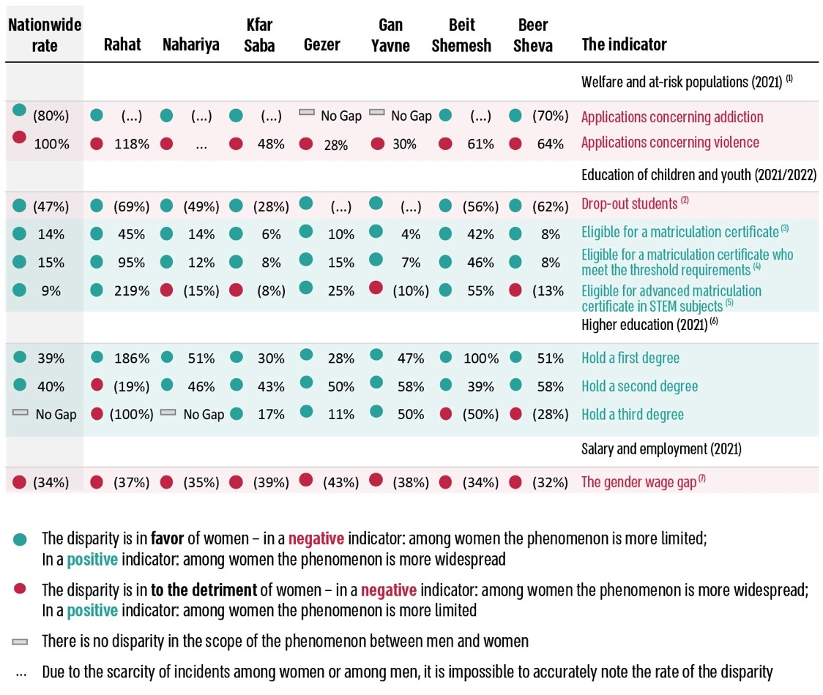

According to the CBS data processed by the Office of the State Comptroller.

* The indicators pertain to issues that significantly affect gender equality. The gap is determined as the difference (indicated in parenthesis as a negative value) between men and women regarding the extent of the examined phenomenon as a proportion of the phenomenon's extent among men.

(1) Applications based on addiction or violence – individuals registered in the local authority's Social Services Department as requiring treatment for addiction or violence-related issues.

(2) School dropouts – the rate of 7th to 12th graders who have dropped out of school, based on the local authority of residence.

(3) Eligible for a matriculation certificate – students who have passed internal matriculation exams and accumulated a minimum of 20 study units in the requisite subjects. This rate is computed from the total number of 12th-grade students.

(4) Eligible for a matriculation certificate who meet the threshold requirements – the rate of students eligible for a matriculation certificate who meet university threshold requirements out of all 12th-grade students.

(5) Advanced matriculation certificate in STEM subjects – the STEM subjects encompass mathematics, physics, chemistry, computer studies, biology, electronics, electronic systems, and biotechnology.

(6) Holders of a first, second, or third degree – an academic degree conferred by a higher education institution. A bachelor's degree is awarded for studies to develop foundational academic skills; a master's degree is conferred for studies designed to enhance advanced academic skills; a PhD is granted for research-oriented studies.

(7) The gender wage gap – disparities concerning wage differences between men and women, specifically the average income of women compared to that of men. The gap is calculated as the rate of difference between the average income of men and women.

**Women Rate Among Senior Officials in Local Authorities, According to Certain Characteristics\***

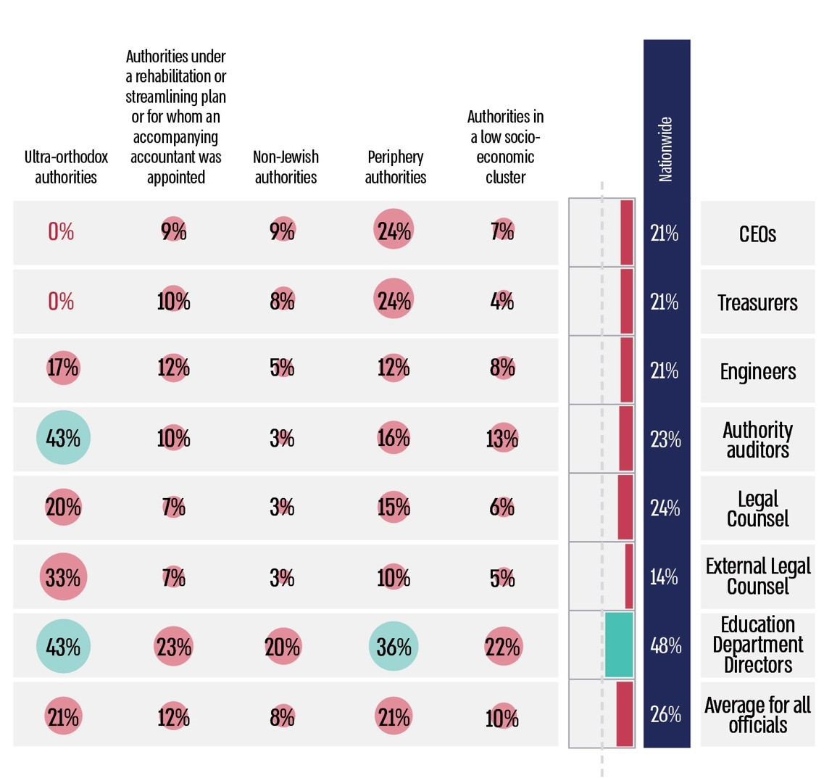

According to data submitted by the local authorities to the Ministry of Interior for their ranking in the Human Capital Index for 2023, the Ministry of Interior's data on the classification of the authorities as known as of the audit end date, and the CBS data for 2022, processed by the Office of the State Comptroller.

* The color represents the percentage of women among senior officials. The red cells represent a representation rate up to 33% (inclusive), and the cells in green represent a representation rate above 33%.

**Quotes from the Answers to the Questionnaires of the Consultants for the Advancement of Women's Status Regarding the Conditions of Their Employment and Their Responsibilities\***







**Summary**

The audit findings highlight the significant gender wage gaps still found among local government employees, with female employees earning an average of about 69% of their male counterparts' salaries. Additionally, women represent about 20% of elected officials and 26% of senior officials within local authorities. These disparities are significant among the local government workforce, where women comprise around 74% of employees, exceeding the general female population rate of about 50%. The gaps are even more severe in local authorities in low socio-economic clusters, as well as in peripheral, non-Jewish, and ultra-orthodox authorities, particularly those lacking strength or stability.

Given the above and Israel's ranking in the global gender gap index (ranked 83rd out of 146 countries, with the top-ranked country being the closest to gender equality), the urgency for proactive measures to enhance gender equality and minimize gender disparities within these bodies is paramount.

It is recommended that local government bodies, including local authorities, formulate a strategic plan to reduce gender disparities among their workforce, from which work plans should be derived, incorporating measurable goals and established timelines for implementation, all with the involvement and leadership of the Consultants for the Advancement of Women's Status serving in these institutions. To optimize the effectiveness of these Consultants, it is crucial for the Ministry of Interior, in collaboration with the Authority for the Advancement of the Status of Women and the Union of Counselors, to finalize the definition of the Consultants' roles and ensure that prerequisites for optimally fulfilling their duties are adequately met.

Moreover, to secure the commitment of local authorities to the promotion of gender equality and recognize the critical link between ensuring equal representation in decision-making centers and the democratic integrity of local authorities and the quality of their decision-making processes, it is recommended that the regulatory bodies collaborate to establish national goals reducing gender gaps and to formulate a structured and systematic action plan to supervise compliance with these objectives.

1. The Ministry for the Advancement of the Status of Women was established pursuant to Government Resolution No. 433 (April 2, 2023), which also mandated the transfer of the responsibilities for the advancement of women's status, including those of the Authority for the Advancement of the Status of Women, from the Ministry for Social Equality to this newly established ministry. Subsequently, in Government Resolution No. 1316 (January 21, 2024), Resolution No. 433 was rescinded, and the responsibilities for advancing women's status were returned to the Ministry for Social Equality, which was renamed the "Ministry for Social Equality and Advancement of the Status of Women".
2. The index ranks countries based on their proximity to achieving gender equality rather than the current state of gender equality.
3. The examination did not include the Sha'ar Shomron and Tzur Hadassah local councils.
4. The definition of "active athlete" refers to participation in a minimal number of competitions and an upper threshold of birth year, which is determined depending on the sport.