­­



The Urban Space

**Addressing Noise   
Nuisances in the Urban Space**

State Comptroller of Israel | Local Government Audit Report | July 2024

Addressing Noise Nuisances in the Urban Space



Usually, the source of the noise nuisance is human activity, which is affected by the number of people in the space and the types of noise. The risk of noise nuisance lies in the fact that it is an integral part of daily life and in the fact that awareness of the damage caused by it is low. According to the European Union, noise nuisances represent the second most significant environmental risk to public health, following air pollution. The Abatement of Nuisances Law, 1961, prohibits the generation of "loud noise" or "unreasonable noise," as defined in the Abatement of Nuisances Regulations (Unreasonable Noise), 1990. In Israel, the Ministry of Environmental Protection, the Israel Police, and local authorities are responsible for noise nuisances. Local authorities are empowered to prevent and manage noise nuisances within their jurisdictions using various tools and mechanisms, including the Committee for Environmental Protection, environmental units supported by the Ministry, enactment of municipal by-laws, stipulating conditions for business licenses, and the municipal enforcement mechanism.



|  |  |  |  |  |  |  |
| --- | --- | --- | --- | --- | --- | --- |
| **400** |  | **about 12,000** |  | **about 657,000** |  | **about 15%** |
| estimated deaths per year in Israel due to indirect harm by noise nuisances – according to the Ministry of Environmental Protection calculation |  | premature deaths every year in EU countries due to the adverse effects of noise nuisances |  | inquiries to the Israel Police on noise in January 2021 – June 2023. The second most common issue of inquiries to the police after traffic offenses |  | of the inquiries to the Israel Police on noise, which ended in a fine in 2022 (about 35,000 fines) |
|  |  |  |  |  |  |  |
| **about 61%** |  | **38–44** |  | **18** |  | **40%–44% only** |
| about 94,000 inquiries on noise out of all inquiries on environmental issues, about 154,00 to **Netanya**, **Afula**, **Petah Tikvah**, and **Safed** hotlines in 2019–2023 |  | average monthly fines for noise violations imposed by **Netanya** and **Petah Tikvah** in 2019–2023. The cumulative sum imposed by **Netanya** in these years for noise violations was about NIS 1.9 million |  | local authorities (out of 259) with no environmental unit to deal with environmental protection and are not members of the Association of Cities for Environmental Protection or a regional cluster |  | the utilization rate of the Ministry's support in the environmental units in **Afula** and **Petah** **Tikvah** in 2017–2023; **Safed** did not receive the Ministry's support because it does not have an environmental unit |



**Audit Actions**

From May to September 2023, the State Comptroller's Office audited local authorities handling noise nuisances and reducing their recurrence within their jurisdictions from 2019 to 2023[1]. The audit was conducted at four municipalities: **Netanya**, **Afula**, **Petah** **Tikvah**, and **Safed** (the audited local authorities). Completion examinations were also performed at the Ministry of Environmental Protection and the Israel Police. Among other things, the officials in the authorities responsible for dealing with noise hazards were examined; this includes examining the use of the budget and their relations with the public, the relevant by-laws for addressing noise, and the authorities' supervision and enforcement to mitigate noise nuisances and prevent their recurrence. A spatial analysis was conducted regarding residents' inquiries at the municipal hotlines on noise nuisances. Data collected from municipal hotlines were mapped utilizing geographic information software (GIS) to identify distribution patterns and prevalent types of nuisances in the urban environment. Furthermore, an analysis of inquiries to audited municipal hotlines was done using open text analysis software (OTC) to highlight the main noise nuisance types reported by residents to municipal hotlines.



**Key Findings**



**Obligation to Map Noise Nuisances in EU Countries –** the EU directive mandates the surveyed EU states to map noise nuisances, prepare action plans for their mitigation, and submit a report every five years detailing the extent of resident exposure to main sources of noise. Conversely, Israel does not have a similar obligation to map noise nuisances, and local authorities are not required to develop action plans for their mitigation.

**The Ministry of Environmental Protection's Policy for Addressing Noise Nuisances** **–** the Ministry does not have a formal policy reducing exposure to noise nuisances, aside from the "Quiet Cities" initiative[2]. Furthermore, the Ministry has not mapped noise nuisances or established a comprehensive national, district, and local database.

**Bodies Responsible for Addressing Noise Nuisances –** the State Comptroller's Office report and analysis raised incidents with a complex legal framework where multiple parties are responsible for addressing noise nuisances, including the Israel Police, local authorities, the Ministry of Environmental Protection, and the courts. An examination of the Ministry of Environmental Protection's website raised the lack of guidance on whom to contact in situations of overlapping responsibilities or how to initiate an inquiry with these bodies.

**Prevalence of Noise Nuisances and Enforcement by the Israel Police –** it was found that inquiries regarding noise making were the second most common issue of calls to the police in 2021–2023, with about 657,000 inquiries. For instance, in 2023, the average monthly calls to the police's hotline regarding noise nuisances were about 16,500. In 2021–2022, there was a recorded decrease of about 15% in inquiries related to noise nuisances, from about 274,700 to about 233,300 inquiries. Correspondingly, law enforcement data indicated a reduction of about 16% in the fines rate issued for noise offenses during the same timeframe.

**Mapping of Noise Nuisances in the Audited Local Authorities – Netanya**, **Afula**, **Petah Tikvah**, and **Safed** had not conducted spatial mapping of noise nuisances within their jurisdictions, nor had they utilized any learned insights to address these nuisances. The State Comptroller's Office Spatial analysis raised that the above mapping, particularly in **Afula** and **Petah Tikvah**, may assists in identifying areas significantly affected by noise nuisances and the predominant types of nuisances. Such data may enable the local authorities to allocate resources effectively and efficiently to address the most pressing noise issues affecting residents.

**Frequency of Noise Inquiries in the Audited Local Authorities –** the frequency of noise inquiries relative to all environmental inquiries is notably high in **Netanya**, about 99% (54,537 inquiries about noise out of 55,365 total environmental inquiries), and **Afula**, about 87% (6,188 noise inquiries out of 7,076 total environmental inquiries). In **Safed**, the noise inquiries rate is about 47% (753 inquiries about noise out of 1,604 total environmental inquiries), while in **Petah Tikvah**, it is about 36% (32,506 noise inquiries out of 89,539 total inquiries). This data indicates that noise nuisances represent a significant nuisance for residents in several of the audited authorities, corroborated by complaints from the police hotline. Examples of specific inquiries include **Netanya** – noise from air conditioning units in businesses, renovation and construction noise, loud music, and domestic alarm noise; **Afula** – noise from karaoke, noise from children and teenagers on the streets, and noise from car wash operations; **Petah Tikvah** – noise from landscaping equipment, loud music from apartments, and street disturbances caused by teenagers; **Safed** – noise from bed-and-breakfast establishments, noise from public spaces, and noise from music in adjacent apartments.

**Analysis of Data on Residents' Noise Complaints to the Audited Municipal Hotlines –** the State Comptroller's Office analysis of complaint data raised that in **Petah Tikvah**, the predominant noise-related issues included disturbances occurring beyond permitted hours when in numerous instances, the responding body arrived after the noise had ceased (4,437 inquiries). Moreover, a high rate of repeated inquiries about noise was noted in the **Netanya**, about 55%. In **Afula**, the main noise sources were identified as karaoke and disturbances caused by teenagers, with 333 inquiries indicating that the responding body did not arrive until after the noise had ended. Conversely, in Safed, no standard response time for noise complaints has been established, and about 64% of cases lack classification of the noise type. The analysis of inquiries indicates that established response times may be excessively lengthy for addressing noise disturbances and that there may be a shortage of resources to deal with the hazard when it occurs and prevent it in the future. Furthermore, the audited authorities have not conducted thorough analyses of residents' inquiries and merely handled the inquiries.

**The Environmental Protection Committees in the Audited Authorities –** **Safed** has not established a mandatory environmental protection committee as stipulated by the Municipalities Ordinance. From January 2019 to June 2023, the environmental protection committees in **Netanya**, **Afula**, and **Petah Tikvah** failed to convene quarterly as required. In **Netanya**, the average attendance of council members at committee meetings from March 2019 to August 2023 was three members, while in **Afula**, participation was reduced to one council member over the period from March 2019 to March 2023, with the committee chairman attending as the sole representative in 11 of the 14 meetings. **Petah Tikvah** had an average participation of less than two council members at each committee meeting from December 2019 to April 2023.

**The Accreditation of Environmental Inspectors in the Audited Local Authorities –** **Petah Tikvah** has accredited only one environmental inspector, while **Afula** and **Safed** have not accredited any inspectors. This undermines the local authorities' capacity to enforce laws and regulations concerning noise offenses within their jurisdictions.

**Utilization of the Ministry of Environmental Protection's Support in the Framework of Calls for Proposals –** it was found that **Safed** had not established an environmental unit, thereby precluding it from accessing the financial resources available through the Ministry's calls for proposals. The environmental units in **Afula** and **Petah Tikvah** similarly failed to fully utilize the approved funding from the Ministry of Environmental Protection, achieving only about 40% (about NIS 767,000 out of roughly NIS 1.9 million) in **Afula** and about 44% (about NIS 1.34 million out of NIS 3.03 million) in **Petah Tikvah** between 2017 and 2023. Better utilization of these supports could have enabled the municipalities to address urban environmental nuisances, particularly noise.

**Noise Nuisances By-laws and Their Enforcement in the Audited Authorities –** as of the audit end date, **Afula** has not enacted a by-law on noise nuisances. **Safed** had passed a by-law but was updating it, while the **Netanya** and **Petah Tikvah** had established noise nuisance by-laws. However, **Petah Tikvah** and **Safed** did not include their by-laws in the Municipalities Order, nullifying the enforcement of related fines (though **Petah Tikvah** still imposes fines under other by-laws). A notable disparity was found between the reporting of noise violations in **Netanya** and Petah Tikva, averaging 38 to 44 monthly reports, and the complete lack of reports in **Afula** and Safed. The cumulative fines imposed by municipal inspectors in **Netanya** from 2019 to 2023 were NIS 1,932,310, averaging about NIS 386,500 annually. Consequently, **Afula** and **Safed** have not effectively monitored and issued fines, compromising their ability to provide quality service to residents.

**Proactive Enforcement by Environmental Units in the Audited Authorities –** it was noted that **Petah Tikvah**'s environmental unit did not engage in proactive initiatives concerning noise nuisances in 2019 and 2021, instead it focused on routine tasks, such as addressing resident complaints and reviewing business licenses and outline plans. In the second half of 2020, the unit conducted 20 monthly inspections of pubs, event halls, and businesses, ultimately reporting "100 inspections". Additionally, in 2022, the environmental unit conducted 28 patrols in noise-prone areas, especially during evening and nighttime hours, including an inspection on August 1, 2022, of several lofts alleged to pose safety risks and cause noise disturbances. Conversely, **Netanya** and **Afula**'s environmental units did not proactively address noise nuisances.



**The Afula's Environmental Protection Committee Activity –** the State Comptroller's Office commends **Afula**'s Environmental Protection Committee for proactively addressing noise nuisances within its deliberations.

**Implementation of Innovative Measures to Reduce Noise Nuisances in Petah Tikvah –** the State Comptroller's Office commends **Petah Tikvah** for its initiative to implement innovative measures, such as the installation of noise detectors at two road intersections, to gather data on illegal vehicle horn usage. Thus, mitigating vehicle noise, including unauthorized siren use, contributes to a quieter and less harmful urban environment.

**Accreditation of Environmental Inspectors Under Local Authorities Law (Environmental Enforcement** **– Inspectors Powers), 2008 –** the State Comptroller's Office commends **Netanya** for its accreditation of 15 inspectors to enforce environmental legislation, thus enhancing its capacity to enforce environmental regulations, particularly in noise nuisances.



**Key Recommendations**

It is recommended that the audited authorities utilize information received from inquiries to the municipal hotline. They should analyze this data to classify noise nuisances, identify the reasons for their increase, and pinpoint areas with a high scope of inquiries. Thus, efficiently and effectively address noise nuisances within their jurisdiction. Furthermore, they should conduct spatial analyses of all content from residents' calls regarding noise nuisances to identify prominent disturbances that affect residents, thereby focusing their efforts and optimizing their responses.

Due to the significance of noise nuisances and their wide-ranging impact on the public, the State Comptroller's Office recommends that the Ministry of Environmental Protection develop a written policy to reduce exposure to noise nuisances. Its implementation can be examined by setting measurable goals.

To clarify the appropriate body for handling inquiries about noise nuisances, it is recommended that the Ministry of Environmental Protection establish definitive responsibilities for the police and local authorities.

Collaboration between the Ministry of Environmental Protection and the Israel Police is recommended to systematically address noise nuisances based on an analysis identifying prevalent and recurring issues.

**Safed** should establish an environmental protection committee as mandated by the Municipalities Ordinance, enabling it to play a central role in planning and initiating environmental protection activities. **Netanya**, **Afula**, and **Petah Tikvah** should convene the environmental protection committee under the mandated scheduling stated in the Municipalities Ordinance.

**Afula** and **Safed** should accredit environmental inspectors to enhance enforcement of laws and regulations about environmental nuisances, particularly noise offenses, within their jurisdictions. Additionally, **Petah Tikvah** should consider accrediting additional environmental inspectors to bolster noise nuisance enforcement.

Upon establishing an environmental unit, **Safed** should utilize its financial resources through the calls for proposals regarding environmental units published by the Ministry of Environmental Protection, ensuring effective management of environmental nuisances, especially noise. The environmental units in **Afula** and **Petah Tikvah** should maximize their financial resource utilization within the framework of these calls for proposals, enhancing their capacity to address noise nuisances.

**Afula** should implement municipal by-laws to manage noise nuisances and impose fines to facilitate enforcement. Similarly, **Petah Tikvah** and **Safed** should consider the imposition of fines under their respective by-laws concerning noise nuisances and incorporate relevant laws into the Municipalities' Order. Furthermore, **Netanya**, **Afula**, **Petah Tikvah**, and **Safed** should monitor noise nuisance enforcement within their jurisdictions, utilizing all available means to uphold enforcement of noise-related laws, including the development of by-laws and schedules updates. Fines should be issued and collected, where feasible, to help maintain service quality for residents.

The environmental units of **Netanya** and **Afula** should address noise nuisances within their jurisdictions and incorporate these initiatives into their work plans.

**Noise Damage Index (in decibels**[3]**)**

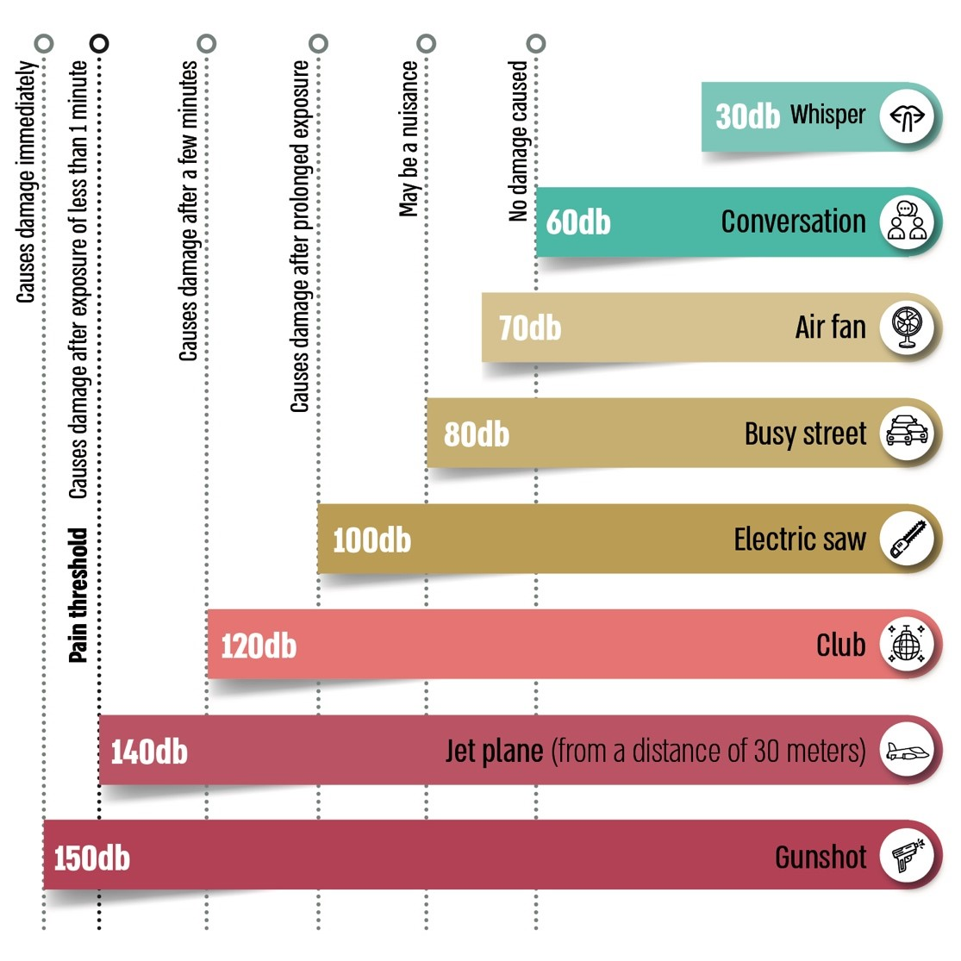

According to the Ministry of Environmental Protection website data, processed by the Office of the State Comptroller.

**Rate of Calls to Municipal Hot-lines on Noise Out of All Inquiries on Environmental Issues 2019–2023**



According to data from the municipalities of Netanya, Petah Tikvah, Afula and Safed, processed by the Office of the State Comptroller.

* In Netanya, the data regarding inquiries concerning environmental protection are until December 2023. Regarding the data concerning inquiries about noise, data was received until June 2023, and an estimate was made for the second part of 2023. Data was received from Petah Tikvah until June 2023, in Afula – until December 2023, and in Safed until December 2022.



**Summary**

Noise is a prevalent environmental nuisance in urban areas, with adverse health effects on the public, including sleep disorders and cardiovascular diseases. The Ministry of Environmental Protection, the Israel Police, and local authorities are responsible for addressing noise nuisances in Israel. Analysis of resident inquiries directed to the Israel Police and municipal hotlines in the audited authorities indicates that noise pollution is a significant and widespread nuisance.

The audit findings raise the issue that the Ministry of Environmental Protection lacks a comprehensive written policy for addressing noise nuisances at the national level, and the Israel Police and audited local authorities have not effectively enforced laws and regulations regarding noise offenses despite having the necessary tools. Given these findings, the Ministry of Environmental Protection should develop a national policy to address noise nuisances. Furthermore, the local authorities should enhance resident awareness of the potential harm caused by noise nuisances in their jurisdictions and the importance of addressing these issues. Authorities should utilize the resources at their disposal and collaborate with the Ministry of Environmental Protection and the police to mitigate and even prevent this pervasive nuisance, including mapping and analyzing resident reports to identify patterns of noise disturbances.

1. Up to June 30, 2023.
2. The "Quiet Cities" initiative is an initiative by the Ministry of Environmental Protection aimed at promoting various regulatory, economic, and informational policy tools to minimize noise nuisances in public spaces. This initiative was conducted in collaboration with the National Digital Agency, with the first phase implemented in four local authorities: Petah Tikvah, Kfar Saba, Rishon LeZion, and Lod. During the pilot phase, noise detectors were deployed in Petah Tikvah to monitor vehicle sirens, enhancing enforcement efforts on this matter.
3. A decibel (dB) is a unit of measure designed to compare two physical variables. This unit is mainly used to measure sound intensity as an expression of the change in air pressure. The ratio between any two noise intensities measured in decibels is not a linear ratio but a logarithmic ratio. For example, an increase of one decibel reflects an increase of approximately 1.3 times in the power of the noise source. An increase of ten decibels is equivalent to a ten-fold increase in power, and an increase of 20 decibels is equivalent to a 100-fold increase in power.