­­



Follow-up Audit

**The Government Authorities Handling of Coastal Cliff Erosion Processes – Follow-up Audit**

State Comptroller of Israel | Local Government Audit Report | July 2024

The Government Authorities Handling   
of Coastal Cliff Erosion Processes –   
Follow-up Audit



Israel borders the Mediterranean Sea to the west along about 190 kilometers, of which about 45 kilometers are on the coastal strip between Hadera and Ashkelon, where there is an unstable coastal cliff at a height between 10 to 45 meters (above sea level). The coastal cliff in Israel has been recognized as a public resource of paramount importance, and as such, it deserves protection and preservation. Natural forces and human activity cause the cliff to collapse, potentially damaging its values, harming national, public, and private assets that rely on it, and even endangering human lives[1]. The need to preserve and protect the coastal cliff and prevent the expected damage from its collapse was discussed and acknowledged by government authorities as early as 2010. In 2010 and 2020, the State Comptroller examined the coastal cliff erosion in Israel[2]. This audit is a follow-up audit on the rectification of the key deficiencies noted in the 2020 audit (the previous report or the previous audit).



|  |  |  |  |  |  |  |
| --- | --- | --- | --- | --- | --- | --- |
| **in 5 out of  8 local authorities[3]** |  | **in 8 out of 13 km** |  | **in 14 out of 27 segments[4]** |  | **670.5 NIS million** |
| partial land or sea protections were constructed from the previous audit until the end of the follow-up audit |  | of cliff segments, no sea protections were constructed, even though a need for them was determind |  | no land protection work was carried out on the cliff, although it was necessary |  | a 2022 estimate for the cost of constructing the required land protections was provided, compared to the NIS 90 million allocated by the state in Phase A for land protection |
|  |  |  |  |  |  |  |
| **300 NIS million** |  | **360 NIS million** |  | **35%** |  | **4 out of 9 local authorities[5]** |
| a 2022 estimate of the maintenance costs for all land protections over ten years |  | an estimate of the costs for sea protection measures in Phase B, in addition to a similar budget allocated for Phase A |  | the utilization rate of the state assistance budget allocated to local authorities for planning and constructing land protections, as of July 2023, about NIS 21 million out of the NIS 60 million allocated |  | no payment requests were submitted by the authorities to utilize the budget provided to them in 2019 for planning and constructing land protections |



**Audit Actions**

From May to September 2023, the State Comptroller's Office conducted a follow-up audit on the government authorities handling coastal cliff erosion processes. The audit followed up on the rectification of the key deficiencies raised in the previous report regarding the planning and constructing of physical cliffs protections, measures taken for public safety, and removing hazards from the beaches (the follow-up audit). The audit also examined issues that were not reviewed in the previous audit: the continued operations of the Government Company for the Protection of Mediterranean Coastal Cliffs Ltd. and the funding of Phase B of the protection measures; measures for adopting innovative sea protection technologies for the coastal cliff; and the response to climate change-related phenomena.

The follow-up audit was conducted at the Ministry of Environmental Protection, the Ministry of Interior, the Government Company for the Protection of Mediterranean Coastal Cliffs Ltd. (the Cliff Protection Company), and the municipalities of **Ashkelon** and **Herzliya**. Supplementary examinations were conducted at the Prime Minister’s Office, the Israel Nature and Parks Authority[6] (INPA), the Knesset’s Interior and Environmental Protection Committee, and the Coastal Authorities Forum[7].



**Key Findings**



**Status of Sea and Land Protections by Segments –** since the previous audit, apart from five local authorities where partial land or sea protections required by national outline plans have been constructed, no protections have been constructed in the remaining segments. It was also found that as of August 2023, no land protection had been constructed in 14 out of 27 segments, and in one additional segment, only partial protection had been constructed. Furthermore, it was found that in 10 out of 18 segments, no sea protection had been constructed, and in one additional segment, only partial protection had been constructed. A document prepared for the Cliff Protection Company in August 2023 indicated that as of that date, sea protections had been constructed for about 5 kilometers out of the 13 kilometers segments requiring sea protection. The failure to carry out the protection works in the left segments could endanger human lives, cause property damage, and lead to the reduction or disappearance of some beaches.

**Cost Estimate for the Construction of Land Protections –** the previous audit raised that the Ministry of Interior did not have a complete and updated estimate of the costs of the required land protections. **The follow-up audit found that this deficiency was not rectified,** and the Ministry of Interior still does not have an updated estimate of these costs. Since 2019, the Ministry of Interior has also not requested that local authorities to provide estimates of the expected costs for planning and constructing the land protections.

**Gap Between Cost Estimates for Land Protection Implementation and Their Funding by the State –** it was found that according to Cliff Protection Company's data collected from local authority engineers and the INPA, the estimated costs for planning and constructing the land protection and land protection in segments within national parks are about NIS 670.5 million. About NIS 580.5 million more than the amount allocated by the state in Phase A for land protection and about NIS 610.5 million more than the state assistance funds allocated for this purpose.

**Responsibility for Funding and Constructing Land Protections –** the previous audit raised that over eight years after the government decision in April 2011, the government ministries, including the Prime Minister's Office, the Ministry of Environmental Protection, and the Ministry of Interior, had not formulated an agreed-upon framework for assisting local authorities in finding sources to fund the land protections within their jurisdictions. **The follow-up audit found that this deficiency was not rectified.** By the end of the audit, the dispute over the body responsible for funding and constructing land protections, was not resolved nor had any assistance mechanism for local authorities been agreed upon. This is despite the Coastal Authorities Forum, and the Cliff Protection Company appeals (that remained unanswered) to the Prime Minister's Office, and discussions held in the Knesset’s Interior and Environmental Protection Committee. By the audit end, an attempt to advance this issue by formulating a suitable draft resolution for government approval was unsuccessful.

**Use of Assistance Budgets for Planning and Construction of Land Protections** – the audit found that as of July 2023, four out of the nine local authorities that received budget allocations and authorizations for the planning and construction of land protections back in 2019[8] had not submitted any payment requests to utilize the allocated budget. Two local authorities, the Tel Aviv-Yafo municipality, and the Emek Hefer regional council, utilized their entire allocated budget. Additionally, the total budget used by the nine authorities was about 35% (about NIS 21 million) of the allocated NIS 60 million. The Ministry of Interior updated that as of February 2024, the total budget utilization had increased to 40%.

**Planning and Construction of Land Protections by Ashkelon –** the previous audit raised that **Ashkelon** had not advanced the planning and construction of urgent and permanent land protections in the **Ashkelon** North segment, nor had it ensured the execution of urgent protections to safeguard public safety, such as fencing and placing warning signs. **The follow-up audit found that the deficiencies were only partially rectified.** **Ashkelon** has prepared and approved a development plan for protecting the **Ashkelon** North Segment; however, as of the audit, it had neither begun implementing the plan nor arranged the drainage on the top of the cliff.

**Analysis of Herzliya's Segments –** the previous audit raised that **Herzliya** and its Local Planning and Building Committee rejected the analysis of the segments prepared by the Cliff Protection Company in 2016 and failed to submit an alternative analysis as they had committed to the Protection of the Coastal Environment Committee (VALHOF)[9] in 2017. **The follow-up audit found that the deficiency was only partially rectified.** As of the follow-up audit, the Cliff Protection Company and **Herzliya** advanced the segments' analysis; however, the analysis has not yet been approved. It should be noted that since a plan regulating the statutory construction of land and sea protections has been approved, the delay in the analysis of the segments is one of the current barriers to advance the necessary protections.

**The Seafront Plan and Land Protections on the Cliff in Herzliya** **–** the previous audit raised that **Herzliya** had neither brought the Seafront Plan to the Tel Aviv District Planning and Building Committee for discussion about ten years after it began promoting it nor advanced the construction of land protections on the cliff during this period. **The follow-up audit found that the deficiency was slightly rectified.** As of the end of the follow-up audit, the plan has been approved; however, the municipality has yet to advance the planning and construction of the land protections, and the analysis of the segments has not been completed either. The delay in planning and constructing the necessary land protections on the cliff could endanger human lives, natural values, and property.

**Planning and Implementing Land Protections by the INPA –** the previous audit raised that the INPA (Israel Nature and Parks Authority) had not advanced the planning and construction of urgent and permanent land protections in the Tel **Ashkelon** National Park segment, which is under its charge, nor had it installed safety measures to keep people away from the cliff top in the Apollonia National Park zone in Herzliya. **The follow-up audit found that these deficiencies were not rectified.** The INPA decided not to advance the land protections on the cliff in Tel **Ashkelon** National Park without bringing its decision for review by the Ministry of Environmental Protection, the Protection of the Coastal Environment Committee (VALHOF), or the Cliff Protection Company, including an assessment of the impacts of this decision on the construction of sea protections in this segment, and on the risk to antiquities and the safety of visitors to the **Ashkelon** National Park. Additionally, the INPA had not addressed the hazards reported by **Herzliya** regarding fencing the Apollonia National Park.

**The Handling of Public Safety Protections by Ashkelon –** the previous audit raised that **Ashkelon** failed to construct urgent protections for the cliff, such as fencing and placing warning signs. T**he follow-up audit found that the deficiency was only partially rectified.** The municipality performs maintenance on existing fencing and warning signs and measures recommended by a safety consultant who conducts risk assessments on the beaches before the bathing season begins. However, the municipality has not consistently installed fencing or signage along all cliff sections, whether at the top or the base[10].

**Implementation of Sea Protection Works in Ashkelon and Herzliya –** the previous audit raised that the Cliff Protection Company had not rehabilitated the northern breakwater in **Ashkelon** in segment 38, had begun sand nourishment without evaluating its effectiveness given the unrehabilitated breakwater and had not started constructing permanent protections in this segment. It was also found that the Cliff Protection Company had not yet begun sea protections in segment 39 (Tel Ashkelon). Additionally, it was noted that no sea planning for the cliff on the beaches of Herzliya had been approved; thus, no protection was implemented. **The follow-up audit found that the deficiencies were only partially rectified.** The Cliff Protection Company rehabilitated the northern breakwater in **Ashkelon** in segment 38 and maintained the Geotubes System[11] it had established, even though it considers this solution less effective. The company has not yet prepared the plan for constructing breakwaters as permanent protections in this section. The company conducted sand nourishment in segment 39 but has not yet completed the evaluation of sea protection solutions in this segment. Additionally, the Seafront Plan in Herzliya was approved. Still, the company has not yet formulated a solution for sea protection north of Sidney Ali, nor has it begun constructing it in **Herzliya**.

**Continuation of the Cliff Protection Company’s Activities and Budget Allocation for Phase B –** as of the audit's end, no government resolution had been formulated for the continuation of the Cliff Protection Company’s work or funding of Phase B of the necessary sea protections for the cliff, while the validity of the Ministry of Environmental Protection’s agreement with the company was until the end of 2023. On June 9, 2024, after the audit's end, the government passed a resolution[12] extending the Cliff Protection Company's work until June 2026.

**Addressing Climate Change –** based on an analysis of reports and expert opinions on climate change from 2017 to 2023, the rate of sea level rise has accelerated since the beginning of the industrial era. Scenarios were presented predicting that this rise would lead to increased coastal erosion[13] and an elevated risk of collapse for the Kurkar Cliffs. The cliff retreat will expand the risk to human life, as well as to assets and coastal infrastructure built on or near it. According to a draft expert opinion from July 2023, the estimated damage resulting from cliff collapse due to the expansion of the risk zone by half a meter per year is about NIS 700 million and NIS 2,450 million for a one-meter per year expansion. This underscores the need and urgency for implementing solutions to strengthen the coastal cliff. It was noted that the expert opinion of the consulting firm contracted by the Cliff Protection Company and the conclusions mentioned therein were sent to the Ministry of Environmental Protection and the Climate Change Preparedness Directorate; however, as of the audit's conclusion, no response was received.



**Estimated Costs of Sea Protections –** the previous audit raised that none of the parties involved had updated estimates of the costs for sea protections and that no comprehensive examination of the complete estimates for constructing sea protections along the cliff had been conducted. **The follow-up audit found that this deficiency was fully rectified,** as the Cliff Protection Company now has a complete estimate for these protections, and the estimates were reviewed in the steering committee meetings[14].

**Implementation of Urgent Protection Measures and Protection of Public Safety –** the previous audit raised that **Herzliya** had not advanced the implementation of urgent protections or measures to safeguard public safety. **The follow-up audit found that the deficiency was considerably rectified.** **Herzliya** has implemented urgent protections and ensured public safety in several cliff segments within its jurisdiction; however, in some cliff segments fencing installation was not yet completed.

**Adopting Innovative Technologies for Sea Protection of the Coastal Cliffs –** the Cliff Protection Company is exploring innovative technologies such as synthetic textile fabric sleeves with metal conductors, embedded metal structures connected to an electrical circuit, and the use of seaweed, and seeks to integrate them into the suite of solutions for cliff protection.

**Development of a Cliff Stability Index for Risk Assessment –** the Cliff Protection Company has developed a cliff stability (risk) index composed of criteria that affect its strength. The stability index has led to an update of the table to prioritize the treatment of segments by the Cliff Protection Company.

**Budget of the Cliff Protection Company –** the previous audit raised that the budget utilization rate for the Cliff Protection Company in the operations category was meager – 5%–19% in 2016–2018. **The follow-up audit found that the deficiency was considerably rectified.** The budget utilization increased, which is reflected in the implementation of sea protection projects in various areas. For example, in the first half of 2023, budget utilization was NIS 23.7 million out of NIS 35.6 million[15], about 66.6% utilization rate. However, full budget utilization has not yet been achieved, and the steering committee continues to monitor this issue.

**Cliff Protection Company’s Preparation for Climate Change** **–** it was found that the Cliff Protection Company engaged a consulting firm to advise and support services on the preparation for climate change and its impacts on the coastal cliff.



**Key Recommendations**

It is recommended that the Ministries of Environmental Protection and Interior examine the reasons for the delays in constructing land and sea protections in each segment, including assessing the implications of rejecting some of the solutions for the required cliff protection. They should find solutions to implement protections in line with the national outline plans to prevent the dangers associated with cliff erosion.

It is recommended that the Ministry of Interior cooperate with local authorities to obtain updated and comprehensive estimates for the construction costs of land protections and their maintenance. The Prime Minister’s Office, the Ministry of regulate the responsibility for funding and constructing land protections, protecting the cliff and ensuring public safety. It is recommended that the Cliff Protection Company advance the planning and construction of sea protections in all segments where sea protection is required. The Cliff Protection Company and **Herzliya** should complete the analysis and approval of its segments and implement the approved protection solutions, especially urgent ones.

**Ashkelon** and **Herzliya** should implement the necessary land protections in their segments and complete the fencing and signage work in areas where required.

It is recommended that the INPA (Israel Nature and Parks Authority) advance the necessary land protections in the cliff segments under its charge. Moreover, suppose the INPA wishes to promote solutions that do not include land protection works on the cliff. In that case, it must bring this to the attention of the Ministry of Environmental Protection and the Protection of the Coastal Environment Committee (VALHOF) for a decision.

It is recommended that the Cliff Protection Company and the steering committee regularly assess the utilization of the operations budget and determine whether there are barriers that could delay the utilization of the annual operations budget and express them in the company’s budget.

It is recommended that the Prime Minister's Office, the Ministry of Environmental Protection, the Ministry of Interior, the Ministry of Finance, and the Israel Land Authority advance an agreed-upon resolution proposal to ensure the continuation of the necessary measures for protecting the coastal cliff and the required budget for this purpose. As part of this, it is recommended that the responsibility for funding and constructing both land and sea protections be addressed.

It is recommended that the Cliff Protection Company formally present the stability index data it developed to the Protection of the Coastal Environment Committee (VALHOF) and the Planning Administration. Following their feedback on the stability index, the company should also review the index results with local authorities. Based on the conclusions, the Planning Administration, the Ministry of Environmental Protection, the Cliff Protection Company, and the local authorities should consider the need for a reassessment of the required protection solutions for different cliff segments and prioritize cliff segment protection according to their level of risk. It is further recommended that the Ministry of Environmental Protection, in collaboration with the Cliff Protection Company, review the conclusions noted in the consulting firm’s opinion on climate change preparedness, as well as the need to update the coastal cliff protection policy, established in the 2010 policy document and the 2011 recommendations of the implementation team, in light of current sea level rise scenarios and potential damage to the coastal cliff.

**Images Illustrating the Extent of the Risk Posed by Cliff Collapse**

Illustrations 1 and 2: Before and after the collapse of the Tel Gador cliff

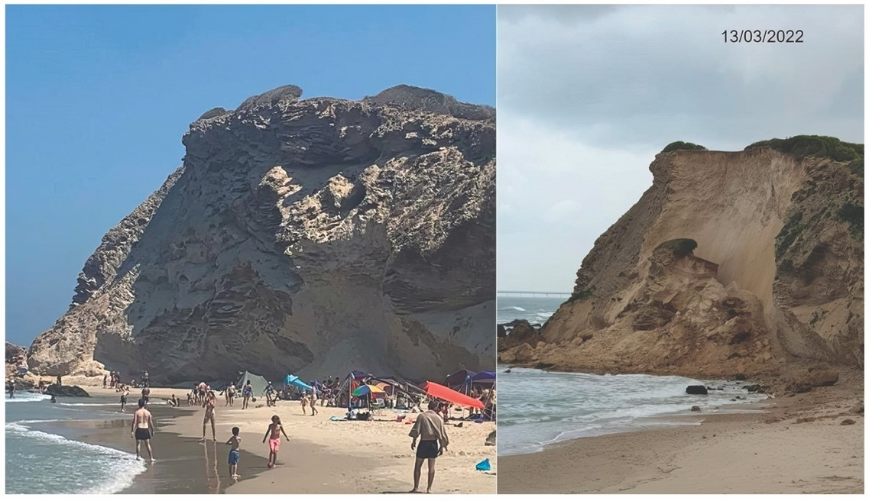

Photographs: The Cliff Protection Company.

Left: the cliff at Tel Gador before the collapse, August 2021; Right: the cliff at Tel Gador after the collapse, March 2022.

.

Illustration 3: The coastal cliff in part of Section 38, Ashkelon

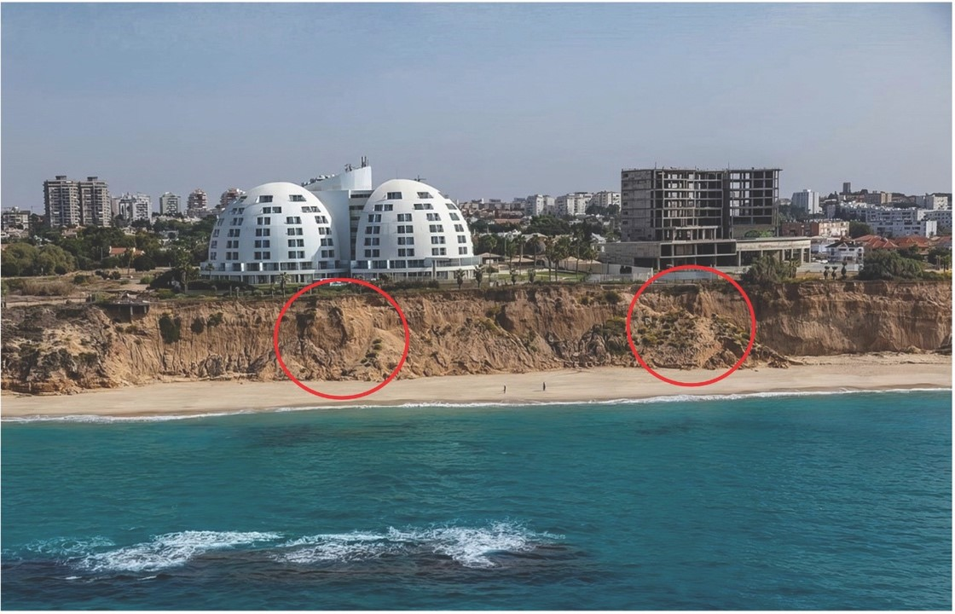

Photograph: The Cliff Protection Company, October 2021, processed by the State Comptroller's Office (two red circles were added, marking areas where collapses occurred in the segment).



**Summary**

In recent decades, the coast cliff along Israel's shores has been collapsing and retreating eastward at several dozen centimeters per year. According to the follow-up audit findings, some of the deficiencies from the previous report were rectified, others were partially rectified, and others were not rectified. It was found that no agreed framework has yet been formulated regarding assistance to local authorities in finding funding sources for land protections; no decision has yet been made regarding the continuation of the Cliff Protection Company’s work and the funding of sea protection measures planned by it for Phase B; the Ministry of Interior has failed to establish a mechanism for making a comprehensive estimate of the costs of land protections; the INPA has failed to complete the protection of the cliff segments under its charge; and **Ashkelon** and **Herzliya** have not yet begun constructing land protections for the cliff.

The State Comptroller's Office recommends that the Prime Minister’s Office, the Ministry of Interior, the Ministry of Environmental Protection, the Ministry of Finance, and the Israel Land Authority advance a resolution proposal that will ensure the continuation of the necessary land and sea protection measures for the coastal cliff and the required budget for these. The State Comptroller's Office recommends that the Ministry of Environmental Protection and the Cliff Protection Company assess the need to update the coastal cliff protection policy in light of the latest sea level rise scenarios and potential harm to the coastal cliff. **Ashkelon** and **Herzliya**, along with the INPA, should advance the necessary land protections in their segments, and the Cliff Protection Company should advance the sea protections in these segments and in other segments where sea protections are required.

**The Extent of Rectification of the Key Deficiencies Noted in the Previous Audit \***

| **The Extent of Rectification of the Deficiencies Noted in the Follow-Up Audit** | | | | **The Deficiency Noted in the Previous Audit** | **The Audited Body** | **The Audit Chapter** |
| --- | --- | --- | --- | --- | --- | --- |
| **Fully Rectified** | **Significantly Rectified** | **Slightly Rectified** | **Not Rectified** |
|  |  |  |  | Over eight years after the government decision in April 2011, the government ministries, including the Prime Minister's Office, the Ministry of Environmental Protection, and the Ministry of Interior have not formulated an agreed-upon framework regarding assistance to local authorities in finding sources to fund their land protections. | **Prime Minister's Office, Ministry of Environmental Protection, and Ministry of Interior** | Responsibility for funding & constructing land protections |
|  |  |  |  | **Herzliya** failed to implement urgent protections or safeguard public safety. | **Herzliya Municipality** | Implementation of urgent protection measures and safeguarding public safety |

* The table presents the main deficiencies reviewed from the previous report. For all the deficiencies reviewed in the follow-up, see the body of the report.

| **The Extent of Deficiencies Rectification Noted in the Follow-Up Audit** | | | | **The Deficiency Noted in the Previous Audit** | **The Audited Body** | **The Audit Chapter** |
| --- | --- | --- | --- | --- | --- | --- |
| **Fully Rectified** | **Significantly Rectified** | **Slightly Rectified** | **Not Rectified** |
|  |  |  |  | The INPA failed to advance the planning and construction of urgent and permanent land protections in Tel Ashkelon National Park nor install safety measures to keep people away from the clifftop in Apollonia National Park in Herzliya. | **INPA** | Planning & implementation of land protections by the INPA |
|  |  |  |  | **Herzliya** and its Local Planning and Building Committee rejected the analysis of the segments prepared by the Cliff Protection Company in 2016, and they failed to submit an alternative analysis as they had committed to VALHOF in 2017. | **Herzliya Municipality and the Cliff Protection Company** | Delay in the analysis of zones in Herzliya |
|  |  |  |  | **Ashkelon** failed to advance the planning and construction of urgent and permanent land protections in the Ashkelon North segment, nor did it construct urgent protections for public safety, such as fencing and placing warning signs. | **Ashkelon Municipality** | Planning and implementation of land protections by the Ashkelon Municipality |
|  |  |  |  | **Herzliya** failed to submit the Seafront Plan to the District Planning Committee for discussion for about ten years after it began promoting it; during this period, it failed to advance the construction of land protections on the cliff. | **Herzliya Municipality** | Approval of the Seafront Plan and advancement of land protections on the cliff in Herzliya |
|  |  |  |  | The Cliff Protection Company failed to rehabilitate the northern breakwater in **Ashkelon** in segment 38. | **Cliff Protection Company** | Implementation of sea protection works in Ashkelon North (zone 38) |
|  |  |  |  | The Cliff Protection Company had not begun to execute sea protections in segment 39 (Tel Ashkelon). | **Cliff Protection Company** | Implementation of sea protection works in Ashkelon South (zone 39) |
|  |  |  |  | No sea protection plans for **Herzliya's** coastal cliff had been approved; therefore, it had not been implemented. | **Cliff Protection Company** | Implementation of sea protection works in Herzliya |
|  |  |  |  | The Ministry of Interior does not have a complete and updated estimate of the costs for the construction of the required land protections. | **Ministry of Interior** | Estimate for implementing land protections |
|  |  |  |  | None of the relevant parties had updated estimates of the costs for sea protections, nor had any comprehensive examination been conducted of the complete estimates for constructing sea protections along the cliff. | **Cliff Protection Company** | Estimate for implementing sea protections |
|  |  |  |  | The budget utilization of the Cliff Protection Company in the operations category was meager and was 5%–19% in 2016–2018. | **Cliff Protection Company** | Budget of the Cliff Protection Company |

**Rate of Deficiency Rectification Noted in Previous Audit\***

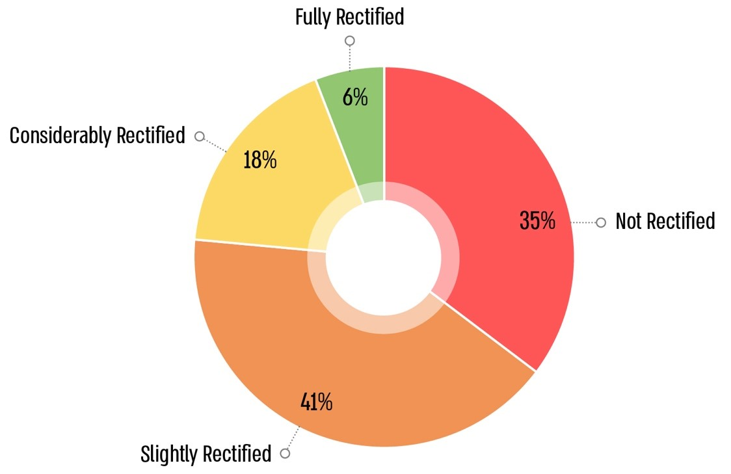

The table presents the main deficiencies reviewed from the previous report.

1. From the policy document titled "Collapse of the Coastal Cliff in Israel – Ways to Address It, and the Economic, Public, and Environmental Implications," Ministry of Environmental Protection and the Jerusalem Institute for Israel Studies (April 2010).
2. State Comptroller, **Reports on the Auditing of Local Government for 2009** (2010), in the chapter "The Government Authorities’ Handling of Coastal Cliff Erosion Processes," pp. 345–408; and State Comptroller, **Reports on Audits of Local Government for 2020** (2020), "The Government Authorities’ Handling of Coastal Cliff Erosion Processes".
3. The authorities in which partial land or sea protections have been implemented: Ashkelon, Bat Yam, Netanya, Tel Aviv-Yafo, and the Emek Hefer Regional Council. In the authorities of Hadera, Herzliya, and Gan Raveh, no protections have been implemented at all.
4. The segment refers to 39 cliff segments defined in National Outline Plan 9/13/A – a detailed plan for the coastal cliff along the Mediterranean Sea, as cliff segments requiring treatment based on their level of urgency.
5. The municipalities of Hadera and Netanya and the regional councils of Hof HaSharon and Gan Raveh, the municipalities of Ashkelon, Bat Yam, and Herzliya utilized the budget partially. The Tel Aviv-Yafo Municipality and the Emek Hefer Regional Council utilized nearly the entire budget.
6. The authority operates under the National Parks, Nature Reserves, National Sites, and Memorial Sites Law, 1998.
7. A forum representing all coastal authorities in Israel. The purpose of the forum is to network between coastal authorities in Israel, promote cooperation, and discuss fundamental and practical issues concerning the coastal authorities. The forum serves, among other things, for peer learning and content development and represents the coastal authorities before decision-makers and regulators. The forum operates under the Federation of Local Authorities in Israel and the Federation of Regional Authorities, with the support of the Institute of Local Government at Tel Aviv University.
8. The municipalities of Hadera and Netanya and the regional councils of Hof HaSharon and Gan Raveh.
9. A national planning institution established under the Protection of the Coastal Environment Law, 2004, and the Second Amendment to the Planning and Building Law, 1965. The committee is in charge of maintaining and balancing planning considerations with the value of protecting the coastal environment. The Coastal Environment Protection Law defines the coastal environment as "an area of 300 meters measured from the shoreline of the Mediterranean Sea, the shoreline of the Red Sea, or the shoreline of the Sea of Galilee, as applicable, inland, as well as the area measured from the shoreline of the Mediterranean Sea or the shoreline of the Red Sea, as applicable, seaward to the end of the territorial waters; regarding the Sea of Galilee $–$ this includes the entire Sea of Galilee including, on land $–$ the surface and subsurface, and in the sea $–$ the seabed and subsoil, as well as natural resources, landscape, natural and heritage values, and antiquities as defined in the Antiquities Law, both within and above them". Section 1 of the Planning and Building Law defines the coastal environment as follows: an area of 300 meters measured from the shoreline of the Mediterranean Sea inland, as well as the area measured from the shoreline of the Mediterranean Sea seaward to the end of the territorial waters, including, on land—the surface and subsurface, and in the sea, the seabed and subsoil, as well as natural resources, landscape, natural and heritage values, including antiquities as defined in the Antiquities Law, both within and above them. Plans and requests for easements and variances within the coastal environment require approval from the Protection of the Coastal Environment Committee (Hebrew acronym: VALHOF), except for certain cases that the committee has defined as exempt. Some requests for easements require approval from the VALHOF only if they are within the coastal area as defined by law.
10. The lower part of the cliff, exposed to wave action. From National Outline Plan (TAMA) 9/13/A $-$ a partial, detailed national outline plan for the protection of coastal cliffs along the Mediterranean Sea (National Urgent Protections Plan).
11. Sand-filled geotechnical fabric sleeves stabilized to the seabed, which may protrude above the sea surface to reduce wave action. From the National Urgent Protections Plan.
12. Government Resolution 1851 on "Extending the Operations of the Government Company for the Protection of Mediterranean Coastal Cliffs Ltd." dated June 9, 2024.
13. Erosion $-$ denudation.
14. After the establishment of the Cliff Protection Company, an inter-ministerial steering committee was formed with the participation of representatives from the Ministry of Environmental Protection, the Israel Land Authority, and the Budget Division of the Ministry of Finance, in order to monitor the progress of addressing coastal cliff collapse. This committee reviews and approves the company’s work plans as well.
15. The annual budget for 2023 stood at NIS 71.2 million.