The Swords of Iron War: Economic and Budget Management Preparation for a War during
2023–2024

The Swords of Iron War: Economic and Budget Management Preparation for a War during
2023–2024
Abstract


On October 7, 2023, the terrorist organization Hamas executed an attack on the State of Israel, characterized by the launching of thousands of rockets and the infiltration of numerous terrorists into Israeli Defense Forces (IDF) bases, urban areas, and communities within the Western Negev, specifically those adjacent to Gaza (the Gaza Envelope localities). Consequently, many communities were evacuated, precipitating the outbreak of the Swords of Iron War. The IDF subsequent mobilized over 300,000 reserve soldiers to confront threats emanating from both the north and south. It addressed the persistent rocket fire from Hamas in the south and Hezbollah in the north. This situation exerted considerable impact on the performance of the Israeli economy, both in the short and long term.
The State of Israel has experience in navigating security events, as well as both short and long-term military campaigns. War is one of the primary risks to which the nation is susceptible, alongside natural disasters such as earthquakes and public health crises like pandemics. Consequently, the State of Israel is obligated to enhance its preparedness for emergency situations, crises, and disasters that pose threats to human life and could inflict significant damage on lifestyles, national infrastructure, security capabilities, and overall national resilience. Economic preparedness for emergencies, can be instrumental in preserving economic stability, promoting resilience against fiscal and monetary challenges, facilitating response to economic crises and emergencies, and ensuring continued access to services and resources during such events.
The sustained economic repercussions stemming from the outbreak of the war and extending into 2024, alongside the financing of war-related expenditures and their consequential effects, have significantly compromised Israel's fiscal situation and substantially increased both state and public debts. This will impact current and future generations. Data from the Accountant General Department in the Ministry of Finance, indicates that as of November 2024, the estimated costs associated with war expenditures from the onset of the conflict to November 2024 amounted to approximately NIS 112.8 billion. Furthermore, the Bank of Israel's forecast from September 2024 posits that, during the years 2023-2025, the totality of war expenses will reach approximately NIS 250 billion. Additionally, from the commencement of the war until November 2024, approximately NIS 17.7 billion were disbursed from the Compensation Fund. Approximately NIS 95 billion of the defense budget pertaining to the Swords of Iron War was expended during the years 2023-2024. In 2024 alone, about NIS 37 billion were allocated for reservist compensation and benefits, which constituted approximately 22% of the defense expenditures.
The following officials held their respective positions during the audit period: Minister of Finance: Mr. Bezalel Smotrich; Director General of the Ministry of Finance: Mr. Shlomi Heizler; Commissioner for Budgets: Mr. Yogev Gerdos; Accountant General: Mr. Yahli Rotenberg; Chief Economist: Mr. Shmuel Abramson; and Legal Advisor to the Ministry of Finance: Mr. Asi Messing.


The Process of Formulating the Supplemental State Budget for 2023 and the Supplemental State Budget for 2024 and their Approval in the Knesset Plenum

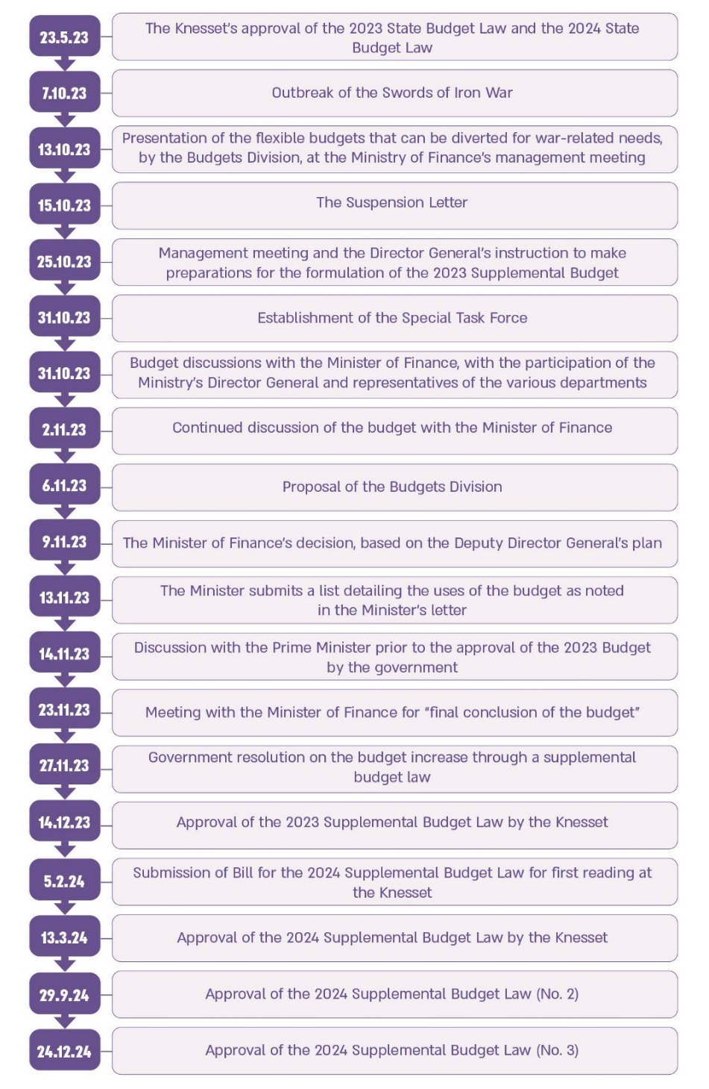

The table below presents key data on key macroeconomic indicators in the economy for the years 2023–2024, as well as a forecast for 2025.
Key Data on Key Macroeconomic Indicators in the Economy for the Years
2023–2024 As Well As a Forecast for 2025 (Rate of Change in Percentage)

 | 2023 (actual) | 2024 (actual) | Forecast for 2025
Gross Domestic Product | 2.0 | 0.9 | 3.8
Private Consumption | -0.9 | 2.6 | 7.0
Government Deficit (Percentage of GDP) | 4.0 | 6.8 | 4.9
Debt-to-GDP Ratio | 61.4 | 69 | 69
Inflation | 3.3 | 3.2 | 2.8
Source: Bank of Israel and Central Bureau of Statistics (CBS) data. Forecast according to the Bank of Israel, Research Division's macroeconomic forecast, October 2024.


NIS 250 billion |  | 6.8% |  | 69% compared to 61.5% |  | 0.9% compared to 3.1%
The Bank of Israel estimate of the total military and civilian cost of the war for the years 2023–2025 as of September 2024 |  | The actual deficit rate in the state budget for 2024, compared to a planned deficit target of 6.6% in the supplementary budget from March 2024. This compares to a budget deficit of 4.1% in 2023 and a budget surplus of 0.6% in 2022 |  | Debt-to-GDP ratio in 2024, compared to a ratio of 60.3% in 2022 and 61.5% in 2023 (including the war months) |  | Actual growth in 2024 compared to a growth forecast for this year of 3.1%, prior to the outbreak of the war
5 |  | Approximately NIS 26 billion |  | Approximately NIS 107 billion |  | NIS 85 billion (net)
Five instances where the three international credit rating agencies downgraded the State of Israel from the beginning of the war until October 2024 (including a double downgrade in September 2024 by Moody's) |  | The budgetary increment incorporated into the state budget for 2023 due to the war, of which approximately NIS 17 billion is for military needs and approximately NIS 8.8 billion is for civilian needs |  | The total budgetary increment incorporated into the state budgets ratified in 2024 due to the war, in comparison to the original budget approved in May 2023 (approximately NIS 70.4 billion in March, approximately NIS 3.4 billion in September, and approximately NIS 33.1 billion in December) |  | The increase in the Ministry of Defense budget for 2024 (net), between the original budget approved in May 2023 (approximately NIS 64.5 billion) and the additional budget approved in December 2024 (approximately NIS 149.5 billion)
NIS 90 billion |  | 3.6% |  | NIS 8.2 billion |  | NIS 27.1 billion
The total impact on GDP for the years 2023-2024: NIS 25 billion in 2023 (approximately 1.4% of GDP) and approximately NIS 65 billion in 2024, based on the Bank of Israel's estimate from July 2025 |  | The cumulative damage to GDP attributable to the war for the years 2023 to 2024 |  | The financial scope of 50 applications approved by the Central Emergency Exemption Committee of the Accountant General Department during the initial three months following the outbreak of the war |  | The anticipated rise in interest payments and repayment of principal to the National Insurance Institute during the years 2025-2027 subsequent to the numerator update in June 2024

The Bank of Israel's Estimate of the Total Cost of the War for the Years
2023-2025, in Billions of NIS as of September 2024
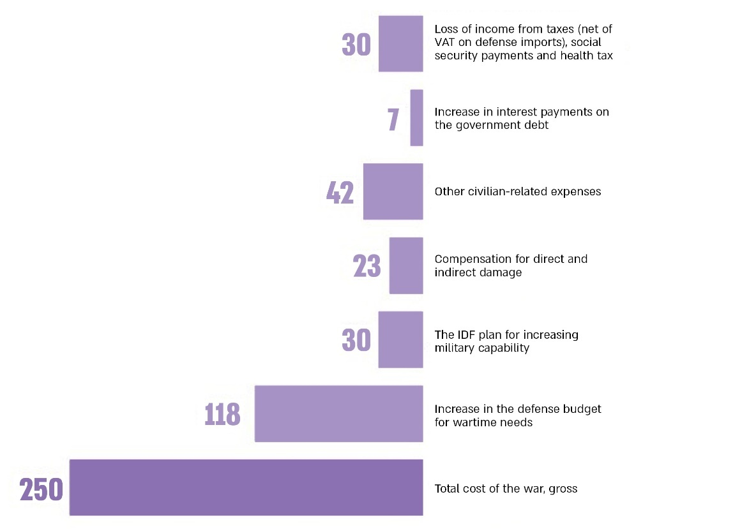

According to Bank of Israel data, September 2024, processed by the Office of the State Comptroller.

Audit Actions

From January to November 2024, the Office of the State Comptroller conducted an examination of the economic preparedness for potential wartime scenarios and the management of the budget associated with the Swords of Iron War for the fiscal years 2023 and 2024. The examination focused, among other things, on the state of economic readiness prior to the onset of hostilities, the formulation of war budgets for 2023 and 2024 by the Ministry of Finance, and the implementation of the war budget during the first 90 days of war. The examination was primarily conducted within the Ministry of Finance, encompassing the Office of the Minister of Finance, the Office of the Director General, the Budgets Division, the Accountant General Department, the Chief Economist Division, and the Salary and Labor Agreements Division. Additional evaluations were carried out in the Bank of Israel and the National Economic Council. Supplementary examinations were conducted at the Ministry of Justice, the Tax Authority, the Ministry of Economy, the Ministry of Tourism, the Ministry of Health, the Ministry of Education, the Ministry of Interior, the Ministry of Transport and Road Safety, the Ministry of Energy and National Infrastructures, and the Ministry of Religious Affairs. Throughout the audit process, the Office of the State Comptroller distributed questionnaires to 37 government ministries that received allocations from the war budget. As of the audit end date, responses had been obtained from 30 of the ministries.

Part One – Economic Preparedness for an Emergency Preceding the Swords of Iron War

Only one month |  | NIS 23.5 billion compared to NIS 90 billion |  | 2016 |  | NIS 8.5 billion
The aggregate reference scenario for the war outlined by the National Emergency Management Authority (NEMA) for the years 2021-2025, referring to a multiple-front period of hostilities lasting approximately one month, compared to the Sword of Iron War, lasting for nearly two years and still ongoing |  | Estimated damage to the GDP caused by a war lasting about a month, according to the Ministry of Finance's sectoral reference scenario for war, compared to the damage to the GDP in 2023-2024 according to the Bank of Israel's estimate from July 2025 |  | The last year in which an internal war preparedness drill was held at the Ministry of Finance |  | The volume of foreign exchange sales by the Bank of Israel in October–November 2023, out of a total plan of $30 billion

Key Findings

The Ministry of Finance's Emergency Preparedness

The Ministry of Finance Emergency Response Plan – It was found that the Ministry's War Response Plan, revised by the designated authority within the Ministry of Finance (the entity representing the Director General of the Ministry of Finance responsible for coordinating emergency preparedness activities), in July 2023, is predicated upon a sectoral reference scenario in alignment with the National Emergency Management Authority's (NEMA) aggregate reference scenario established in March 2022. This reference scenario encompasses a singular depiction of a potential multiple-front conflict anticipated to endure for approximately one month, with an estimated economic impact quantified as a GDP loss of around NIS 23.5 billion.
In practice, the Swords of Iron War has persisted for nearly two years without resolution, resulting in a GDP loss attributable to this conflict of approximately NIS 25 billion in the last quarter of 2023 alone. Furthermore, it is imperative to highlight that, prior to the onset of the war, the growth forecast for 2024 was projected at 3.1%, whereas current realities indicate a mere 0.9% growth, representing a disparity of 2.2 percentage points. This discrepancy equates to an estimated financial shortfall of approximately NIS 65 billion due to the escalation of the Swords of Iron War across multiple fronts. Additionally, as per the Bank of Israel's assessment, anticipated damage to GDP for 2025 is estimated to range between NIS 65 and 75 billion (at 2024 prices). This analysis underscores the obsolescence of the Ministry of Finance's response plan, derived from NEMA's reference scenario, in relation to the Swords of Iron War and its economic ramifications for the Israeli economy.
Lack of a Reserve and Designated Budgetary Sources for Emergencies – The provisions of the 'Basic Law the State Economy' mandate that the state budget encompasses expected and planned governmental expenditures. In recent years, various emergency incidents have transpired, incurring significant expenses that were not accommodated within the existing budgetary framework for the fiscal year. The State of Israel has frequently encountered security and civil emergencies throughout its history; however, the audit demonstrated that the Ministry of Finance lacks a dedicated budgetary mechanism to facilitate a prompt response to unforeseen and unplanned financial requirements in the event of a significant emergency. Furthermore, it was determined that the Ministry of Finance did not allocate a designated reserve item within the state budget for emergencies that could be immediately accessed in the event of an emergency without necessitating an update to the budget. It is pertinent to mention that, as part of the approval of the 2025 Budget Law, a legal mechanism was instituted for the first time to regulate emergency responses. Consequently, a framework was established wherein approximately NIS 4 billion would be earmarked within the "General Reserve" budget item to finance war-related expenses for that year, contingent upon the fulfillment of specified conditions. The audit also indicated that during the formulation of the annual budget, the Budgets Division does not proactively identify a list of potential budgetary sources within the proposed state budget framework (that is to be specified in law) from which, based on professional priorities, resources could be reallocated to address initial needs that may arise in response to an emergency event. Additionally, it was found that the Ministry of Finance management did not establish a mechanism for the rapid disbursement of funds or a system for assisting local authorities, in accordance with the requirements of the ministerial response plan for the war.
Drills for Addressing Emergency Situations – The audit revealed that the last internal drill, simulating an all-out war, conducted by the Ministry of Finance was in 2011, incorporating a "surprise attack" scenario from Lebanon and Gaza, alongside an "all-out war" scenario. It was found that the most recent internal drill at the Ministry of Finance, which did not address an all-out war, took place in 2016 and included a joint desk drill involving the management of the Ministry of Finance and the Ministry of National Infrastructures, Energy and Water, focused exclusively on damage to energy infrastructure and the gas rig. Furthermore, it was noted that no internal emergency drills have been conducted at the Ministry of Finance since 2019.
The Office of the State Comptroller expresses concern to the directors general of the Ministry of Finance and the designated authority at the Ministry for failing to conduct an internal drill addressing a war scenario for over eight years, and for not conducting an internal drill pertaining to an all-out war for more than 13 years. Consequently, the Ministry did not adhere to the procedural guidelines regarding emergency training and drills established in July 2023, which stipulate that emergency drills must be performed annually. The absence of such drills has adversely affected preparedness and the capacity for preemptive response.
Drafting Professionals Essential to the Activities of the Ministry of Finance During an Emergency – The audit revealed that prior to the conflict, only 137 employees were identified as essential within the Ministry of Finance, out of a total workforce of approximately 800 individuals. Furthermore, 100% of these essential employees were classified by the Ministry of Labor as being "essential for the economy". In actuality, findings indicate that during the Swords of Iron War 204 employees from the Ministry of Finance, encompassing both essential and non-essential personnel, were drafted into the military reserves, including six of those classified as being essential for the economy. For instance, at the onset of the conflict, the individual responsible for salary and labor agreements, and the Budget Division supervisor for emergencies were drafted. The extensive mobilization of reservists posed significant challenges for the Ministry of Finance in its planning endeavors following the outbreak of the war. Specifically, personnel from the Budgets Division's Macro Team were drafted, thereby increasing the workload on the remaining team members, who were tasked with expediting the passage of two new budget laws within a constrained timeline. The Ministry of Finance asserted that this situation adversely affected its capacity to promptly promote the addressing of the budgets necessary for the war.
Declaring a State of Emergency in the Ministry of Finance and Opening a Joint Situation Room of the Ministry of Finance Departments – It was found that the Ministry of Finance failed to establish an emergency situation room in accordance with the stipulations outlined in the Ministry’s response plan procedure of July 2023. The situation room that was opened consisted solely of personnel from the Cyber Emergency and Security Division, without representatives from various departments within the Ministry of Finance, including the Budgets Division, the Accountant General Department, the Chief Economist Division, and the Salary and Labor Agreements Division. There is considerable concern that the operation of a situation room without departmental representation, as mandated by the Ministry’s response plan procedure, impeded the ability to deliver an immediate response to the diverse economic requirements emerging in the field during the state of emergency. Additionally, it was determined that the Ministry of Finance's emergency information center continued its usual operations throughout the war, without transitioning to an emergency format, and without organized information regarding assistance programs for citizens or a dedicated hotline for authorities and citizens.

The Emergency Preparedness of the Political Echelon – the Prime Minister and the Minister of Finance
The Socio-Economic Cabinet – Insufficient Engagement in Economic Emergency Preparedness – It was found that during the tenure of the 36th and 37th governments from 2021 to 2023, prior to the onset of the war, the Socio-Economic Cabinet (members of which include the Prime Minister, the Minister of Finance, and other relevant ministers such as the Minister of Interior, the Minister of Construction and Housing, and the Minister of Economy and Industry) demonstrated inadequate engagement in economic emergency preparations. This despite the lessons learned from the COVID-19 crisis and recommendations from the State Comptroller emphasizing the necessity of addressing and evaluating significant economic issues pertinent to emergency situations. With respect to the program for distributing grants to the population – the Social-Economic Cabinet failed to initiate grant distribution programs during a crisis, did not analyze the lessons learned from previously implemented initiatives, and did not establish guidelines for implementing grant programs during emergencies. With respect to the examination of the unpaid leave model for employees during an emergency – the Socio-Economic Cabinet failed to make decisions regarding this model in the context of a crisis and neglected to explore alternative methods for labor market crisis management. With respect to providing aid to businesses – the Socio-Economic Cabinet did not formulate policies aimed at assisting businesses during emergencies.
The Office of the State Comptroller directed observations toward the current Prime Minister, Knesset Member Benjamin Netanyahu, and former Prime Ministers Mr. Naftali Bennett and Knesset Member Yair Lapid, along with the current Minister of Finance, Mr. Bezalel Smotrich, and former Minister of Finance, Knesset Member Avigdor Lieberman, noting that given the critical nature of economic preparation for emergencies, the Israeli governments should have undertaken processes for deriving lessons and conducting discussions on this matter, whether through the Socio-Economic Cabinet or via alternative governmental forums.
Failure to Establish a Ministerial Committee for Socio-Economic Strategy – It was revealed that the six Israeli governments in office since 2012 did not constitute a Ministerial Committee for Socio-Economic Strategy, thereby neglecting to implement the governmental resolution adopted in 2012. This committee, with the authority to conduct discussions on strategic situation assessments and the promotion of strategic outline plans for government approval, has not been formed by Israeli governments and, in any event, has not convened to discuss matters related to war preparations.

The Emergency Preparedness of the Ministry of Finance's Director General
Preparation and Updating of the Ministry of Finance's Director General's Emergency Response Plan –The Director General of the Ministry of Finance is responsible for preparing his office's emergency response plan.in accordance with the Ministry of Finance's War Response Plan procedure. He is also responsible to ensure annual updates. It was found that the Director General updated the response plan only in March 2024, approximately six months after the onset of the war and nearly two and a half years following the formulation of the prior director general's response plan in December 2021. Furthermore, the revised response plan lacks specificity regarding the implementation of service objectives, such as conducting a situation assessment process and developing the national economic message. The formulation, prior to the war, of a comprehensive response plan that delineates the instruments by which the Ministry of Finance management will achieve its service objectives, as well as the proactive review and updating of the plan in accordance with the Ministry's response plan procedure, rather than during a state of conflict, could have facilitated the provision of the Ministry's response in an emergency.
The Office of the State Comptroller emphasizes the necessity for the Director General of the Ministry of Finance to act promptly in preparing detailed plans that specify the tools and actions required for achieving service objectives. Additionally, the Director General was expected to devise solutions to bridge the gaps between service objectives and the service levels established for the emergency, as well as the feasibility of their realization in light of reference scenarios. Moreover, the Director General was required to monitor and control the service objectives, service levels, and response plan, ensuring their adaptation to alterations in national reference scenarios for the emergency, evolving national service objectives, the Ministry's periodic tasks, and the policy directives set forth by the Minister.

The Emergency Preparedness of the Chief Economist Division
The Formulation of the Chief Economist Division Response Plan for a War Scenario – Since its establishment in 2012, the Chief Economist Division has failed to update the emergency procedures for its units – the Research and Forecasting Unit and the International Relations Unit – despite the passage of approximately 12 years since their initial formulation. These procedures explicitly stipulate the necessity of annual updates. Furthermore, it was noted that as of February 2024, the Chief Economist Division had not included a procedure for the State Revenue Administration Unit concerning emergencies, which is vital for monitoring state revenues during crisis situations.
The Office of the State Comptroller notes that for nearly 12 years, from 2012 to February 2024, there was a lack of annual updates to the Division's emergency procedures files, particularly concerning warfare scenarios. This occurred despite organizational changes within the Chief Economist Division and various emergency situations that Israel experienced during that period, including rounds of combat, military operations, and a pandemic, underscoring the increasing necessity for systematic monitoring and updating of emergency procedures in the Division.
The Actual Damage to Gross Domestic Product (GDP) for 2023 and the Projected Damage for 2024, Compared with the Estimates Provided by the Chief Economist Division Prior to the War – The audit found that compared to the damage to GDP, as estimated by the Chief Economist in March 2022 for an aggregate war scenario, projected at NIS 23.5 billion per month, the actual GDP damage for the months of October to December 2023 amounted to approximately NIS 25 billion (for three months), representing a damage to GDP of around 1.5%. These disparities between estimates and the actual situation can be attributed to the divergence between projected scenarios and the actual scope of the event. It was further revealed that the Chief Economist Division utilized scenarios that assumed a one-month duration for the war, based on the reference scenario provided by the National Emergency Management Authority in March 2022. In actuality, these scenarios were not realized as the Swords of Iron War has persisted for nearly two years as of the audit end date, and has yet to end.
Additionally, following the war, the projected damage to GDP for 2024, as estimated by the Bank of Israel, is approximately NIS 65 billion, resulting in cumulative GDP damage of around NIS 90 billion for the years 2023 and 2024. Furthermore, the Bank of Israel projects that the anticipated damage to GDP for 2025 will range from approximately NIS 65 to 75 billion (in 2024 prices). These estimates highlight the urgent need for the Ministry of Finance to develop relevant economic contingency plans to address potential economic emergencies, particularly given that the actual duration of the conflict has exceeded the timeframe upon which the initial estimates were predicated.

The Emergency Preparedness of the Budgets Division
Formulation of the Budgets Division's Response Plan for a War Scenario – It has been observed that up until the commencement of 2024, the Budgets Division lacked a departmental emergency portfolio. Subsequently, following the outbreak of the Swords of Iron War and the initiation of the audit, the Division developed a departmental emergency portfolio that consolidated the necessary operational procedures required for executing tasks within its purview.
The Office of the State Comptroller informed the Commissioner for Budgets that it was only after the onset of the Swords of Iron War and the initiation of the audit that, at the beginning of 2024, the Division established this emergency portfolio to facilitate preparedness for various potential emergency scenarios within Israel, ensuring the Division's proper and continuous functioning.
Contingency Plan to Address Various Emergency Needs –The State Comptroller's 2021 report on budgetary management amidst the COVID-19 crisis, recommended to the Ministry of Finance and other pertinent governmental ministries to devise an economic plan that would serve as a "contingency plan" to address the economic repercussions stemming from a pandemic outbreak. This plan was to be derived from lessons learned from the experiences of the ministries during the COVID-19 period.
The Office of the State Comptroller has indicated to the Commissioner for Budgets that prior to the Swords of Iron War, the Division did not possess a systematic and documented contingency plan developed in conjunction with relevant ministries, which would outline mechanisms for responding to a variety of emergency scenarios and events across multiple sectors. Such mechanisms would include strategies for ensuring employment security for employees, providing direct grants to diverse populations (e.g., organization grants), establishing aid routes for businesses, and covering costs associated with population evacuation. Moreover, the Division's conduct predominantly relied on organizational memory without being substantiated in formal, detailed documentation, necessitating the Division to contact former officials, if required.
Lack of a Budgetary Mechanism for Emergencies – As previously indicated, it was determined that the Ministry of Finance did not have a dedicated budgetary mechanism to swiftly address unexpected and unplanned financial requirements arising from significant emergency events. Additionally, it was found that the Ministry of Finance had not allocated a dedicated reserve item in the state budget for emergencies that could be made operational immediately in the event of a widespread emergency without necessitating budgetary revisions. It should be emphasized that during the approval of the 2025 Budget Law, a legal mechanism was introduced for the first time to govern the provision of emergency responses. Consequently, a framework was established under which approximately NIS 4 billion would be budgeted within the "General Reserve" item to finance war-related expenses for that year, contingent upon the fulfillment of specific conditions. Furthermore, it was ascertained that during the formulation of the annual budget, the Budgets Division does not proactively identify a list of potential budgetary sources within the proposed state budget framework (that is to be specified in the law) from which, based on professional priorities, resources could be reallocated to address initial needs that may arise in response to an emergency event.
For instance, it was found that following the declaration of war and at the request of the Minister of Finance, the Accountant General Department conducted a mapping of all reserve line items within the 2023 budget in November 2023. This analysis ostensibly indicated that the reserve budget balance in the state budget, as of that date, was approximately NIS 30 billion. Nevertheless, the Budgets Division informed the audit team that although financial balances existed in the reserve regulations prior to the war, these balances were earmarked for various purposes, the final allocation of which would only be determined at the conclusion of the fiscal year. Hence, the effective reserve in the state budget was essentially zero. In practical terms, there were no reserves in the state budget that could be immediately accessed upon the outbreak of the war, necessitating the identification of alternative budgetary sources.

The Emergency Preparedness of the Accountant General Department
Accountant General Department of Emergency Preparedness - Oversight of Government Ministry Accountants – It was found that the Head of the Emergency Sector within the Accountant General Department verifies the establishment of emergency procedures by the accountants of government ministries. However, it has been observed that there is no verification to ensure that the documented procedures are in compliance with the TAKAM (Financial and Economic Regulations) directive concerning the preparation of accounting departments for emergencies. Furthermore, the Head of the Emergency Sector does not ascertain whether government ministry accountants have undertaken the requisite actions to adequately prepare for emergencies, such as identifying critical processes relevant to each ministry.
The Government Procurement Administration - Pooling the Anticipated Procurement Requirements of Government Ministries During Emergencies – The Procurement Administration does not engage in comprehensive aggregation of expected procurement needs of government ministries during emergency situations. The Procurement Administration does not prepare in advance for the cross-cutting needs of these ministries, and exhibits insufficient advance preparation of cross-cutting agreements or engagements necessary for effective emergency response. Consequently, such needs are identified only through inquiries from procurement personnel at the time of an emergency event. For instance, following the onset of the Swords of Iron War, multiple government ministries requested the procurement of protective shelters. The Government Procurement Administration subsequently recognized a widespread demand for this procurement and initiated a centralized procurement process for protective shelters. This suggests that the response to cross-cutting procurement needs could have been expedited and potentially incurred lower costs.
Mandatory Tenders Regulations – It was found that an amendment to the Mandatory Tenders Regulations, which expanded the authorities of government ministries to contract with suppliers through an exemption from tendering, was introduced by the Minister of Finance more than two months after the war commenced.
Centralization of Requests for Engagements by Government Ministries During Emergencies – There is no section within the Accountant General Department to consolidate all available information regarding engagement requests during emergencies from government ministries, including data from ministerial tender and exemption committees. The lack of data prevents an examination of potential delays or obstacles in the ministerial procurement process during states of emergency.
The Emergency Checklist of the Finance and Credit Division – It has been found that the Finance and Credit Division's Emergency checklist addresses the operational response to emergency events; however, it does not encompass considerations related to debt management.

The Ministry of Finance - Lessons Learned from Previous Emergency Events
The Lessons Learned by the Ministry of Finance Management from the COVID-19 Crisis – The Ministry of Finance management, as the coordinating headquarters for the economic response to the COVID crisis, initiated a process of deriving lessons from the COVID-19 crisis. However, the management has not completed the development of comprehensive contingency plans to address the economic repercussions of emergency situations.
The Office of the State Comptroller reminds the Minister of Finance, the Director General of the Ministry of Finance, and the heads of various departments within the Ministry – including the Budgets Division, the Accountant General Department, and the Chief Economist Division – that, as indicated in the 2021 COVID-19 Audit Report, to complete the economic contingency plans for emergency events, as well as the necessary preparatory strategic work.
Thus, the Minister of Finance and the Ministry's Director General did not complete the Ministry of Finance's emergency response plan; the Commissioner for Budgets did not develop emergency budget plans; and the Accountant General did not establish the requisite cross-cutting agreements in advance to ensure a timely response in emergency situations.
The Lessons Learned by the Budgets Division from the COVID-19 Crisis – It was found that until the onset of the Swords of Iron War, the Budgets Division had not conducted a systematic lessons-learning process that included the documentation of insights from previous emergency events. Furthermore, the Division failed to collaborate with various government ministries to formulate contingency plans for future emergencies with budgetary implications. The lessons and insights garnered were communicated orally and retained solely within the institutional memory of the various coordinators and referents, thereby risking the recurrence of deficiencies in the event of personnel changes. It was only in June 2024, at the time of the audit, that the Budgets Division developed a preparedness document pertaining to a northern Israel scenario, which articulated key insights from past crises, including the COVID pandemic and the Swords of Iron War, as a foundation for formulating concrete recommendations for budgetary management in such a scenario.

Ministry of Finance Reports on the Rectifying Deficiencies Identified in Previous State Comptroller Audit Reports
A Notably Low Reporting Rate by the Ministry of Finance on the Rectification of Deficiencies Outlined in State Comptroller Audit Reports published between 2019 and 2023 –The Ministry's reporting rates on the rectification of deficiencies was notably low, varying between 4% and 18%. This practice contravenes the stipulations of the State Comptroller Law, which mandates that audited entities submit reports to the Office of the State Comptroller within 105 days concerning the rectification of identified deficiencies. The failure to report such corrections without reasonable justification constitutes a disciplinary offense under the applicable disciplinary regulations for the audited entity. Thus, for example, the Office of the State Comptroller did not receive a report from the Ministry of Finance pertaining to the recommendations made in the 2021 State Comptroller report regarding budgetary management during the COVID-19 pandemic. This report emphasized the necessity of developing an economic plan to act as a "contingency plan" for addressing the economic ramifications arising from a pandemic, informed by insights drawn from the experiences of various ministries during the COVID-19 period.
The Office of the State Comptroller has issued a strong critique directed at the Ministers of Finance, the Directors General of the Ministry of Finance, and the heads of departments for the years 2019-2023. This criticism centers on the Ministry of Finance's failure to consistently report on all decisions related to the rectification of deficiencies, a practice that is inconsistent with the requirements established in the State Comptroller Law.

The Emergency Preparedness of the Bank of Israel
Monetary Emergency Plan – The Bank of Israel has a variety of tools available for addressing a monetary emergency. However, by May 2024, it had not finalized the development of a comprehensive monetary emergency plan. This plan was intended to outline various criteria for identifying monetary emergency events, including the thresholds at which a bank transitions from a liquidity challenge to a solvency issue. It was also to delineate the set of tools accessible to the Bank under different monetary emergency scenarios, along with the advantages and disadvantages associated with each tool; the legal, operational, and technological constraints related to the implementation of each tool; the tools available to other entities, particularly the Ministry of Finance; and the cooperative mechanisms with the Ministry of Finance for each monetary emergency situation.
Schemes for Coping with Credit Shortages in Emergency Situations – On October 15, 2023, the Supervisor of Banks released a framework for deferring loan repayments for households, which was subsequently adopted by commercial banks. This framework aims to alleviate the financial burden on specific groups adversely impacted by the Swords of Iron War. Initially extended multiple times to include additional population segments, the framework pertained to the deferral of loan payments, without interest or fees, in three sectors (mortgages, consumer credit, and business credit), as well as to overdraft and current account balances and fees. Although the Bank of Israel has established a structure for addressing credit shortages post-emergency events, it was noted that, on the eve of the war, no action plans had been developed by the Bank regarding credit provisions for various categories of emergency events, including the specific "triggers" for their activation.
Data revealed that the scope of payments deferred under this framework totaled approximately NIS 2.6 billion at the end of October 2023, approximately NIS 5.6 billion at the end of December 2023 (an increase of approximately 115% compared to October 2023), approximately NIS 4.2 billion at the end of February 2024 (a decrease of approximately 25% compared to December 2023), and approximately NIS 3.5 billion at the end of April 2024 (a decrease of approximately 17% compared to February 2024). Between October 2023 and January 2024, the deferral rate for all credit types, excluding housing loans, ranged from approximately 80% to 100%. In contrast, for housing loans, the deferral rate ranged from approximately 55% to 65%. During February 2024, the deferral rate for all credit types, except housing loans, was approximately 50% to 83%, with a rate of approximately 28% for housing loans. By April 2024, the deferral rate for all credit types, aside from housing loans, fell to approximately 27% to 59%, while the rate for housing loans decreased to approximately 16.5%. Overall, a declining trend in the deferral rate of up to three months and an extension of the deferral period has been observed, which raises concerns regarding the repayment capacity of borrowers.
The Duration of the Bank of Israel's Programs to Encourage Loans to Small Businesses and Control Over Transmission of Credit Terms from Commercial Banks to the Business Owners – It was determined that the Bank of Israel's loans to commercial banks as part of the program for small and micro businesses amounted to approximately NIS 2.1 billion each month from December 2023 to February 2024, with a cumulative total of approximately NIS 6.4 billion. The program which concluded at the end of February 2024 and was not reactivated in March 2024, failed to address the needs of small and micro businesses affected by the war thereafter. Additionally, the Bank of Israel maintained oversight of the transmission of credit terms from commercial banks to business owners in need through a prescribed reporting requirement, ensuring that loans were only disbursed following the satisfactory completion of these controls.
Data related to credit performance for small and micro businesses under this monetary program indicated that the distribution of internal ratings for businesses receiving credit was comparable to the distribution of general credit provided during the corresponding period outside the program. Notably, a greater proportion of loans was awarded to small and micro businesses with low failure risk ratings, while a smaller proportion was extended to those with higher failure risk ratings. This discrepancy raises concerns that certain small and micro businesses did not obtain loans in alignment with the program's credit criteria.

The Emergency Preparedness of the National Economic Council
The National Economic Council's Actions Concerning the Issue of War Preparedness –Despite the significance of analyzing the economic risks associated with the occurrence of a major security event, the situation assessments prepared by the Strategic Division and the Professional Forum at the National Economic Council over the past decade, including the 2022 situation assessment, failed to address the potential outbreak of war and its implications for the resilience and economic stability over time. Additionally, while the discussions within the Professional Forum during the 2022 situation assessment underscored the necessity of crisis preparedness, the Forum members failed to address this specific issue, nor did they explore the risks and implications of various security crises.

The Actions Undertaken by the Bank of Israel to Stabilize the Markets in Response to the Outbreak of the Swords of Iron War – On October 9, 2023, the Bank of Israel announced a strategy involving the sale of foreign currency amounting to up to $30 billion. Additionally, it activated swap mechanisms in the foreign exchange market for an amount of up to $15 billion, alongside implementing a plan for repo transactions involving government and corporate bonds. These measures aimed to mitigate fluctuations in the NIS exchange rate and ensure liquidity for the routine operations of the financial markets. The Office of the State Comptroller has positively acknowledged the prompt actions of the Bank of Israel in this context. It is also pertinent to mention that $8.5 billion of the proposed foreign currency sales was actualized.

The Cumulative Financial Scope of Applications Submitted by Government Ministries and Bodies to the Central Emergency Exemption Committee, along with the Number of Applications from Each Ministry – October to December 2023 (expressed in millions of NIS)
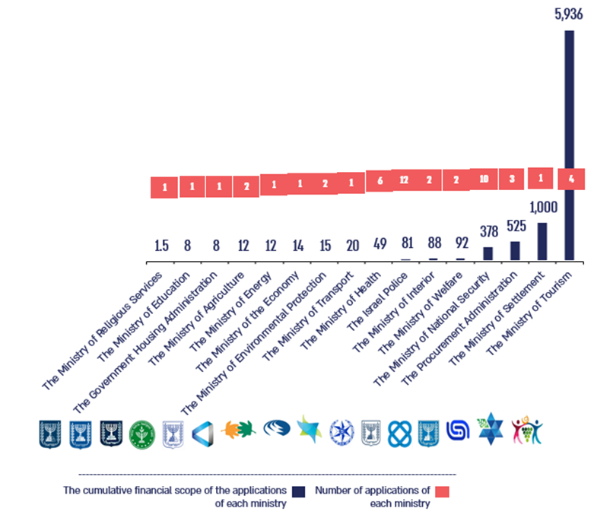
According to data from the Central Emergency Exemption Committee in the Accountant General Department, processed by the Office of the State Comptroller.

The chart indicates that during the initial three months following the outbreak of the war, the ministries submitted 50 applications to the Central Emergency Exemption Committee, all of which received approval. Furthermore, the data reveals that the largest number of applications originated from the Israel Police and the Ministry of National Security, with 12 and 10 applications, respectively. The financial scope of these applications totaled approximately NIS 8.2 billion, of which NIS 5.9 billion was attributed to the Ministry of Tourism. It is noteworthy that the Central Exemption Committee operated with high levels of availability; however, the extent of its activities at the onset of the war highlights significant deficiencies in the advance preparedness of government ministries regarding necessary emergency engagements, particularly in relation to the emergency circumstances that arose following the events of October 7.

Part Two – Preparation of the "War Budgets" for 2023–2024 by the Ministry of Finance

NIS 11.8 billion |  | Only NIS 3 billion |  | NIS 17 billion |  | 3.7%
The war budget for civilian uses budgeted in the supplementary budget for 2023. Approximately NIS 8.8 billion of this amount was budgeted as a supplementary amount |  | The scope of the budget designated for civilian expenditures in 2023 that were financed through a change in priorities (diversion of resources to these uses) |  | The war budget for security uses, which was budgeted for in the supplementary budget for 2023, and was fully implemented |  | The new planned deficit cap in the supplementary budget for 2023 (instead of 2.75% in the original budget for 2023 approved in May 2023, and compared to an actual deficit of 4% that year)
68 days |  | NIS 81 billion |  | NIS 36.5 billion |  | NIS 30 billion vs. NIS 0
The length of time that elapsed from October 7, 2023, until the approval of the supplemental budget for 2023 on December 14, 2023, without there being a budgetary mechanism that allowed for an orderly budget approval |  | Total debt raised in 2023 since the outbreak of the war, out of a total debt increase of NIS 160 billion for this year (approximately 50%) |  | The additional increase made to the state budget for 2024 through two supplemental "budget boxes" to the Supplemental Budget Law approved by the Knesset in March 2024 (approximately NIS 3.4 billion in September 2024, and approximately NIS 33.1 billion in December 2024) |  | The difference in the reserves in the state budget as presented to the Minister of Finance at the time of the onset of the war: The Accountant General Department presented reserves of NIS 30 billion in the state budget, while the Budget Division's position was that these reserves were not available and therefore the effective reserve was zero

Key Findings

Background
- Section 3 of the Basic Law: The State Economy stipulates that the state budget is to be established by legal mandate, encompassing a one-year period that reflects anticipated and planned government expenditures. Nonetheless, Section 3(c) permits the government to present an additional budget bill during the fiscal year, if necessary, thereby facilitating responsiveness to changing needs and unforeseen circumstances beyond government control.
- Following the onset of the war in October 2023, the government has been compelled to allocate substantial resources for both military and related civilian expenditures that were not foreseen when the budgets for 2023 and 2024 were designed and ratified in May 2023. Consequently, it became imperative to defer the attainment of fiscal targets originally delineated upon the approval of the 2023 budget and to establish more expansive temporary targets. To this end, a comprehensive reassessment of the priorities outlined in the budget laws for the fiscal years 2023 and 2024 was necessary, along with an increase in permissible government spending as stipulated in the Frameworks Law for those years.
- Discussions held by the audit team with the Minister of Finance revealed that in initial consultations, he engaged with several former Ministers of Finance. All but one expressed the opinion that the adoption of a budgetary "box" mechanism was requisite for augmenting government spending to cover civilian expenses related to the war in 2023. Consequently, the Minister of Finance advocated for the implementation of a budgetary "box" and stated that he had instructed the Budgets Division accordingly, aiming to provide a swift response to the varied requirements presented by government ministries.
- In a legal opinion provided by the Legal Advisor to the Ministry of Finance, it was asserted that the intent of Section 3(c) of Basic Law: The State Economy is unequivocally to address circumstances arising from new and unforeseen needs necessitating additional budgetary allocations. Furthermore, the Legal Advisor emphasized that while Basic Law: The State Budget allows for modifications during the fiscal year in response to unanticipated budgetary needs, such mechanisms may not be sufficient due to the extensive alteration of priorities and the necessity to exceed the approved budgetary framework to adequately respond to diverse needs. Consequently, the Legal Advisor recommended the submission of a new budget bill. The audit team's engagements with the Budgets Division indicated that the complexities of the 2023 Supplementary Budget Law stemmed from the multitude of changes required across various budget items since the outbreak of hostilities, necessitating more intricate amendments than those typically associated with a supplementary budget law reflecting fewer variations.
- Ultimately, in light of the imperative for augmentation of the approved budget and the significant realignment of priorities necessitated by evolving security and civilian requirements due to the war, the management of the Ministry of Finance was obligated, in accordance with the counsel of the Ministry's Legal Advisor, to propose a Supplementary Budget Law for 2023 structured according to the most recent priorities.

The Decision-Making Process Pertaining to the Preparation of the "War Budget" For 2023
Continuation of the Budget Increase Process – On December 14, 2023, the Knesset approved an increase of approximately NIS 26 billion for the state budget for 2023 for the needs arising from the Swords of Iron War, through a supplementary budget bill, which allocated approximately NIS 17 billion for military expenses and approximately NIS 8.8 billion for civilian expenses, a mere 68 days following the events of October 7. Furthermore, a span of 18 days intervened between the government’s decision to augment the budget via a supplementary budget law on November 27, 2023, and the subsequent approval of the supplementary budget by the Knesset on December 14, 2023. During this interval, there was no budgetary mechanism that facilitated an orderly and controlled transfer of funds to the requisite entities, encompassing both military and civilian sectors.
The Rationale Underlying the Decision Regarding the Method of Budget Augmentation – The audit revealed that the Minister of Finance's decision to augment the budget by substituting the entire budget law with a new bill, which entailed altering priorities within the pre-war approved budget and updating the budget framework, was predicated on various factors, including the counsel of the Legal Advisor of the Ministry of Finance. Notably, this process took place without the involvement of senior economic stakeholders in the decision-making apparatus, such as the Socio-Economic Cabinet, the Governor of the Bank of Israel, and the Head of the National Economic Council. Thus, the budget increase via a new budget bill was fundamentally motivated by legal considerations, lacking a thorough assessment of the macroeconomic implications for the Israeli economy in both the short and long term, and did not undergo deliberation within the Socio-Economic Cabinet.
International Overview – Regulating an Emergency Mechanism from an Economic Perspective – An overview conducted by the State Comptroller indicates that the budgetary sources allocated for emergencies in the United States, United Kingdom, Australia, and India exhibit comparable characteristics, which include:
- Designation confined solely to national emergencies;
- Provision of immediate liquidity for executing emergency controls;
- Implementation mechanisms wherein the regulation is modified to function in an emergency, as opposed to the regulation employed in executing the current budget during normal operating conditions;
- Requirement to report to Parliament and to return funds utilized to the budgetary source/designated fund.
This international overview reveals that several advanced nations, including the United States, United Kingdom, and Australia, have established a legislative framework for emergency situations, encompassing their economic preparations for emergencies and the economic mechanisms necessary for immediate action.
Thus, for example, in the United States, the President is empowered to declare a state of emergency or "major disaster" and to direct any federal agency to utilize its resources as prescribed by federal legislation to assist a specific state in an emergency, while accessing a fund designated for this purpose. It is noteworthy that the annual allocation for the disaster relief fund in the United States averaged approximately $40–50 billion per year during the period from August 2017 to September 2024, primarily intended for public assistance, individual assistance, emergency response operation, and emergency recovery assistance (mitigation). Additionally, at the onset of the COVID-19 pandemic (2020–2022), the budget for the "Individual Assistance" program was established at approximately $40 billion cumulatively during this period, representing an increase compared to previous years.
Moreover, a 2019 OECD study indicates that the majority of OECD countries (31 countries) allocate budgetary sources for emergencies and future expenses. Specifically, 23 countries maintain contingency reserves in various forms. Generally, the objective of these contingency reserves is to finance unanticipated events.
This underscores the significant importance and necessity for advance preparation within the State of Israel, experienced in facing national emergency situations. Such preparation should be based on systematic strategic planning and, in particular, evaluate the need to regulate the legislative framework governing emergency situations, enabling the immediate allocation of funds during emergencies through pre-established economic mechanisms, while adhering to predefined control measures. This approach would conserve critical time during emergency responses and yield an effective economic reaction that incorporates control mechanisms.

The Process of Constructing the "War Budgets" For the Fiscal Years 2023–2024 at the Ministry of Finance
Budgetary Conduct Within Civilian Government Ministries at the Onset of the Swords of Iron War – Approximately one week following the commencement of hostilities, on October 15, 2023, the Director General of the Ministry of Finance, the Commissioner for Budgets, and the Accountant General disseminated a communication to the Directors General of the governmental ministries (the Budget Freeze Letter), containing an update pertaining to budgetary conduct amid the ongoing conflict and included a directive to suspend budgets allocated to ministries, that had not yet been designated for new non-urgent activities at that juncture. Specifically, the budgets affected were those that had neither been allocated nor implemented in 2023 and 2024, which did not address the needs of the war, the impacted civilian population, or the provision of essential services to the economy. The directive contained in the letter from the Director General of the Ministry of Finance, the Commissioner for Budgets, and the Accountant General to the directors general of government ministries dated October 15, 2023, lacked an appropriate and detailed resolution regulating the budget freeze, constituting a follow-up action to the Ministry of Finance's intention to suspend budgets that had not been allocated or implemented and were unrelated to wartime needs. Consequently, this directive was interpreted variably across different governmental ministries based on their respective understandings. Notably, a questionnaire distributed to government ministries on behalf of the Office of the State Comptroller revealed that certain ministries indicated that the letter precipitated a significant cessation of their operations and complications in their interactions with the Ministry of Finance.
Thus, for instance, the Ministry of Economy and Industry expressed that "on October 15, 2023, we received a letter suspending all of the Ministry's budgets without differentiation, which dramatically hindered our ability to undertake any actions". Meanwhile, the Ministry of Agriculture remarked that "following the outbreak of the war, the Budgets Division of the Ministry of Finance halted the transfer of budgets intended for the Ministry of Agriculture as per the budget agreement. Subsequently, only after considerable persuasion efforts by the Ministry, did the Ministry of Finance allocate a portion of these budgets to the Ministry for wartime needs. Time could have been conserved had the budgets been transferred to the Ministry as initially planned, allowing the Ministry to independently decide on their reallocation for wartime purposes".
Resolution of Disputes and Interdepartmental Coordination – On October 31, 2023, the Minister of Finance directed the management of the Ministry of Finance to establish a specialized task force dedicated to the administration of the war budget, led by the Director General of the Ministry and inclusive of the Commissioner for Budgets and the Accountant General (the Special Task Force), with the objective of addressing civilian needs arising from the wartime context. Meetings conducted by the audit team with the Director General of the Ministry of Finance suggest that the establishment of the Special Task Force aimed to accelerate the formulation of a civilian budget framework for the war and facilitate prompt decision-making. The Minister of Finance and the Director General articulated that this action was necessitated by divergences of opinion between the Accountant General Department and the Budgets Division concerning the implementation data of various budgets, particularly regarding the amount of budget reserves available within the system.
The administrative challenges experienced routinely within the Ministry of Finance, which had remained unaddressed over the years and pertained to interdepartmental coordination, decision-making processes, and dispute resolution, persisted even amidst the outbreak of the Swords of Iron War, and contributed, according to the Minister of Finance, to the establishment of the aforementioned Special Team. However, the Legal Advisor of the Ministry of Finance opined that the creation of such a team constitutes a structural and fundamental modification within the Ministry of Finance, with implications extending across governmental operations. Consequently, enacting this change solely on the basis of the aforementioned directive, irrespective of its temporary and urgent nature related to wartime needs, faces a set of substantive legal complexities rendering compliance unfeasible; thus, the team was formed without conferring upon the Director General of the Ministry of Finance the authority to adjudicate disputes.
Process of Formulating the Allocations and Sources for War-Related Expenditures in the Supplementary Budget for 2023 at the Ministry of Finance – In the endeavor to delineate the sources and allocations for the war budget, two concurrent plans were devised at the Ministry of Finance: one by the Budgets Division and the other by the Deputy Director General of the Ministry of Finance, on the basis of which the Minister of Finance made his decision. This methodology deviates from the conventional budget preparation process, wherein the Budgets Division is expected to formulate its proposal for the state budget and secure approval prior to submitting it to the Minister of Finance.
The following table delineates the sources and uses for financing civilian expenditures in 2023 as per the proposal from the Budgets Division and the Minister of Finance's decision, which was formulated based on the plan of the Deputy Director General of the Ministry of Finance (in billions of NIS):

The Sources and Uses for Financing Civil Expenditures in 2023 According to the Budget Division's Proposal and the Minister of Finance's Decision, Formulated Based on the Plan of the Deputy Director General of the Ministry of Finance (in billions of NIS)

 | The Budget Division's Proposal | The Minister of Finance's Decision, Formulated Based on the Plan of the Deputy Director General of the Ministry of Finance
Sources | 16 | 4.47
Uses | 10.9 | 13.3
According to the letter from the Commissioner for Budgets to the Minister of Finance dated November 6, 2023 and the letter from the Minister of Finance dated November 9, 2023, processed by the Office of the State Comptroller.

- The table indicates that the sources and uses as per the proposal from the Budgets Division were NIS 16 billion and NIS 10.9 billion, respectively. Furthermore, the plan formulated by the Deputy Director General of the Ministry of Finance, which served as the basis for the Minister of Finance's decision, delineated sources and uses amounting to NIS 4.47 billion and NIS 13.3 billion, respectively.
- On one hand, the Budgets Division reported sources totaling approximately NIS 10.2 billion derived from the state budget for 2024, of which around NIS 5.4 billion comprises coalition funds that have yet to be allocated. This assessment did not evaluate the implications of these diversions on the 2024 budget in the event that the conflict persisted into 2024, which ultimately transpired. Conversely, the sources provided by the Deputy Director General of the Ministry of Finance, within the framework of the plan approved by the Minister of Finance, were based on uncertain budgetary sources. This included a budgetary source amounting to approximately NIS 0.5 billion from the Jewish National Fund (JNF), which in actuality was not received, as well as a total of NIS 0.6 billion, whose availability had not been verified at the time of the plan's formulation. Additionally, there was an increase in the deficit of the 2023 budget to accommodate the extent of uses.
- The situation where two parallel budgetary plans are developed, when one - formulated by the Deputy Director General of the Ministry of Finance, who is not the designated professional entity responsible for formulating the state budget, and adopted in the Minister of Finance's decision on November 9, 2023, arose as a consequence of suboptimal working relations among the departments of the Ministry of Finance, particularly between the Budgets Division and the offices of the Minister and the Director General. This dynamic resulted in disagreements regarding the data, extended the planning process, and contributed to the budget being ratified by the Knesset only on December 14, 2023, more than two months following the commencement of the war.
Moreover, it is pertinent to note that three days prior to the Minister of Finance's decision, the Legal Advisor of the Ministry of Finance articulated in his correspondence to the Minister dated November 6, 2023, that he believed the Deputy Director General lacked the authority to oversee the Budgets Division and the Accountant General Department in their respective areas of responsibility, and was not empowered to address these domains in their stead. The Budgets Division further asserted in its response that there was no justification for the Deputy Director General, who is not the competent professional authority, to engage with the matter.
Lack of Applicable Reserves in the State Budget for 2023, Which Was Formulated Prior to the Onset of the War – At the behest of the Minister of Finance, the Accountant General Department conducted an analysis of all reserve regulations within the 2023 budget in November 2023. The findings indicated that the reserve balance during September-October 2023 approximated NIS 30 billion. However, information from the Budget Department conveyed to the audit team indicated that, although there existed financial reserves in the reserve regulations before the war, these reserves were earmarked for various purposes, the full extent of which was to be determined only at the conclusion of the fiscal year. Consequently, the effective reserve within the state budget is reported as zero.
The lack of transparency surrounding the allocation and utilization of reserve regulations in the state budget, in conjunction with the budgetary summaries realized through transfers during the current fiscal year, complicates the monitoring of the use and designation of reserve items and hinders the evaluation of the reserves’ availability for unforeseen exigencies. This challenge was exacerbated during the process of identifying available resources for wartime requirements in 2023. The reserves, assigned for diverse needs, resulted in a situation wherein, at the outbreak of war, an effective reserve within the state budget was nonexistent, necessitating the identification of alternative budgetary sources.
It is pertinent to reference a prior report by the State Comptroller from 2018 entitled "Reserves and Various Expenditures in the State Budget – Budgeting, Utilization and Transparency", which highlighted deficiencies and failures related to the budgeting, utilization, and representation of reserves by the Budgets Division. The report noted issues regarding the transparency of reserve budgets, which impeded decision makers’ capacity to understand the utilization and intended purposes of reserve allocations and budget items administered by the Budgets Division, thereby constraining their ability to audit both budgeting processes and its implementation.

The Budget Division's Interaction with Government Ministries in Formulating the War Budget – The majority of bodies examined, including the Ministry of Labor, the Ministry of Construction and Housing, the Ministry of Welfare and Social Affairs, the Ministry of Defense, the Ministry of Culture and Sports, and the Ministry of National Security, acknowledged the collaborative role of the Budgets Division in the development of the 2023 war budget, recognizing them as partners in the budget-building process. Specifically, the Ministry of Defense reported its active engagement in evaluating the war budget through the Ministry of Finance; the Ministry of National Security indicated its representatives' involvement from the outset of the war in discussions concerning supplementary budgetary requirements with Ministry of Finance officials. Conversely, the Ministry of Economy and Industry raised allegations concerning its exclusion from the process, asserting that it was not involved in determining the required budget and was not consulted regarding its needs, apart from a single discussion with the Director General of the Ministry of Finance, in which the Ministry's emergency needs were presented, a discussion that did not yield any results. Additionally, both the Ministry of Tourism and the Ministry of Education identified barriers in their interactions with the Budgets Division. These barriers manifested as unilateral cuts to their respective budgets, which were only rectified following negotiations in the case of the Ministry of Tourism, or during the duration required for budget framework approval, in the case of the Ministry of Education, impeding the ministries' abilities to provide a comprehensive response.
The Allocation of Coalition Funds in the Formulation of the War Budget for 2023
- The audit indicated that, notwithstanding the Minister of Finance's decision of November 9, 2023, to reallocate NIS 1.6 billion from coalition funds for war-related purposes (35% of the total resources planned for the war budget), only about NIS 860 million were actually redirected for such purposes by November 27, 2023. This resulted in a reduction of approximately NIS 740 million in the resource estimates outlined by the Minister, with no alternative funding sources provided for the amount that was not reallocated.
- Additionally, the findings revealed that despite the Minister of Finance's assertion that budgets unrelated to the core functions of ministries and not essential to wartime efforts or national resilience would be diverted for wartime needs, numerous coalition funds remained untouched or faced minimal reductions, with some even experiencing increases subsequent to the onset of the war. Specifically, Government Resolutions No. 1172 dated December 24, 2023, and No. 1096 dated November 27, 2023, authorized the designation of coalition funds for programs not directly associated with wartime efforts, assistance for the civilian population affected, or the delivery of essential services to the economy. For instance, an examination of several coalition fund programs, totaling NIS 1.375 billion, approved in May 2023, identified approximately NIS 300 million in unallocated balances at the onset of the war. These funds were not used for wartime needs. Furthermore, subsequent government resolutions increased the allocation for these programs to a cumulative total of NIS 1.421 billion.
- At the same time, it is pertinent to note that coalition funds encompass programs analogous to those in the budget base particularly in domains such as culture and education. This indicates that the management of the Ministry of Finance prioritized the identification of available sources, such as coalition funds, rather than establishing overarching priorities throughout the entire state budget, in a manner that will provide a budgetary balancing response amid ongoing warfare, neglecting a forward-looking outlook concerning security requirements. The Ministry's focus stemmed, in part, from the budget update occurring at the conclusion of the 2023 fiscal year, after a significant number of programs within the budget base had been implemented, thereby limiting the potential diversion of funds for the war budget.
- Discussions Regarding the Approval of the Supplemental Budget for 2023 with the Prime Minister – Despite the critical importance of involving the Governor of the Bank of Israel in the budget discussions with the Prime Minister, and his insights on the matter, particularly amid the preparation of the war budget – contrary to established practice, the Prime Minister's Office did not extend an invitation to the Governor for the budget meeting on November 14, 2023, nor was the Governor's opinion formally submitted in writing.
The Duration of the Approval of the Supplemental Budget for 2023 – It was found that approximately seven weeks elapsed from the onset of the war to the date of approval of the supplemental budget proposal for 2023 by the government, with an additional period exceeding two months before the Knesset granted its approval. This delay was attributed, in part, to a lack of collaboration and disagreements that arose during the preparation of the supplemental budget for 2023 within the Ministry of Finance. This particularly between the professional staff in the Budgets Division and individuals operating on behalf of the Minister of Finance, as well as a personnel shortage resulting from the mobilization of certain employees from the Budgets Division and the Minister's Office into military reserves. Furthermore, on December 4, 2023, the Ministry of Finance, on behalf of the government, presented to the Knesset the supplemental budget bill for 2023, for its first reading. However, it failed to attach an estimation of the sources of budget financing, as mandated by the Basic Law.
The Timely Submission of the Supplementary Budget Law for 2024 – It was found that the bill for the Supplementary Budget Law for 2024 was tabled in the Knesset for its first reading only on February 5, 2024 – more than two weeks later than the deadline mandated by law. It subsequently received approval in its third reading by the Knesset on March 13, 2024 – over three weeks past the stipulated timeline. The Office of the State Comptroller admonished the Ministry of Finance and its head, the Minister of Finance, emphasizing the necessity of strict adherence to the deadlines set forth in various legal provisions, particularly in Basic Law: The State Economy. Non-compliance with these deadlines not only constitutes a violation of the Basic Law but also adversely impacts the continuous operations of government ministries.
The Duration of the Approval of the Supplemental State Budget for 2024 – The supplemental budget law enacted in March 2024, involved an increase in the projected budget deficit cap to 6.6% of GDP (up from 2.25% in the original budget). Additionally, the permissible expenditure was augmented by NIS 55 billion to sustain military financing and approximately NIS 15.3 billion for civilian needs, resulting directly from the conflict.
It was revealed that the supplemental budget bill for 2024 was, once again, tabled for its first reading on February 5, 2024 – a delay exceeding two weeks compared to the deadline stipulated by law – and was approved in its third reading on March 13, 2024 – surpassing the timeline stipulated by law by more than three weeks. Due to this delay, a cross-the-board reduction was implemented on the budgets of governmental ministries from February 20, 2024, until the law's approval on March 13, 2024.
The Absence of Discussions in the Government or the Socio-Economic Cabinet Regarding the Implications of the Downgrade to the State of Israel's Credit Rating – In light of the war and the expectations of rating agencies regarding a deterioration in the country's fiscal indicators and an escalation in defense expenditures, international credit rating firms Moody's, S&P, and Fitch executed several downgrades of Israel's rating from the commencement of the war until October 2024, with Moody's effecting an unusual two-notch reduction in September 2024; furthermore, these agencies altered the credit rating outlook for Israel to "negative". It was observed that no discussions were held within the government or the Socio-Economic Cabinet concerning the ramifications of the nation's credit rating downgrades and the negative outlooks.
The Utilization of Budget "Boxes" to Augment Government Spending in 2024 – It was revealed that subsequent to the approval of the initial supplemental budget for 2024 by the Knesset in March 2024, government expenditures were increased by approximately NIS 36.5 billion through supplemental budget laws approved in September and December of 2024 (when the Frameworks Law was amended twice, accordingly). It is pertinent to note that the modifications to the Frameworks Law throughout 2024, related to these supplemental budget laws, were executed using one-time budget "boxes", indicating that these budget augmentations would not be factored into the calculation of permissible government spending in subsequent years. Ultimately, budget increments totaling approximately NIS 107 billion and adjustments in spending frameworks were sanctioned in the additional budgets for 2024, compared to the original budget for this year from May 2023, alongside an increase in the legally mandated deficit cap from 2.25 percent of GDP to 7.7 percent of GDP.
The Multi-Year Budget Plan for the Years 2025 to 2027 – Key measures totaling approximately NIS 3 billion (such as a mileage tax, increased fees on electric vehicles, emissions taxation, cigarette taxation, a purchase tax for investors, rent taxation, and the automatic fueling devices reform) that were presented in the three-year plan alongside the supplemental budget for 2024 in March 2024, were divided during budget discussions and consequently not approved together with the budget bill. As a result, a budgetary shortfall amounting to billions of NIS was created within the state budget. This will manifest starting in 2024, primarily affecting the fiscal landscape in 2025 and beyond, thereby directly hindering the government's ability to achieve the planned deficit targets.

The State of Israel's Credit Rating from the Beginning of the War up to
October 2024
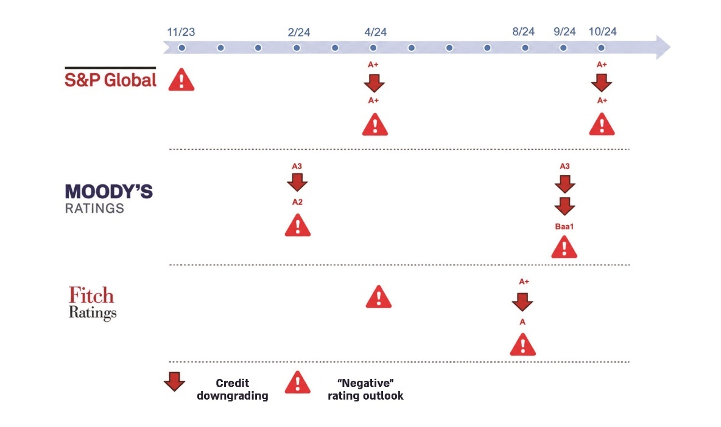

According to notifications from international rating companies, processed by the Office of the State Comptroller.

Part Three – Implementation of the "War Budget" at the Commencement of the Swords of Iron War

NIS 24.9 billion |  | NIS 95 billion |  | 9 days |  | NIS 17.2 billion
War expenses (military and civilian), net – which are war expenses net of payments from the Compensation Fund, in 2023 |  | Direct military expenditure for the Swords of Iron War in 2023–2024 (NIS 17 billion in 2023, and NIS 78 billion in 2024) |  | Time taken for the beginning of payment of the first organization grants to evacuees ("the first pulse" of NIS 1,000 per person) from the beginning of the war |  | Military and civilian war expenditure paid in December 2023
NIS 3.6 billion |  | 67% |  | Approximately NIS 37 billion |  | NIS 1.9 billion
30% of the war budget for civilian purposes, which was designated to budget civilian wartime expenses, was budgeted in existing budget regulations in the various ministries and not in separate budget regulations designated for the Swords of Iron War expenses |  | The cash execution rate of the war budget for civilian purposes from the supplemental budget for 2023. The execution rate, including commitments, stood at approximately 88% |  | Total expenditure in 2024 for the payment of military reserve pay and military reserve benefits – over NIS 3 billion per month (approximately 22% of defense system expenditures in 2024). This compares to an expenditure of approximately NIS 8.7 billion in 2023, and approximately NIS 2 billion in 2022. Appropriate supervision by the Accountant General Department over this expenditure was not identified |  | Payments made to hotels for the evacuation of civilians during the war in October–December 2023. Of which, approximately NIS 1 billion were paid with the approval of the Accountant General Department even before the approval of the supplemental state budget for 2023
Key Findings

The Allocation, Recording, and Management of the "War Budgets" Designated for Civilian Purposes
The Timing of the Disbursement of Expenses from the War Budget for 2023 – A significant portion of military and civilian-related war expenditures – approximately NIS 17.2 billion out of a total of NIS 29.6 billion (including the Compensation Fund) – was disbursed in December 2023. It is noteworthy that the supplementary state budget for 2023 received approval on December 14, 2023, suggesting the potential influence of this approval on the concentration of payments occurring predominantly in December 2023.
The Deficiency in the Separate Budgeting for the Additional War Expenses Within the 2023 Budget – The Budgets Division designated distinct and unique budget regulations for civilian-related war expenditures totaling NIS 8.12 billion; however, an amount of NIS 3.6 billion (representing 30% of the civilian-related war budget) was not allocated in separate budget regulations but rather within existing budget regulations. Consequently, this arrangement impedes the effective oversight and monitoring of these budgets, ascertaining the degree to which they were utilized to address the needs stemming from the Swords of Iron War. In December 2023, the Budgets Division of the Ministry of Finance allocated approximately NIS 28.8 billion for war-related requirements, with NIS 11.8 billion designated for civilian needs (approximately 41%) and NIS 17 billion assigned to security needs. An examination conducted by the Accountant General Department indicated that, within the total budget allocated for civilian-related war needs, it remains indeterminate whether approximately NIS 1.5 billion was expended for the originally defined war needs or diverted to other non-related requirements.

Monitoring and Control of the Implementation of the Supplemental State Budget in 2023
Discrepancies Between the Implementation Data of the Swords of Iron Expenditures in the Regulations Formulated by the Budgets Division and the Implementation Data Within the SIGMA System (System for Integrated Government Management and Administration) – The total budget implementation for the months of October to December 2023, as represented in the Swords
of Iron Regulations, was approximately NIS 5.7 billion, while the implementation related to the "Swords of Iron" overarching tasks reached approximately NIS 4.8 billion. This discrepancy suggests that not all ministries adhered to the directive issued by the Accountant General, which mandated that war expenses be recorded in the SIGMA System as part of the overarching task designated "Swords of Iron".
The Reliability of Data from Diverse Financial Systems With Respect to the Civilian-related War Budget for 2023 – The pronounced discrepancies in total budget execution data from various sources during the months of October to December 2023 – NIS 7.4 billion as reported by the accountants, to the Accountant General, NIS 5.7 billion according to the Swords of Iron Regulations in the SIGMA System, and NIS 4.8 billion associated with the Swords of Iron overarching task in the SIGMA System – illustrate a substantial discrepancy of NIS 2.6 billion between the overarching task data and the Accountant General's records, alongside a NIS 1.7 billion discrepancy between the Swords of Iron Regulations data and the Accountant General's information. These discrepancies underscore underlying issues regarding the reliability of data from various systems, thereby hindering the ability to conduct adequate and comprehensive supervision and control of the expenditures associated with the civilian-related war budget.
Methodology for Control Over the Execution of War Expenditures in 2023 – The Accountant General utilized data from Excel files provided by the government ministries' accounting departments for the purpose of supervision over war expenditure in 2023. This data was subsequently published by the Accountant General in the budget execution report issued in April 2024. Consequently, the information contained in the SIGMA System was only partial, precluding real-time supervision and control. The absence of reliable data undermines the Ministry of Finance's capacity to evaluate the reasons for deviations in execution across various categories, impedes the assessment of potential barriers that may inhibit the execution of the war budget, and obstructs necessary actions to facilitate the implementation of the war budget.
Missing Data in the Accountant General's Reports on Budget Execution for 2023 – The reports lacked information on the execution rate of the Swords of Iron War budget. Instead, they solely presented total state budget execution data and a breakdown of the war budget due to the unreliability of the war budget execution data and the failure to segregate all supplementary war budgets into specific regulations. Although the Accountant General acknowledged in the 2023 War Budget Execution Reports that execution data and outstanding commitments are reliant on the reports from ministries, he did not address the discrepancies between the data from the SIGMA System and the accounting data provided by the ministries.
Obstacles in the Process of Implementing Budgets for War Purposes – Case Studies
Budgeting of the Ministry of Tourism – In light of the exceptional circumstances that have arisen, specifically the necessity to compensate hotels for accommodating evacuees, there exists a notable absence of budgetary provisions within the Ministry of Tourism regulations. This deficiency is attributed to the failure to approve the budgetary request by the Finance Committee. Consequently, the Accountant General Department authorized the Ministry of Tourism to disburse payments amounting to approximately NIS 1 billion, despite the absence of a budgetary source, in order to fulfill the state's obligations to the Hotel Association. Thus, until 14 December 2023, the Ministry of Tourism was compelled to financially support hotels for hosting evacuees without an available budgetary source, thereby exceeding the budget plan and contravening the provisions of the TAKAM (Financial and Economic Regulations), in light of the lack of a budgeting mechanism during emergencies.
Budgeting of the "Tkuma" Directorate – Due to the urgent requirement to execute engagements associated with the Tkuma Directorate for the rehabilitation of peripheral localities and in response to the delays in the approval of budgetary requests submitted by the Budgets Division, the Directorate resorted to soliciting assistance from other government ministries to execute contracts with suppliers for the purpose of assisting residents in the Gaza Envelope.
Timing of Payment of the Organization Grant to Residents Evacuated from Combat Zones – The initial disbursements to evacuees who applied for the organization grant of NIS 1,000 per individual were only initiated by the Ministry of Finance and the Tax Authority on 16 October 2023 – nine days subsequent to the onset of hostilities. At this juncture, NIS 6.14 million were distributed, with the majority of grants disbursed on 18 October 2023 – eleven days after the outbreak of the war (NIS 19.06 million) – and on 19 October 2023 – twelve days following the commencement of the war (NIS 15.32 million). The elapsed time from the outbreak of the war and the evacuation of residents from combat zones to the provision of economic assistance left many citizens without financial solutions during the initial week of the conflict, rendering them reliant on aid and donations from both organizations and private citizens. This scenario underscores the absence of a governmental economic contingency plan for emergencies and exacerbated the distress experienced by evacuees who endured the events of 7 October.
At the same time, it is pertinent to note that the average duration from the submission of the grant application by evacuees to the receipt of the grant amount was 2.82 days, with the median duration being merely two days.
Working Interfaces between Government Ministries and the Budgets Division
Approximately 42% of the ministries that responded to the questionnaire issued by the Office of the State Comptroller regarding the potential for improving the process of obtaining the war budget indicated that, in their assessment, the process could indeed be improved. Furthermore, 55% (11 ministries out of 20) expressed a need for budgetary supplements and formally requested them; however, these requests were not fulfilled for various reasons.
The respondents to the Office of the State Comptroller questionnaire from among the various ministries articulated divergent opinions concerning the efficiency and accessibility of budgeting for war-related needs. Some ministries reported that the Budgets Division exhibited a prompt initial response in budget transfer procedures. Conversely, other ministries claimed the absence of an expedited procedure to abbreviate the process in light of the emergency event's magnitude, resulting in considerable delays in the actual disbursement of funds. This delay was, in part, attributed to the Finance Committee's sluggish operation within the Knesset. Additionally, several ministries noted that the budget freeze letter contributed to a cessation of certain operational activities and complicated their interactions with the Ministry of Finance, contingent upon their interpretation of the letter.
Below are illustrative examples derived from the ministries' responses to the Office of the State Comptroller questionnaire concerning the budgeting process with the Ministry of Finance:
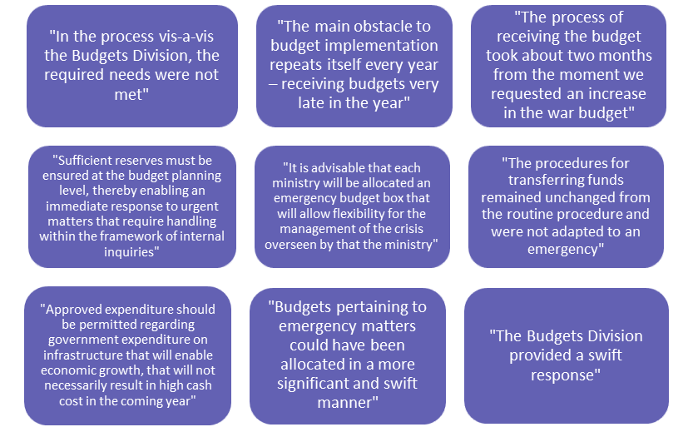
According to the ministries' responses to the questionnaire, processed by the Office of the State Comptroller.

Working Interfaces between Government Ministries and the Accountant General Department
Approximately 37% of the ministries that responded to the questionnaire regarding the assistance provided by the Accountant General Department for the implementation of rapid contract procurement, as part of the Office of the State Comptroller questionnaire (6 out of 16 ministries), indicated that the process for executing rapid contract procurement could have been enhanced in the initial months of the war and that they did not receive adequate assistance and support for this endeavor. Approximately 58% of the ministries reported encountering obstacles in the execution of the budget. Several ministries noted challenges in obtaining timely responses from the Accountant General concerning rapid and immediate procurement, as well as difficulties related to changes in work procedures and emergency guidelines. The aforementioned ministries asserted that the procurement processes had not undergone substantial modifications, that they were not granted innovative relief for expedited procurement, and that this situation resulted in delays with suppliers. Some ministries recommended exploring the potential for rapid procurement processes to provide immediate responses in emergency situations by expanding the Accountant General’s authority regarding tenders for emergency matters.
It was noted that only on December 27, 2023, more than two months after the onset of the war, Mandatory Tenders Regulations were enacted, which expanded the powers of government ministries to engage with suppliers through exemptions from tendering processes. Consequently, several ministries contended that until the regulations were instituted, they had been unable to establish obligations with suppliers.
Below are examples of the ministries' responses to the Office of the State Comptroller questionnaire regarding the interface between them and the Accountant General:
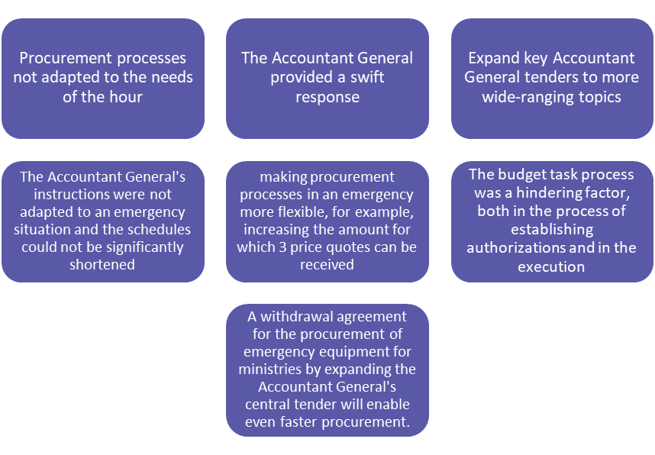
According to the ministries' responses to the questionnaire, processed by the Office of the State Comptroller.

Issues in the Defense Budget
The Ministry of Finance's Oversight of the Budgets Allocated to the Ministry of Defense – The additional budget provided to the Ministry of Defense for the fiscal years 2023–2024, aimed at financing the expenditures related to the Swords of Iron War, totals approximately NIS 115 billion (gross). This includes NIS 17 billion in the supplementary budget for 2023, about NIS 66 billion from the first supplementary budget approved in March 2024, and approximately NIS 32 billion from the third supplementary budget approved in December 2024.
Following the onset of the conflict, the Accountant General permitted the Ministry of Defense to incur expenses and establish unlimited commitments and obligations, ensuring the continuity of war operations and the associated military requirements. However, this approach was executed without adequate control and oversight mechanisms, thereby hindering the systematic management and classification of the defense budget. Had the war budget for 2023 been approved in a timelier manner after the war commenced, it would have created a clear budgetary framework for defense expenditure, facilitating enhanced oversight and control by the Ministry of Finance regarding the pace of defense spending.
The Establishment of a Public Committee to Examine Security Needs – Since the war's outbreak there has been a substantial increase in the budgets allocated to the Ministry of Defense – comprising both the current and reinforcement budgets. The altered perspective on addressing security threats in the aftermath of the war necessitated the formation of a committee to delineate the requisite scope of the defense system's needs, while simultaneously balancing security imperatives with civilian demands. However, conflicts that arose between the Ministry of Finance and the Ministry of Defense concerning the composition of the committee, the matters to be addressed by it, and the budget provisions for the defense system until the end of the committee's deliberations (mainly for reinforcement purposes), resulted in the committee commencing its activities only in August 2024, rather than January 2024 as originally scheduled. Consequently, concerns emerged regarding the relevance of the committee's findings in relation to the preparation of the 2025 budget. The Office of the State Comptroller has commented on the prolonged failure of the Ministry of Defense to resolve the disputes with the Ministry of Finance, which delayed the establishment of the committee by approximately seven months.
Oversight Over the Use of Reserve Days During the War – During the years 2023–2024, there was a marked increase in expenses associated with reserve benefits: from an annual expenditure of less than NIS 2 billion in 2022 to approximately NIS 8 billion in 2023, and projected expenditures of around NIS 32 billion in 2024. Additionally, expenditures related to reserve benefits surged from approximately NIS 0.5 billion in 2022–2023 to about NIS 5 billion in 2024, leading to a cumulative annual expenditure of approximately NIS 37 billion in 2024 – translating to over NIS 3 billion per month, accounting for roughly 22% of the defense system's expenditures that year. In light of claims made by the Accountant General, there is concern regarding the insufficient and ineffective control exercised by the IDF over the utilization of reserve days during the war. Conversely, the Accountant General Department has demonstrated insufficient oversight over this expenditure, which according to him is due to the absence of adequate tools necessary for comprehensive supervision.
Execution and Control of Individual Payments Within the IDF – As part of the multi-year plan initiated in June 2023, it has been decided to establish a joint pension and salary administration for the Accountant General and the IDF. This joint administration will commence operations on October 1, 2023, with the objective of executing and monitoring individual payments within the IDF. However, it was determined that by the audit end date in November 2024, the joint administration had not been established. This failure to implement the administration hampers the achievement of its intended purpose – namely, the supervision and oversight by the Accountant General over individual payments in the IDF. Notably, on November 22, 2024, an appointment was made for the head of the IDF Salary and Pensions Administration under the auspices of the Accountant General.

The Government Ministries' Participation in the War Budget Review Process – A substantial majority of the ministries that responded to the inquiry regarding their involvement in the review of the supplemental budget for 2023 (89% of the participating ministries – 17 out of 19) indicated their participation in collaboration with the Budgets Division in the war budget review process for the year 2023.
Promoting Procurement Procedures During the War Period – Approximately 63% of the ministries that addressed the question concerning the assistance provided by the Accountant General Department in implementing rapid contract procurement, as articulated in the Office of the State Comptroller questionnaire, acknowledged that the Accountant General facilitated the execution of rapid contract procurement. Numerous ministries expressed appreciation for the Accountant General's availability, proactive engagement in the field, readiness to devise solutions, and prompt convening of central exemption committees in response to emergencies. A significant number of ministries conveyed that, on occasion, representatives of the Accountant General authorized the exemption of contracts prior to the receipt of a budget, citing the urgency associated with the execution of these contracts.
Breakdown of Swords of Iron War Expenditure, Gross*, by Month, 2023
(in billions of NIS)
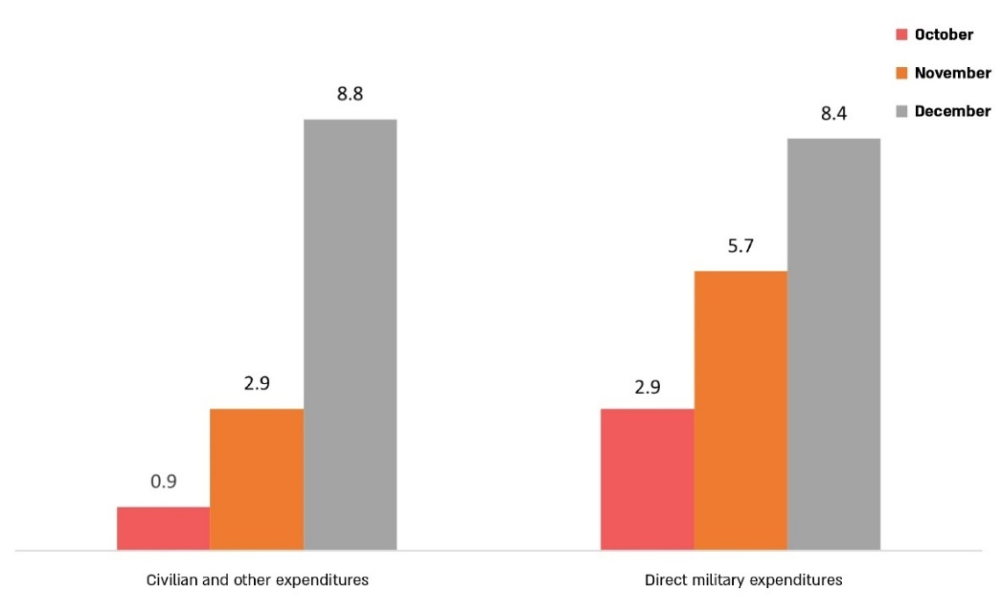

Source: Accountant General, Budget Execution Reports for 2023.
* Including the Compensation Fund.

Details of Payments in the Defense Budget, Including Reserve Pay and Reserve Benefits in the Years 2022–2024 (net, in billions of NIS)

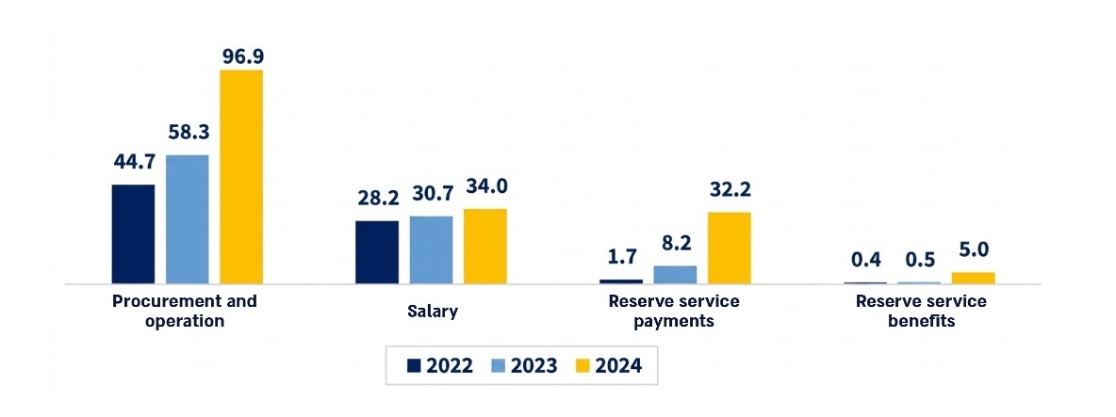

Source: The state's financial statements as of December 31, 2024.

Key Recommendations
Recommendations for Part One – Economic Preparedness for an Emergency Preceding the Swords of Iron War

- Given the occurrence of numerous emergency events in recent years, necessitating substantial increases in the state budget during the budget year, it is advisable for the Ministry of Finance to explore the formulation of a systematic legal mechanism that facilitates rapid budget allocation during emergencies for specific and unforeseen purposes, which cannot be addressed within the current framework of the Budget Law. This mechanism should encompass clear criteria, decision-making authorities for its implementation, and structured control measures. Furthermore, it is proposed that the Ministry assess the feasibility of pre-identifying potential sources that may be reallocated within the existing budget during the preparation of the state budget, thereby enabling an initial response to emergencies based on various scenarios. This approach would facilitate the quick identification of suitable budget allocations in the event of an emergency, in alignment with the priorities set by professional bodies. Additionally, it is recommended that the Ministry of Finance, in collaboration with the Ministry of Justice, explore the establishment of an "emergency reserve" item within the state budget to enable immediate budgetary responses to emergencies. It is also suggested that the Ministry evaluate the practical application of the dedicated reserve budget mechanism outlined in the 2025 Budget Law to improve future state budget formulation.
- It is recommended that the Ministry of Finance, along with its various departments, including its Director General, the Chief Economist Division, the Budgets Department, and the Accountant General Department, develop, in coordination with the National Emergency Management Authority (NEMA), a response plan for potential war scenarios. This plan should incorporate diverse alternatives, including the duration and intensity of combat, the scope of operational arenas, and the anticipated economic impact. Moreover, it is advisable for NEMA to adjust the reference scenarios, in coordination with the IDF, pursuant to the parameters of the Swords of Iron War. The Director General of the Ministry of Finance must ensure that the designated authority for emergencies conducts annual drills, involving both management staff and field-level personnel, deputies, coordinators and various referents, aimed at addressing the economic ramifications of emergency situations and the provision of budgetary responses within tight timelines. The Director General and the designated authority within the Ministry are also to engage in annual assessments to rectify any deficiencies identified in the drills, as specified in the procedure governing emergency training and drills. The participation of the Minister of Finance in these drills is recommended to verify that the Ministry is adequately prepared for emergencies and wartime scenarios.
- The Prime Minister should appoint an integrating political entity to spearhead Israel's strategy for emergency preparedness and economic resilience against risks posed by various emergencies, including warfare, pandemics, and extreme natural events. This entity should facilitate timely discussions and promote the implementation of lessons learned regarding governmental preparation, particularly within economic contexts.
- It is advisable for the Ministry of Finance to derive insights from the procurement processes employed by government ministries during wartime, assess whether gaps existed in relation to the requests from entities in the field, and consider the necessity of formulating "contingency regulations" in accordance with the Mandatory Tenders Law for procurement during emergencies. Additionally, the Ministry should evaluate the need to establish advance contracts ("contingency contracts") for essential cross-cutting requirements at the onset of emergencies, particularly in wartime scenarios. Considering the substantial financial implications of requests processed by various exemption committees, it is recommended that the Accountant General explore alternative strategies to streamline and expedite urgent procurement processes during such emergencies.
- It is proposed that the Bank of Israel finalize the development of a comprehensive contingency plan encompassing a range of cases and responses pertinent to monetary emergencies, as defined by the Bank. Furthermore, the Bank should continue to evaluate the cost-effectiveness of monetary programs, such as credit initiatives for small and micro businesses impacted by warfare, and endeavor to ensure that favorable credit terms from banks reach the business owners in need.

Recommendations for Part Two – Preparation of the "War Budgets" for 2023–2024 at the Ministry of Finance
- It is advisable for the Ministry of Finance to derive insights and establish protocols for the allocation of alternatives in budgeting for unforeseen needs that were not accounted for during the initial budget formulation. It is proposed that these protocols encompass various methods for financing unexpected expenditures, including, but not limited to, the reallocation of priorities within the existing budget and/or the utilization of a budgetary reserve, in compliance with the provisions of Section 3(c) of the Basic Law: State Economy, as well as the promotion of an additional budget law. It is crucial that the legislative framework developed for the immediate allocation of funds during emergencies involves the participation of senior economic officials, including the Minister of Finance, the Governor of the Bank of Israel, the Commissioner for Budgets, the Accountant General, the Chief Economist, and the Head of the National Economic Council, among others. Furthermore, it is recommended to engage with the Director of the Tax Authority and the Director of the National Insurance Institute regarding the establishment of mechanisms for the prompt provision of financial assistance. As part of this initiative, it is advisable to examine the mechanisms employed and regulated in advanced nations globally, alongside the supervisory controls governing their execution.
- In light of the disagreements that arose during the formulation of the 2023 war budget among the departments within the Ministry of Finance, particularly between the Budgets Division and the offices of the Minister and the Director General, it is essential for the Ministry of Finance to implement procedural guidelines for coordinating interdepartmental actions. This will ensure that following the determination of priorities by the political echelon, the process of preparing the state budget is conducted efficiently, appropriately, and professionally by the competent professional staff as is customary.
- The Minister of Finance should assess the recommendations of the Kochik Committee and address the deficiencies within the existing ministry structure. Additionally, the Ministry of Finance should evaluate the incorporation of procedural guidelines for the formulation of the annual economic plan and for interdepartmental coordination, while adjusting timelines for operations during emergencies. This approach would have mitigated the disputes surrounding the establishment of the special task force and its authority, thereby enhancing the implementation of an effective operational framework during emergencies, including a mechanism for the rapid disbursement of funds as stipulated in the emergency procedure. The Ministry's response plan during wartime should integrate the necessary controls.
- It is recommended that the Budgets Division analyze how the budget summaries and the anticipated allocation of reserve regulations within the SIGMA System can be effectively communicated to the Ministry's management throughout the fiscal year, with reference to the likelihood of actual budget execution. This enhancement will foster improved transparency towards all stakeholders within the Ministry of Finance and facilitate decision-makers' ability to monitor budgeting processes and implementations, which is particularly crucial during emergencies. Additionally, it is advised that the Budgets Division conduct a lessons-learned exercise from the war budget formulation process with the relevant ministries and enhance ongoing collaboration with government ministries by establishing appropriate working mechanisms to optimize interfaces for budget formulation and updates.
- It is recommended that, during the formulation of the state budget, the management of the Ministry of Finance focuses on establishing priorities across the entire state budget to maintain budgetary equilibrium amidst ongoing conflict, while also proactively addressing the security needs that must be met within the state budget, thus providing responses to the citizens of Israel during emergencies.
- The downgrading of the state's credit rating by international credit rating agencies, coupled with their negative forecasts (notably given the repeated occurrence of such downgrades), significantly influences the projected increase in interest expenses within the state budget. Furthermore, there is an expectation of a continual rise in both defense and civilian expenses attributable to the war. In light of these factors and the prevailing fiscal uncertainty, it is recommended that the Minister of Finance and the Ministry's management consider the guidance of professional entities, including the Bank of Israel, to examine the necessity of implementing measures aimed at improving the country’s fiscal health and reinforcing its commitment to debt repayment. Additionally, it is advisable for the Prime Minister and the Minister of Finance to convene a discussion within the government or the Socio-Economic Cabinet regarding the repercussions of the downgrade in the country’s credit rating and the associated negative forecasts.
- As noted by the State Comptroller in a previous report, it is prudent to utilize a budget "box" exclusively under exceptional circumstances that sufficiently justify this approach, to preserve, to the extent possible, the fiscal, governmental, and legal principles underpinning the annual state budget approval process. It is recommended for the Ministry of Finance to devise potential solutions promptly, both in the short and long term, to converge as closely as possible with the deficit rate prescribed by law. The escalation of military conflict in the north and other arenas and the realization of scenarios divergent from the foundational assumptions upon which the 2024 budget was constructed necessitate government consideration of necessary actions and adjustments to preclude a significant increase in the deficit, which would entail the incurrence of substantial and costly debt in the financial markets.
Given the marked increase in defense and civilian expenditures resulting from the war, the impact of the credit rating downgrade on interest payments, the extent of governmental debt, and the rising debt-to-GDP ratio, alongside the insufficient adjustments made in the 2024 budget, there is a concerning prospect that the nation’s fiscal resilience will be compromised. Given the imperative of maintaining governmental fiscal credibility, it is advisable for the Minister of Finance and the Ministry of Finance to consider adopting restrictive measures with enduring effects, predicated on establishing priorities within the state budget.

Recommendations for Part Three – Implementation of the "War Budget" in the First 90 Days Following the Outbreak of the Swords of Iron War
- It is recommended that the Budgets Division and the Accountant General Department within the Ministry of Finance develop a comprehensive and systematic policy concerning the allocation and management of special budgets within the state budget, as well as the monitoring and control of these mechanisms, particularly during emergencies. The manner in which the war budget has been allocated has hindered decision-makers' access to pertinent data, thereby obstructing the potential for informed decision-making and the realization of governmental objectives utilizing allocated public funds. The protraction of the Swords of Iron War and the escalation of hostilities across various fronts underscore the necessity of rectifying existing deficiencies to facilitate more effective preparedness, which includes enhancing real-time decision-making processes.
- The substantial rise in military expenditures by the Ministry of Defense during the Swords of Iron War, encompassing both current expenditures and operational costs, requires the Ministries of Finance and Defense to implement stringent oversight and control mechanisms regarding the rate of military spending in relation to the approved funding sources. This is particularly crucial given the considerable uncertainty surrounding future scenarios and requisite expenditures, alongside the implications of escalating defense expenditures on the state budget and adherence to fiscal frameworks. The Accountant General must exercise stringent control and oversight over the utilization of both war budgets and the current budgets allocated to the defense establishment, especially considering the protracted nature of the conflict and the imperative for judicious and efficient management of the state budget over time.
- The budgetary allocation for reserve service days in 2023–2024 amounts to several billion NIS and represents a primary war expenditure. In light of the financial and economic ramifications of reserve service, it is essential for decision-makers to address this matter promptly. As time elapses following the commencement of the conflict, and in consideration of the evolving circumstances, the Ministries of Finance and Defense, in collaboration with the Israel Defense Forces, should evaluate the compensation model for reserve service members, assessing its appropriateness for the current context. This evaluation should include the potential differentiation between combat and non-combat reserve personnel, compensation for partial reserve days, and rigorous supervision and control over the allocation and utilization of reserve days, while also investigating suitable and effective frameworks for their deployment. This process should consider the requirements of the defense establishment, the broader economic context, and the constraints of finite resources.
- Given the significant anticipated increase in defense spending in forthcoming years and its repercussions on both the state budget and the economy, it is crucial that resource allocation for defense strikes a balance between defense priorities and civilian needs. Furthermore, consideration should be given to the implications of Operation "Rising Lion", aimed at enhancing Israel's capacity to address security demands while exhibiting fiscal responsibility and a holistic economic perspective. In light of the projected escalation in direct military expenditures for the Swords of Iron War in 2023–2024, estimated at approximately NIS 95 billion, it is advisable to ensure adequate oversight of the execution of the budgets of the Ministry of Defense and the IDF by the Ministry of Finance.
The Accountant General should also engage in a thorough process of reviewing lessons learned with various ministries and addressing the gaps identified. Additionally, it is recommended that the Accountant General anticipate procurement needs for emergencies by assessing the services and goods required by each ministry based on its expected operations in crisis situations. This preparation should include the development of expedited emergency procedures to streamline procurement during emergencies, the consideration of broad central tenders as necessary for emergencies, and the exploration of advance contracts ("contingency contracts") for essential cross-cutting needs that may arise at the onset of crisis situations, particularly in the context of armed conflict. Furthermore, the Accountant General should clarify with ministries the alternative strategies available when engaging with suppliers in emergency procurement procedures, including the use of exemption clauses and existing mechanisms within the framework of the Mandatory Tender Regulations.
xtent the Key Deficiencies Noted in the Previous
Report were Rectified

Summary
The Swords of Iron War and its economic implications for the Israeli economy exemplify the state's inadequate advance preparation for emergency situations, particularly the absence of economic contingency plans tailored to various emergency scenarios, especially that of a prolonged conflict.
This deficiency is further exacerbated by the lack of a designated emergency budget reserve in the state budget for 2023–2024, which could be promptly utilized for both military and civilian requirements.
Effective economic emergency preparedness is essential for maintaining economic stability, addressing fiscal and monetary challenges, and ensuring continued access to services and resources during times of crisis.
Since the State of Israel navigates ongoing security events, encompassing both short and long-term systemic threats, it remains susceptible to risks associated with warfare, in addition to other significant hazards such as earthquakes and pandemics. Consequently, the state must undertake comprehensive preparations for emergencies, crises, and disasters that pose threats to human life and may severely disrupt lifestyles, national infrastructure, security capabilities, and overall national resilience.
The audit revealed that the process of developing the supplementary budget for 2023 and 2024 experienced substantial delays, despite the urgency prompted by the war's demands. This lag was attributed to disagreements between the professional echelon and the Minister of Finance regarding the appropriate mechanisms for crafting the wartime budget, the requisite allocations, and the sources for financing civilian war-related expenses within the supplementary budget framework for 2023, the ramifications of which extended to the preparation timeline for the supplementary budget for 2024. It was also observed that no significant austerity measures were enacted within the supplemental budgets for 2023 and 2024, particularly regarding the reduction of coalition funds and the number of government ministries.
As a result of insufficient fiscal restraint within the wartime budgets for 2023 and 2024, the government was compelled to exceed the legally permissible spending cap by tens of billions of NIS during 2024 in order to accommodate war-related expenditures. These actions, which necessitated considerable increases in tax obligations imposed on the public, adversely impacted market conditions and manifested in elevated interest payments, which will continue to accrue in subsequent years, diverting resources that could otherwise benefit the citizenry. Given the substantial increases in defense and civilian expenditures due to the conflict, alongside credit rating downgrades affecting interest payments and the escalation in government debt and debt-to-GDP ratios, and in light of insufficient adjustments in the 2024 budget, concerns arise regarding the potential erosion of the nation's fiscal resilience.
Moreover, the audit disclosed weaknesses in the existing management approach to allocating the war budget, its execution, and oversight of its implementation. This may hinder decision-makers from acquiring a comprehensive understanding of the situational landscape and pertinent data prior to making impactful decisions concerning the achievement of governmental objectives related to the war budget and the allocation of governmental resources necessary for these ends.
According to an estimate released by the Bank of Israel in September 2024, the anticipated total financial burden of the war for 2023–2025 is approximately NIS 250 billion. In light of the ongoing hostilities and the intensification of military conflicts in the northern region and other arenas, alongside a deterioration in key economic indicators since the onset of the war, including a series of credit rating downgrades, an increased debt-to-GDP ratio (from approximately 61.4% in 2023 to approximately 69% in 2024), a rise in the government budget deficit by approximately 2.7 percentage points (from approximately 4.1% of GDP in 2023 to approximately 6.8% of GDP in 2024), and a downward revision of growth forecasts by all relevant professional entities, the Minister of Finance is advised to conduct a periodic review with all pertinent professional bodies, both within and outside the Ministry of Finance, to evaluate necessary measures to bolster the country's economic resilience. This includes implementing growth-enhancing initiatives aimed at improving the country's fiscal conditions and reinforcing its commitment to debt repayment.
Furthermore, it is imperative that the Ministry of Finance, and the Minister of Finance, the Bank of Israel, the National Economic Council, and all entities bearing economic responsibilities towards the State of Israel, take decisive actions to rectify the identified deficiencies and implement the recommendations presented in this report. This will facilitate national economic preparedness for emergencies and ensure a swift and effective economic response to the needs of the citizenry.

The groups are: households and businesses located within 30 kilometers of the Gaza Strip; civilians who were evacuated from their residences or enlisted into the reserves under Order 8, as well as individuals with first-degree relatives who were killed in the conflict or who are kidnapped or missing.
Sales and repurchase agreement. A repurchase agreement, or repo transaction, is a form of short-term borrowing utilized for liquidity purposes, secured by high-quality collateral, primarily government securities. The trader sells the securities to investors and subsequently repurchases them shortly thereafter, typically the following day, at a marginally higher price that reflects the interest rate associated with the transaction.
Budgeting and Public Expenditures in OECD Countries 2019, OECD.
However, it should be noted that in particular, the Budgets Division's proposal for sources to finance civilian war expenses from November 6, 2023, also included budget sources that do not originate solely from coalition funds.
The budget received from the Budgets Division is managed in the SIGMA System, in which all budgets are managed. The "designation" of separate regulations enables monitoring of the pace of spending on a monthly basis of associating budgets designated for special situations (such as war situations) in accordance with the classifications established by the Accountant General.
This is the budgetary tool intended to classify expenses for the Swords of Iron War in all government ministries.

