Preparedness of the Education System for Learning in an Emergency and its Operation during the Swords of Iron War

Preparedness of the Education System for Learning in an Emergency and its Operation during the Swords of Iron War
Abstract


On Simchat Torah, October 7, 2023, the Hamas terrorist organization launched an assault on the State of Israel, through the launch of thousands of rockets and the infiltration of thousands of terrorists into Israel Defense Forces (IDF) bases, as well as into cities and communities located in the Western Negev (the Gaza Envelope communities). The terrorists also targeted large gatherings near the Gaza Strip. The thousands of terrorists perpetrated heinous acts of cruelty, resulting in the deaths of 415 soldiers and security personnel, the murder of 905 Israeli and foreign civilians, and the abduction of 251 individuals into the Gaza Strip. On October 7, 2023, the Swords of Iron War broke out.
The war profoundly affected the education system, which has been functioning in a continuous state of emergency. Among other things, this has led to the disruption of its routine operations – the inability to conduct in-person learning in schools and the transition to distance learning, due to lack of protective measures within the schools, risks associated with transportation of students, and a shortage of teaching staff. During this ongoing emergency, the education system, under the leadership of the Ministry of Education, has faced complex challenges. The primary challenges relate to maintaining a consistent and high-quality educational routine, as far as possible, across all educational institutions, while addressing the social and emotional needs of the students.
To ensure the education system remains prepared for unforeseen circumstances and to enable continuous learning regardless of the situation, distance learning has been established as a key solution. This learning takes place online, with the support and guidance of teachers by means of collaborative communication tools, and relies on advanced digital literacy. Preparation for digital learning and its incorporation should take place during periods of normalcy. At the same time, the education system should maintain an effective mechanism for transitioning back to in-person learning when possible, during the conflict, along with ensuring adequate protection for schools.


5,653 and about 1,986,000 |  | Only 11% |  | 72% and 48% |  | 59%
The number of schools and the number of students, respectively, in the education system in the 2023–2024 school year, during which the Swords of Iron War broke out |  | The percentage of schools found to be highly technologically equipped for implementing blended learning in a survey conducted by the Ministry of Education in February 2023 (480 schools out of 4,522) |  | The percentage of schools that lacked end-user equipment for distance learning and teaching for students and teachers, respectively, according to the School Principals Survey (Principals' Survey) conducted by the Office of the State Comptroller (976 and 653 schools out of 1,347, respectively) |  | The percentage of schools where distance learning is incorporated during routine times to a limited extent or not at all, according to the Principals' Survey conducted by the Office of the State Comptroller (795 schools out of 1,347)
Only 45% and 46% |  | 39% |  | 257 and 741 |  | 3.5%–17.5%
The percentages of students and teachers, respectively, who participated in synchronous lessons in the national distance –learning drill that took place in the 2022–2023 school year |  | The percentage of schools, according to the Principals' Survey, in which not all students were able to reach the protected areas within the warning time |  | The number of schools where there was no security coordinator and the number of schools where the security coordinator did not undergo professional training, respectively, according to the Protection Survey conducted by the Ministry of Education in 2018–2024 |  | The range of increase rates in average grades on the 4-unit mathematics matriculation exam in 2024 (compared to 2023), as a result of the concessions scheme for examinees according to the impact circles: Circle 1 – 3.5%; Circle 2 – 4.3%; Circle 3 – 8.5%; Circle 3.5 – 10.3%; Circle 4 – 17.5%
Audit Actions

From January 2024 to June 2025, the Office of the State Comptroller conducted a comprehensive examination of the Ministry of Education's preparations and actions to ensure effective learning within the education system on the home front (excluding evacuated communities). This evaluation included an analysis of the procedures implemented for operating schools during emergencies, the Ministry's readiness for digital learning and distance education during crises, and the measures undertaken to foster digital learning and its integration into schools during routine times as an infrastructure for distance education during emergencies. The review also encompassed the preparations of schools for emergencies and the processes involved in their re-operation following closures at the onset of the war; and the adaptation of matriculation exam formats to accommodate the ongoing emergency conditions since the war began. The examination was carried out at the Ministry of Education in the Head Office units, as well as the Central and Haifa districts, and the National Authority for Measurement and Evaluation in Education (RAMA). Additionally, the Office of the State Comptroller conducted surveys targeting school principals and parents of students, which focused on the emergency preparedness of schools and their operations after the war broke out.
It is important to note that this report did not address the measures taken by the Ministry of Education to provide solutions for schools in evacuated communities (except for those concessions made regarding matriculation exams in light of the war). The educational responses to the students displaced from their homes and the educational institutions they attended are included in the audit framework conducted by the Office of the State Comptroller on the subject of the absorption of the evacuee population during the Swords of Iron War and its handling by governmental entities.

Key Findings

The Ministry of Education's Preparation for and Implementation of Digital Learning

Lessons Learned by the Ministry of Education from the COVID-19 Crisis and the Impact on the Education System during the Swords of Iron War – During the COVID-19 crisis the education system gained experience in the implementation of digital learning in an emergency due to the circumstances of that time. It was to be expected that these lessons would be effectively integrated into the education system, thereby significantly enhancing the efficacy of digital learning during the Swords of Iron War. The audit revealed that despite the fact that since COVID-19 the Ministry of Education has recognized the importance of advancing digital learning as an infrastructure for distance learning in emergency settings and as a fundamental prerequisite for effective learning during emergencies, and has taken measures to advance it, essential components for improving the effectiveness of digital learning during routine times have not been implemented. As a result, the effectiveness of this learning did not improve significantly during the Swords of Iron War, and the required "leap" in the quality of distance learning in the education system did not materialize.
Multi-Year National Strategic Plan for Promoting Digital Learning in the Education System – Digital learning within the education system encompasses the integration of digital tools and the utilization of the Internet in the processes of learning, teaching, and assessment, including online courses, computer-based learning tasks, and synchronous online lessons. The audit found that despite the recommendations put forward in the State Comptroller's report published in 2021 regarding distance teaching and learning during the COVID-19 period, and despite the Ministry of Education's notification in response to the report that it had devised a strategic framework for digital-blended learning as the foundation of a national multi-year work plan, the Ministry had not yet finalized the preparation of this plan as of the audit end date. The Ministry failed to complete the strategic process initiated in 2021, no products from that process were presented to the Ministry's management for discussion and review, and in any case, no decision was reached regarding the continuation, alteration, or cessation of the process. In practice, the Ministry did not advance this initiative, and its products were neither developed nor incorporated into a cohesive plan.
Lack of Technological Infrastructure for Digital and Distance Learning
- A technology equipment survey conducted by the Ministry of Education in early 2023 revealed that the preparedness of schools to equip themselves with digital learning resources in both routine times and times of emergency was inadequate, with approximately 23% of the responding schools having a low level of equipment, and 66% having a medium level of equipment. This was so, despite the recommendations put forward in the State Comptroller's report from 2021 and the strategic initiatives undertaken by the Ministry of Education during 2021-2022, and despite the importance of end-user devices in the homes of students and teachers to enable distance learning during emergencies.
- Surveys conducted by the Office of the State Comptroller among school principals and parents disclosed that even amidst wartime conditions, there existed a notable deficiency in the resources for distance education, particularly among students (in approximately 72% of the schools), but also among teachers (in about 48% of the schools). This deficiency affected the ability to conduct distance learning and impacted its effectiveness. About a quarter of the school principals who did not implement distance learning during the emergency situation (27%) attributed this primarily to the lack of necessary resources.
- It was further noted that during the COVID-19 pandemic in 2020, the Ministry of Education directed school principals to establish lending libraries for end-user equipment and to identify students in need of such resources. However, despite the lack of end-user equipment among students, which hindered distance learning during the war, parents were not sufficiently aware of the availability of school lending libraries. Indeed, approximately 85% of parents who responded that their child lacked resources for distance learning did not reach out to the school for assistance regarding distance learning devices for their children.
Training Teachers for Digital Teaching – During the 2021-2022 and 2022-2023 school years, only about 12% to 15% of teaching staff received training in digital learning. A questionnaire distributed among teachers by the Ministry of Education in April 2024, addressing distance teaching, learning, and assessment skills, disclosed that between 36% and 40% of teachers did not perceive themselves as skilled in the necessary subjects for distance teaching. Furthermore, despite the high importance of a school ICT coordinator for incorporating ICT within the school, during the school year 2023-2024 around 27% of all schools (1,544 out of 5,647 schools) had not appointed an ICT coordinator.
Emergency Distance Learning Preparation Drills – It was to be expected that following the prolonged periods of distance learning experienced during the COVID-19 pandemic, both the number of students taking part in the distance-learning drill and the participation rate would increase in the 2021-2022 and 2022-2023 school years. However, the audit revealed that, in practice, on the eve of the Swords of Iron War, approximately a quarter of the students (around 350,000) had not participated in the distance -learning drill, which serves as a fundamental tool for enhancing preparedness for distance learning. The non-participation rates of 23% of all schools (excluding the ultra-orthodox Jewish sector) in the 2021-2022 school year and 16% in the 2022-2023 school year, particularly among the schools in the ultra-orthodox Jewish sector (where in the 2022-2023 school year only 16% of the schools participated in the drill), are significantly below the Ministry's target of 100% participation. The percentage of students reported to have participated in the drill was also very low, standing at 12% and 40%, respectively. These deficiencies undermine the ability of schools to adequately prepare for distance learning in emergency situations.
Integrating Digital Learning and Distance Learning during Routine Times – The responses of school principals and parents to surveys conducted by the Office of the State Comptroller revealed that despite acknowledgment of the importance of distance learning during the COVID-19 pandemic and the recommendations put forward in the State Comptroller's report, together with insights gained by the Ministry of Education from the pandemic, most schools failed to integrate distance learning into their routine operations or did so only to a limited extent. The Principals' Survey conducted by the Office of the State Comptroller revealed that approximately 59% of principals (795 out of 1,347) incorporate distance learning in their schools in routine times to a minimal extent or not at all, while only around 21% of principals (284 out of 1,347) incorporated distance learning in their schools to a large or very large extent.
School Emergency Preparedness Procedures
Challenges in Accessing Protected Spaces in Schools – In their responses to the Principals' Survey conducted by the Office of the State Comptroller, approximately 15% of principals reported that only up to half of the students were able to reach the protected spaces within the designated warning time; about 24% responded that more than half, but not all, of the students succeeded in doing so. This shows that in nearly 40% of schools (out of the approximately 1,300 principals who responded to the question), not all students were able to reach the protected spaces within the warning time. The responses from school principals also highlighted that the most common reasons for this were lack of adequate spaces for accommodating all the students, excessive distances from classrooms, and overly narrow access routes. Special challenges in bringing students to the protected spaces emerged from the responses of principals of special education schools, attended by students with mobility disabilities.
Appropriateness of Protected Spaces in Schools – The results of the Protection Survey conducted by the Ministry of Education from 2018 to 2024 revealed that in 186 schools (4.2% of all surveyed schools with protected spaces), inappropriate doors or windows were identified within the protected space, and in 96 schools (2.2%), the escape hatch of the protected space was inappropriate. The survey also disclosed that the percentage of schools lacking essential components in their protected spaces –toilets, an air filtration system, and a communication system – were high and even very high. Specifically, approximately 55% of the schools lacked toilets in the protected spaces, around 69% lacked a filtration system, and nearly 87% did not have a communication system. As of June 2025, the Ministry of Education lacked information regarding the rectification of the deficiencies disclosed by the Protection Survey, including the completion status of the essential components mentioned above.
Appointment of a School Security Coordinator – The security coordinator is the senior professional who works alongside the school principal in matters of security, safety, and emergency preparedness during both routine times and emergency situations. According to the Protection Survey conducted by the Ministry of Education from 2018 to 2024, 257 schools lacked a security coordinator at the time of the survey (approximately 5% of the surveyed schools). By population group, the highest number of schools lacking a security coordinator (184 schools) were those operating within the ultra-orthodox Jewish community, amounting to close to 12% of the schools within this community. Furthermore, it was found that in 741 schools, the security coordinator had not received professional training for the position at the time of the survey (15.5% of the schools with a security coordinator assessed in the Protection Survey). These gaps have the potential to significantly undermine the preparedness of these schools for emergencies and their operational effectiveness during such times.
Communication between Schools and Students' Parents during Wartime – Appropriate and continuous communication between schools and students' parents during emergencies is vital. It is essential for conveying crucial information regarding the continuation of studies during the emergency, addressing parents' inquiries and concerns, and fostering their cooperation to ensure the smooth functioning of the educational system during emergencies. The responses of parents to the Parents' Survey conducted by the Office of the State Comptroller revealed that the primary modes of communication between schools and parents during the war were WhatsApp groups or email (68% of respondents), whereas other modes of interaction , allowing for more personal communication and the opportunity to provide reassurance and enhance the trust between the parties – a direct conversation between the form teacher and the parents; a Zoom meeting between the school principal or form teacher and the parents; and the establishment of an "open line" for responding to parents' questions- were utilized at lower rates (approximately 15%–17% of respondents).
Changes to the Matriculation Exam Scheme Following the Swords of Iron War
Following the Swords of Iron War, the Ministry of Education established a scheme for granting concessions on the matriculation exam requirements. This scheme included differentiating between all examinees nationwide and those from populations particularly impacted by the conflict. The Ministry divided schools with students participating in the matriculation exams into categories ("impact circles") based on the severity of the impact they experienced during the Swords of Iron War: Circle 1 – the lowest impact level (most students); Circles 2–3.5 – a higher impact level (students who were evacuated, students whose communities were harmed by the events of October 7); and Circle 4 – the highest impact level (a few schools that were particularly badly affected). The higher the impact circle, the greater the concession given to students classified in it.
The audit revealed that the policy of granting concessions on the matriculation exams effectively prevented a decline in exam grades among participants. However, akin to the effects observed during the COVID-19 pandemic, this policy also resulted in increases in exam grades, some of which were significant. Generally, a correlation was noted whereby a higher circle of concession, indicating greater concessions, was associated with a more substantial increase in grades from 2023 to 2024. For instance, during the 2023-2024 period, the average grades on the 4-unit mathematics matriculation exam rose from 77.3 to 80 in Circle 1 (an increase of 3.5%); from 76.4 to 79.7 in Circle 2 (an increase of 4.3%); from 73.9 to 80.2 in Circle 3 (an increase of 8.5%); from 78.3 to 86.4 in Circle 3.5 (an increase of 10.3%); and from 74.3 to 87.3 in Circle 4 (an increase of 17.5%).
Consequently, while the concessions policy has mitigated the impact of the emergency situation on exam grades, it may also have resulted in the overshooting of grades, potentially undermining the credibility of the matriculation exams as an accurate indicator of students' academic abilities, among others.

The Activities of Employees within the Education System during the War – Over an extended period, teaching and educational staff in schools, as well as the staff at the Ministry of Education Main Office and within its districts, have mobilized to provide educational services to all Israeli children, including those who were evacuated from their homes, across the country, even in areas under fire.
The Ministry of Education has Instituted Specialized Projects Aimed at Providing Remote Support to Students within Arab, Bedouin, and Druze Communities – In response to the challenges presented by the COVID-19 pandemic, the Ministry of Education initiated such projects in locations equipped with suitable technological infrastructure and end-user equipment, leveraging the participation of students collaborating with local authorities and academic institutions, as well as individuals serving in the National Civil Service and volunteers.
The Ministry of Education Established a Framework for Coordination and Collaboration with Stakeholders in the Education System – Following the onset of the war, the Ministry created an "Emergency Partners Forum" managed by the Ministry's Head Office, which includes representatives from the education departments of local authorities, parent leadership, the National Student Council, the Society of Community Centers, the Committee of Heads of Arab Local Authorities and Education Networks. The objectives of this forum were to foster a common understanding among all parties heading the education system, provide and receive current information, and disseminate unified instructions to the field.

Key Recommendations

Formulation of a Multi-Year National Strategic Plan for Promoting Digital Learning in the Education System – It is recommended that the Ministry of Education finalize the development of a strategic plan for promoting digital learning that will serve as a foundation for the initiatives and processes of all administrative units involved, according to their respective areas of responsibility and expertise. From this strategic plan, operational plans for advancing digital learning across all educational stages, particularly in secondary education, should be derived. These operational plans will encompass objectives, success indicators, and monitoring and control mechanisms. Additionally, it is advisable to identify a coordinating entity that will guide the plan, coordinate among the relevant sources, make decisions regarding its implementation and updates, and integrate processes conducted at both the Head Office and field levels.
Practice and Implementation of Digital Learning – Integrating digital learning into studies during routine times is the foundation for effective distance learning during emergencies. Consequently, the lack of such integration during routine times undermines the ability to conduct effective distance learning during emergencies. It is recommended that the Ministry of Education incorporate distance learning, including synchronous learning, into standard curricula on a consistent and meaningful basis, while also increasing the number of days allocated for distance-learning drilling during emergencies. The Ministry should closely monitor participation in distance-learning drills and enforce participation across all schools, particularly in the ultra-orthodox Jewish sector. This includes identifying schools that do not engage in distance-learning drills or whose student participation is low, as well as verifying their involvement in future drills to ensure that all students and teachers meet participation requirements. Moreover, it is advisable for the Ministry of Education to ensure the implementation of comprehensive synchronous lessons, in accordance with age group recommendations, in all schools, as part of distance-learning drills.
Training Teachers in Distance Learning and Providing Them Support – It is recommended that the Ministry ensure all teaching staff in the education system receive sufficient training in distance learning, equipping them with the necessary tools and skills. This training should be conducted periodically to maintain the currency of their acquired knowledge and skills. It is recommended that the Ministry of Education take measures to complete the appointment of ICT coordinators in all schools and establish the parameters of their positions, based on the size of the school, to enhance the efficacy of digital learning.
Lack of Technological Infrastructure for Digital Learning and Distance Learning – It is recommended that the Ministry of Education periodically compile data on the shortage of end-user devices and assess whether a policy revision is necessary regarding the provision of digital learning devices, at least for specific populations. Steps should be taken to address the shortage.
Improving Student Adherence to the Mandated Arrival Times to Protected Spaces – It is recommended that the Ministry of Education update the Protection Survey previously conducted or undertake a new survey to complete data regarding the distances between protected spaces and classrooms across all schools. This should include an assessment of student adherence to the arrival times at these protected spaces, with efforts aimed at reducing identified gaps. Special attention should be afforded to this issue in special education schools.
Ensuring the Appropriateness of Protected Spaces – The Ministry of Education should ensure the completion of all the aforementioned essential components in protected spaces within schools, and the rectification of any components identified as non-compliant. The absence or malfunction of vital components are liable to jeopardize the safety and well-being of students within these designated spaces.
Regulating the Matter of School Security Coordinators – The Ministry of Education should conduct a prompt and updated review of all schools concerning the staffing of the security coordinator position and the provision of professional training. Based on the results of this review, it should take urgent actions to appoint security coordinators in schools that lack them and provide necessary professional training to existing coordinators who have not yet received appropriate training.
Improving Communication with Students' Parents in Times of Emergency – It is recommended that the Ministry of Education direct schools to enhance personal communication between form teachers and parents during emergencies – giving them frequent and detailed updates, to the extent possible, regarding school and classroom activities and facilitating personal conversations about their children.
Improving the Formulation of the Policy of Concessions in Future Matriculation Exam Schemes – To formulate a more precise policy of concessions for future emergency situations, the Ministry of Education should draw lessons from the concessions policy implemented during the Swords of Iron War. This policy, while preventing the emergency from adversely affecting exam grades, may have inadvertently resulted in inflated scores that could compromise the integrity of the matriculation exams as a reflection of students' academic abilities, among others.


School Principals' Responses to the Question: To what Extent is Distance Learning Integrated into Your School in Routine Times?

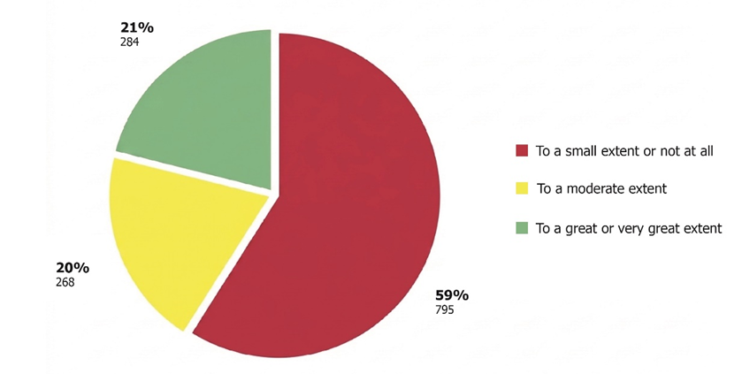
According to the Principals' Survey conducted by the Office of the State Comptroller.

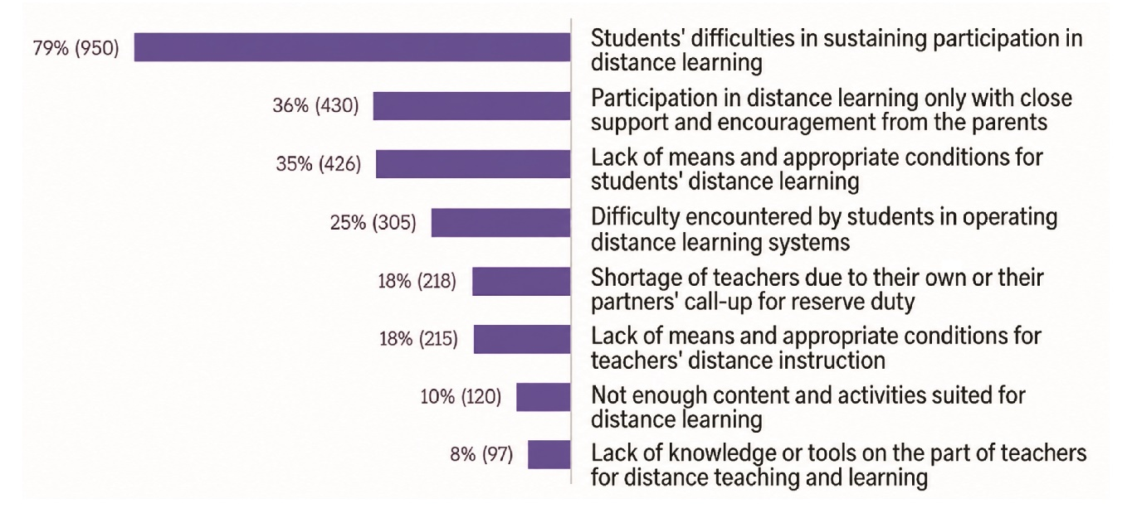
According to the Principals' Survey, processed by the Office of the State Comptroller.

School Principals' Responses to the Question: What are the Three Main Difficulties You Encountered in Distance Learning during the War?

Summary
In the ongoing state of emergency initiated by the outbreak of the Swords of Iron War, the education system, under the leadership of the Ministry of Education, should have sustained a continuous and high-quality academic routine, to the greatest extent possible. Achieving this goal necessitated the maintenance of quality distance learning and the implementation of an effective mechanism to promptly restore schools to in-person learning.
Despite the importance of promoting digital learning during routine times as an infrastructure for distance education in emergency situations, the Ministry of Education has yet to develop a comprehensive ministerial strategic plan addressing this matter. Key deficiencies that emerged during the COVID-19 period persist, including inadequate training for teachers in digital instruction, insufficient practice of distance learning, especially synchronous learning, and shortcomings in the availability of digital content and devices for students. Digital learning, including synchronous learning, had not been fully integrated into the educational processes during routine times. Consequently, when the education system was compelled to transition to distance learning in response to the emergency, the effectiveness of this learning was not as high as expected, given the experience that the education system garnered during the COVID-19 pandemic.
To ensure the continuity of in-person learning during emergencies, schools must have appropriate protected spaces. The Protection Survey conducted by the Ministry of Education revealed that the protected spaces of schools contained defective essential components, while in many schools the protected spaces lacked essential components such as toilets, air filtration systems, and communication systems. It was also found that in some of the schools no security coordinator had been appointed or the existing security coordinator had not received suitable training. Data from the Principals' Survey conducted by the Office of the State Comptroller indicated that in a significant number of schools, not all the students were able to reach protected areas within the warning time established by the Home Front Command. Additionally, the Parents' Survey conducted by the Office of the State Comptroller revealed that over half of the parents felt only moderately or slightly satisfied with the level of the school's communication with them during the war, while some were not satisfied at all, primarily due to the absence of personal interaction.
The integration of digital learning during routine times is foundational for effective distance education during emergencies. The lack of such integration undermines the capacity to provide robust distance learning in times of emergency. It is recommended that the Ministry of Education systematically implement digital learning across all educational stages, in routine times and on a permanent basis. This should include appointing a coordinating entity to lead the effort and facilitate coordination among involved stakeholders, alongside finalizing a strategic plan to promote digital learning, from which operational plans for the promotion of digital learning throughout all stages of education will be derived.
The Ministry of Education should ensure the rectification of defective components within the protected spaces of schools and the completion of components that are missing. Furthermore, it should take measures to appoint security coordinators in schools that do not have them and promote appropriate professional training for those who have not received it. Additionally, schools should be directed to enhance personal communication between form teachers and parents during emergency periods. Regarding the policy of matriculation exam concessions in emergency situations, the Ministry of Education should learn from the concessions policy enacted during the Swords of Iron War, in order to formulate a policy that yields results that are as accurate as possible.
Learning from the experiences of the Swords of Iron War and applying those lessons, particularly through drills and increased preparedness during routine times, is essential for the effective functioning of the education system during emergencies. This is a critical element in Israel's capacity to sustain functional continuity and maintain national resilience.

A lesson held in a video space that allows participants, teachers and students, to talk, hear, and see each other (such as Zoom).
The Ministry of Education divided the schools whose students took the matriculation exams into groups ("impact circles") according to the level of impact they suffered in the Swords of Iron War: Circle 1 – the lowest impact level (most students); Circles 2–3.5 – a higher impact level (students who were evacuated, students whose communities were harmed due to the events of October 7); and Circle 4 – the highest impact level (a few schools that were particularly badly affected). The higher the impact circle, the greater the concessions given to students classified in it.
State Comptroller, Special Report: The State of Israel's Coping with the COVID-19 Pandemic (2021), "Distance Teaching and Learning during the COVID-19 Pandemic Period".

