Protection of Hospitals

Protection of Hospitals
Abstract


On the Jewish holiday of Simchat Torah, October 7, 2023, the Hamas terrorist organization launched an assault on the State of Israel, launching thousands of rockets and infiltrating thousands of terrorists into Israel Defense Forces (IDF) bases, cities and communities located in the Western Negev (Gaza Envelope communities). The terrorists perpetrated horrific acts of extreme brutality; 415 soldiers and members of the security forces fell in the fighting, and 905 Israeli and foreign civilians were murdered. The terrorists committed shocking crimes against women, men, the elderly, children, female and male soldiers, and foreign nationals. In addition, they wounded thousands of people, committed severe sexual violence against victims, and abducted 251 people into the Gaza Strip – infants, children, adolescents, women, men, the elderly, soldiers and foreign citizens. They also caused damage to property, destroying and burning homes and factories, and damaging equipment.
On the same day, at 8:00 am, the Minister of Defense declared a "special situation on the home front" (Emergency Situation). Subsequently, on October 8, 2023, the Ministerial Committee on National Security (the State-Security Cabinet) announced the initiation of significant military actions, designating it as the Swords of Iron War.
When a "special situation on the home front" is declared, the healthcare system provides a response to casualties among both the civilian population and military personnel, requiring functionality under extraordinary conditions, which includes safeguarding the lives of medical staff and patients in the hospitals.
A failure of the hospitalization system to operate on the required scale may compromise the resilience of the home front and its capacity to cope with emergencies, as well as its frontline combat capability. A fundamental condition for ensuring the sustained operation of the hospitalization system during emergencies and the capacity to provide medical care for the injured is the provision of security, as an integral aspect of war preparedness. Previous reports from the Office of the State Comptroller have examined the Israeli healthcare system's preparedness for emergencies, particularly concerning the protection of hospitals, and have underscored that during wartime, the importance of safeguarding medical institutions heightens.
The Ministry of Health serves as the regulatory body for the delivery of medical and health services to residents of the country. The Supreme Authority for Hospitalization and Health in Emergencies functions as a designated authority under the Ministry of Health, operating with the endorsement of the Supreme Emergency Economic Committee, which is tasked with ensuring the operational integrity of the essential health sector and the provision of critical products and services to the population and the IDF during emergencies. Additionally, the Emergency Department within the Ministry of Health possesses the professional mandate to plan and prepare for emergencies across the healthcare system, encompassing all its institutions and services: hospitalization, community (the HMOs), and Magen David Adom. The IDF's Home Front Command (HFC) is responsible for defense measures within the State of Israel, in accordance with the Civil Defense Law, 2013–1951 (the Civil Defense Law).
The Home Front Command established the norms for protection within hospitals in the Civil Defense Regulations (Specifications for the Construction of Shelters), (Amendment), 5773–2013 (the Civil Defense Regulations). This amendment determines, among other provisions, the design principles for designated protected spaces within health institutions. It should be pointed out that these protection norms apply exclusively to new structures within health institutions, constructed subsequent to the date of the regulatory amendment (2013). Furthermore, the existing protections in health institutions, as stipulated by the Regulations, are designed to protect against blast and shrapnel, rather than to provide defense against direct missile strikes.
"Protection gaps" denote areas within hospitals that remain unprotected according to the standards set forth by the HFC for adequate protection during emergencies. Such gaps undermine the capacity of hospitals to safeguard the lives of patients, medical personnel, nursing staff, and other professionals, in addition to their ability to maintain continuity of care and operational functionality. These protection gaps primarily arise from the fact that numerous hospital structures were constructed prior to the enactment of the Civil Defense Regulations in 2013.
In a correspondence dated November 2023 from the State Comptroller to the Prime Minister, the State Comptroller pointed out the key deficiencies and shortcomings in the management of the civilian home front, as observed during his visits to communities located near the border, as well as to local authorities and hospitals, immediately following the events of October 7. The State Comptroller noted that tours of certain hospitals exposed inadequacies in the protective measures necessary for immediate medical interventions, particularly concerning life-saving treatment facilities. In relation to the reduction of elective medical procedures in hospitals to prioritize the hospitalization of war victims and to facilitate emergency preparedness, the State Comptroller advocated for the establishment of a community treatment model to compensate for services that the hospitals were unable to provide.
And indeed, the ramifications of these protective gaps became evident in an incident involving a missile launched from Iran on June 19, 2025 (subsequent to the audit end date), which struck Soroka Hospital in Be'er Sheva during Operation Rising Lion.
Following the missile strike – which did not result in any fatalities, as patients had been transferred in advance – the hospital's functional continuity was significantly compromised due to the presence of unprotected areas and the resulting damage. This affected the institution's capacity to operate continuously and effectively in delivering essential medical services and providing patient care.
Since 2016, the Home Front Command has been conducting protective assessments in general and continuing care hospitals (geriatric, psychiatric, and rehabilitation), mapping the protection levels of all hospital sites. These levels are categorized according to an engineering scale that indicates the sites' resilience to damage from weaponry. Drawing on these assessments, hospitals develop a comprehensive action plan that incorporates protective guidelines (emergency file). This strategy enables advanced planning for hospital operations during emergencies and significantly reduces anticipated damage.


Mapping of Areas in a Hospital Building by Level of Protection, According to HFC Protection Surveys

"Unprotected" | "Most Protected" | "Protected" | "Protected According to Standard"
Area of ​​the hospital with the lowest level of protection (such as light buildings and upper floors) | An interior area within a building or an area with exterior walls without openings – including two or more ceilings, at least one of which is made of concrete | An area of ​​a hospital building that is surrounded by concrete walls but is not considered a space protected according to the standard (such as a basement, stairwell, or elevator shaft) | An area of ​​a hospital building whose protection measures comply with the standard (such as a shelter, a floor/institution protected area)
- These structures are not protected and are not recommended for use or hospitalization in an emergency | - A structure that is not protected according to the standard, but may be used in an emergency if a structure protected according to the standard or a protected structure is not available, subject to the limitations detailed in the hospital's emergency file | A structure that is recommended for use in an emergency, if a structure protected according to the standard is not available | A structure that is recommended for use in an emergency
According to HFC guidelines for conducting protection surveys and preparing the protection plan in hospitals, processed by the Office of the State Comptroller.


Approx. 25,000 inpatient beds in 52 hospitals |  | Approx. NIS 4.8 billion |  | Only about NIS 500 million |  | Only One project
comprising approximately 17,500 general inpatient beds in 27 general hospitals (70%), approximately 3,900 inpatient beds in 13 geriatric hospitals (16%), approximately 3,000 inpatient beds in 10 psychiatric hospitals (12%), and 420 inpatient beds in two rehabilitation hospitals (2%), as of June 2025 |  | Estimated cost of closing the protection gaps in the hospitalization system – general and continuing care hospitals (geriatric, psychiatric and rehabilitation), as of December 2023 |  | A dedicated budget allocated within the Swords of Iron framework for protecting hospitals, which amounts to approximately 10% of the estimated budget required to close the protection gaps |  | dedicated to protection, budgeted at approximately NIS 16 million, which constitute approximately 2% of the Ministry of Health's average annual development budget for the years 2015–2023 – which stood at approximately NIS 940 million; excluding new construction that is required to be protected. This is due to the high cost of projects for protecting existing structures

About 56% |  | About 41% |  | About 67% |  | About 56%
of the inpatient beds in the 27 general hospitals examined in the audit, 10,500 out of 18,900 are not protected |  | of the operating rooms in the 27 general hospitals inspected are not protected (168 out of 406) |  | of the imaging devices in general hospitals near the border are not protected (10 out of 15) |  | of the catheterization and angiography rooms in the supercenters close to the border are not protected (5 of 9)
About 86% |  | 93% |  | About 75% |  | About 63%
of the general inpatient beds at Hospital X (500 out of 581) are not protected. About 200 of them are in the "most protected" sites |  | of the beds for continuing care hospitalization – geriatric, psychiatric and rehabilitation hospitals – in the Ministry of Health's Tel Aviv Metropolitan Area are not protected, including beds in the "most protected" area (1,860 inpatient beds out of 2,000) |  | of the inpatient beds in psychiatric hospitals are not protected, including beds in the "most protected" area (approximately 2,230 beds out of approximately 3,000) |  | of the inpatient beds in geriatric hospitals are not protected, including beds in the "most protected" area (2,453 beds out of approximately 3,900)

Audit Actions

From January to September 2024, the Office of the State Comptroller conducted an examination of the protective measures in place for hospitals within the general and continuing care system (general, geriatric, psychiatric, and rehabilitation hospitals) and the preparedness of the healthcare system for emergencies. This evaluation focused on the scope of the existing protection gaps within the hospitalization system and their implications, including for the continuity of care and functionality of the hospitals; government initiatives aimed at closing the protection gaps; and regulation of the implementation, oversight, and enforcement of related matters. The examination was undertaken at the Ministry of Health, select general hospitals, and certain continuing care hospitals (geriatric, psychiatric, and rehabilitation); at the Budget Division of the Ministry of Finance; and at the IDF's Home Front Command. Furthermore, the audit team distributed a questionnaire (the Hospital Protection Questionnaire) to 52 hospitals, receiving responses from all of them.
It should be emphasized that this audit was performed prior to the military campaign against Iran – Operation Rising Lion – in June 2025. The significance of this audit, along with the gravity of the deficiencies detailed therein, is underscored by the potential risks to human life and property that are liable to arise from incidents affecting hospitals, such as missile strikes and earthquakes, as exemplified by the attack on Soroka Hospital during Operation Rising Lion. Supplementary examinations were conducted in June 2025, following the conclusion of Operation Rising Lion.

Key Findings


Protection Gaps in General Hospitals Situated Near the Border – Protection, within the framework of war preparedness and as a measure for providing some resilience during earthquakes, is fundamental for maintaining the operational continuity of the healthcare system during emergencies and ensuring the provision of medical assistance to victims. The audit revealed protection deficiencies vis-à-vis essential operational sites and general inpatient beds within the hospitals near the border. Specifically, 67% of imaging devices (10 out of 15), 48% of inpatient beds (851 out of 1,762), 25% of intensive care beds (41 out of 162), 22% of operating rooms (8 out of 36), 18% of dialysis stations (14 out of 79), and 17% of neonatal intensive care cribs (12 out of 70) are not protected. Furthermore, it was found that certain areas within the hospitals are classified as "the most protected", which includes 17% of catheterization and angiography rooms (1 out of 6), 14% of operating rooms (5 out of 36), 7% of intensive care beds (12 out of 162), and imaging devices (1 out of 15). Additionally, it was noted that 41% of general inpatient beds are relocated to a protected alternative site during emergencies (722 out of 1,762). It should be emphasized that the areas designated as "the most protected", where the hospitals operate when instructed to move to protected areas in the absence of a standard protected structure or any protected structure, are actually not in compliance with standard protection criteria. Notwithstanding, it is permissible to use them subject to the restrictions laid down in the hospitals' emergency files. These sites are situated in the interior areas of buildings or in spaces with external walls devoid of openings, below two or more ceiling layers, at least one of which is concrete.
The implications of the protection gaps in Hospitals B, C, and D, situated in proximity to the border, mean, inter alia, that during security escalations, and in accordance with the HFC's protection policy and the alert levels established by the Ministry of Health, these hospitals are compelled to curtail general activities involving hospitalizations, inclusive of elective procedures. For instance, in Hospital C, one ward was closed in October 2023 due to its position within an unprotected compound, and it was only in July 2024, after the hospital found a suitable protected compound, that the department began bringing back some of its beds into use.
Protection Gaps in the Seven "Supercenters" in Israel – The Ministry of Health classifies hospitals into three categories: a supra-regional trauma center (a "supercenter"), a regional trauma center, and local hospitals; this is based on their capabilities and a regional approach, which centers on the combination of hospitals with diverse capabilities and the transfer of severely injured individuals to hospitals equipped with superior treatment options. The audit revealed the following findings:
- In the supercenters situated near the border, there exist protection gaps within areas designated for essential activities and inpatient beds. Specifically, 56% of catheterization and angiography rooms (5 out of 9), 30% of imaging devices (3 out of 10), 27% of intensive care beds (59 out of 218), 18% of general inpatient beds (593 out of 3,298), and 16% of operating rooms (8 out of 50) are unprotected. Furthermore, certain areas within these supercenters have been classified as "the most protected" including 30% of imaging devices (3 out of 10), 8% of general inpatient beds (251 out of 3,298), and 6% of stations in the Emergency Medicine Department (13 out of 220). Additionally, 86% of the dialysis stations are transferred to a protected alternative site in times of emergency (102 out of 118).
- In supercenters not adjacent to the border, protection gaps exist in areas where essential activities are carried out and in general inpatient beds. Specifically, 69% of imaging devices (29 out of 42), 61% of inpatient beds (3,632 out of 5,929), 64% of intensive care beds (224 out of 348), 38% of operating rooms (54 out of 144), 56% of catheterization and angiography rooms (15 out of 27), and 43% of dialysis stations (96 out of 224) are not protected.
- It also appears that a considerable proportion of areas within the supercenters that are not located near the border have been designated as "the most protected", meaning, as said, that the level of protection does not conform to the established standards. For instance, 21% of the Emergency Medicine Department stations (100 out of 484), 14% of operating rooms (20 out of 144), 10% of imaging devices (4 out of 42), and 11% of catheterization and angiography rooms (3 out of 27) fall into this category. There is concern that the capacity of the supercenters to effectively treat a substantial number of wounded individuals and to sustain medical services for the entire population throughout a prolonged conflict will be limited.
The implications of the protection gaps within the supercenters include requiring hospitals, when adhering to instructions to relocate all activities to protected areas only (classified as "reduced" or "essential" activity), to suspend operations at essential sites that lack protection for extended durations, thereby compelling medical staff to perform certain activities in unsuitable environments. Additionally, at sites deemed "the most protected", both staff and patients remained susceptible to potential harm due to protection not meeting the standard. When complying with directives to enter protected spaces only upon the activation of alarms (classified as "full" or "partial" activity), medical personnel working in essential unprotected sites, such as operating rooms, dialysis, and imaging rooms, received instructions to leave the room and relocate to a nearby protected area during an alarm, in order to avoid endangering life. In practice, however, there were numerous instances in which patients and a significant portion of the staff were unable to vacate the site, due to their being in the middle of surgery or dialysis treatment at the time.
Protection Gaps in Twenty-Seven General Hospitals – There exist considerable protection gaps within hospital complexes where essential medical activities are conducted, as well as in general inpatient beds across the twenty-seven hospitals. Specifically, 56% of general hospital beds (10,493 out of 18,637) are unprotected, alongside 61% of imaging devices (78 out of 129), 41% of operating rooms (168 out of 406), 50% of catheterization and angiography rooms (42 out of 83), 43% of intensive care beds (491 out of 1,147), 33% of dialysis stations (284 out of 867), 28% of Emergency Medicine Department stations (440 out of 1,578), and 18% of neonatal intensive care cribs (124 out of 702). Furthermore, a substantial proportion of designated hospital areas fall under the category of "the most protected", indicating protection levels that are not according to the standard; this includes 10% of Emergency Medicine Department stations (164 out of 1,578), 10% of catheterization and angiography rooms (8 out of 83), 10% of imaging devices (13 out of 129), and 6% of intensive care beds (72 out of 1,147).
These findings raise significant concerns regarding the limited capacity of numerous hospitals to sustain medical service provision to the entire population amid a comprehensive and prolonged conflict.
Additionally, events such as the Swords of Iron War and, in particular, Operation Rising Lion, have underscored that the entire nation, rather than merely the hospitals situated near the borders, is susceptible to threats from rockets and missiles. This reality serves to heighten the importance of protecting all hospitals.
Integrating Private Hospitals into the National System During Emergencies – Private hospitals accommodate 253 protected inpatient beds, in addition to protected operating rooms and imaging devices. Consequently, the Ministry of Health believes that their incorporation into the national system during emergencies could enhance the capacity for protected hospitalization in times of crisis. However, it was found that, as of the audit end date, the Ministry had not yet established a regulatory framework for the integration of private hospitals into the national war effort during emergencies.
The Scope of Protected Inpatient Beds Within Continuing Care Hospitals (Geriatric, Psychiatric, and Rehabilitation) – Sensitive and vulnerable individuals, including those involuntarily admitted or housed in closed wards, are among the patients residing in psychiatric hospitals. This population has a limited capacity for coping with emergencies, understanding such situations, and consequently evacuating to overcrowded protected areas. Similarly, geriatric hospitals accommodate a vulnerable and sensitive population characterized by immobility or restricted mobility, complicating the transfer of these individuals to safe spaces during emergencies. However, the audit revealed that in the Southern District – near the border – less than one third of the beds in continuing care hospitals are protected (29%). The situation within the Tel Aviv Metropolitan area is particularly serious, with an exceedingly low average rate of protected beds, amounting to only 7%.

Reducing Occupancy and Relocating to Protected Areas in Continuing Care Hospitals – The ability of geriatric hospitals to reduce occupancy during emergencies averages 20%. Consequently, despite inadequate protection measures and the policy for decreasing the number of hospitalized patients in these facilities, they remain nearly fully occupied, where a substantial number of the inpatients, including dependent nursing-care patients, are accommodated in unprotected areas. Given the limited protection and the architectural design of approximately 50% of long-term care facilities, not all patients, and frequently staff, evacuate to protected zones during alarms, due to accessibility challenges. An example of this is Geriatric Hospital W, which lacks any designated protected space for the majority of its patients; during a partial evacuation in accordance with the Times of Emergency Order, patients are moved to the "most protected space", thereby placing both them and the medical personnel at risk of physical harm. It should however be noted that the hospital's operations were transferred to an alternative facility during certain periods of the Swords of Iron War and Operation Rising Lion.
Protection at Psychiatric Hospital P – The hospital, constructed several decades ago, currently accommodates 300 standard inpatient beds alongside approximately 900 patients and staff. At the onset of the Swords of Iron War, and given the prevailing state of protection at Hospital P, the Home Front Command guidelines and the defense policy necessitating relocation to protected areas, three departments were transferred to other hospitals along with their medical staff. The remaining departments were relocated to a protected emergency hospitalization building, which accommodated approximately 200 patients in shared open spaces, resulting in crowding and an inherent risk due to their mental state and extended stays in one large open space. It is pertinent to note that this single protected building does not address the needs of all patients hospitalized there; it is able to accommodate roughly 200 patients (approximately two-thirds of the total number of hospitalized individuals) and the medical staff, but it is mandated for demolition based on the building permit issued for the inpatient building several years ago. Consequently, the hospital lacks an alternative protective solution for all hospitalized patients and the medical staff.
As for the remaining hospital structures, it was determined that most are outdated concrete edifices. The Home Front Command recognized the necessity for a more protected site for the psycho-geriatric department within the hospital, "taking into account the patients' capacity to access this area". Therefore, due to the restricted mobility of the hospitalized patients, particularly during the night, the HFC instructed that the patients get out of bed and lie on the floor during an alarm.
The Ministry of Health's Plan to Address Protection Gaps in Hospitals – The Israeli government's approach to rectifying the protection gaps in hospitals lacks a comprehensive long-term strategy that addresses all national hospital protection needs, defining a budgetary framework, timelines, and implementation priorities. Rather, the existing plans are fragmented and targeted primarily for hospitals located along the frontlines in the northern and southern regions, with a cumulative budget of NIS 900 million allocated since 2007, which fails to address the significant protection deficiencies present. In December 2023, as part of a plan aimed at closing these protection gaps within the healthcare system, the Ministry of Health projected the cost of rectifying these deficiencies at NIS 4.8 billion; the plan established priorities based on defined timelines (short, medium, and long-term). The Ministry of Health and the Ministry of Finance provisioned funding for projects slated for short and medium-term implementation only. However, the anticipated remaining cost needed to close protection gaps, designated for long-term execution and estimated at approximately NIS 4.3 billion, was not budgeted.

A Comprehensive Plan and Schedule for the Transfer of Medical Departments and Activities to Protected and "Most Protected" Sites – Hospitals are not required to establish standard timeframes for each stage of the transition from routine operations to emergency conditions. The audit revealed that all hospitals devised plans for bed deployment during emergencies as stipulated; however, six hospitals (26% of the total 23) did not formulate detailed procedures on this matter. Additionally, 13 hospitals (57% of the total 23) failed to establish a standardized timeframe for the complete bed deployment procedure during emergencies, including preparation of the protected area, transfer of equipment and patients. Four hospitals (17% of the total 23) determined standard times for only part of the transfer procedure – for instance, while a standard time was established for patient transfers, no timeframe was assigned for the preparation of the protected area.
Regular and Adapted Drills Tailored to the Hospital's Protective Characteristics – The Emergency Department at the Ministry of Health does not maintain a database concerning the existence of procedures and protocols for transitioning from routine to emergency operations within hospitals. This includes plans for bed deployment during emergencies and the response of hospitals in various emergency scenarios. Moreover, the Department lacks a database that documents deficiencies identified during inspections and drills in hospitals, nor does it have a systematic process in place for monitoring the rectification of these deficiencies.
Reducing Occupancy and Hospitalization in General Hospitals – During the initial three months of the conflict, the occupancy rate of inpatient beds across all hospitals declined in comparison to the corresponding period in 2022. The reduction in occupancy rates ranged from 13% in October and November to 6% in December. Furthermore, all districts recorded a decrease in occupancy during the first three months of hostilities, with the exception of Hospital K. The most pronounced declines were observed in the northern and southern districts, with decreases ranging from 24% in the southern district in October to 21% in November for the South and 20% for the North. This phenomenon can be explained by several factors, including a reduction in hospitalizations aimed at increasing capacity to accommodate the wounded, gaps in protective measures, and the evacuation of segments of the population in both the northern and southern regions. The reduction in hospitalizations within general hospitals entails the postponement of medical activities, which may result in inconveniences for patients and could even jeopardize their health.
Reduction of Ambulatory Services in General Hospitals Close to the Border – The hospitals situated near the border – B, C, and D – are positioned at the forefront of any security incident resulting from missile and rocket attacks on the State of Israel. Throughout the first six months of hostilities, spanning from October 2023 to March 2024, there were significant declines in the number of visits to the ambulatory services in these hospitals compared to the corresponding period in 2022–2023. A particularly pronounced reduction was evident at Hospital D, where visits decreased by 72% in October 2023 (from approximately 12,900 visits in October 2022 to roughly 3,600 visits in October 2023). The outpatient services were reduced, inter alia, due to deficiencies in protective measures and the reallocation of resources for urgent hospitalizations. Consequently, these hospitals referred patients to other hospitals located farther from their places of residence, and those of their families, sometimes disrupting the continuity of care and complicating access to necessary medical treatment.
The Effects of Protection Gaps on the Functioning of the Hospitalization System During Emergencies – The substantial discrepancies between the desired and actual levels of protection in general and continual care hospitals impede the continuity of care and their overall functioning. On occasion, hospital operations are suspended for prolonged periods, and entire wards are relocated to protected areas. For instance, Hospital D transferred its operations to solely protected areas ("reduced" activity) from October 7, 2023, to February 15, 2024. During periods of heightened security threats, hospitals are compelled to operate in unprotected spaces, including emergency medicine departments, operating rooms, and imaging centers. This situation presents two interrelated consequences: first, it subjects patients and hospital personnel – comprising medical, nursing, paramedical, and other teams – to tangible threats to their lives amid missile and rocket assaults on the home front; second, it undermines the continuity of care and the operational integrity of hospitals, in the medical services provided to the population, including wounded soldiers evacuated from the battlefield. Moreover, the necessity to function in the inadequate protected areas in hospitals, leads to the overcrowding of patients, sometimes for extended periods, thereby exposing them to health risks, such as infections and contraction of diseases. This circumstance could adversely affect the quality of medical care delivered to hospitalized patients, particularly among vulnerable populations within the continual care hospitalization system.
During Operation Rising Lion, certain hospitals were transferred to underground facilities designated for hospitalization during emergencies, contingent upon the availability of such compounds at the hospitals. For example, as soon as the operation started, Hospital F relocated, within seven hours, numerous inpatient beds to an underground area normally serving as the hospital's car park. Conversely, other hospitals, such as Hospital X, lack underground amenities for emergency hospitalization and have approximately 500 unprotected inpatient beds, of which 200 are situated in the "most protected" sites.
Supervision of the Ministry of Health's Projects Committee over Construction in Government Hospitals – The Projects Committee, appointed by the Director General of the Ministry of Health, serves as an advisory body on construction and establishment projects within the healthcare system. This includes construction and protection measures in alignment with the Civil Defense Regulations. Although the appointment letter for the Committee explicitly states that it is tasked with discussing all projects pertinent to the healthcare system in Israel, it was found that, in practice, the Committee does not engage in discussions regarding construction projects at the eleven government hospitals, but rather, its focus is on construction projects occurring outside the government sector. For instance, the Committee did not deliberate on the addition of three operating rooms to Hospital E and was completely unaware of their construction, which was conducted without the requisite protective measures mandated by the Civil Defense Regulations.
Construction of Inpatient Buildings with Glass Curtain Walls in General Hospitals – Despite the significant number of inpatient structures built with glass curtain walls in hospitals over the past decade, neither the Ministry of Health nor the HFC has examined the potential risks associated with such distinctive construction in scenarios of war or terrorism, and with respect to the necessity for continuous treatment within hospitalization wards, juxtaposed against the environmental and health benefits that these glass walls confer. An explosion or blast in proximity to glass curtain windows, as occurred at the Soroka Hospital during Operation Rising Lion, is liable to result in numerous casualties, lead to the loss of walls in hospitalization wards, and hinder the operational capabilities of the hospital due to the significant number of glass panels falling from considerable heights into the hospital over several days. It is noteworthy that the State Comptroller addressed this issue in a report published in 2019, which examined the topic of "Preparedness of Home Front Command Forces for Emergency Search and Rescue" concerning emergency rescue operations in light of contemporary construction challenges, particularly the construction of buildings with glass curtain walls.
Unprotected New Construction at Hospital E – Pursuant to a directive issued as part of the healthcare system's response to the Covid-19 pandemic, which permitted the construction of buildings within hospitals without necessitating a building permit prior to the initiation of construction (the Covid Order), Hospital E constructed three operating rooms within an existing structure without the protective measures mandated by the Civil Defense Regulations, which require comprehensive protection for operating rooms in hospitals. Hospital E also failed to request approval from the Home Front Command, as the competent authority, for the construction or for an exemption from the obligation to establish the rooms as protected spaces, as stipulated by both the Civil Defense Law and the Covid Order, thereby jeopardizing the safety of individuals within that area of the hospital. It was also found that the Planning and Building Administration, along with the Projects Committee at the Ministry of Health, only became aware of the construction of the operating rooms at Hospital E in retrospect, when the project was already in its final stages.

Transition of Operations to Protected Areas at Soroka Hospital during Operation Rising Lion – At the onset of the attack on Iran on June 13, 2025, the Ministry of Health directed all hospitals, to relocate their inpatients to protected areas. Consequently, on the evening preceding the missile strike on the hospital's inpatient facility on June 18, 2025, the management of Soroka Hospital decided to evacuate a ward within the building to a more secure location in a different structure – a decision that saved lives.

Key Recommendations

- Due to the expansion of alternative protected sites that are not utilized for hospitalization during routine periods, and in consideration of the unique difficulties associated with transferring patients from hospital wards to these sites, it is recommended as follows: (a) The Supreme Authority for Hospitalization and Health in Emergencies should instruct the Emergency Division to revise the content requirements for bed deployment plans during emergencies, which includes updating specifications regarding the establishment of standard times for patient transfer stages; (b) Hospitals that have not yet formulated detailed procedures or determined standard times in their protocols should prepare comprehensive transition plans to streamline and enhance the shift from routine to emergency conditions, thereby minimizing potential harm to patients and medical and other personnel; (c) The Emergency Division and the Medical Department at the Home Front Command should assess whether hospitals have assimilated lessons from the transfer processes to protected areas during the initial days of conflict and whether there was an improvement in transfers at the onset of Operation Rising Lion. Furthermore, it is recommended that the Emergency Division and the HFC revise, as needed, the annual drill plan devised to prepare hospitals for emergencies, ensuring it incorporates periodic drilling of emergency hospital transitions, including transportation of the requisite operational equipment and infrastructure.
- In light of the substantial increase in underground compounds repurposed for emergency hospitalization during the Swords of Iron War, and particularly during Operation Rising Lion, and future planning for the construction of dual-use underground compounds in additional hospitals, it is advised that the Ministry of Health and the HFC, in collaboration with the hospitals, ensure that the designated alternative sites, emphasizing underground compounds, are suitable and offer effective solutions. Furthermore, it is recommended that additional provisions be added to the Civil Defense Regulations, explicitly addressing protected underground compounds to ensure continuity of care and operational capability in hospitals, particularly those situated near the border.
- Considering the ongoing Swords of Iron War and the risks associated with rocket falls across the nation, as evidenced during the Swords of Iron War and Operation Rising Lion, the Ministry of Health and the HFC should examine the necessity of establishing criteria for the approval of glass curtain walls in hospitals, to ensure that approved structures guarantee the safety of patients situated in rooms with glass curtain walls who lack protection and cannot evacuate rapidly during a warning.
- To mitigate risks to public health and avert deterioration in the medical condition of patients, measures should be taken to ensure that even amidst ongoing emergencies. such as the Swords of Iron War, the population is afforded ambulatory medical services within the framework of hospitals. It is advisable that the Ministry of Health, in collaboration with the HFC, explore the feasibility of enhancing protections at outpatient treatment sites or expanding the locations where ambulatory treatments may be administered during emergencies.
- In response to the necessity of sustaining the functional continuity of hospitals during emergencies, the Ministry of Health should, in coordination with the Ministry of Finance and the hospitals, develop a long-term strategy that establishes priorities for addressing the identified protection gaps within hospitals, which, according to estimates from the Ministry of Health, exceed NIS 4 billion. This financial requirement necessitates the creation of a multi-year national plan, informed by the lessons learned from the multi-scenario war, and particularly from Operation Rising Lion. It is suggested that this plan be incorporated into a designated government resolution that includes specific budgeting and prioritization, while balancing other national budgetary needs.
- Considering the designation by law of the HFC as the "competent authority" to serve as regulator in the domain of physical protection, Hospital E and the Ministry of Health should collaborate with the HFC in devising an appropriate protective response to the gaps identified in the construction of the three operating rooms that were erected without adequate protection, as mandated. Furthermore, the hospital should address these protection gaps by the end of 2028, in accordance with the agreement reached with the HFC, and comply with the requirements of the Civil Defense Law in all future construction projects on the hospital premises.
- The Ministry of Health, with the assistance of the HFC, should investigate whether construction without protective measures has been conducted across all the hospitals. It is additionally recommended that the Ministry of Health establish protocols for its supervisory role as regulator concerning the execution of projects within government hospitals, to guarantee that construction activities in these institutions are compliant with the pertinent laws and regulations.
- In light of the ongoing Swords of Iron War, it is advisable that the Ministry of Health, the HFC, all hospitals nationwide, the Ministry of Finance, and other entities within the healthcare system that operate hospitals engage in a systematic and collaborative process to draw lessons regarding the protection of hospitals, including all relevant implications, ensuring that measures are in place to sustain operations during prolonged periods of emergency.
Emergency Protection Gaps at Selected Essential Activity Sites and General Inpatient Beds in 27 General Hospitals, 2024

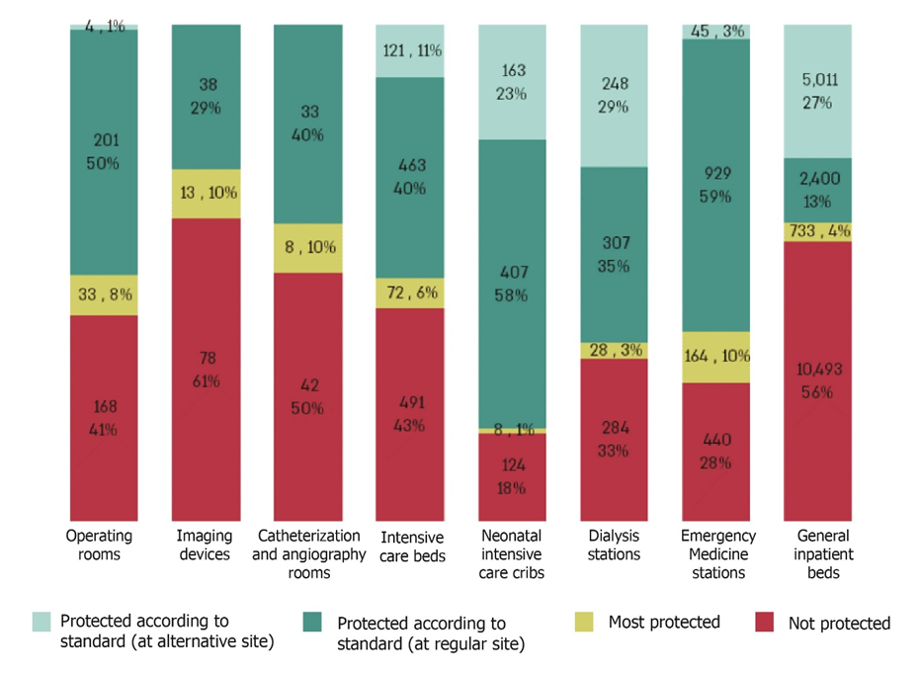
According to data from the hospitals, the Home Front Command and the Ministry of Health, processed by the Office of the State Comptroller.

Destruction to the Inpatient Building in Soroka Following a Direct Iranian Missile Strike (June 19, 2025)
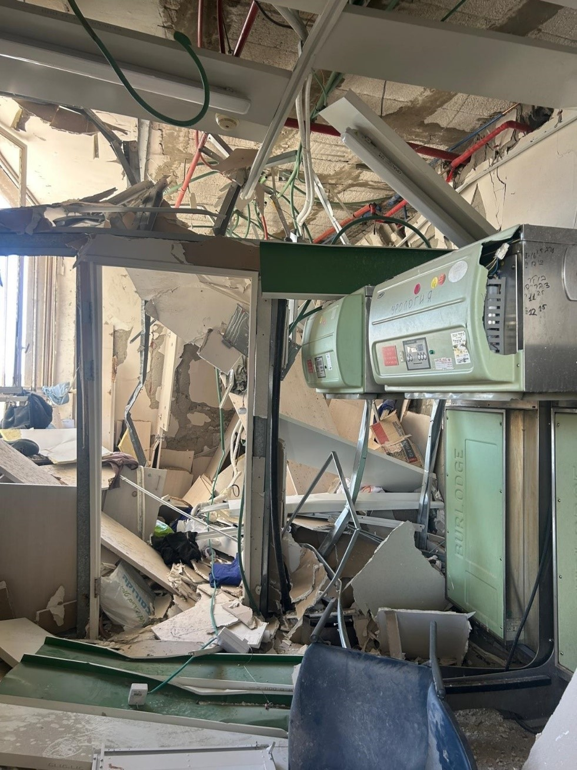
Photographed by the Office of the State Comptroller on June 19, 2025.

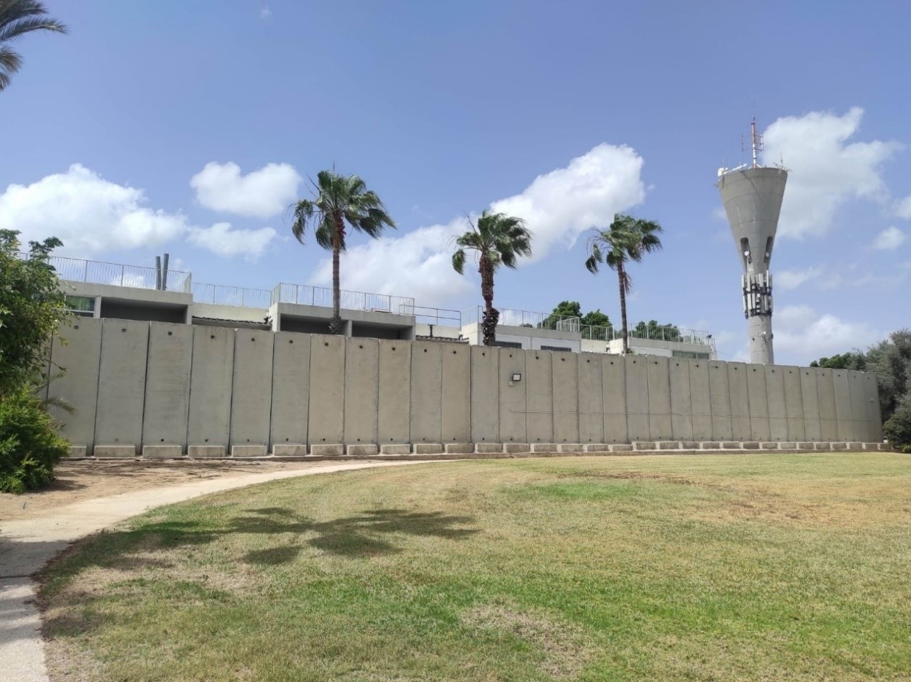
Placement of 7-Meter-High Concrete Columns in Front of the Wards Located on the First Floor of Geriatric Hospital V

Photographed by the Office of the State Comptroller on May 5, 2024.

Summary
During periods of emergency, the healthcare system serves both the civilian populace and the Israel Defense Forces. Inappropriate protective measures within the hospitalization framework is liable to undermine the resilience and capacity of the home front to cope with emergencies, as well as adversely impact the combat effectiveness at the front. The Swords of Iron War and Operation Rising Lion, during which, up until June 2025, over 37,500 missiles were launched at the territory of the State of Israel, particularly targeting the southern and northern regions, have introduced a new challenge, including for the healthcare system – a prolonged state of emergency and its geographical breadth.
The State Comptroller has repeatedly highlighted the lack of protective measures across various hospitals. This report illustrates the detrimental effects of existing protection shortfalls in both general and continuing care hospitals (geriatric, psychiatric, and rehabilitation) – with emphasis on Soroka Hospital, which sustained a direct hit during Operation Rising Lion. Such deficiencies jeopardize the hospitals' capacity to sustain care and functional continuity over time.
Consequent to these protection gaps, including in the general hospitals, operations at critical facilities are occasionally suspended for protracted periods, compelling hospitals to function in unprotected environments. There has been a decline in hospital occupancy rates, exacerbated by population evacuations in the northern and southern regions, and there has been a reduction in ambulatory medical services – sometimes compromising continuity of care and hindering access to necessary medical treatment. The deferral or relinquishment of medical services poses a threat to public health.
With respect to continuing care hospitals (geriatric, psychiatric, and rehabilitation) which accommodate a sensitive and vulnerable population, and also play an important role in helping to alleviate occupancy pressures within the general hospitalization system during emergencies – less than one-third of the beds in these facilities are protected or can be relocated to alternative protected sites, while approximately half of the beds are situated in unprotected locations, and the remainder are in areas designated as being the "most protected". Furthermore, the capacity of geriatric hospitals to reduce occupancy in alignment with the Home Front Command guidelines and the directives of the Supreme Authority for Hospitalization and Health in Emergencies is restricted. Despite this inadequate protection, these institutions maintain near-total occupancy levels, leading to a considerable proportion of patients being accommodated in unprotected environments. This matter gained added significance during Operation Rising Lion in June 2025, due to the State of Israel's having to cope with ballistic missile threats from Iran, capable of carrying warheads weighing hundreds of kilograms and inflicting extensive damage from blast effects and shrapnel as well.
Since 2007, the government has adopted three resolutions addressing, among other priorities, the protection of hospitals in northern and southern regions, with a financial commitment approximating NIS 900 million. Nevertheless, the government has failed to reach a decision pertaining to the implementation of a multi-year budget plan for rectifying the protection deficits prevalent in general hospitals. To ensure the continuity of care and operational viability over an extended period, particularly during prolonged conflict, and in light of the damage sustained by Soroka Hospital in June 2025, it is important to address the protection deficiencies in the hospitals to safeguard the lives of both patients and healthcare providers. The Ministry of Health has projected the financial requirements for these enhancements to be nearly NIS 5 billion. Funding of such magnitude necessitates the formulation of a long-term national strategy, which should be included as part of a targeted governmental resolution outlining budgetary allocations and prioritization.
To optimally prepare for prospective emergencies, it is advised that the Ministry of Health and the Home Front Command persist in revising the protection regulations, which have already commenced updates, to meet the evolving needs identified on the ground. Additionally, it is recommended that the Ministry of Health develop methodologies for supervising the execution of all hospital construction projects, ensuring compliance with the requisite laws and regulations as mandated by the Defense Regulations. In light of the ongoing Swords of Iron War, it is recommended that the Ministry of Health, the HFC, the Ministry of Finance, and the various healthcare system entities operating hospitals conduct a systematic and collaborative process for drawing lessons from the numerous challenges encountered regarding the continuity of care and operational functionality associated with unprotected hospitals.

These areas are not considered protected spaces according to the standard, since they were not constructed in compliance with the Civil Defense Regulations, which define what constitutes a standard protected space in hospitals.
In addition, there are four general hospitals, of which three are located in East Jerusalem, which are not audited bodies under the State Comptroller Law, 5718-1958 [Consolidated Version].
Includes approximately 1,000 additional inpatient beds that operate only in emergencies in underground emergency hospitalization compounds at Rambam Hospital.
Vascular imaging.
Services provided in the form of outpatient services, mainly in hospital outpatient clinics.

