Management of Information Concerning the Care of Evacuees

Management of Information Concerning the Care of Evacuees
Abstract


Since its early days, the State of Israel has faced security threats from enemy states and terrorist organizations. Security threats or natural disasters that are about to materialize or are materializing raise the need to evacuate populations from risk areas. During the Swords of Iron War, about a quarter of a million residents were evacuated or self-evacuated from their homes, and a substantial need arose to provide services to this population—hundreds of thousands of people, evacuees (residents of localities that the government had approved to evacuate) and self-evacuees (residents of localities that were not evacuated but decided to self-evacuate in order to move away from risk areas). To manage information about a population dispersed across hundreds of sites, detailed, up-to-date, and comprehensive information about those residents is required—who they are, where they are staying, and what their needs are. For this purpose, an information and communications technology (ICT) system is required for the national coordination of information on evacuees and those who have self-evacuated. The relevant information will be fed into the system, which will provide government bodies and local authorities with a comprehensive, national situational overview in real-time, as well as detailed information according to specific characteristics. Such an ICT system is intended to serve as a basis for decision-making during the management of a complex process of absorbing evacuees and addressing their needs in different locations, coordinating between government bodies and local authorities, allocating resources and continuously updating the information regarding every person evacuated by the state or self- evacuated whose needs must be met. Efficient and immediate operation of such an ICT system in an emergency, as was required upon the outbreak of the Swords of Iron War, necessitates advance preparedness during routine times and optimal operation in real time.


Review of the ICT Systems Established Before and After the Outbreak of the War Regarding Information on the Evacuees
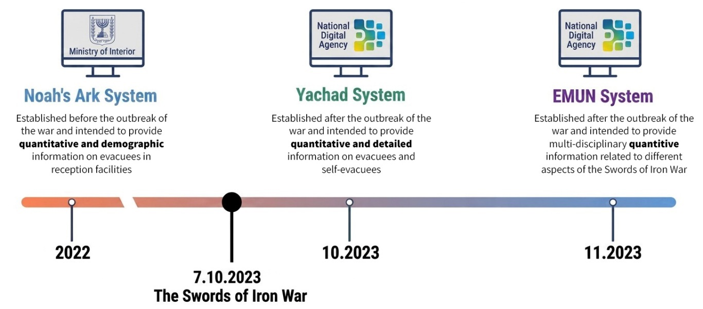


As early as 2007 |  | About a quarter of a million residents |  | NIS 5.26 billion |  | NIS 15 million
the then State Comptroller warned about the need to establish a computerized system for tracking and communicating with evacuees during an emergency (in the report on the government's preparedness for managing the home front during the Second Lebanon War) |  | were evacuated by the state or self-evacuated from their places of residence, according to National Emergency Management Authority (NEMA) estimates as of the beginning of November 2023 |  | Total payments from the state treasury to fund the accommodation of evacuees in hotels from the outbreak of the war until the end of July 2024 |  | Total establishment and development costs of the ICT system for managing information on evacuees and self-evacuees ("Yachad" system) from October 2023 to May 2024

0 |  | For only 50% |  | For only 13% |  | Approximately 500%
The demographic information possessed by the government relating to the evacuees or self-evacuees and their individual needs in the first three weeks after the outbreak of the war. During these weeks, the government's action relied on general estimates |  | of the evacuees and self-evacuees were there updated data in the Yachad System at the end of three months, as well as at the end of six months from the outbreak of the war |  | of all evacuees staying in state-funded hotels were demographic details fed into the Noah's Ark information system (9,000 out of approximately 70,000). The entry of details was carried out during a short period after the outbreak of the war in which the Home Front Command operated the system |  | The discrepancy between the figures representing the number of evacuees staying in hotels in mid-November 2023: according to the EMUN System of the National Digital Agency, there were 87,000 people, whereas according to the Yachad System of the National Digital Agency there were only 15,000 people

Audit Actions

From January to May 2024, the Office of the State Comptroller conducted an audit on the preparedness for managing information about the evacuees prior to the outbreak of the war and the management of information throughout the war. This included examining the ability to collect, consolidate, and manage the information using a designated ICT system, and the ability to channel the information to the various government bodies required to provide services to the evacuees and self-evacuees, each according to their areas of responsibility. The examination covered two periods of time—before and during the Swords of Iron War. The ICT preparedness carried out before the outbreak of the Swords of Iron War was examined with regard to the collection of information on evacuees and their needs and the presentation of this information to government bodies and local authorities; the ICT response provided after the outbreak of the war was also examined, as it was actually required to collect this information and present it to them. The audit was conducted at the Ministry of Interior—at the Emergency Administration and the Evacuation, Relief and Casualty (ERC) Authority, the National Digital Agency, the Ministry of Defense—at the National Emergency Management Authority (NEMA), the Prime Minister's Office (PMO) and the Home Front Command (HFC). Supplementary examinations were conducted at the Ministry of Education, Ministry of Health, Ministry of Tourism, National Insurance Institute and Israel Tax Authority.

Key Findings


Infrastructure for Collecting, Managing, and Presenting Information on all Evacuees and Self-Evacuees—At the outbreak of the war, the emergency bodies, led by NEMA—the body required to coordinate the inter-ministerial staff work regarding the evacuation and reception of the population in an emergency, according to the "Guest Hotel" Resolution—did not have mechanisms for collecting information including demographic data and other personal information on all evacuees and self-evacuees, nor did they have an ICT system for coordinating, pooling and managing information on evacuees. Therefore, at the outbreak of the war, they were not prepared to consolidate and manage the information on approximately a quarter of a million residents who were evacuated or self-evacuated from their homes during the war, so that the information would be available to government ministries and local authorities required to address the needs of these residents. It should be noted that prior to the outbreak of the war, there was an ICT system, "Noah's Ark," established at the initiative of the Ministry of Interior for its use together with the ERC Authority, for the purpose of consolidating, managing, and presenting a situational review to the government bodies regarding those evacuees who would seek shelter in reception facilities—the number of these in the first weeks of the Swords of Iron war was about 70,000; however, in practice, this system was not actually used by the emergency bodies (on this matter, see below).
Pre-War Development of the Noah's Ark System for Managing Information on Evacuees at Absorption Facilities—The "Guest Hotel" government resolution from 2012 stipulated the need to prepare for an emergency situation that would include the evacuation of residents to reception facilities, and enable the reception and accommodation of up to approximately 300,000 residents in local facilities—in schools, public institutes, and national facilities (hotel rooms), with reception in local facilities as first priority. The audit found that only in 2022, about a decade after the Guest Hotel government resolution was adopted, did the Ministry of Interior establish the "Noah's Ark" ICT system, developed for the Ministry by the Home Front Command, which was intended to manage information on evacuees arriving at reception facilities. The system was designed to include information about each of the evacuated residents who arrived at the reception facilities to which they were directed by the state, the distribution of evacuees among the reception facilities according to district and local authority, demographic details, and needs expressed by these residents upon their admission to the facility.
Non-Activation of the Noah's Ark System by the Ministry of Interior Following the Outbreak of the War—The audit found that upon the outbreak of the Swords of Iron War, the Ministry of Interior did not activate the Noah's Ark System and did not feed into it the details of the evacuees who arrived to stay at the facilities to which they were referred by the state—hotels, despite the fact that the Ministry of Interior was responsible for the operation of the system and had made preparations in advance for doing so. Furthermore, there was no other entity that was designated for operating the system or required to be prepared for doing so. In this state of affairs, tens of thousands of evacuated residents were accommodated in hotels during the first weeks without their details being recorded in any government information system. As a result, government ministries and other government bodies that needed information were unable to obtain details about these residents and did not have information relating to their distribution among the various hotels at the locations in which they were absorbed. This impaired their ability to provide an optimal and rapid response to the evacuated residents staying at the hotels.
Simultaneous Questioning of Evacuees Staying at Hotels Regarding their Personal Details and Needs by Different Government Ministries—In the absence of information from the Noah's Ark System, every government ministry that was required to address the needs of the evacuated residents staying at the hotels was forced to act on its own during the first weeks and months of the war in order to collect and consolidate pieces of relevant information about the residents from various sources, including local authorities and the Home Front Command. It was further found that every government ministry that needed information sent representatives to the hotels to question the evacuated residents who were staying there regarding their personal details and needs. This created duplications of ministry activity at the hotels, burdened the evacuees with unnecessary bureaucracy and reflected uncoordinated government activity.
Operation of the Noah's Ark System by the Home Front Command—On October 12, 2023 (Decision 950), the government tasked NEMA with the responsibility of managing the reception and accommodation of evacuees in hotels, including the allocation of IDF manpower. The audit found that the Home Front Command assumed responsibility for operating the Noah's Ark System.
- Non-registration of Database by the Ministry of Interior—When the Home Front Command took over the operation of the system following the outbreak of the war, it became clear that the Ministry of Interior, which was supposed to operate it itself according to the original plan, had not registered a database that would enable the system to accumulate information, including personal data of evacuated residents. This failure to register the database in advance caused an additional delay in the collection and consolidation of information regarding these residents. Hence, tens of thousands of evacuees had already been accommodated in hotels without their details being recorded in any national database. On October 16, 2023, after the Ministry of Defense approached the Ministry of Justice and registered a database in its name, the Home Front Command began feeding evacuee data into the system.

- The Collection of Data for the Noah's Ark System Applied Only to a Small Number of the Evacuees who Stayed at the Hotels—The Home Front Command operated the Noah's Ark System for only ten days—from October 16, 2023, until it was decided on October 26, 2023, in an inter-ministerial discussion chaired by the Director General of the Prime Minister’s Office, that the ICT system that would be used for displaying and managing the information about evacuated residents would be a new one—the Yachad System, which at the time was still under development by the National Digital Agency.

During the ten days in which the Home Front Command operated the Noah's Ark System, it managed to collect and feed only partial information into it—relating to only approximately 9,000 (about 13%) evacuated residents out of about 70,000 who were actually staying at hotels at that time. It was found that in the absence of authority or appropriate tools to motivate the evacuees to provide information to the control units that were operated by the Home Front Command at the hotels, and in the absence of regulation for receiving detailed information about them from the hotels, NEMA and the Home Front Command found it difficult to collect data on the evacuees staying at the hotels.

- The Limited Scope of Information Fed into the Noah's Ark System Did Not Reach Government Ministries—It was found that even the individual-level information relating to only about 9,000 evacuees that was fed into the Noah's Ark System during the ten days in October when the system was operated by the Home Front Command did not reach the government ministries requiring it during that month.

The partial collection of information and the fact that even this limited information did not reach the government ministries impaired the ability to provide optimal service to the evacuees during the first weeks in which they stayed at the hotels, as well as the ability to maintain effective oversight over the implementation of the project for accommodating evacuees at the hotels. This gap further impaired the effectiveness of the Home Front Command's operations designated to assist in the management and coordination of efforts vis-a-vis the evacuees at the hotels where they were staying during the first weeks of the war.
Advancing the Development of a New ICT system (Yachad System) during the War—Ten days after the Home Front Command started using the Noah's Ark System, it was determined, during an inter-ministerial discussion led by the Director General of the Prime Minister’s Office, that the National Digital Agency would begin advancing the development of a new information system, the Yachad System, that would consolidate and manage information on all evacuees and self-evacuees. The sequence of events reveals that the choice of establishing a new system (Yachad) was not examined in comparison to another alternative: the continued development of the system that already existed at the time—Noah's Ark. For example, no comparison was made between the estimated costs of developing the new system and the continued development of the existing one.
Questionnaires for Evacuees in the Yachad System—The Yachad System was activated at the end of October 2023, about three weeks after the outbreak of the war, and its launch was accompanied by a campaign urging the evacuees and self- evacuated persons to log into the National Digital Agency website and provide information about their personal data and needs in the questionnaires within the system, in order to enable government ministries to address their needs. When the Yachad System was activated, the National Digital Agency, like NEMA and the Home Front Command when they attempted to consolidate the information in the Noah's Ark System, lacked the authority or tools to require evacuees to provide the information so that it could be quickly consolidated within the system. Therefore, the National Digital Agency relied on the goodwill of the evacuees to provide information in the system. As a result, the Yachad System received information on only a small number of evacuees—by mid-November 2023, about two weeks after the activation of the Yachad System, information was received from only about 15,000 residents out of approximately 70,000 who were staying at hotels at that time.
Significant Delay in Transferring Information from the Yachad System to Government Ministries—It was found that although the peak in occupancy at the hotels, over 70,000 evacuees, was reached about a month after the outbreak of the war, the data from the hotels regarding these evacuees was transferred to the Yachad System more than a month after the outbreak of the war. It was further found that the transfer of information on evacuees obtained from the Ministry of Tourism (hotels) and the National Insurance Institute (NII), through the Yachad System, to government ministries, was delayed by several weeks and up to several months, since every ministry that needed the information was required to arrange it with the National Digital Agency, in compliance with privacy protection regulations. The Ministry of Health informed the Office of the State Comptroller that only in January 2024 did it start to receive useful data from the Yachad System. The Ministry of Education was not aware that, in addition to data from questionnaires, data from the hotels and the NII had reached the Yachad System, and therefore it did not make arrangements with the National Digital Agency to obtain this information—even in November 2024, about a year after the start of the evacuation, the Ministry of Education lacked information from the Yachad System about the evacuees, except for the very partial information originating from the questionnaires —a state of affairs that could undermine the quality of services provided to residents.
Lack of Information Required for Implementing Effective Financial Control over Payments to Hotels—By the end of July 2024, the state incurred approximately NIS 5.26 billion in expenditures to cover the costs of evacuee accommodation in hotels and guest houses. In order to be able to implement effective and even real-time control over the payments made to the hotels, information on the evacuees had to reach a governmental ICT system from a governmental entity and be cross-referenced with the information received from the hotels. However, the audit revealed that information on the evacuees originated only from the hotels and not from a governmental body that collected the information from the evacuees themselves. It should be noted that the information from the hotels, which included the personal details of the evacuees staying with them, was also received with a delay, and only after the Ministry of Tourism was tasked with transferring the payments to them. This prevented the ability to implement effective and even real-time control over the government's payments to the hotels.
Information on Evacuees who Stayed at Different Frameworks in the Community—Tens of thousands of evacuees who were not accommodated in hotels and guest houses at the state's expense (state-funded facilities), but preferred to find other solutions in the community, such as renting an apartment, were eligible for an occupancy grant from the NII. It was found that the NII did not include in the occupancy grant application form a section in which the evacuated resident was required to specify in which locality he and his family were staying, and therefore the information that the NII submitted to the Yachad System about evacuated residents in the community lacked a central and fundamental piece of data. Including this piece of data in the application form would have allowed government ministries to know the whereabouts of residents and their families who had moved to different localities, thereby enabling them, together with the receiving local authorities, to make preparations for addressing their needs. Furthermore, although the NII had information including personal data of both adults and children evacuees, it did not submit the individual-level information of the children to the Yachad System, but only that of the adults. As a result of all the above, the information submitted by the NII to the Yachad System was partial and incomplete.
Transfer of Individual-Level Information on Evacuees from the Yachad System to Local Authorities—The audit found that the transfer of individual-level information on evacuees from the Yachad System to the local authorities by the National Digital Agency began more than three months after the outbreak of the war. The delay stemmed from the fact that only in January 2024, after some of the local authorities arranged a process for obtaining individual-level information from the Yachad System in accordance with the Protection of Privacy Law, was the National Digital Agency able to transfer the information to them. The fact that the receiving local authorities did not have such essential individual-level information during the first months of the war harmed their ability to provide services to the evacuees residing within their jurisdiction, including education and welfare services.

The National Digital Agency's Activities for Consolidating and Managing Information on Evacuees and Self-Evacuees—The initiative and commitment of the National Digital Agency at the start of the war to the effort of collecting, consolidating and managing the information on evacuees and self-evacuees should be commended. Its initiative was expressed in proposing to develop the Yachad System and in its actions to develop and manage it in order to provide government ministries and local authorities with a situational overview and individual-level information about this population.
Completion of Personal Information Regarding Evacuated Residents in the Community by the National Digital Agency—The actions taken by the National Digital Agency to complete the data that were not included in the information provided to it by the NII regarding evacuated residents in the community—ID numbers and ages of the children—in order to provide this essential information to the government ministries, should also be commended.
Key Recommendations

- It is recommended that government bodies that are mentioned in the "Guest Hotel" Government Resolution, as the bodies responsible for the reception and accommodation of evacuees and self-evacuees—and primarily NEMA, the body required to coordinate the implementation of the "Guest Hotel" resolution—review the existing ICT solutions on an ongoing basis, so that they can continue to be developed as needed, in accordance with the reference scenarios that are updated from time to time.
- Every government body, including the Ministry of Interior, that plans to operate an ICT system into which personal information of residents will be fed, especially one intended to operate during an emergency, should register a database in its name, immediately upon the system's launch, that will allow it to store and use the information; this is a lesson learned from the failure of the Ministry of Interior to register a database after launching the Noah's Ark System, which led to a delay in its operation when the war broke out and the evacuation of residents began.
- In order for the state to be able in the future, through an entity on its behalf, whether it be the Ministry of Interior, the Home Front Command, the National Digital Agency, or any other entity, to collect and consolidate information on evacuees in an emergency, the Prime Minister's Office as a leading ministry and the government bodies responsible for handling the home front in emergency situations, headed by NEMA, should establish arrangements for receiving the authority and tools for collecting information on evacuated residents. This is necessary so that the entity required to collect and consolidate the information on these residents will be able to complete the task successfully and in a short time, and will not, for this purpose, be dependent on the voluntary cooperation of the evacuated residents in providing the information. In this matter, the obligation of the evacuated residents to provide their demographic data to the body that will be authorized on behalf of the state to collect the information about them, should be regulated. Further regulation should be enacted with regard to an obligation to provide information to the authorized body. The obligation should also apply to government bodies that provide these residents with grants or services, as well as to bodies such as hotels that provide them with state-funded services.
- A state of emergency—and especially a war, in which government ministries need immediate information about evacuated residents—requires the shortening of bureaucratic procedures concerning the transfer of information between them. It is recommended that the Ministry of Justice, which headed an inter-ministerial team to examine the appropriate arrangement for the transfer of information between public bodies in accordance with the Protection of Privacy law, and the bodies whose representatives were appointed as members of it—the Prime Minister’s Office, the Ministry of Justice, the Ministry of Finance, the Privacy Protection Authority, the Israel National Cyber Directorate, and the National Digital Agency—continue to work vigorously to advance and establish expedited procedures for the transfer of information during an emergency between public bodies, including local authorities.
- From a forward-looking perspective, it is recommended that the Prime Minister’s Office, the Ministry of Interior, and the National Digital Agency, who participated in an inter-ministerial discussion in which the establishment of a new ICT system (Yachad System) by the National Digital Agency was determined, act as required prior to making a decision on the establishment of a new information system for managing information on evacuees—as the basis for such a decision, a process of comparison between alternatives should be conducted: the alternative of establishing the new system versus the alternative of continued use and further development of the existing one. All parties involved in the development of the existing system should be involved in this analysis, and the full range of aspects that will allow for an informed decision-making process should be analyzed, including timeframes, system availability, costs, the quality of the final response, the response during the interim period, etc. It is also recommended that actions to develop or upgrade such an information system be carried out during periods of respite, in order to ensure advance preparedness for an emergency.
- The NII should update the occupancy grant application form so that it includes a question about the locality where the applicant is staying, in order to provide the government bodies and receiving authorities with information regarding the location of the evacuees. Furthermore, the NII should take measures to submit to the Yachad System data on evacuated children for whom it paid occupancy grants, and not suffice with submitting information on adults only. NEMA, as a coordinating body, should insist that the NII update the form as required. It is recommended that the Ministry of Finance, in its capacity as the government's representative, include in the agreement with the NII regarding the payment of an occupancy grant to evacuees, the requirement that the recipient of the occupancy grant specify in the application form their place of stay and any other detail necessary for completing the information required by government bodies regarding the evacuees. All these bodies should act to legally enshrine the possibility of collecting from the evacuees all the information required for their care. The sharing of information between the public bodies regarding the personal data of evacuees should be conducted in accordance with the information required for each body and subject to privacy protection regulations.
- The Prime Minister’s Office as a leading ministry and NEMA, in cooperation with all government bodies required to act in an emergency situation that includes evacuation and reception of residents, should learn the lessons from the findings of this report, so that in a future emergency involving evacuation, a government information system will operate immediately, in a consistent, continuous, and efficient manner in order to collect, pool, manage, and present information on evacuated and self-evacuated residents, regardless of the reception framework that will be decided upon. This should be done, since information is fundamental for government ministries and local authorities in order to be able to make preparations and address the needs of these residents.
- The National Digital Agency and other entities involved in managing information about evacuees should consider the establishment of a unified system that will collect data on the evacuees, but will also serve as a tool for rights take-up and the receiving of services from government bodies. Until such a system is established, the National Digital Agency should exercise particular care ot ensure the accuracy of the information presented to citizens, especially in sensitive cases of handling the evacuee population in times of war or disaster. It is recommended that the National Digital Agency update the description of the Yachad System presented to the public, so that it faithfully reflects what it is able to provide as well as what it is unable to provide. In this regard, it is appropriate to state in the publication that the provision of information to the Yachad System, at this stage, does not replace the completion of forms of various bodies regarding rights take-up and the receiving of services or grants related to evacuation and damages caused by war.
- To improve public trust in government bodies, it is appropriate to make public information based on data from the Yachad System or the EMUN System, concerning the scope of evacuees and self-evacuees and general characteristics of the population that left its home due to the war, as long as it is not personal information or information whose publication is prohibited. The National Digital Agency should consider, in collaboration with the relevant government bodies, the information that may be published and how it should be made accessible to the public.

Information on the Number of Evacuees and Self-Evacuees Over Time—The National Situational Overview Presented in the Yachad System, October 2023–April 2024
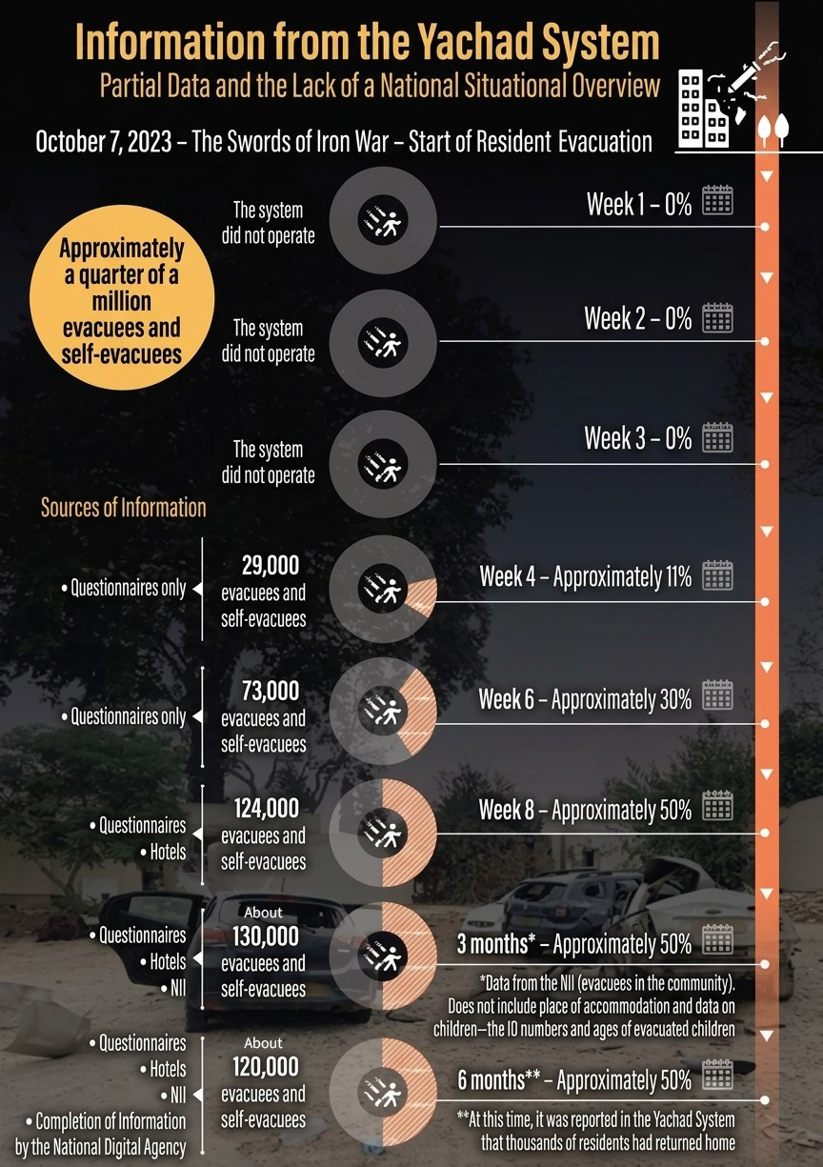

According to data from the National Digital Agency, processed by the Office of the State Comptroller.
Summary
During the Swords of Iron War, a total of about a quarter of a million people were evacuated upon government approval or evacuated independently from localities that were not evacuated. These are evacuees who were accommodated in hotels or found housing solutions in the community, as well as residents who self-evacuated from localities to which the evacuation resolutions did not apply. All these residents—women and men, children and the elderly—moved to different localities, scattered among hundreds of hotels and hostels, in rented apartments, or with relatives and acquaintances. From the very beginning of the war, it was evident that this was an emergency situation unprecedented in its intensity and scope, that the residents would be residing outside their original hometowns for a long period of time, and that the solutions offered to them must be compatible with the "new routine" into which they were thrust—meaning not only "overnight shelter" solutions but the provision of necessary services, including educational frameworks for children, healthcare and welfare services. Arrangements and mechanisms for collecting the relevant information relating to approximately a quarter of a million people, its consolidation, management, and transfer to the relevant parties in government ministries and local authorities, all through a computerized information system, are mandatory conditions for the provision of governmental response. The information stored in such a system is also required as a basis for performing effective and even real-time control over government expenditures on grants or compensation for residents following evacuation.
The findings of this report revealed significant gaps and flaws in the government system regarding the consolidation and management of information on evacuated and self-evacuated residents: (a) prior to the outbreak of the war, government bodies lacked an ICT infrastructure for consolidating, managing, and presenting a situational overview of the residents who were evacuated or self-evacuated; (b) the information system that existed at the outbreak of the war—the Noah's Ark System—was established at the request of the Ministry of Interior only in 2022—about a decade after a government resolution mandating this was adopted; (c) the system was intended for use by the Ministry of Interior for the purpose of consolidating and managing information on evacuees arriving at reception facilities, but when the war broke out and the hotels started accommodating evacuees, the Ministry of Interior did not activate the system. Thus, government bodies were also deprived of the portion of information that could have been obtained with the help of the Ministry of Interior through the Noah's Ark System; (d) the Home Front Command, which began operating the Noah's Ark System itself in mid-October 2023, encountered difficulties in collecting individual-level information on the evacuated residents in hotels and was not successful in performing this task because it lacked adequate authority or tools to receive the information from the residents or the hotels; (e) the Home Front Command attempted to collect the information for only ten days and stopped after it was decided in an inter-ministerial discussion to advance the development of a new ICT system (the Yachad System) that would be operated by the National Digital Agency and used for pooling and managing the information on all evacuees and self-evacuees. All of the above—the barriers to the implementation of the advance preparedness and the shift to identifying and implementing an alternative solution during the war—led to a failure of the government apparatus during the first month of the war— October 2023, which prevented the collection and management of demographic data and needs of most evacuees and self-evacuees.
In the following months, it turned out that although government bodies expected the new system—Yachad —to provide them as soon as possible with individual-level information and a situational overview of all the evacuees and self-evacuees, precious weeks and months passed until each of them received significant information that they could rely on due to various difficulties and barriers specified in the report.
Ultimately, about six months after the outbreak of the war, the Yachad System collected up-to-date information on only about half of the evacuees and self-evacuees.

State Comptroller, The Home Front's Preparedness and Functioning during the Second Lebanon War (2007).
The data on the number of evacuated and self-evacuated residents were dynamic and updated during the war.
This is because there was no source of information regarding self-evacuated persons, but only estimates, as well as information that only some of them submitted to the Yachad System in a manner that was not updated over time; as will be further specified in the report.
Regarding the evacuees who stayed in hotels at that time, the quantitative data source used for the EMUN System was Home Front Command estimates; whereas the data source used for the Yachad System was questionnaires filled out by evacuees who submitted information to the system. As it appears, there was a discrepancy between the data presented by the two sources of information.

