Governance Aspects in the Negev – Expanded
Follow-Up Audit

Governance Aspects in the Negev – Expanded
Follow-Up Audit
Abstract


Public governance is defined as the ability of the state, through its governmental authorities, to act within the scope of its powers and to implement its policies effectively and efficiently. This term reflects the government's capacity to perform its functions successfully. The absence of governance is manifested, inter alia, in a lack of enforcement and deterrence on the part of the state, failure to implement lawfully adopted decisions, failure to provide public services that the state is obligated to deliver, and a deterioration of social order. Such a situation also leads to citizens failing to meet their civic obligations to the expected extent.
The Bedouin population in the Negev increased six-fold between 1995 and 2023, and by approximately 20% between 2018 and 2023. At the end of 2023, this population numbered approximately 325,000 individuals, according to data from the Central Bureau of Statistics (CBS). The proportion of youth (ages 0–17) was particularly high, at 48.6%. According to data from the Population and Immigration Authority, approximately 315,000 Bedouin reside in the Southern District, constituting approximately 20% of the district's total population.
Approximately 72% of the Bedouin population in the Negev live in 18 recognized localities, while 28% reside outside recognized localities (in dispersed settlements). As of the audit period (August–December 2024), the population of the dispersed settlements is estimated to be between 70,000 and 90,000. This population resides outside the boundaries of the recognized localities, beyond the jurisdiction of the local government, and in illegal structures scattered throughout the Negev.
Furthermore, over the years, the conflict between this population and the state has intensified, due to a phenomenon referred to as 'Palestinization,' denoting a growing affinity with the Palestinian population in Judea and Samaria. This is the result of marriages to Palestinian women from Judea, Samaria, and Gaza, limited Hebrew proficiency, a weakening of identification with the State of Israel and its institutions, and exposure to incitement against the state and to various forms of violence.

Audit Actions

In 2021, Annual Report 72A of the State Comptroller's Office was published, titled: Governance Aspects in the Negev (hereinafter: the previous report or the previous audit report). From August to December 2024, the State Comptroller's Office examined the correction of certain deficiencies and the implementation of some of the recommendations raised in the previous report. The review focused on the following areas: verification of residency, the handling of polygamy offenses, benefit payments, enforcement proceedings and tax debt collection, environmental damage, damage to infrastructure owned by government and private companies, protection of life and property, supervision and enforcement of traffic laws, trespassing into Israel Defense Forces (IDF) firing zones, and the need for centralized and reliable data and for a coordinating body.
The audit was conducted at the Ministry of Environmental Protection; the Israel Electric Corporation (IEC); Mekorot Water Company Ltd.; Energy Infrastructures Ltd. (EIL); the Population and Immigration Authority; the National Insurance Institute of Israel (NII); the Israel Tax Authority; the Authority for the Development and Settlement of the Bedouin in the Negev; the Israel Nature and Parks Authority (INPA); the Land Crossings Authority at the Ministry of Defense; the Israel Police; and the Ministry of Justice. Supplementary examinations were conducted at the Ministry of Labor; the Central Bureau of Statistics (CBS); the Be'er Sheva Municipality; the Lehavim Local Council; the Al-Kaysum Regional Council; and the Neve Midbar Regional Council.


Part I – Enforcement and Public Health


‏16,256 women |  | Only 3 |  | 299 cases |  | 87%
Number of women in polygamous family units in the Negev |  | Number of indictments filed in polygamy cases during 2022–2024 |  | in which survivors' pensions are paid to more than one widow for the same deceased person in Bedouin localities in the Southern District |  | of the contractors reported being asked to pay protection money (according to a survey conducted by the Contractors and Builders Association – Tel Aviv and Central District, February 2025)
‏‏24.98‏  NIS million |  | ‏96.25‏  NIS million |  | 355 tons |  | Only 3.5 km
Amount of excise tax lost in 90 cases opened from January 2020 to August 2024 |  | Allocated to the Ministry of Environmental Protection for the treatment of Bedouin localities in the Negev for the years 2022–2026 under Government Resolution No. 1279 |  | of animal carcasses were collected by the Israel Nature and Parks Authority in the Negev during 2024 |  | separate the Neot Hovav chemical industrial zone from schools and kindergartens in the Wadi al-Na'am settlement
Key Findings


Scope of the Polygamy Phenomenon – The previous audit found that there were approximately 14,000 women in polygamous family units in the Negev and 6,179 polygamous men. The follow-up audit found that there are 16,256 women in polygamous family units (an increase of 16%), of whom 2,423 (15%) are from the Palestinian Authority. There are also 7,159 polygamous men (an increase of 16%). However, the proportion of polygamous men out of all men with children in the Negev decreased between 2016 and 2023 from 18.1% to 15.4%. Polygamy has negative consequences, including economic harm to the family unit, psychological and emotional damage, intra-familial conflicts, harm to women's dignity and status, violence against women, harm to children, and the creation of marginalized youth. The primary victims of polygamy are women and children. The follow-up audit indicates that, five years on, the phenomenon persists.
Law Enforcement Response to Polygamy – In the previous audit, following the recommendations of the Palmor Committee, the State Comptroller's Office recommended considering an amendment to Section G.16 of the Attorney General's guideline on the offense of multiple marriages. This amendment stipulated that false reporting to state authorities for the purpose of obtaining benefits and other advantages should be considered an aggravating circumstance and should justify enforcement, even if the additional marriages took place long before they came to the attention of enforcement authorities. The follow-up audit found that in 2021 the Attorney General amended Section G.16; however, this guideline was not enforced with respect to offenses committed prior to the amendment.
Filing of Indictments for Polygamy – The previous audit found that indictments were filed in only 5% of the cases. The follow-up audit found that this deficiency has not been rectified. It transpires that in the years 2022–2024, 113 cases were opened; however, the Southern District Attorney's Office (Criminal) filed only three indictments. Accordingly, there has been a decrease (of 2%) in the rate of indictments filed (3%) compared to the previous audit, despite the establishment of the Polygamy Unit in the Southern District on October 6, 2024.
Payment of Benefits to Polygamous Family Units – The follow-up audit found that the National Insurance Institute (NII) pays substantial sums to many families in the Bedouin sector in the Negev as part of a "dependents' supplement to disability benefits." This results from applying the definition of "dependents" to two or more wives, as well as to all children from all wives combined. This leads to increases in the benefit amount by hundreds of percent, reaching significant sums. NII representatives informed the audit team that they did not have data on the scope of this phenomenon.
Difficulties in Locating Taxpayers in the Negev Region – The previous audit found that the Israel Tax Authority faced difficulties in handling taxpayers residing in non-Jewish localities in the Negev, due to the absence of street names and house numbers. The follow-up audit found that this deficiency has been rectified to a minor extent; difficulties in locating taxpayers persist due to the lack of formal addresses. This challenge is reflected, inter alia, in difficulties in locating businesses and delivering mail, with many letters failing to reach their destination and being returned to the sender. However, the Israel Tax Authority has begun implementing a GIS system that will enable mapping and the integration of relevant data.
Fuel Adulteration at Illegal Gas Stations – The previous audit found that the Israel Tax Authority had no estimate of tax losses resulting from tax evasion at illegal gas stations and did not take actions against such stations. The follow-up audit found that this deficiency has been rectified to a minor extent. The Israel Tax Authority still lacks an estimate of tax losses resulting from tax evasion at illegal gas stations; however, its activity in this area increased in the years 2022–2024. From January 2020 to August 2024, 90 cases were opened in which the tax loss involved excise tax on fuel, amounting to NIS 24,988,750. Cooperation and coordination among the various supervisory and enforcement bodies in this field remain partial.
Harm to Environmental Quality and Public Health – The Ministry of Environmental Protection is responsible for safeguarding the environment and public health through the promotion of laws, regulations, and standards, and through supervision of their implementation and enforcement. The Ministry is also required to act pursuant to binding international conventions. Its areas of responsibility include, inter alia, air quality management, waste management, supervision of hazardous materials, and the protection of natural resources and the marine environment.
  - Waste Dumping and Burning – The previous audit found that in both temporary settlements and permanent settlements inhabited by the Bedouin population, waste is dumped in public areas and uncontrolled waste burning occurs, causing significant air pollution to which residents are exposed. It was further found that local authorities in temporary Bedouin settlements do not collect and treat waste properly, and that conditions in permanent settlements are also unsatisfactory, due both to the lack of recycling facilities and to the low frequency of waste collection and the poor quality of its treatment. The follow-up audit found that the deficiencies identified in the area of construction waste dumping have not been rectified, while some improvements were observed in the area of household waste disposal and waste burning. However, the phenomena of waste dumping in public areas and waste burning in violation of the Maintenance of Cleanliness Law, the dumping of animal carcasses, and the obstruction of stream channels persist throughout the Negev and are not enforced as required by the Ministry of Environmental Protection and the local authorities.
Staffing of Police Stations in the Negev District – The previous audit identified a gap between actual police staffing and the approved quota at the Segev Shalom and Aro'er stations: a shortage of 6% at Segev Shalom and 8% at Aro'er. The follow-up audit found that this deficiency has not been rectified and has even worsened: The average shortfall at Segev Shalom was 22%, and at Aro'er 21%. As of the end of 2024, more than 41 officers were lacking across the two stations combined. At the Aro'er station, 86 positions had been filled out of an approved staffing quota of 106.5 positions; at the Segev Shalom station, 97 out of 117.5 positions had been filled. This audit further found that at the Ayarot Police Station, which provides services, inter alia, to the localities of Lakiya, Kramim, Meitar, Hura, Omer, and Tel Sheva, there is an average shortfall of 43 police officers (25%), and at the Rahat station, a shortfall of 27 (20%). At the Ayarot Station, the approved staffing quota for 2024 is 180.5 positions, while 127.5 are actually staffed (a shortage of 53.5 officers); at the Rahat station, 138 and 117, respectively (a shortfall of 21 officers). This shortage of officers may impair operational capacity to enforce the law, the level of service provided to residents, and the sense of personal security among residents of the Negev.
Extortion of Protection Money from Negev Residents – The previous audit identified the phenomenon of extortion of protection money and noted the harm it causes to business owners in the Negev. It further found that many contractors refrain from filing complaints with the police, and that the Israel Police classifies such extortion as an "exposure offense" – an offense for which complaints are typically not filed and which is therefore investigated through proactive police activity. The follow-up audit found that this deficiency has not been rectified. A meeting held as part of the follow-up audit with the Contractors Association in the Negev disclosed that contractors are compelled to pay huge sums for "protection" that, in practice, is not provided. In addition to protection payments and the takeover of work, many contractors suffer from extortion by threats, theft of equipment and inventory from construction sites, and are afraid to file complaints. A survey conducted in February 2025 by the Contractors and Builders Association – Tel Aviv and Central District found that 87% of contractors and developers were asked to pay protection money at construction sites, indicating that this is a nationwide phenomenon. The survey also disclosed that contractors refrain from participating in tenders; construction projects become more expensive by amounts ranging from NIS 250,000 to NIS 1 million (according to 50% of the respondents); and 75% of contractors are fearful of filing complaints.
Palestinization, the Spread of Violence and Crime, and Harm to Personal Security – It was found that within the Bedouin sector in the Negev there is a widespread phenomenon of residents with Palestinian affiliation, including tens of thousands of youths. This affiliation stems, inter alia, from marriages between Bedouin men from the Negev and Palestinian women, from unlawful presence, and from the absence of effective monitoring and registration mechanisms at border crossings. According to an assessment by the Israel Security Agency, approximately 22% of the Bedouin population currently residing in the Negev has Palestinian affiliation. The absence of an affiliation with Israel, combined with weak governance in the Negev, contributes to identification with and involvement in incidents of violence and terrorism against the State of Israel, and, according to security officials, constitutes a strategic threat to the state.
Traffic Offenses in the Southern District, Negev Area – The previous audit found that the proportion of traffic tickets issued to drivers from the non-Jewish population in the Negev area in the years 2016–2019 ranged from 51% to 60% for life-threatening offenses, from 59% to 64% for aggressive driving offenses, and from 47% to 68% for other offenses. The follow-up audit found that this deficiency has not been rectified. On average, from 2020 to 2024, 64% of traffic tickets (312,455 tickets) were issued to non-Jewish drivers, a rate significantly higher than their share of the driving population in the Negev (15%). The continued increase in calls to police control centers in cases such as aggressive driving and shooting incidents indicates a failure requiring intervention by the Israel Police, the Ministry of National Security, and the Ministry of Transport and Road Safety.
Employment of Minors Across the Negev – During the follow-up audit period, representatives of the State Comptroller's Office were exposed to a phenomenon of minors employed in various businesses, such as car wash facilities and illegal gas stations. In addition, representatives of local authorities, the police, and environmental protection bodies noted that this is a widespread phenomenon among the Bedouin population in the South. They indicated that it stems from several factors, including economic need and hardship among the families from which these minors originate, as well as the prevalence of polygamy in the region, which makes it difficult to supervise minors and ensure their attendance at school. The combination of idleness among youths in dispersed settlements, the failure of many to integrate into educational institutions and schools, and the increase in the number of at-risk children (it is estimated that approximately 40% of at-risk children are from polygamous families) leads many of them, particularly those from polygamous families, to engage in prohibited and harmful employment.

Recruitment of Investigators to the National Insurance Institute – The previous audit found a significant shortage of investigators at the National Insurance Institute (NII). The follow-up audit found that this deficiency has been rectified to a large extent. Six investigators were recruited to assist in addressing the implications of the polygamy phenomenon for NII benefits, and approximately 4,600 benefit-related cases were investigated in the years 2021–2025. However, since these investigators do not have police powers, they are limited to rejecting benefit claims and cannot take additional deterrent measures, such as detention or a summons for questioning.

Key Recommendations

- It is recommended that the State Attorney's Office, in cooperation with the Israel Police, examine the reasons for the low rate of indictments filed for polygamy and, accordingly, enhance cooperation between them in order to ensure effective and consistent enforcement that will lead to a change in the situation on the ground.
- It is recommended that the National Insurance Institute (NII) continue to examine the issue of benefit payments to polygamous families, through the inter-ministerial team addressing this matter. It is further recommended that the NII adjust the resources available to its investigations department in order to intensify the fight against the phenomenon of fraudulent benefit claims.
- It is recommended that the Israel Tax Authority, in cooperation with the Ministry of Environmental Protection, the Israel Police, and the Ministry of Energy and Infrastructure, strengthen enforcement and oversight with respect to illegal gas stations in the Negev and undertake updated mapping of the phenomenon. This will enhance deterrence in this field of activity and may also increase required tax collection, given the persistence of the phenomenon during the follow-up audit and its negative implications across multiple areas, including environmental issues, the employment of minors, and loss of tax revenues.
- The Ministry of Environmental Protection should act to rectify the severe situation in the areas of illegal waste burning and dumping across the Negev, the disposal of animal carcasses in the public domain, and the dumping of waste in streams in the Southern District and the blockage of stream channels. The State Comptroller's Office reiterates its recommendation that the Ministry, in cooperation with local authorities in the Negev, formulate a comprehensive plan to remove the numerous environmental hazards in the region.
- It is recommended that the Ministry of National Security, in cooperation with the Israel Police, examine whether changes are required in the staffing of positions in the Southern District, particularly in Aro'er, Segev Shalom, Ayarot, and Rahat. It is further recommended to assess the extent of police presence in urban areas and to examine the potential use of technological measures to enhance the sense of security and ensure public safety.
- The accompanying committee, chaired by the Director General of the Ministry of Diaspora Affairs and Combating Antisemitism, should submit to the government its recommendations on addressing the issues of Palestinization in Bedouin society, identity and belonging, local governance, and recruitment to the Israel Defense Forces (IDF), in accordance with the Government Resolution of September 2025.
- It is recommended that the Ministry of National Security, the Ministry of Transport and Road Safety, and the Israel Police formulate a coordinated action plan, which will include, inter alia, enhanced enforcement through the use of technological measures for the detection, documentation, and enforcement of offenses; increased police presence on high-risk routes, with the allocation of the necessary resources; and the expansion of prevention and public awareness activities.

Part II – Government Infrastructure

103 |  | NIS 3.1 million |  | 29 |  | 2.5-fold
Average number of infrastructure damage incidents handled annually by Mekorot Water Company |  | Extent of damage to Mekorot infrastructure in 45 major cases for which data were collected |  | Average number of infrastructure damage incidents handled annually by the Israel Electric Corporation |  | Average number of electrical faults in dispersed settlements handled by the Israel Electric Corporation, compared to the national average
12 |  | Hundreds of thousands of citizens |  | 1,730 |  | 4,498 dunams
incidents handled by Energy Infrastructures Ltd. in the years 2019–2024, including three fuel theft incidents and nine infrastructure sabotage incidents |  | affected by complete disruption of telephone and internet communications resulting from infrastructure theft and sabotage affecting Company A |  | cannabis eradication operations carried out from 2021 to 2023 in firing zones of the Tze'elim National Training Center |  | (≈450 hectares) in which land clearing was carried out for the purpose of destroying cannabis crops in the years 2021–2023 in areas under the Planning Directorate of the Ministry of Defense and in the vicinity of Nevatim Airbase

Key Findings

Damage to Infrastructure of Mekorot Water Company – The previous audit identified a phenomenon of damage to the infrastructure of Mekorot Water Company in the Negev, with an average of approximately 105 incidents per year and a total of 1,150 incidents in the years 2008–2018. The follow-up audit found that this deficiency has not been rectified. The average annual number of incidents handled by Mekorot has remained nearly unchanged, at approximately 103 incidents per year, including, inter alia, cable cutting, theft, and arson of transformers.
Damage to Infrastructure of the Israel Electric Corporation – The previous audit identified a phenomenon of damage to the infrastructure of the Israel Electric Corporation in the Negev. The follow-up audit found that this deficiency has not been rectified and has even worsened, including in terms of the frequency of incidents. It was found that 131 incidents had occurred from January 2020 to July 2024 (compared to 13 incidents from January 2018 to September 2019 in the previous audit). The average number of incidents handled annually by the Israel Electric Corporation increased from 7.8 during the period of the previous audit to 29 during the follow-up audit period.
Damage to Water Utility Infrastructure – The audit findings revealed a severe and widespread phenomenon of illegal takeover and construction by residents on public land where infrastructure is located, resulting in deliberate and significant damage to the essential systems of Neve Midbar Water Corporation. Such damage leads to the collapse of sewer lines, blockage of main collection lines, disruption of processes at the wastewater treatment plant, and severe damage to existing sewage manholes. In addition, illegal construction and damage to water and sewage infrastructure occur across the Negev, as well as the dumping of construction waste, household waste, and large mounds of soil – several meters high – over existing sewer lines. These actions result in harm to public health and environmental quality, as well as economic damage to Neve Midbar Water Corporation, which is responsible for providing water and sewage services.
Trespassing into IDF Firing Zones – The previous audit identified a phenomenon of trespassing into IDF firing zones in the Negev and the conduct of various types of criminal activity, including the establishment of cannabis-growing greenhouses, land seizure and cultivation without authorization, and agricultural encroachments. The follow-up audit found that this deficiency has been rectified to a minor extent. In the firing zones of the Tse'elim National Training Center, 1,730 cannabis eradication operations and 1,855 evacuations from firing zones were carried out in the years 2021–2023. In addition, in areas under the Planning Directorate of the Ministry of Defense and in the vicinity of Nevatim Airbase, land-clearing operations were carried out over 4,498 dunams, and 43 land eviction orders were issued in the years 2021–2023. However, in 2024, and already toward the end of 2023, there was a significant decline in the scope of these activities, attributed primarily to the Swords of Iron (Gaza) war and its impacts. The follow-up audit further found that in 2025 there had been progress in the IDF's handling of this issue.
Bedouin Population in Excessive Proximity to Nevatim Airbase – The previous audit identified several phenomena occurring in the vicinity of Nevatim Airbase, including livestock grazing near the base, the dumping of tires and stones on access roads leading to it, and damage to the base's electronic perimeter fence. The follow-up audit found that this deficiency has not been rectified. While incidents of stone-throwing at military vehicles on Highway 80 and incursions into the base no longer occur, other phenomena identified in the previous audit persist. Inter alia, there has been a significant increase in shooting incidents in close proximity to the base, including spillover of gunfire onto its grounds (in one instance, an aircraft wing was damaged by such fire). It was further found that residents of dispersed settlements can still get very close to the base, enabling observation of activities within it and potentially compromising information security related to its operations. This phenomenon is reflected in the filing of an indictment in July 2025 against a resident of a dispersed settlement who was in contact with Iranian intelligence elements and carried out various security-related tasks for them, including during "Operation Rising Lion", gathering intelligence on the base and photographing fighter jet takeoffs. In addition, a concerning development that did not occur during the previous audit period has emerged and is liable to have strategic implications: the infiltration of drones into the base's airspace.

Key Recommendations
It is recommended that the Israel Police, in cooperation with Mekorot Water Company, enhance the effectiveness of the protection systems for Mekorot's infrastructure and strengthen cooperation between them in this area.
It is recommended that the Israel Police, in cooperation with the Israel Electric Corporation, enhance the effectiveness of the protection systems for the Corporation's infrastructure and strengthen cooperation between them in this area.
The water corporation and local authorities in the Negev should act to repair damaged water and sewage infrastructure. The Israel Police should act to prevent the phenomenon of illegal construction and damage to water and sewage infrastructure in the Negev, which has a material impact on residents' quality of life and on the region's flora and fauna.
It is recommended that the IDF, in cooperation with the Israel Nature and Parks Authority and the Israel Police, enhance supervision and enforcement with respect to trespassing and other criminal activities, such as cannabis cultivation, carried out in IDF firing zones across the Negev.
It is recommended that the IDF, the Ministry of Defense, the Israel Police, and the Authority for the Development and Settlement of the Bedouin in the Negev continue to regulate the handling of trespassing into IDF firing zones and act to rectify the situation.

Part III – Government Policy Formulation

325,000 persons |  | 20% |  | 6-fold |  | 48.6%
Bedouin population in the Negev as of the end of 2023, according to data from the Central Bureau of Statistics (CBS) |  | Share of the Bedouin population out of the total population residing in the Negev |  | Growth rate of the Bedouin population in the Negev in the years 1995–2023 |  | Relative proportion of youth up to age 17 within the Bedouin population in the Negev as of the end of 2023
0 |  | 3 |  | Only 4% |  | Only 30%
Number of times the Ministerial Committee for the Development of the Negev, the Galilee, and National Resilience, chaired by the Minister for the Negev, the Galilee, and National Resilience, convened during the two years since its establishment, from March 2023 to February 2025 |  | Number of land border crossings between Judea and Samaria and Israel at which no monitoring is conducted of the exit of Israeli residents, including members of the Bedouin population in the Negev, from Israel to Judea and Samaria |  | Response rate among residents of dispersed settlements in the census conducted by the Central Bureau of Statistics (CBS) in 2022 |  | Response rate among residents of recognized Bedouin settlements in the census conducted by the Central Bureau of Statistics (CBS) in 2022

Key Findings

Discussions in Ministerial Committees on the Lack of Governance in the Negev – A Ministerial Committee on the Regulation of Settlement and Economic Development of Bedouin Society in the Negev, chaired by the Prime Minister, was established by Government Resolution No. 356 of March 19, 2023, for the term of the 37th Government. The resolution stipulates that the Committee's responsibilities will be to formulate overall policy on the regulation of Bedouin settlement in the Negev, including the socio-economic development of the population. A review of the Committee's protocols indicates that it has focused primarily on settlement regulation issues and the Focus Plan, and has hardly addressed matters of governance, coordination of information, or activities of the various government ministries in the Negev. The State Comptroller's Office further found that, as of the conclusion of the audit, despite the establishment (pursuant to Government Resolution No. 274) of the Ministerial Committee for the Development of the Negev, the Galilee, and National Resilience, chaired by the Minister for the Negev, the Galilee, and National Resilience, this Committee had not convened at all during the two years since its establishment (as of February 2025). Accordingly, the issue of the lack of governance in the Negev and the coordination of government activity in this area has not been discussed by any ministerial committee.
Actions by the Population and Immigration Authority to Verify Residency – The previous audit found that the Population and Immigration Authority lacked the tools to thoroughly examine claims for recognition of residency by members of the Bedouin population, and that forged documents and certificates were often used to substantiate residence in Israel. The follow-up audit found that this deficiency has not been rectified. Even as of the conclusion of the audit, the Population and Immigration Authority lacks the appropriate investigative means, as well as the necessary resources and tools, to establish and verify the true center of life of residency applicants, and is therefore sometimes required to rely on the findings of investigations conducted by the National Insurance Institute (NII). It was found that the Authority continues to contend with the submission of various fictitious certificates for the purpose of registering residency. If the Authority's ability to investigate and thoroughly examine such fictitious certificates does not improve, significant financial damage to the state treasury will ensue.
Oversight at Land Crossings to the Judea and Samaria Area – The previous audit found that no monitoring was conducted at land crossings of the exit of Israeli residents—including members of the Bedouin population in the Negev—from Israel to Judea and Samaria, and that only partial oversight exists, reflected solely in the registration of Judea and Samaria residents upon entry into Israel. The follow-up audit found that this deficiency has not been rectified. The Land Crossings Authority in the Ministry of Defense does not monitor the exit of residents from Israel. Moreover, despite the recommendation of the inter-ministerial committee for addressing the phenomenon of the import of Palestinian women into the Bedouin sector in the Negev, the Population and Immigration Authority and the Land Crossings Authority have not yet established a system at land crossings to record entries and exits of all populations. As a result, difficulties persist in verifying the residency status of individuals seeking to be registered as residents of Israel.
The Need for Centralized and Reliable Data and for a Coordinating Body
  - Population Surveys Conducted by the Central Bureau of Statistics – The previous audit found that the Central Bureau of Statistics (CBS) faces difficulties in conducting population surveys among the Bedouin population in the Negev, which serve, inter alia, as a tool for government ministries in allocating budgets for activities under their responsibility. The follow-up audit found that this deficiency has not been rectified. The CBS still does not receive cooperation from the Bedouin population when conducting population surveys, despite employing surveyors from within the Bedouin community. The low response rates among Bedouin residents of the Negev—only 4% among residents of dispersed settlements and approximately 30% among residents of recognized localities—and the lack of socio-economic data on residents of dispersed settlements compel the CBS to rely on estimated data.
  - The Need for a Unified and Reliable Database – The previous audit noted the absence of a unified and reliable database accepted by all relevant government ministries and the impact of this gap on their operations vis-à-vis residents. Such a database could prevent manipulation of residents' data and avoid the resulting additional financial costs to the state treasury. For example, a situation may arise in which an individual reports to the Ministry of the Interior that he is married so that his wife may obtain citizenship, while reporting to the National Insurance Institute (NII) that they are divorced, enabling each of them to receive an income support benefit. The follow-up audit found that this deficiency has not been rectified. The relevant government ministries and bodies, including the Population and Immigration Authority and the NII, have not yet ensured more structured and unified information sharing between them, subject to the required legal arrangements.
  - Absence of a Coordinating Authority – A substantial portion of the deficiencies described in the previous report persist to this day across the various areas examined, including residency verification by the Population and Immigration Authority, the handling of polygamy offenses, benefit payments by the National Insurance Institute (NII), enforcement proceedings and tax debt collection, environmental harm, damage to infrastructure of government and private companies, protection of life and property, supervision and enforcement of traffic laws, trespassing into IDF firing zones, and the need for centralized and reliable data and a coordinating authority. The persistence – and even the worsening – of these deficiencies stems, in part, from coordination problems among the various bodies, the division of responsibilities, and the mobilization of the entities to support other bodies. Even the establishment of inter-ministerial committees – within the Population and Immigration Authority (the inter-ministerial committee on the import of women) and within the NII (the committee for examining benefits paid to polygamous families and their implications) – has not yielded the desired solutions in their respective areas. In addition, despite the establishment, pursuant to a Government Resolution, of the Ministerial Committee for the Development of the Negev, the Galilee, and National Resilience, chaired by the Minister for the Negev, the Galilee, and National Resilience – this committee has not convened at all during the two years since its establishment. Under the current decentralized model of governance, no significant progress has been made in addressing the lack of governance in the Negev; rather, the situation has worsened, characterized, inter alia, by the spread of some of these phenomena to other regions of the country. This clearly indicates the need for a systemic government response. It was found that this deficiency has not been rectified: there is no overarching government body responsible for centralizing information and coordinating the handling of the full range of issues and characteristics associated with the lack of governance in the Negev. The follow-up audit further found that, despite the evident need arising from the situation on the ground as described in this report, no government entity exists that formulates overall policy and oversees its implementation with the aim of reducing the gaps between the Bedouin population in the Negev and the general population.
Key Recommendations
It is recommended that the Minister for the Negev, the Galilee, and National Resilience, in his capacity as Chair of the Ministerial Committee for the Development of the Negev, the Galilee, and National Resilience, convene the Committee in order to advance the issues defined within its mandate under the relevant Government Resolution, including strengthening national and social resilience in the Negev.
The Population and Immigration Authority and the Ministry of Justice should act promptly to examine the adequacy of the investigative means, resources, and tools required in order to thoroughly assess residency claims submitted by Bedouin residents. Given the need for investigative tools and the conducting of investigations to verify the reliability of data and documents submitted to the Population and Immigration Authority, and in light of the many significant – including economic– implications arising from determinations of residency, as well as the Authority's lack of ability to rely on investigation findings of the National Insurance Institute (NII), the Population and Immigration Authority should establish investigative capabilities, whether through the assistance of other bodies or through a dedicated entity equipped with the necessary tools and authorities to fulfill its functions.
It is recommended that the Land Crossings Authority and the Population and Immigration Authority promote the establishment of an online information system to record the entry and exit of all individuals passing through land crossings, for the purpose of monitoring and oversight of residents' movements to and from Judea and Samaria. This, inter alia, would support the assessment of the center of life of members of the Bedouin population.
It is recommended that the Central Bureau of Statistics (CBS) act to significantly improve response rates to the census among Bedouin residents in the Negev and intensify efforts to obtain more reliable and accurate socio-economic data on residents of dispersed settlements in the Negev.
It is recommended that all relevant government ministries and bodies, including the Population and Immigration Authority and the NII, act promptly to establish more structured and unified information sharing among them, subject to the required legal arrangements.

Number of Cases Opened by the Police per 1,000 Residents, by Police District, 2020–2024
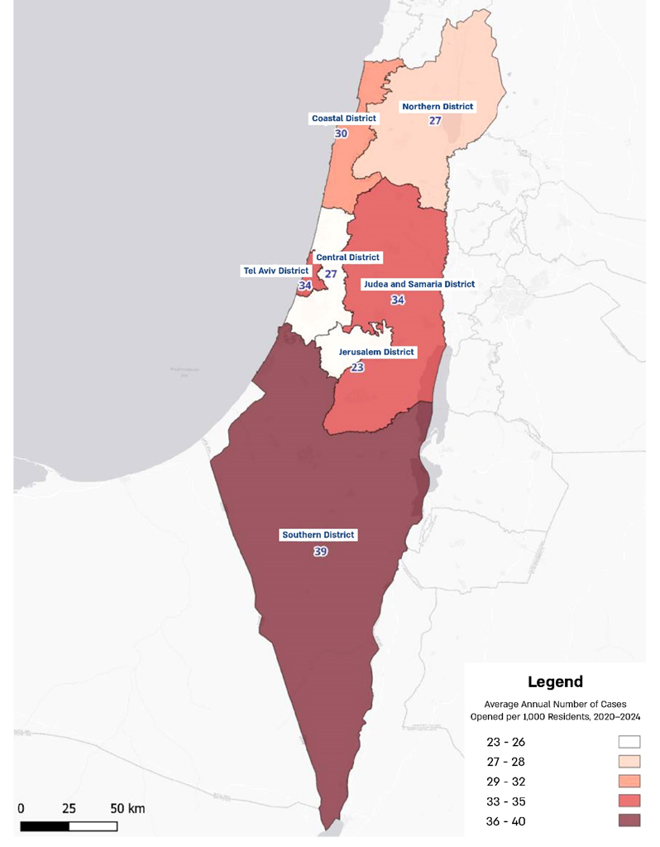

Source: Knesset Research and Information Center, Selected Data on Reported Crime in Israel from the Beginning of 2019 to the End of the Third Quarter of 2024 – Revised Version (November 25, 2024; updated January 28, 2026).
Unregulated waste on the banks of the Be'er Sheva stream, near Tel Sheva, August 2024

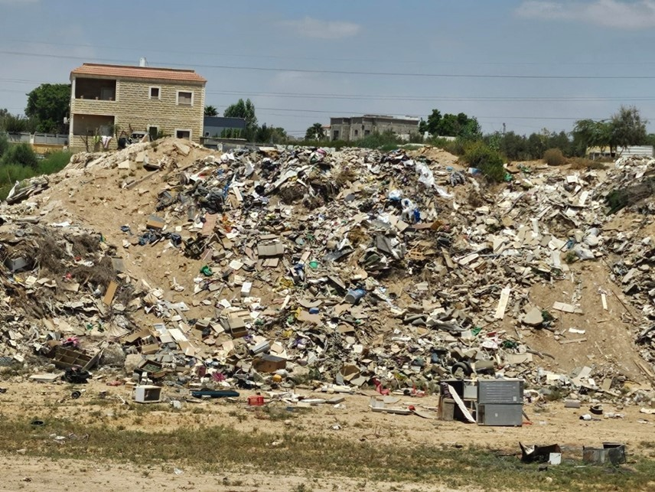
Photographed by the audit team, August 2024.

Summary
The state's governance in the Negev and throughout the country is essential for the maintenance of orderly life and proper relations among all segments of the population and is required to ensure the provision of proper and regular services to all residents, regardless of gender or religion. The absence of governance undermines the deterrence capability of enforcement authorities vis-à-vis lawbreakers, affects the sense of personal security and the level of trust of citizens and residents in state institutions, and has significant economic implications, including unwarranted benefit payments, underpayment of taxes, threats against legitimate businesses and resulting economic harm, as well as drug cultivation and a drug economy.
The findings of this report revealed a situation of deficient governance across a wide range of areas of life in the Negev, including enforcement and regulatory challenges, lack of coordination among government ministries, and even the absence of a unified and reliable database. The report shows that several government ministries and other government bodies are acting to address the governance challenges in the Negev but are encountering difficulties in doing so. It further indicates a lack of coordination and integration of government activities, underscoring the need to improve inter-ministerial coordination. Such coordination could be achieved through a government body in charge of coordinating overall government activity in the Negev. The need for an overarching authority, tasked with overseeing and coordinating the response to the lack of governance in the Negev described above, is significantly reinforced in light of the findings of this report and the severe impact on the sense of personal security and the level of trust that Negev residents place in the state and its enforcement agencies. It was found that the governance problem in the Negev persists and has, in fact, worsened in the years since the publication of the previous report. Under the current circumstances, government bodies face difficulties in addressing the issue independently. Accordingly, intervention by the Prime Minister's Office is required to designate a coordinating government authority for this matter. The Prime Minister's Office should ensure that this authority is vested with appropriate powers, should oversee the formulation of a multi-year national plan with measurable targets for monitoring and addressing the problem of governance in the Negev, and should promote increased national attention and prioritization of this serious issue among all relevant bodies. In addition, the coordinating authority should strengthen coordination among the various bodies, resolve inter-agency issues, and mobilize different entities to support the activities of other bodies, based on a holistic approach to addressing all aspects of the governance challenges in the Negev, as identified in this report.
The comprehensive follow-up audit reveals a highly concerning situation. Most of the deficiencies identified in the previous report have not been rectified at all or have not been fully rectified. The decentralization of areas of activity and the lack of cooperation among the relevant bodies continue to undermine state governance and erode the trust of the public residing in the Negev. It was found that cooperation among government bodies is inadequate: data concerning a substantial portion of the population are unreliable; enforcement capabilities are limited; and enforcement activities in certain areas are almost nonexistent. The persistence and intensity of these serious phenomena clearly indicate a deterioration in state governance in the southern region of the country and result in tangible harm to law-abiding residents, as well as a loss of trust in state institutions. There is a lack of a guiding and coordinating authority to centralize information, adopt a forward-looking approach, define clear and measurable objectives, and monitor their implementation. Addressing the phenomenon of deficient governance in the Negev requires a multi-system, cross-government effort involving numerous bodies.
The Prime Minister should address the issue of deficient governance in the Negev—an issue of strategic importance with far-reaching implications for the State of Israel—together with its underlying causes and significant deficiencies, as detailed in this audit report, and act to improve the situation. This should include, inter alia, leading a coordinated, multi-system response involving multiple bodies and appointing a government authority tasked with overseeing and coordinating their activities in an efficient and effective manner, based on the formulation of clear, actionable objectives and the monitoring of their implementation.

NIS 43.75 million was allocated from the Ministry of Finance budget, with the remainder funded by the Maintenance of Cleanliness Fund.
Based on data from the Population and Immigration Authority.
A District Police Control Center (DCC) is responsible for operational command and control and for providing services to all residents of the district in which it operates. A resident's initial contact with the Israel Police, by dialing 100, is with DCC operators.
Final Report, the Inter-Ministerial Team for Addressing the Negative Implications of Polygamy (2018), p. 271.
Data processing for the map was carried out by Matan Shahak, Head of Unit, Knesset Research and Information Center. Population data by police district are based on data from the Israel Police and refer to the estimated population in 2023.

