The Structure of the Government in Israel: Changes and Their Implications for Government Performance

The Structure of the Government in Israel: Changes and Their Implications for Government Performance
Abstract


The government is the executive branch of the state, and it holds office by virtue of the confidence of the Knesset. The executive branch in Israel comprises the Government of Israel and its executive arms, principally the government ministries and their affiliated agencies, each of which is in charge of specific areas of responsibility (hereinafter collectively referred to as “the structure of government”). The structure of government and the composition of government ministries reflect the institutional and organizational foundations upon which the executive branch operates. With the Knesset’s approval, the government may alter the allocation of functions among ministers, except for the office of the Prime Minister; transfer, in whole or in part, a statutory power vested in one minister or a duty imposed on that minister by law to another minister; merge, divide, abolish or establish government ministries. The government may also transfer areas of responsibility from one ministry to another. The optimal organizational structure of government, including the allocation of powers and areas of responsibility among government ministries and their affiliated agencies, has a significant impact on the ability of the executive branch to operate professionally, efficiently, and effectively.
In practice, the structure and composition of the government are determined, inter alia, by agreements among Knesset factions for the purpose of forming a coalition, commonly referred to as "coalition agreements". This report focuses on the structure of the 35th, 36th, and 37th Governments of Israel. For the formation of the 35th Government, headed by Benjamin Netanyahu, in May 2020, coalition agreements were signed between the Likud faction and several Knesset factions. For the formation of the 36th Government, headed by Naftali Bennett and Yair Lapid, in June 2021, coalition agreements were signed between the Yesh Atid faction and several Knesset factions. For the formation of the 37th Government, headed by Benjamin Netanyahu, in December 2022, coalition agreements were signed between the Likud faction and several Knesset factions. Coalition agreements are likely to include structural changes to the composition of government ministries, such as the establishment or closure of ministries and the transfer of areas of responsibility among them. Accordingly, the structure of government is likely to change over time, particularly when a new government is formed. The stability of the governmental structure and the functioning of the government’s executive arms are therefore influenced both by the frequency with which governments are formed and by the provisions set forth in coalition agreements between Knesset factions.

Number of Ministers and Deputy Ministers in Israeli Governments Since the Establishment of the State
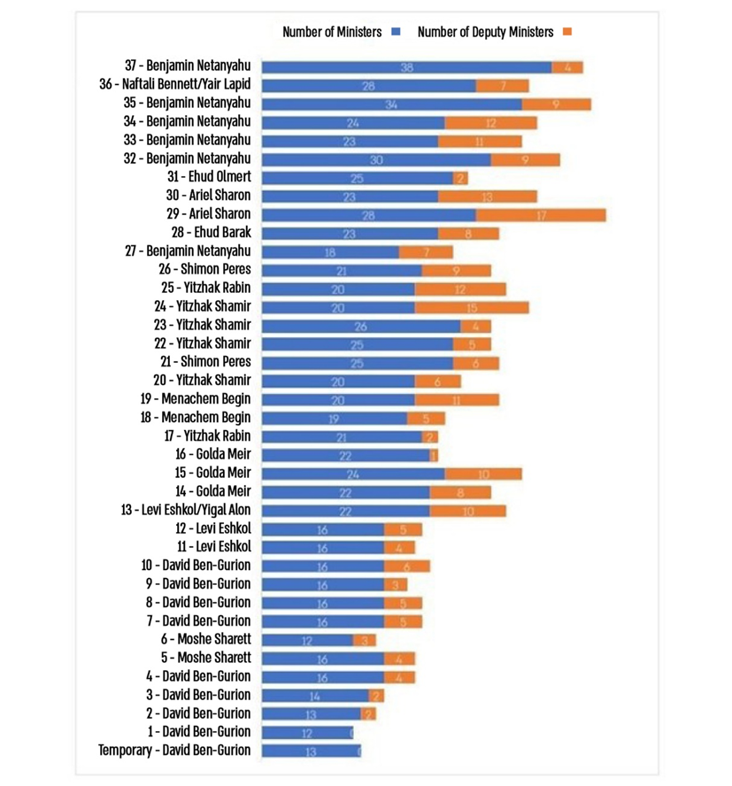

Prepared by the State Comptroller’s Office.

Number of Ministers and Government Ministries in Israel and Comparator Countries, as of 2024

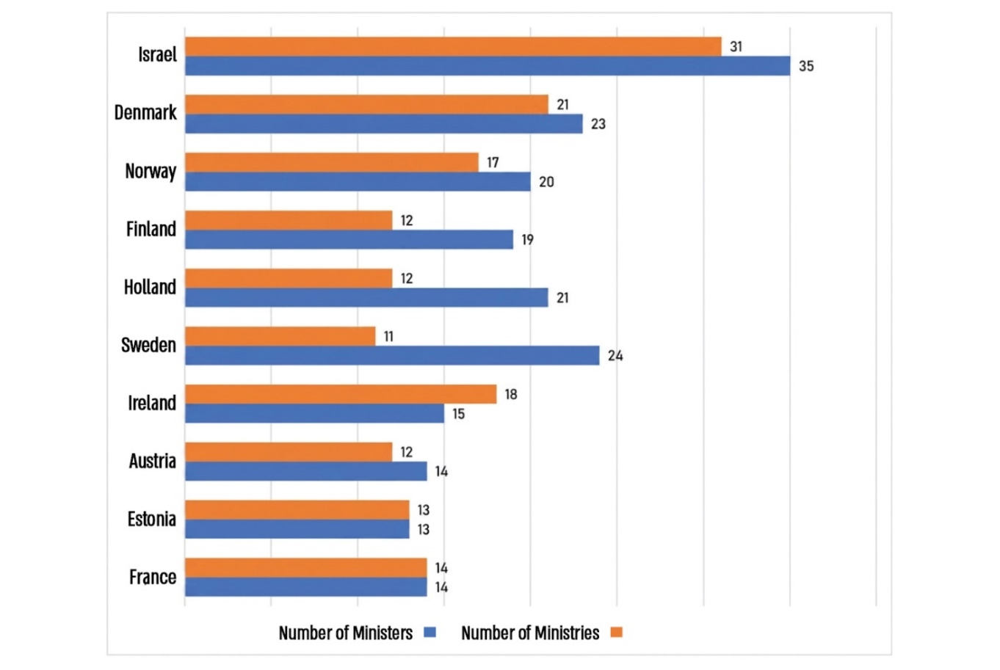
Prepared by the State Comptroller’s Office.


1.5–2.7-Fold |  | Approx.  Two Years |  | 15
The number of government ministries in Israel was 1.5–2.7 times that of the comparator countries during the term of the 37th Government, and 1.3–2.4 times that of the term of the 36th Government. |  | Average tenure of an Israeli government (over the 76 years from the establishment of the State through the end of the 36th Government’s term in December 2022). |  | of the 31 ministries in the 37th Government (the government in office during the audit period), do not exist—or are almost non-existent—in the comparator countries (as of May 2024).
14 |  | 76 |  | 50
of the 29 ministries in the 36th Government (from its establishment in mid-2021 through the end of 2022), did not exist—or are almost non-existent—in the comparator countries (as of May 2024). |  | changes to the structure of government were approved by government decisions in the 35th, 36th, and 37th Governments, over a period of four and a half years (from mid-2020 through the end of 2024). |  | areas of responsibility were transferred between ministries pursuant to government decisions during the terms of three governments (a total of four and a half years). 40% of the areas of responsibility were transferred more than once.
6
government ministries to which the Authority for the Development and Settlement of the Bedouin in the Negev was subordinated, from its establishment in 2007 through 2025.

Audit Actions

From March 2024 to March 2025, the State Comptroller conducted an audit on the structure of the government in Israel: changes and their implications for government performance. The audit examined characteristics of the structure of government in Israel, the management of changes to the governmental structure, and the effects of such changes on the functioning of government units and the provision of services to the public. The audit was conducted at the Prime Minister's Office (PMO) and the Civil Service Commission (CSC or the Commission). Supplementary examinations were conducted at the Ministry of Finance—in the Budget Department and the Accountant General’s Department—as well as at the Ministry of Agriculture and Food Security (Ministry of Agriculture), the Ministry of the Negev, Galilee and National Resilience (Ministry of the Negev and Galilee), the Ministry of Economy and Industry, the Ministry of Labor, the Ministry for Social Equality, and the Holocaust Survivors' Rights Authority.

Key Findings
Number of Changes to the Structure of Government Approved by the 35th–37th Governments, May 2020–December 2024

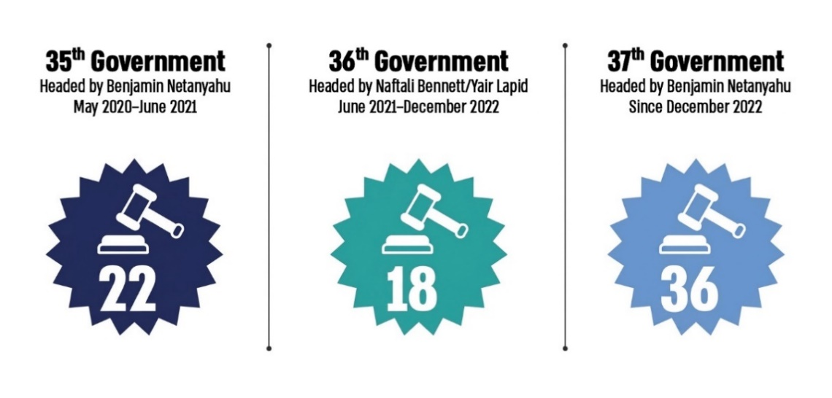
Based on data from the Prime Minister’s Office website, as processed by the State Comptroller’s Office.
The Structure of Government in Israel and Other Countries: An International Comparison
Three Characteristics of Israeli Governance and Their Implications—The first is the higher-than-planned frequency of government formation (on average, every two years rather than every four years), resulting in more frequent changes to the configuration of government ministries and their areas of responsibility. The second is the large number of government ministries: their number peaked in the 35th Government, headed by Benjamin Netanyahu (which served from May 2020 to June 2021), declined somewhat in the 36th Government, headed by Naftali Bennett and Yair Lapid (from mid-2021 through the end of 2022), and increased again under the current government – the 37th Government, headed by Benjamin Netanyahu (since the end of 2022). The third is the relatively large number of ministries that are unique to Israel compared with other countries, resulting in the fragmentation of areas of responsibility among various ministries.
With the Knesset’s approval, the government may alter the allocation of functions among ministers, except for the office of the Prime Minister; transfer, in whole or in part, a statutory power vested in one minister or a duty imposed on that minister by law to another minister; merge, divide, abolish, or establish new ministries.
At the same time, these characteristics carry a “functional cost” in the form of multiple government ministries and a reduction in the effectiveness of government operations and the services provided to the public. In addition to this functional cost, there is a substantial economic cost, estimated by the Budget Department of the Ministry of Finance at hundreds of millions of shekels annually, at a minimum.


Attempts to Limit the Number of Government Ministries
- Failure to Reach Decisions Regarding the Implementation of Recommendations Made By Professional Teams—As noted, with the Knesset’s approval, the government may alter the allocation of functions among ministers, except for the office of the Prime Minister; transfer, in whole or in part, a statutory power vested in one minister or a duty imposed on that minister by law to another minister; merge, divide, abolish, or establish government ministries. Since 2011, successive governments have adopted a series of decisions aimed at introducing structural changes to the governmental system, including reducing the number of government ministries. Recommendations made by professional teams aimed at reducing the number of ministries or eliminating overlaps among them failed to result in government decisions on the matter: a team established in 2011 did not address the structure of government, as required; the recommendations of a team established in 2015 were not adopted, and its work led to the establishment of another team in 2016, whose recommendations were likewise not implemented. Similarly, recommendations issued by the Budget Department in December 2023, following the outbreak of the war, did not lead to a decision to substantially reduce the number of ministries. The audit findings point to a recurring pattern of government action: decisions are reached to examine the structure of government and the number of ministries; the examinations are conducted and identify inefficiencies in the governmental structure and the need to reduce the number of ministries; yet despite these findings, the measures required to reduce the number of ministries and eliminate overlaps among them are not implemented. For example, the 36th Government adopted no decisions on the matter, while the 37th Government adopted a decision to examine a proposal to abolish five government ministries and reduce operational headquarters, but that decision was not implemented. Given that this pattern has persisted for years and across the terms of several governments, it may be concluded that political considerations and constraints ultimately outweigh the need to examine the recommendations of the teams appointed for this purpose and to improve the structure of government.
- The Prime Minister’s Office Did Not Examine the Abolition of Ministries, as Required by a Government Decision of November 2024—In October 2024, the government decided to examine, within 30 days—that is, by the end of November 2024—a proposed decision to abolish five government ministries. It also decided to formulate recommendations for consolidating headquarters and transferring areas of responsibility within 120 days, that is, by the end of February 2025—through a working team headed by the Director General of the Prime Minister's Office. The audit found that the Prime Minister’s Office did not act as required under the government decision. As of August 2025, nine months after the deadline set by the government decision, the Prime Minister’s Office had not completed its examination of the proposal to abolish the five ministries and therefore had not formulated a draft government decision on the matter. In addition, six months after the deadline set by the government for the submission of recommendations by the team regarding the consolidation of headquarters and the transfer of areas of responsibility among ministries, the Prime Minister’s Office had not completed the formulation of those recommendations.
- The Government Took Almost No Action to Eliminate Overlaps—In December 2023, the Budget Department identified 12 areas in which overlaps existed among different government ministries. The audit found that by May 2025, the government had decided to eliminate overlaps in only one of those 12 areas; in three of the 12 areas, the government decided to establish teams to examine how to address the overlaps; however, with respect to one of those areas, the decision to establish the team was subsequently rescinded. In seven of the 12 areas, the government adopted no decision at all, and in one area, it decided to reduce activity by cutting the budget. The response of the Prime Minister’s Office disclosed that several working teams had been established and adjustments made in various units, in order to strengthen government implementation abilities.

Managing Structural Changes: Establishing and Abolishing Ministries and Transferring Areas of Responsibility
- Frequent Transfers of Areas of Responsibility Among Government Ministries—During the four-and-a-half-year tenure of Israel’s three most recent governments (from mid-2020 through the end of 2024), the governments adopted decisions involving an unusually large number of changes to the structure of government—76 changes in total, including the establishment and abolition of government ministries as well as the transfer of areas of responsibility among ministries. The audit found that nearly half of these changes (36 changes, approximately 47%) were approved during the first two years of the 37th Government headed by Benjamin Netanyahu; about one-third (22 changes, approximately 29%) during the one-year term of the 35th Government headed by Benjamin Netanyahu; and about one-fifth (18 changes, 24%) during the year-and-a-half term of the 36th Government headed by Naftali Bennett and Yair Lapid.
- It was found that during the tenure of three governments—a period of four and a half years—government decisions were adopted to transfer 50 areas of responsibility among ministries. Thirty of these areas (60%) were transferred once. Forty percent of the areas of responsibility were transferred more than once: 16 areas (32%) were transferred twice; 2 areas (4%) were transferred three times—the Information Center and the Government Companies Authority; and 2 areas (4%) were transferred four times—the Authority for the Development and Settlement of the Bedouin in the Negev and the Senior Division for the Socio-Economic Development of the Bedouin Society. The transfer of an area of responsibility two or more times within a period of four and a half years creates disruption for organizational units, their managers, and their employees, and therefore poses a risk to their proper functioning and to the quality of the services they provide to the public.
- Closure and Establishment of Government Ministries—The following changes occurred in the configuration of government ministries from May 2020 (the beginning of the term of the 35th Government) to December 2024:
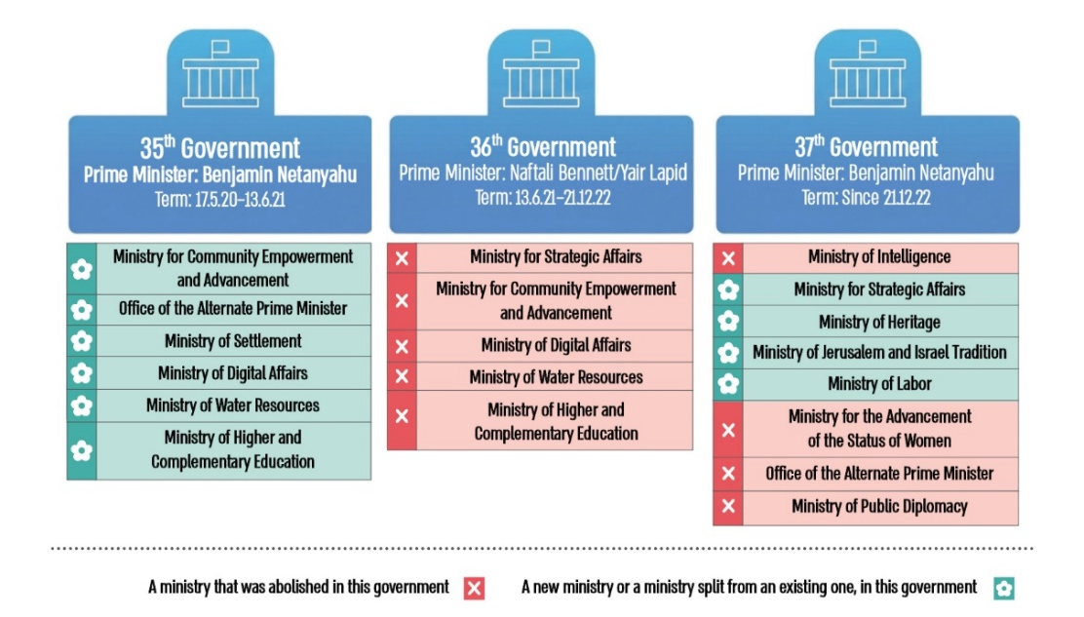
- Government Decisions Based on Staff Work—The audit found that the Government Secretariat does not maintain consolidated data on government decisions concerning the transfer of areas of responsibility during the terms of different governments. As a result, it is not possible, on the basis of consolidated data (as opposed to examining each decision individually), to track the affiliation of a particular area of responsibility to different ministries over time. An analysis conducted by the State Comptroller’s Office found that during the terms of three governments—the 35th Government headed by Benjamin Netanyahu, the 36th Government headed by Naftali Bennett and Yair Lapid, and the 37th Government headed by Benjamin Netanyahu (from June 2020 to December 2024)—government ministers approved transfers of areas of responsibility between ministries without having before them data on the resources to be transferred: in only 5 of the 75 transfers of areas of responsibility approved by the government (7%) were the ministers who were required to reach decision provided with data on the budget implications of the transfer. For the remaining 70 transfers (93%), the government made decisions without such information. In only 6 of the 75 transfers (8%) were ministers provided with data on the number of positions to be transferred; for the remaining 69 transfers (92%), the government reached its decisions without such information.
- Management of Transfers from Budgetary and Financial Perspectives—Ministry of Finance—The audit found that, as a general rule, neither the Accountant General’s Department nor the Budget Department possessed documentation of the activities of the transfer management teams in their respective areas of responsibility. These areas included financial management, procurement, and information systems, which fall under the responsibility of the Accountant General’s Department, as well as budget management, which falls under the responsibility of the Budget Department. Consequently, based on the information available to these departments, it is not possible to determine how areas of responsibility were transferred between government ministries or what lessons may be drawn from those transfers in order to improve future transfer processes. In the absence of records of the transfer management teams’ activities in the areas of budgetary and financial management, it is not possible to conduct a cross-government review of such transfers in these areas, with a view to improving transfer processes and minimizing their adverse effects on the functioning of government ministries and the units transferred between them.
- Management of Transfers in Human Resources Matters—Civil Service Commission—The Civil Service Commission lacks information regarding transfers from an HR management perspective. Moreover, it lacks records demonstrating the performance of the duties assigned to it in connection with the transfer of areas of responsibility; records of the work of transfer management teams; or detailed data regarding the transfers—the date of completion, the number of positions required to be transferred, and the number of positions actually filled before and after the transfer. The Civil Service Commission does not systematically monitor the planning and implementation of transfers from an HR management perspective, does not oversee the execution of such transfers, and has not drawn lessons from completed transfers. In light of the finding that overall staffing rates in transferred units are significantly lower than the corresponding staffing rates across government ministries and affiliated agencies as a whole, there is concern that some employees in units transferred between ministries leave their positions as a result of the transfer process.
- Duration of Transfer of Areas of Responsibility Between Government Ministries—According to data from the Accountant General’s Department regarding 41 out of 76 transfers conducted during the four-and-a-half-year period from May 2020 to December 2024 (54% of the transfers), the time taken to complete the transfer of a unit following a government decision to transfer its area of responsibility was lengthy, averaging approximately 7.5 months. The audit further found that the shortest period between a government decision to transfer a unit’s area of responsibility and completion of the transfer was three weeks, whereas the longest period was approximately 30 months. The entities in charge of the cross-government management of structural changes—the Civil Service Commission, the Budget Department, the Accountant General’s Department, and the Governance and Social Affairs Division within the Prime Minister's Office—did not possess consolidated data on the duration of the transfer of areas of responsibility between government ministries.
- Monitoring the Implementation of Government Decisions Concerning the Transfer of Areas of Responsibility Between Government Ministries—The audit found that the Government and Social Affairs Division within the Prime Minister’s Office does not systematically monitor the transfer of areas of responsibility between ministries. The Division is responsible for promoting structural reforms in government and making public monitoring reports aimed at improving government performance and implementation capacity. Upon completion of the audit, the Government and Social Affairs Division stated that, as part of the government decisions report published by the Prime Minister’s Office in August 2025, a systematic review had also been conducted of decisions concerning the transfer of areas of responsibility.

Transfer of the Authority for Planning and Development of Agriculture, Settlement and Rural Areas Between Government Ministries (Authority for Agricultural Planning)—A Case Study
- Deficient and Disrupted Transfer Process—The Authority for Agricultural Planning is the body responsible for promoting the planning and development of agricultural areas. In 2022, its budget amounted to NIS 40 million, and in 2023, it employed 14 members of staff. Within a short period of two years, the government twice decided to transfer the Authority between ministries: in February 2023, it decided to transfer the Authority from the Ministry of Agriculture and Food Security to the Ministry of the Negev and the Galilee, and in February 2025, it decided to return the Authority to the Ministry of Agriculture. The audit found that the process of transferring the Authority for Agricultural Planning from the Ministry of Agriculture to the Ministry of the Negev and the Galilee, pursuant to coalition agreements and a government decision, was fundamentally deficient and flawed. The combination of government decisions to transfer the Authority twice within a two-year period and the deficient transfer process itself adversely affected, in practice, the services provided to members of the public requiring the allocation of agricultural land, as well as agricultural sectors whose activities also involve the allocation of agricultural land. The Ministry of Agriculture, the Ministry of the Negev and the Galilee, the Accountant General’s Department, the Budget Department, and the Civil Service Commission failed to operate as a transfer management team making recommendations regarding the transfer of the Authority and its powers, as required under the government decision. As a result of the failure to complete the necessary staff work for the transfer of an area of responsibility between two government ministries, no professional foundation was laid for the effective implementation of the transfer, including with respect to the number of positions and the budget to be transferred.
- Transfer of the Authority for Agricultural Planning Without Its Staff—The Ministry of Agriculture transferred an “empty authority” to the Ministry of the Negev and the Galilee, as none of the employees or managers of the Authority for Agricultural Planning were transferred, requiring the receiving ministry to rebuild the Authority from scratch. Only ten months after the government decided to transfer the Authority between ministries was the position of Director of the Authority actually filled in the Ministry of the Negev and the Galilee. The Ministry began staffing the Authority’s remaining positions only in July 2024, a year and a half after the government decision. The transfer of the Authority to the Ministry of the Negev and the Galilee without its staff had significant implications for its ability to ensure continuity of operations and carry out its professional responsibilities, including the formulation and implementation of rural development policy, the implementation of infrastructure rehabilitation projects in rural communities, and representation of the rural development field in planning institutions. It may also reasonably be assumed that such a process, which takes a substantial amount of time, results in the loss of organizational memory, in whole or in part, and significantly impairs the Authority’s ability to maintain operational continuity.
- Transfer of the Authority for Agricultural Planning Without an Activity Budget—During its first year of activity within the Ministry of the Negev and the Galilee, the Authority operated without a budget. In its second year, it was allocated resources amounting to only one-quarter of those allocated to it in the last year in which it operated within the Ministry of Agriculture.
- Mechanisms for the Allocation of Agricultural Land—The Programming Committee and the Land Committee—Against the backdrop of the deficient process for transferring the Authority for Agricultural Planning, its activities were substantially impaired during the two-year period from February 2023 to February 2025. As a result, services provided to the public requiring the allocation of agricultural land to agricultural communities and to parties seeking to engage in agricultural activity were adversely affected. The impairment was reflected in a sharp decline in the volume of applications handled by the Authority through the two principal mechanisms for allocating agricultural land: the Programming Committee and the Land Committee. These two committees were largely inactive during that two-year period. The audit found that the Programming Committee, operating under the Ministry of the Negev and the Galilee, did not consider 34 applications submitted between July 2023 and May 2024; the Land Committee within that ministry convened for the first time only five months after the transfer, the number of its meetings declined by 50%, the number of applications it reviewed fell by 68%, and the total area of land covered by its approvals decreased by 87% (from 21,414 dunams to 2,781 dunams). The Ministry of Agriculture did not promptly transfer the documents required by the Ministry of the Negev and the Galilee for the operation of the Programming Committee, and the absence of these documents constituted a significant obstacle to advancing applications for land allocation.

Transfer of Responsibility for Certain Adult Vocational Training Activities Between Government Ministries—A Case Study
- Transfer of Areas of Responsibility Contrary to a Government Decision—Two governments—the 36th Government and the 37th Government—decided to transfer areas of responsibility in the field of vocational training between government ministries, including the division of units. The 37th Government also decided to revoke the Labor Division's status as an independent affiliated agency and to divide one of its principal divisions—the Vocational Training Division—between two government ministries. The Vocational Training Division’s budget in 2022 totaled NIS 1.132 billion; of this sum, NIS 370 million was allocated to adult vocational training, including NIS 230 million allocated that year to employer-provided training. At the end of 2022, the Division had 190 positions, of which 19 dealt with adult vocational training and the remaining 171 with vocational training for youth. Two government ministers—the then Minister of Economy and Industry and the then Minister of Labor—even decided, contrary to the government decision, to carry out an additional division under which an area of responsibility was transferred from the Ministry of Economy and Industry to the Ministry of Labor. This additional division was implemented beginning in March 2023 and was approved retroactively by a government decision only about two years later, in November 2024. As a result of this additional division, the Vocational Training Division’s activities were frozen for several months. Among other consequences, progress was not made on a reform of the vocational training system that had begun approximately two years earlier and was intended to improve responsiveness to the needs of the economy, industry, and employers and to increase labor productivity. Nor was progress made on the organizational restructuring required for implementation of the reform and for recruitment processes for filling new positions within the Division. In addition, the budget of the Vocational Training Division was not discussed in an orderly manner as part of the ministry’s budget formulation process, and uncertainty remained regarding the scope of resources to be allocated to funded training programs.
- Scope of Adult Vocational Training Programs in 2022–2023—The audit findings disclosed a sustained and significant decline in the field of vocational training, against the backdrop of the decisions of the 37th Government and government ministers regarding the transfer of areas of responsibility and the implementation of those decisions. The number of participants in adult vocational training programs declined by 22% in 2023 compared with 2022 (from 17,189 to 13,385). In employer-provided training programs, the number of participants fell by 30% in the years 2022 to 2023 (from 11,485 to 8,101). During the first eight months of 2023, the Ministry of Economy and Industry did not conduct any employer-provided vocational training activities. In 2023, the number of participating employers was only approximately one-third of their number in 2022 (466 and 1,295, respectively), and vocational training activities were carried out only during the final third of the year.
- Implementation of the Government Decision with Respect to Staffing and Budgetary Matters —The audit found that the actions required for implementing the transfer of responsibilities in the field of vocational training during the tenure of the 37th Government were not carried out. As of October 2024, nearly two years after the government decision on the transfer of responsibilities was adopted, the transfer of staff positions from the Ministry of Labor to the Ministry of Economy and Industry had still not been implemented. In addition, the budget allocated to the Ministry of Economy and Industry for the provision of employer-based adult training programs in 2023 totaled approximately NIS 95 million—only 42% of the corresponding budget in the previous year—despite employers’ expressed need for adult vocational training.

Transfer of the Authority for the Development and Settlement of the Bedouin in the Negev Between Government Ministries—A Case Study of Damage to IT Infrastructure—The Authority for the Development and Settlement of the Bedouin in the Negev (the Bedouin Authority) is responsible for regulating Bedouin settlement in the Negev and provides services to approximately 300,000 residents. The Authority’s budget totaled NIS 530 million in 2023, and it had 74 filled staff positions. Since its establishment in 2007, six decisions have been made to transfer the Bedouin Authority between government ministries, and it has operated under a total of seven different ministries. The current government (the 37th Government) decided twice within a single year to transfer the Authority between ministries. The audit found that the frequent transfers of the Bedouin Authority between government ministries—and in recent years, on average once every fifteen months—have adversely affected the management and maintenance of the Authority’s information systems. Among other things, the Authority’s systems are still installed on and hosted by servers belonging to the Ministry of Agriculture, to which it was organizationally affiliated until 2020; resources allocated for the development of new system components were not utilized; and the Ministry for Diaspora Affairs, to which the Authority has been affiliated since January 2024, lacks suitable infrastructure to operate the Authority’s systems.

Transfer of the Authority for the Advancement of the Status of Women Between Government Ministries—A Case Study of Damage to Databases—The Authority for the Advancement of the Status of Women was established under the Authority for the Advancement of the Status of Women Law, 5758–1998. Its responsibilities include encouraging, coordinating, and advancing the activities of government ministries, local authorities, and other bodies operating in fields within its mandate. The Authority’s budget totaled NIS 25.5 million in 2023. As of October 2025, it had 10 staff positions. As a result of the transfer of the Authority’s area of responsibility between government ministries, combined with personnel turnover within the Authority, matters fell through the cracks. As a consequence, the Authority lacks information concerning three databases, including details regarding their registration as required by law.

Transfer of the Holocaust Survivors' Rights Authority Between Government Ministries—A Case Study
- The Holocaust Survivors' Rights Authority provides services to approximately 120,000 Holocaust survivors. It was established as an arm of the state in order to ensure the provision of state-funded benefits to Holocaust survivors. In 2023, the Authority’s budget totaled NIS 3.9 billion, and it had 114 staff positions. From its establishment in the 1950s until 2020, the Authority operated under the Ministry of Finance. The 35th Government, established in mid-2020, decided to transfer the Authority to the Ministry for Social Equality, and two and a half years later the 37th Government decided to transfer it to the Prime Minister's Office. During the three-and-a-half-year period from mid-2020—when the government decided to transfer the Authority from the Ministry of Finance to the Ministry for Social Equality—until January 2024, the ministers heading that ministry changed five times. Notably, during a single year, from June 2020 to June 2021, the ministry was headed by three different ministers. The Authority’s computerized systems are used to manage the information and professional processes conducted by the Authority vis-à-vis Holocaust survivors and their entitlements, such as the processing of benefit applications, scheduling medical committee hearings, and the provision of medical services. These systems are extensive and complex and maintain computerized interfaces with several public bodies, including health maintenance organizations (HMOs), local authorities, and government agencies. While the Authority operated under the Ministry of Finance, until mid-2020, these systems relied on the Ministry of Finance’s IT infrastructure.
- During the four-year period from 2021 to 2025, during which, as stated, the Authority was transferred among three government ministries, efforts were made to improve its information systems, including replacing key system components, at a total cost of NIS 24 million; of this amount, NIS 14 million was wasted. However, due to the Authority’s transfers between government ministries and instability in its management, the planned improvements to its information systems were not completed. As of the conclusion of the audit in 2025, the Authority continued to rely, in part, on its legacy system, which operates in an outdated technological environment that has not been supported by the manufacturer for 17 years. The Authority’s legacy IT systems are outdated and are at a “real risk of collapse”, therefore posing a significant risk to the Authority's information in the event of a major system failure.

Transfer of Areas of Responsibility Between Government Ministries for the Rehabilitation of the South and the North and for Long-Term Disaster Recovery—A Case Study
- In May 2024, the government decided to establish, within the Prime Minister's Office and reporting directly to the Prime Minister, an implementation headquarters for the execution of a plan for the rehabilitation of northern Israel and for long-term disaster recovery, including recovery from earthquakes. Approximately six months later, in November 2024, the government decided that responsibility for these two areas, as well as for a third area of responsibility—the rehabilitation and development of the Tekuma Region and its population—would be transferred from the Prime Minister’s Office to a minister in the Ministry of Finance serving under the Minister of Finance. In July 2024, a head of the implementation headquarters was appointed, and in October 2024 he was assigned a central role in advancing large-scale efforts to rehabilitate northern Israel following the war and the damage sustained by northern communities. Only five months after his appointment, in December 2024, and against the backdrop of the transfer of responsibilities described above, he announced his resignation due to a substantial reduction in his authority and responsibilities. Two months later, in February 2025, an acting head of the implementation headquarters (the “Northern Project Coordinator”) was appointed in his place. She was a senior official in the Ministry of the Interior and was appointed for a short three-month term, which was subsequently extended twice (through November 2025). Thus, within a relatively short period of less than two years, the 37th Government adopted several decisions reflecting repeated transfers of three broad and resource-intensive areas of responsibility among ministries and among the officials charged with implementing them. This occurred during an emergency period and in the midst of a war and concerned responsibilities relating to the development and rehabilitation of regions, communities, and populations that had been severely affected—or could be catastrophically affected—by war or disasters, such as earthquakes. During this period, two officials were tasked with leading these areas of responsibility; one left the position within a few months, while the other, who was subsequently appointed in an acting capacity in addition to her senior position in the Ministry of Interior, spent approximately ten months formulating a draft multi-year plan—which was not submitted to the government for review and approval—and advancing specific government decisions. The government later assigned the Prime Minister’s Office, with the consent of the Ministry of Finance, to formulate a proposed framework for the spatial development of the Northern District and submit it to the government by mid-January 2026. The audit found, however, that no such proposal had yet been submitted to the government.
- The acting head of the implementation headquarters informed the State Comptroller’s Office in September 2025 that the implementation headquarters, which had been established within the Prime Minister’s Office and subsequently transferred to the Ministry of Finance, was not carrying out one of its designated responsibilities: long-term disaster recovery, including recovery from earthquakes. This was despite the substantial knowledge accumulated during that period following the events of October 7. Accordingly, in practice, while the headquarters was being transferred between the Prime Minister’s Office and the Ministry of Finance, one of the its areas of responsibility was never actually established. In December 2025, approximately one year after the government had decided to transfer responsibility for long-term disaster recovery from the Prime Minister’s Office to the Ministry of Finance, it decided to transfer that responsibility back to the Prime Minister’s Office.
- The harm resulting from the absence of a stable governmental framework responsible for leading and advancing these areas of responsibility, as well as from the fragmentation of responsibility among the Prime Minister’s Office, the Ministry of Finance, and even the Ministry of the Interior, as a consequence of government decisions, was reflected in fundamental deficiencies identified in the State Comptroller’s report of June 2025, including the absence of a multi-year plan for the rehabilitation and development of northern Israel. These deficiencies were at the heart of the government's failure, as of June 2025, to provide an adequate response to the return of northern residents to their communities and to the rehabilitation of the North, as detailed in the State Comptroller’s report published at that time. As of February 2026, a framework for the spatial development of the Northern District had still not been submitted to the government for review and approval.

Key Recommendations

- The Prime Minister’s Office should act in accordance with the government decision of October 2024 by completing its review of the proposed abolition of five government ministries and formulating a draft government decision on the matter. It should also formulate, in cooperation with the Budget Department and the Civil Service Commission, recommendations concerning the consolidation of headquarters and the transfer of areas of responsibility between ministries. In addition, it is recommended that the Prime Minister’s Office, through the Government Secretariat or another unit within the Office, establish a database of government decisions concerning the transfer of areas of responsibility, to serve as a basis for future decisions regarding the transfer of responsibilities between government ministries.
- It is recommended that the Prime Minister’s Office, with the assistance of the Civil Service Commission, the Budget Department, and the Accountant General’s Department, establish a database on the duration of transfers of areas of responsibility between government ministries. It should also establish a timeframe for carrying out such transfers and submit it to the government for approval and implementation by all relevant government bodies. It is recommended that the Budget Department and the Accountant General’s Department maintain records documenting the activities of transfer management teams in matters relating to budgetary and financial management and draw lessons from the teams’ work and from completed transfers in order to improve and streamline future transfer processes.
- The Government Secretariat should ensure that the explanatory notes to proposals for changes to the structure of government include complete information on the staffing and budgetary matters of any unit being transferred, as required by the Government Rules of Procedure. The Government Secretariat, the Civil Service Commission, the Accountant General’s Department, and the Budget Department should use the tools at their disposal to ensure that transfer management teams are established and operate effectively in carrying out transfers; these units, together with the Prime Minister’s Office, should also regularly monitor the implementation of government decisions concerning the transfer of areas of responsibility.
- It is proposed that the Government Secretariat draw lessons from all aspects of the implementation of changes to the structure of government during the tenure of recent governments, at least with regard to the 35th, 36th, and 37th Governments (since 2020). It should initiate the formulation of government guidelines concerning changes to the structure of government and ensure that these lessons and guidelines are presented to all relevant parties when a new government is formed, and whenever the government considers structural changes during its term of office. The Civil Service Commissioner, the Accountant General, and the Director of Budgets should each draw lessons within their respective areas of responsibility in order to improve the implementation of government decisions concerning the transfer of areas of responsibility.
- It is recommended that the Ministry of Agriculture, the Ministry of the Negev and the Galilee, the Ministry of Economy and Industry, and the Ministry of Labor—each within its respective area of responsibility and in cooperation with the Civil Service Commission, the Accountant General’s Department, and the Budget Department—formulate conclusions regarding the government decisions to transfer the two areas of responsibility—the Authority for Agricultural Planning and the field of adult vocational training—between government ministries, as well as the implementation of those decisions. These conclusions should be submitted to the Prime Minister’s Office, either to the Government Secretariat or to the Governance and Social Affairs Division, as determined by the Office. This would enable the Prime Minister’s Office to consolidate the lessons arising from the implementation of recent government decisions concerning the transfer of government units and present them to the government in a consolidated manner for the purpose of drawing lessons for the future.
- The Minister of Economy and Industry and the former Minister of Labor should make sure to act in accordance with government decisions.
- The Ministry for Diaspora Affairs should work with the Bedouin Authority to carry out the necessary improvements to the Authority’s information systems and ensure that those systems provide the computerized tools required for the Authority to carry out its functions.
- The Authority for the Advancement of the Status of Women should register the details of the databases in its possession, as required under the Protection of Privacy Law, and close databases that are no longer in use.
- The Prime Minister’s Office, in cooperation with the Ministry of Finance and the Holocaust Survivors' Rights Authority, should take the necessary steps to place the Authority’s information systems on a robust infrastructure, including by ensuring that all its system components are supported by their respective manufacturers.
- The Prime Minister’s Office should formulate the framework for the spatial development of the Northern District, as required by the government decision of December 2025, and submit it for government approval. It is further recommended that the Prime Minister’s Office and the Ministry of Finance, including the minister in the Ministry of Finance, establish an appropriate organizational framework for implementing government decisions concerning the three areas of responsibility: the rehabilitation and development of the Tekuma Region and its population, the rehabilitation and development of northern Israel, and long-term disaster recovery, including recovery from earthquakes.if
Summary
With the Knesset’s approval, the government may alter the allocation of responsibilities among ministers, except for the office of the Prime Minister; it may transfer, in whole or in part, a statutory power vested in one minister, or a duty imposed on that minister by law to another minister; it may merge, divide, abolish, or establish government ministries. The government may also transfer areas of responsibility from one ministry to another. The optimal organizational structure of government, including the allocation of powers and areas of responsibility among government ministries, has a significant impact on the ability of the executive branch to operate professionally, efficiently, and effectively.
The audit identified three characteristics of Israeli governance. The first is the frequent formation of governments, which is part of Israel’s democratic framework (and is not examined in this report). The second is the large number of government ministries, including ministries that are unique to Israel compared with other countries. The third, which is a consequence of the first two characteristics, is the fragmentation of areas of responsibility among different ministries. These characteristics impose a “functional cost” in the form of reduced effectiveness of government activity and the services provided to the public, as well as an economic cost amounting to hundreds of millions of shekels annually, at the very least.
As a result of the large number of government ministries, and against the backdrop of governments being formed more frequently than originally envisaged, the tenures of the 35th, 36th, and 37th Governments—from mid-2020 through the end of 2024, a period of four and a half years—were marked by numerous and frequent transfers of areas of responsibility between ministries. During this period, the government adopted decisions resulting in 76 changes to the structure of government. This is a broad and unusual phenomenon of governments transferring areas of responsibility between ministries. Nearly one-third of these changes (22 changes, approximately 29%) were approved during the tenure of the 35th Government, headed by Benjamin Netanyahu; about one-fifth (18 changes, 24%) were approved during the year and a half of the 36th Government, headed by Naftali Bennett and Yair Lapid; and nearly half (36 changes, approximately 47%) were approved during the first two years of the 37th Government, headed by Benjamin Netanyahu. During this period, government decisions were adopted to transfer 50 areas of responsibility between ministries. Thirty areas of responsibility (60%) were transferred once; 16 (32%) were transferred twice; 2 (4%) were transferred three times; and 2 (4%) were transferred four times. The average time required to complete a transfer was approximately 7.5 months, equivalent to approximately 31% of the average tenure of an Israeli government (approximately two years). In other words, on average, an elected government spends nearly one-third of its term completing the transfer of areas of responsibility that it decided to reassign at the outset of its tenure.
The frequent government decisions to transfer areas of responsibility between ministries constitute a growing phenomenon, to the point of causing ongoing and substantial harm to the work of government bodies. Several case studies analyzed by the State Comptroller’s Office illustrate the damage caused by such transfers and by deficiencies in their management. These include a substantial impairment of the activities of the Authority for Agricultural Planning, which in turn adversely affected services provided to the public that requires that allocation of agricultural land to agricultural communities and to parties interested in engaging in agriculture; a significant decline in the field of adult vocational training, reflected in a reduction in the number of participants in vocational training programs, which generally provide training and certification for approximately one-quarter of the age cohort; and the frequent transfers of the Authority for the Development and Settlement of the Bedouin in the Negev—on average once every fifteen months in recent years—which have adversely affected the management and maintenance of the Authority’s information systems. The audit also disclosed harm stemming from the absence of a stable government policy for leading key areas of responsibility concerning the development and rehabilitation of regions, communities, and populations that have been severely affected—or are likely to be severely affected—by war or disasters, such as earthquakes. Furthermore, as noted in a previous State Comptroller report, the transfer of areas of responsibility between ministries lies at the heart of the government's failure, as of June 2025, to facilitate the timely return of northern residents to their communities and to advance the rehabilitation of northern Israel.
The picture that emerges from this report and the examples analyzed in it reflects a phenomenon rooted in legitimate political processes. Notwithstanding, its scale and frequency in Israel, particularly in recent years, have significantly impaired the government's ability to operate efficiently and purposefully across many areas and to achieve long-term goals and objectives. This phenomenon at times results in diminished public services, a decline in the professional quality of government activity, the loss of knowledge essential to the functioning of government units, and the waste of public resources. Areas of responsibility or government ministries that are transferred several times within a few years between different branches of government and ministries—while substantial time is devoted to the transfer process itself and their resources are sometimes ultimately diluted—struggle to pursue meaningful objectives over time. The harm caused to government activity in routine times by the frequent transfer of areas of responsibility between ministries is likely to become more pronounced during emergencies.
The audit findings further indicate that government decisions concerning changes to the structure of the executive branch—including the establishment and closure of ministries and the transfer of areas of responsibility between them—are made without relying on a professional information base or lessons learned from previous transfers. The Government Secretariat, the Civil Service Commission, the Accountant General’s Department and the Budget Department in the Ministry of Finance, and the Prime Minister’s Office lack a comprehensive picture of past changes to the structure of government, as well as statistical data on the scope of such transfers. Nor have lessons been drawn from previous transfer processes. The audit also identified deficiencies in the monitoring carried out by the Prime Minister’s Office, and the Government Secretariat within it, of the implementation of government decisions concerning the transfer of areas of responsibility between ministries.
Alongside the government's authority to establish and abolish government ministries and to transfer areas of responsibility between them, and in light of the frequency with which governments are formed in Israel (the average tenure of an Israeli government since the establishment of the state is approximately two years), the relatively large number of government ministries compared with other countries, and the frequency of changes to the structure of government, it is necessary to establish mechanisms that will, to the greatest extent possible, ensure the continuity and proper functioning of government activity despite such changes. In this regard, consideration should be given to proposals raised in the past to limit the number of government ministries, the adoption of which could reduce the extent of changes to the structure of government and thereby enhance the stability of government operations. Similarly, as part of implementing the government decision of October 2024, which determined that adjustments to the transfer of affiliated agencies would be examined in order to achieve economies of scale, the government could advance efficiency measures along the lines of proposals previously put forward by professional teams.
At the same time, all government units involved in implementing government decisions on changes to the structure of government must carry out ongoing, thorough, and purposeful staff work; draw conclusions from the results of that work; and take the initiative to present those conclusions to all parties involved in the formation of a new government and in implementing changes to the structure of government during its term of office. It is recommended that the Government Secretariat, the Civil Service Commission, the Accountant General’s Department, and the Budget Department use the tools at their disposal to ensure that transfer management teams are established and operate effectively in carrying out transfers. These units, together with the Prime Minister’s Office, should regularly monitor the implementation of government decisions concerning the transfer of areas of responsibility.
Based on the full range of the staff work described above, it is proposed that the Prime Minister’s Office—which includes the Government Secretariat and the Governance and Social Affairs Division, both of which fall under the responsibility of the Director General of the Office—draw lessons from all aspects of the implementation of changes to the structure of government during the tenure of recent governments, at least in relation to the 35th through 37th Governments (since 2020). The Office should initiate the formulation of government guidelines concerning changes to the structure of government and ensure that these lessons and guidelines are presented to all relevant parties when a new government is formed, and whenever the government considers structural changes during its term of office. The Civil Service Commissioner, the Accountant General, and the Director of Budgets should each draw lessons within their respective areas of responsibility in order to improve the implementation of government decisions on the transfer of areas of responsibility.
It is recommended that Prime Minister Benjamin Netanyahu, who is authorized to appoint members of the government and to place proposals for changes to the structure of government on the government’s agenda, act to ensure the continuity and proper functioning of government activity, while giving due consideration to the need to ensure optimal public services and efficient government operations, including when government ministries are established or abolished and areas of responsibility are transferred between them. In this context, it is recommended that the Prime Minister complete the review of proposals advanced in the past concerning limitations on the number of government ministries and reach a decision on the matter. Consideration should be given to adopting suitable proposals, including implementation of the October 2024 government decision to examine adjustments to the transfer of affiliated agencies in order to achieve economies of scale; requiring that decisions concerning the establishment of ministries or the transfer of areas of responsibility between them be preceded by comprehensive staff work accurately reflecting the resources to be transferred; reaching conclusions from the establishment and closure of ministries and from transfers of areas of responsibility between them, in order to present those conclusions to all parties involved in the formation of a new government and in making changes to the structure of government during its term of office; and monitoring the implementation of government decisions concerning the transfer of areas of responsibility.

Knesset website: https://main.knesset.gov.il/mk/government/pages/coalitionagreements.aspx (retrieved on February 24, 2025).

