Employment of Non-Israeli Workers Before and During the Swords of Iron War

Employment of Non-Israeli Workers Before and During the Swords of Iron War
Abstract


The Israeli The Israeli labor market employs Israeli workers and non-Israeli workers. The non-Israeli workers are divided into two main groups: Palestinian workers whose place of residence is in Judea and Samaria and Gaza (Palestinian workers) and workers who come to Israel from foreign countries (foreign workers).
The regulation of the employment of foreign workers is anchored in the Foreign Workers Law, 5751-1991 (Foreign Workers Law); in the Entry into Israel Law, 5712-1952 (Entry into Israel Law); in the Employment of Workers by Manpower Contractors Law, 5756-1996 (Employment of Workers by Manpower Contractors Law); in regulations and procedures. The employment of Palestinian workers is regulated in the Foreign Workers Law, in procedures of the Population and Immigration Authority and of the Coordinator of Government Activities in the Territories (COGAT).
In 2008, the Population and Immigration Authority was established as an auxiliary unit of the Ministry of the Interior (the Population Authority). Since then, it has been the body responsible for granting permits to employers to employ non-Israeli workers; for granting entry visas and residence permits to foreign workers; for licensing and supervising construction corporations (construction corporations or corporations) and foreign workers recruitment offices (recruitment offices) etc.
In Israel, authorization to bring in and employ non-Israeli workers, with the exception of home-based caregivers, is only within the framework of separate quotas for foreign workers and Palestinian workers, which are determined by the government. Prior to the Swords of Iron War, the sectors in which it was permitted to employ foreign workers within the framework of quotas were: construction, agriculture, industry and services, institutional caregiving and hospitality. In addition, there is a special permit pertaining to employment of foreign workers who are experts in their field.
At the end of 2023, there were quotas in the Israeli economy for approximately 250,000 non-Israeli workers, about half of whom were Palestinians and the remainder were from China, Thailand, Moldova, etc. In addition to these quotas, at that time approximately 76,000 foreign workers worked as home-based caregivers. In some of the sectors, such as construction, home-based caregiving and agriculture, the rate of non-Israeli workers out of all employees was high.
Following the outbreak of the Swords of Iron War, many foreign workers left Israel, and by the end of 2023 approximately 12,500 foreign workers had left. In addition, the employment of Palestinians in Israel was halted for security reasons. This immediately resulted in a shortage of approximately 110,000 non-Israeli workers, the vast majority of whom (91%) were Palestinians who stopped working in Israel; most of these Palestinian workers had been employed in the construction and agricultural sectors (92%). The decline in the number of foreign workers and Palestinians, in addition to the extensive mobilization of reservists and the closure of businesses in conflict zones, affected the country's economy. Despite actions taken by the government to bring foreign workers to Israel, as of March 2025 there was still a shortage of approximately 71,000 foreign workers.


265,000 |  | 92,000 |  | 110,000 |  | 91%
foreign workers and Palestinian workers were employed in Israel prior to the outbreak of the war |  | Palestinians from Judea and Samaria worked in Israel in the agricultural and construction sectors prior to the outbreak of the war |  | The immediate shortage of foreign and Palestinian workers following the outbreak of the war |  | of the non-Israeli workers who were missing at the beginning of the war were Palestinians  (approximately 100,000 Palestinian workers) of whom 92% (approximately 92,000) had worked in construction and agriculture
NIS 3.1 billion |  | Only one country |  | NIS 85 billion |  | Approximately 37,000
Expected damage to the GDP in the short term as a result of the shortage of Palestinian workers, as calculated by the Ministry of Finance in December 2023 |  | The number of countries with which Israel had an active agreement for the recruitment of foreign workers for each of the economy sectors that employed foreign workers before the war, with the exception of the construction sector for which Israel had similar agreements with three countries |  | The cumulative loss, from the fourth quarter of 2023 until the end of 2024, in gross investment in residential construction (according to the Israel Builders Association) |  | Number of workers missing in the construction sector (number of workers), as of June 2025

Audit Actions

From January 2024 to June 2025, the Office of the State Comptroller conducted an audit on the employment of non-Israeli workers prior to the outbreak of the Swords of Iron War and during the war. The audit examined the formation of policy on employment of non-Israeli workers, crisis preparedness, the decision-making process regarding the cessation of employment of Palestinians following the outbreak of the war, actions taken by the government to deal with the shortage of workers and obstacles that led to delays in increasing the number of foreign workers. In addition to these examinations, the report examines the way the construction sector coped with the shortage of workers and the impact of this shortage on the sector.
The audit was conducted at the Population and Immigration Authority; the Budget Department of the Ministry of Finance; the Ministry of Economy and Industry (Ministry of Economy); the Strategy and Policy Planning Division and the Regulation & Enforcement Administration of the Ministry of Labor; the Ministry of Construction and Housing; the Ministry of Transport and Road Safety (Ministry of Transport); and the Ministry of Foreign Affairs. Supplementary examinations were conducted at the Office of the Coordinator of Government Activities in the Territories (COGAT); the Chief Economist Division within the Ministry of Finance; the Ministry of Agriculture and Food Security (Ministry of Agriculture); the Bank of Israel; the Central Bureau of Statistics (CBS); Israel Railways Ltd.; and Netivei Israel – The National Transport Infrastructure Company Ltd. (Netivei Israel Company).
In this report, the term "ministries regulating sectors in which non-Israeli workers are employed" applies to the following bodies: the Ministry of Construction and Housing, the Ministry of Transport, the Ministry of Agriculture, the Ministry of Economy, the Ministry of Tourism, the Ministry of Welfare and the Ministry of Health.

Key Findings

On the eve of the Swords of Iron War, there were 150,000–170,000 foreign workers in Israel, and in addition, approximately 105,000 Palestinians were employed, totaling approximately 255,000–275,000 non-Israeli workers. Following the outbreak of the Swords of Iron War, an immediate shortage of approximately 110,000 non-Israeli workers was created, the vast majority (91%) of whom were Palestinians who stopped working in Israel. Most of these workers were employed in construction and agriculture (92%), the sectors most severely affected by the war.
Government Preparedness for the Employment of Non-Israeli Workers Prior to the Outbreak of the Swords of Iron War

Absence of a Strategic Plan for Employing Non-Israeli Workers in the Israeli Economy (Foreign and Palestinian) – A committee headed by Prof. Zvi Eckstein (Eckstein Committee) published in 2007 several recommendations for significantly reducing the number of non-Israeli workers. The program focused on recommendations with the greatest contribution to expanding the employment of unskilled Israelis, raising their wages and reducing poverty among them, while taking into account certain benefits to the economy and society from employing non-Israeli workers, particularly in the field of caregiving and settlement in the remote periphery. The committee noted that the scope of employment of non-Israeli workers had expanded over the years, and that it deviated, by any standard, from what is customary in developed Western countries. The principles of the committee's report were adopted in the government resolution of August 2008. Since then, many changes have occurred, both in the characteristics of the Israeli labor market and in the work characteristics of Israelis. For example, there has been an increase in the employment rate of Israelis, and many Israelis are no longer interested in performing manual labor. Moreover, studies show that in certain cases employment of foreign workers leads to an increase in the employment of Israelis and contributes to the Israeli economy; therefore, it is possible that some of the conclusions of the Eckstein Committee are no longer valid.
However, the audit revealed that since the publication of the conclusions of the Eckstein Committee until the audit completion date, the Ministry of Labor, the Population and Immigration Authority, the Ministry of Finance and the ministries regulating sectors in which non-Israeli workers are employed had not prepared a comprehensive updated strategic work program dealing with the amount of non-Israeli workers required for the economy; therefore no such program has been submitted for government approval. Such a program should be based on an analysis of macro-economic changes that have occurred in the Israeli economy, such as changes in unemployment rate, as well as changes in the specific aspects of the sectoral structure, the degree of substitutability between non-Israeli workers and Israeli workers, the productivity of Israeli workers and the impact of employing non-Israeli workers on the wages of Israeli workers, with segmentation according to characteristics such as level of education and geographic area.
Multiple Entities Involved in the Decision to Bring Foreign Workers (Non-Palestinian) to Israel – Many government bodies address the issue of employing foreign workers, including the Population and Immigration Authority; the Ministry of Finance; the Ministry of Foreign Affairs; the Ministry of Justice; the Ministry of Labor and the ministries regulating sectors in which non-Israeli workers are employed. Each of these bodies has responsibilities and authorities in different areas and therefore a different perspective on the issue. There is fragmentation of authority between these bodies as well as involvement of additional bodies in the field (such as the Israel Builders Association and construction corporations). All these complicate and prolong the process of setting policy goals, which affect the actual entry of foreign workers who are required in order to respond to the need for recruiting workers. The Population and Immigration Authority was established in 2008, however, until the establishment of a committee of directors general in May 2024, designated to deal with the issue of bringing in foreign workers due to a shortage of workers after the outbreak of the Swords of Iron War (see below), there was no government body that coordinated all the issues related to foreign workers and which has a comprehensive view that enables it to take into account the range of considerations and possible impacts of employing these workers. Therefore, the decisions regarding the number of foreign workers were negotiated between the regulating ministries and other ministries and were not always in full compatibility with the needs of the various sectors, which caused delays in work processes, and sometimes even the rejection of requests by designated ministries to employ additional foreign workers or to reduce their number. For example, in the 2021 negotiations with Vietnam for employing foreign workers in agriculture, government ministries raised different considerations: the Ministry of Justice raised the need for legal review regarding the protection of citizen rights in Vietnam; the Population and Immigration Authority reported the problems involved in the seasonal employment method, due to foreign workers who chose to remain in Israel, as well as the need for a deposit requirement; the Ministry of Agriculture expressed the need for regulating the employment of workers who were reported as having abandoned their employers. Ultimately, the negotiations did not mature into an agreement.
Establishing a Structured Mechanism for Determining Quotas of Non-Israeli Workers – Economy-Wide Quotas versus Sector-Specific Quotas – The determination of quotas in Israel as sector-specific quotas rather than aggregated economy-wide quotas has become a norm over the years, without the Ministry of Labor, the Ministry of Finance and the ministries regulating sectors in which non-Israeli workers are employed ever considering the matter thoroughly and deciding that this is the preferable method. According to this method, the determination of the scope of sector-specific quotas was based mainly on specific sectoral requests, and less on a comprehensive overview of all non-Israeli workers in the economy. As a result, each government ministry is interested in securing the number of workers required by it, and changes in sectoral quotas require obtaining a government resolution, which causes excessive regulation and makes it difficult for the economy to function. Moreover, setting sectoral quotas may ultimately lead to an unplanned increase in the total number of foreign workers in the economy. It should be noted that only in May 2024 did a government resolution (Government Resolution 1752) set a maximum overall quota of foreign workers – up to 3.3% of the state's population (at the time of the resolution, the scope of the quota was more than 300,000 foreign workers) and it was also determined that a committee of directors general would be established, which would establish the quota of foreign workers allocated to each sector.
Preparedness for an Ongoing Shortage of Non-Israeli Workers as Part of a Reference Scenario Related to Emergency Events – The national reference scenario of the National Emergency Management Authority (NEMA) prior to the Swords of Iron War did not relate to an ongoing workforce shortage and only predicted workforce gaps in the agricultural sector during a short-term emergency situation. Moreover, the scenario did not address a shortage of non-Israeli workers in the construction sector, a sector which, according to past experience, tends to be affected in emergency situations and, during the Swords of Iron War, likewise suffered from a severe shortage of workers – 91% of the non-Israeli workers who were missing at the beginning of the war were Palestinians (about 100,000 Palestinian workers), of whom 92% (about 92,000) worked in the construction and agricultural sectors. It was also found that the Ministry of Construction and Housing was preparing for an earthquake situation, however, prior to the Swords of Iron War, the Ministry of Construction and Housing and the Ministry of Agriculture had not made preparations for coping with a shortage of non-Israeli workers in a prolonged emergency situation, despite past experience of worker shortage and difficulty in bringing foreign workers to Israel: in 2000, following the Second Intifada, there was a shortage of construction workers and it took more than a year (five quarters) to bring in new foreign workers. Similarly, during 2021, following strict restrictions imposed by China due to the outbreak of COVID-19, a shortage of workers was created in the construction sector in Israel.
Lack of Diversification in the Sources of Non-Israeli Workers from Foreign Countries – At the beginning of the Swords of Iron War, in almost every one of the main sectors that relied on foreign workers, there was an active agreement with only one foreign country for bringing in foreign workers, with the exception of the construction sector (Moldova, Ukraine and China): agriculture – Thailand; domestic caregiving – Sri Lanka; institutional caregiving – Nepal; hotel industry – Philippines. As a result, the proper operation of each of the economic sectors employing foreign workers was dependent on the policy of a single foreign country. Although the Committee for Bilateral Agreements at the Ministry of the Interior made efforts to expand the bilateral agreements and the Ministry of Foreign Affairs and the Ministry of Justice tried to formulate bilateral agreements with additional countries, in October 2023 these attempts had not yet matured into signed agreements and there was no diversification of workforce sources. As a result, when the Swords of Iron War broke out there was a shortage of workers from other countries for the sectors in which foreign workers were employed, even though there may have been countries from which workers could have been brought in. In the years preceding the war, the Population and Immigration Authority, the Ministry of Foreign Affairs, the Ministry of Justice, the Ministry of Construction and Housing, the Ministry of Agriculture, the Ministry of Economy, the Ministry of Tourism, the Ministry of Welfare and the Ministry of Health did not make vigorous efforts to sign new bilateral agreements.
Government Preparedness for Employing Non-Israeli Workers Following the Outbreak of the Swords of Iron War
The Decision-Making Process regarding the Cessation of Employment of Palestinian Workers following the Outbreak of the Swords of Iron War – On the one hand, in December 2023, the Ministerial Committee on Socio- Economic Affairs (the Socio-Economic Cabinet) decided to recommend to the Ministerial Committee on National Security Affairs (the Security Cabinet) not to approve the entry into Israel of Arab workers who are residents of Judea and Samaria; on the other hand, there has been no decrease in the number of illegal residents. In May 2024, a police representative estimated that since the outbreak of the Swords of Iron War, there has been a "slight increase" in the number of illegal residents entering Israel in order to work – given that on the eve of the war the police estimated their number at about 30,000. Furthermore, since December 2023, the Socio-Economic Cabinet has not held a discussion on the subject of entry of Palestinian workers into Israel. It also emerged that two different bodies decide whether Palestinians are able to work in Israel and in Judea and Samaria: the Security Cabinet regarding work in Israel, and the Commander of the IDF Central Command regarding work in the Judea and Samaria areas under Israeli control. In practice, the policy established for employing Palestinians in Judea and Samaria was different from the policy regarding their employment in Israel. In April 2025, about 33,000 Palestinians held permits to work in the Judea and Samaria areas under Israeli control, compared with about 8,000 who held permits to work in Israel. Nevertheless, it was found that in practice about 4,000 Palestinian workers entered Israel in order to work.
The Impact of the Shortage of Palestinian Workers on the Economy – A December 2023 analysis by the Chief Economist at the Ministry of Finance, in cooperation with the Ministry of Construction and Housing and the Ministry of Agriculture, noted that according to the forecast, the scope of damage to the GDP as a result of the war would amount to NIS 3.1 billion in the short term. The anticipated damage to the GDP due to the shortage of Palestinian workers in the three main employment sectors was examined – the agricultural, construction and manufacturing sectors. The analysis included only the short-term impact, while indirect effects and the medium and long-term effects of the worker shortage were not examined. Consequently, the decision of the Socio-Economic Cabinet, in December 2023, not to approve the National Security Council's proposed scheme for the entry and possible employment of Palestinians, was reached without receiving from the various ministries all the necessary information pertaining to the anticipated financial harm. By the audit completion date, neither the Chief Economist at the Ministry of Finance, nor any other entity, had examined the long-term cumulative damage to the economy anticipated due to the shortage of non-Israeli workers.
The Decisions to Increase Quotas of Foreign Workers – The government's decision-making process to increase the quotas of foreign workers, from October 2023 to May 2025, was based on the need for workers expressed by employers in the field and on the anticipated economic damages due to the shortage of foreign workers in the short term. However, this process did not take into account all the economic effects of the shortage of foreign workers on other sectors in the economy, the economic effects of the shortage in the long term and its effects on Israeli society. It should be noted that by May 2024, the government approved an increase in the quota of foreign workers as follows: for construction corporations an increase of up to 65,000, for contracting companies an increase of up to 15,000 and for the agricultural sector an increase of up to 50,200.
Obstacles that Led to Delays in Increasing the Number of Foreign Workers – The delay in the arrival of foreign workers to Israel was caused, among other things, by the lack of ability of foreign countries to conduct supervised recruitment procedures, by the reluctance of Israeli employers to employ workers from certain countries, by the reduction in the number of flights to Israel and the increase in their prices, as well as by decisions made by foreign governments that affected the ability to recruit foreign workers. In April 2024, the State of Israel signed a memorandum of understanding with Malawi and Ecuador, designated to bring in foreign workers to work in agriculture; in September 2024, the State of Israel signed a bilateral agreement with Nepal, designated to bring in foreign workers for employment in institutional caregiving; and in October 2024 – an agreement was signed with Sri Lanka with the aim of bringing in foreign workers to work in the restaurant and industrial sectors. By July 2025, agreements had not been signed with several countries, despite the fact that the Ministry of Foreign Affairs had attempted to advance agreements with them. In practice, in June 2024 there was a shortage of about 105,000 workers and in March 2025 there was still a shortage of about 71,000 workers. These obstacles indicate that increasing foreign worker quotas is not sufficient; it is necessary to make preparations in advance for handling obstacles, while developing alternative options, as well as adapting the steps taken by government ministries to the actual capability of the economy.
Handling Obstacles to Bringing in Foreign Workers – Due to the complexity involved in bringing in and employing foreign workers, and in the absence of a coordinating body with a comprehensive view of the economy that is authorized to handle the obstacles to bringing foreign workers to Israel, from the beginning of the war until May 2024 the considerable attention given to the matter did not yield satisfactory results. Throughout the economy, there was a shortage of about 105,000 foreign workers, and foreign workers were not allocated to industry sectors and construction sub-sectors, such as scaffolding, mainly due to disagreements between the Ministry of Finance, the Ministry of Labor, the Ministry of Construction and Housing and the Ministry of Economy. Despite actions taken by the Population and Immigration Authority to increase the number of construction corporations – 32 new construction corporations as of March 2024 – the increase did not bring about the desired result of increasing competition and increasing the rate at which foreign workers were brought to Israel, and in March 2024 there were only 31,000 foreign construction workers in Israel. After the establishment of the Directors General Committee in May 2024, the following issues under the government's control that needed to be resolved had not yet been addressed: reducing the amounts of fees that the employers of foreign workers across all sectors must pay to the authorities, obstacles to signing new bilateral agreements, additional means for bringing in foreign workers during an emergency, a methodology for long-term employment of foreign workers, enforcement related to departure of illegal foreign workers, etc.
Government Efforts to Address the Shortage of Workers in the Construction Sector following the Outbreak of the War – Since the outbreak of the Swords of Iron War, the Population and Immigration Authority and the Ministry of Construction and Housing have invested efforts in bringing in foreign workers for the construction sector. Throughout the process, various difficulties emerged and the Ministry of Construction and Housing and the Population and Immigration Authority, in cooperation with the Directors General Committee, began to act to remove the obstacles and expand the possibilities of bringing in foreign workers for the construction sector. As a result of these efforts, the number of foreign workers in the construction sector grew from about 30,000 in May 2024 to about 63,000 in June 2025. However, by June 2025 (the audit completion date) the operations had not yet been completed, and approximately 37,000 foreign workers were still missing in the construction sector and many obstacles remained: bringing foreign workers to Israel through a private recruitment mechanism, without harming bilateral agreements; the challenge involved in securing the rights of foreign workers brought in through private recruitment; issues related to assessing the level of foreign workers' professionalism through screening in countries of origin; lack of competition among construction corporations; the amounts of fees paid for employing foreign workers; the challenge arising from the war vis-à-vis countries with which Israel wishes to sign bilateral agreements; scarcity of flights and flights costs; the burden placed on the Population and Immigration Authority; and the phenomenon of foreign workers who arrive to work in a certain sector or for a certain employer, abandon them and start working for another employer, sometimes in a different sector.
Foreign Workers for Small-Project and Renovation Contractors – Only 14 months following the outbreak of the Swords of Iron War, in December 2024, the Ministry of Construction and Housing and the Population Authority, in cooperation with the Ministry of Finance, the Ministry of the Interior and the Ministry of Labor, provided a solution suitable for small-project and renovation contractors by allocating a dedicated quota for them. Furthermore, according to a summary of the Bilateral Committee discussion held in April 2025, by March 2025 not even a single foreign worker had arrived to work in renovations. This negatively affected both contractors and Israeli citizens requiring their services, especially citizens whose homes were damaged during the Swords of Iron War and particularly during Operation Rising Lion. Moreover, the shortage of workers in the renovation sector is likely to lead to employment of illegal Palestinian workers.
The Impact of the Shortage of Non-Israeli workers in the Construction Sector on the Economy – The shortage of foreign workers in the construction sector has broad impacts that go beyond the specific impact on the construction sector. Damage to or collapse of the construction sector is liable to affect other sectors and the entire economy. It was found that as of February 2025, the Ministry of Construction and Housing and the Ministry of Finance had not yet discussed the impacts of the on-going war on the construction sector and on the contractors and the steps that should be taken to assist in the recovery and stabilization of the sector. The Socio-Economic Cabinet had not yet discussed the issue either.
The Construction and Transport Infrastructure Sector – The Israel Builders Association's forecast at the end of 2024 raised the need to bridge a gap of approximately NIS 9 billion in infrastructure investments, not including infrastructure renewal following the Swords of Iron War and Operation Rising Lion. Nevertheless, in February 2025, approximately eleven months following the government decision of March 2024, regarding the allocation of a dedicated quota of 5,000 foreign workers for infrastructure works, and even after the Directors General Committee allocated this quota out of the overall quota of the construction sector for transportation infrastructure, the Ministry of Transport had not yet created the appropriate conditions for bringing in foreign workers to work in infrastructure and not even a single new foreign worker had arrived to work in infrastructure - neither a skilled worker nor an unskilled one. Thus, more than a year after the outbreak of the Swords of Iron War, no solution to the shortage of foreign workers had been found, due to the failure to complete the required actions for bringing in foreign workers for work in infrastructure The shortage of workers in the infrastructure sector hinders the advancement of vital transportation projects, delays population of residential neighborhoods due to their dependence on the expansion of different types of infrastructure or alternatively, affects the quality of life of residents who are forced to live in these neighborhoods prior to the completion of infrastructure. The gap is becoming more acute given the fact that following the Swords of Iron War, the need for infrastructure renewal and the need for establishing new infrastructure have increased, which may further exacerbate the shortage of workers.
Establishment of a Directors General Committee headed by the Director General of the Prime Minister's Office – The Directors General Committee, established in May 2024, included the directors general of the Ministry of Labor, the Population and Immigration Authority, the Ministry of Justice, the Ministry of Finance, the Ministry of Foreign Affairs and the ministries regulating sectors in which non-Israeli workers are employed. Following its establishment, the Committee began to act to remove the obstacles preventing the recruitment of foreign workers to Israel, taking into account the overall needs of the economy.
Key Recommendations

- It is recommended that the Ministry of Labor and the Ministry of Finance, in cooperation with the Ministry of Construction and Housing, the Ministry of Transport, the Ministry of Agriculture, the Ministry of Economy, the Ministry of Welfare, the Ministry of Tourism, the Ministry of Health, and the Israeli Employment Service examine the relevance of the objectives established at the time by the Eckstein Committee and the changes that have occurred in the economy since the Eckstein report was published. They should subsequently prepare a comprehensive summary of the specific aspects in each sector that includes references to the workforce mix required in each field of occupation, while addressing various aspects, such as planning the allocation of Israeli workers in high-productivity sectors, reducing dependence on foreign workers, and particularly in sectors that are important for the economy's ability to function independently, and the social and economic impacts of employing foreign workers. It is further recommended that the Ministry of Labor and the Ministry of Finance, in cooperation with the Ministry of Construction and Housing, Ministry of Transport, Ministry of Agriculture, Ministry of Economy, Ministry of Welfare, Ministry of Tourism, and Ministry of Health integrate into the program objectives for the coming decade in accordance with the various fields, as well as a periodic mechanism for examining the objectives and the gaps that hinder their implementation.
- It is recommended that the National Emergency Management Authority (NEMA) update the reference scenario, in accordance with the IDF's reference threat, so that it also includes references to the threat of the absence of non-Israeli workers across all vital sectors of the economy that rely on these workers, both for short and extended periods, based among other things on lessons learned from the Swords of Iron War. The national reference scenario should serve as a basis for preparing action plans by the relevant government ministries, in cooperation with NEMA, in order to enable the various sectors to make preparations in advance and provide an appropriate response should the threats materialize in each sector. NEMA should ensure that the action plans of the various government ministries pertaining to the threat of the absence of non-Israeli workers are coordinated and prepared based on a comprehensive review of the economy.
- The relevant government ministries should continuously prepare for the threat of a workforce shortage. It is recommended that the Directors General Committee advance research in order to enable the creation of a broad professional infrastructure, in a way that would enable identification of all the obstacles to bringing in foreign workers and their removal as soon as possible. In doing so, it would advance the consolidation of a methodology for employing non-Israeli workers in the long term, lead and coordinate the preparation of the strategic plan for employing foreign workers, examine and recommend the extent of fee reduction across all sectors employing foreign workers, as well as examine and recommend alternatives for recruiting foreign workers and for maintaining operational continuity in emergency situations. The government should take the required complementary steps to remove obstacles for the purpose of ensuring operational continuity while preserving the rights of foreign workers and protecting the employment of Israelis, including obstacles to signing bilateral agreements, as well as increasing enforcement pertaining to the departure of illegal foreign workers.
For this purpose, it is recommended that the government consider the expansion of the Committee's powers. It is further recommended that in a continuous security emergency situation, the National Security Council (NSC) examine from time to time the policies it has set for employing Palestinian workers in Judea and Samaria versus the policy pertaining to their employment within Israel, and whether it is possible to bridge the gaps, taking into account both security and economic considerations. All this, with the aim of placing the issue on the government's agenda in order to improve, if possible, its handling of the emergency situation. Moreover, it is recommended that the Socio-Economic Cabinet discuss the issue of the entry of Palestinian workers to Israel in accordance with the recommendations of Israel's security agencies. It is further recommended that the Minister of Defense and the Minister of Public Security monitor the phenomenon of illegal residents and initiate a government discussion on the impact of their presence in Israel.
- It is recommended that government ministries involved in the employment of non-Israeli workers, in cooperation with the Ministry of Labor and the Ministry of Finance, map the needs in each of the sectors requesting to employ non-Israeli workers and, based on the findings, determine workforce needs in each sector for the short, medium, and long term. The Ministry of Construction and Housing, in cooperation with the Ministry of Finance, should examine the damage caused to the construction sector and formulate a systematic plan to bring about recovery and stabilization of the sector. The Ministry of Transport, in cooperation with the Ministry of Construction and Housing and the Population and Immigration Authority, should formulate a plan for closing the gap in the number of foreign workers in infrastructure and take measures to implement it.
- It is recommended that the Prime Minister and the Minister of Finance discuss, within the framework of the Socio-Economic Cabinet, the ongoing impact of the shortage of non-Israeli workers on the Israeli economy and find solutions for the short, medium, and long term as part of a plan to promote growth across the economy in general, and particularly in the construction sector. In addition, it is recommended that they monitor the implementation of the program.

Multiple Government Entities Involved in Handling Foreign Workers

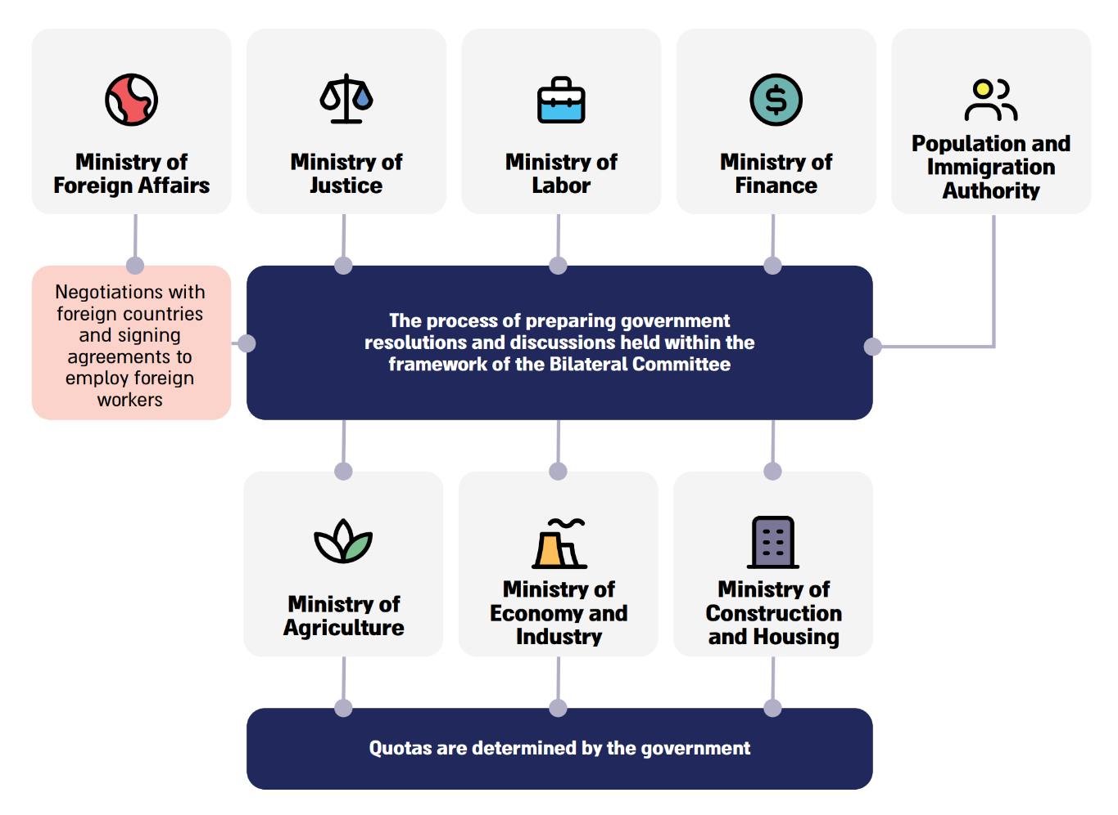

Change in the Number of Legal and Illegal Foreign Workers Employed Across
All Sectors of the Israeli Economy, 2010–2023

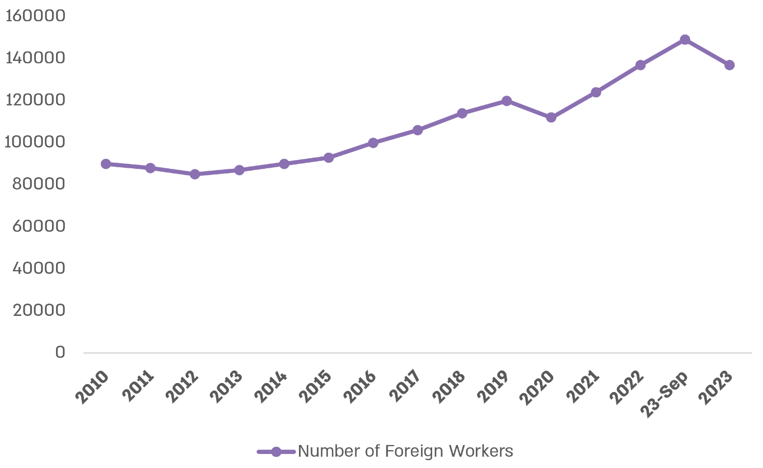

According to data from the Population and Immigration Authority, processed by the Office of the State Comptroller.

Number of Palestinians Employed in Israel in the Various Sectors, March 2024
and September 2024

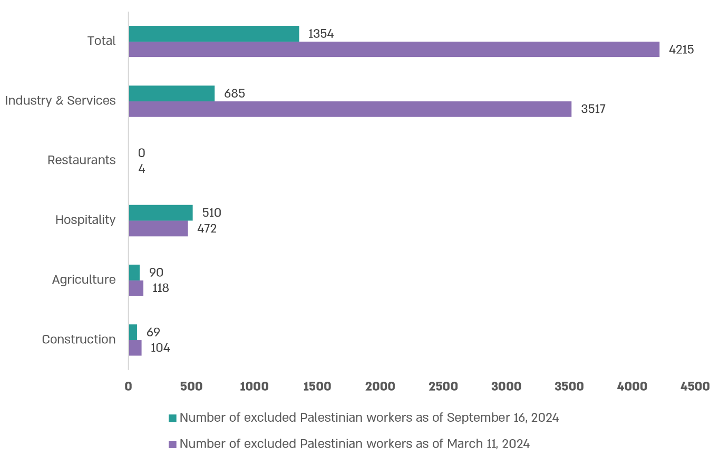

According to data from the Population and Immigration Authority, processed by the Office of the State Comptroller.

Summary
Preparedness Regarding the Employment of Foreign Workers in Israel Prior to the Swords of Iron War – The audit revealed flaws in various aspects in this area, such as multiplicity of bodies dealing with the issue of employing foreign workers, each of which has responsibilities and authorities in different areas and therefore different perspectives, as well as a division of authorities among them and the involvement of additional bodies. All these complicate the process of determining policy objectives, causing delays and affecting the actual bringing in of foreign workers in order to address the need for labor recruitment in the economy. The Ministry of Labor, the Population and Immigration Authority, the Ministry of Finance and the ministries regulating sectors in which non-Israeli workers are employed have not completed an updated strategic assessment pertaining to the need to employ foreign workers in the Israeli economy. Furthermore, the method of determining quotas in Israel was established without a sound basis and any change in quota requires a government decision. In addition, the lack of an appropriate reference scenario by NEMA, the Ministry of Construction and Housing and the Ministry of Agriculture; the absence of appropriate risk management and the lack of diversification in the sources of non-Israeli workers led to the fact that the State of Israel was not properly prepared for the shortage of non-Israeli workers created as a result of the Swords of Iron War.
Following the Outbreak of the Swords of Iron War – The audit found flaws in various aspects: – no entity, including the Ministry of Finance, examined the indirect, medium and long-term effects of the shortage of non-Israeli workers as a result of the war; no objectives were set regarding the number of foreign workers or the timeline for their arrival; in May 2024, approximately nine months following the outbreak of the Swords of Iron War, there was still no coordinating entity with a comprehensive view of all the needs of the economy and the authority to handle obstacles to bringing in foreign workers, and the extensive attention devoted to the matter did not yield satisfactory results. Even in June 2025, upon completion of the audit, government entities had not yet completed handling important issues: reducing the fees paid by employers of foreign workers across all sectors, obstacles to signing new bilateral agreements, finding additional means to recruit foreign workers in times of emergency, formulating a methodology for long term employment of foreign workers, law enforcement pertaining to the departure of illegal foreign workers from Israel, etc.
Regarding the Construction Sector – The audit found that despite the efforts to recruit foreign workers to work in the construction sector during the war, in June 2025 there was still a shortage of approximately 37,000 non-Israeli workers. According to the Bank of Israel's assessment, the volume of activity in the construction sector decreased in the fourth quarter of 2023 by approximately 50%, which is approximately 3% of the GDP – NIS 56 billion in 2023 prices (0.75% of the GDP in annual terms).
Regarding the Construction and Transportation Infrastructure Sector – In February 2025, more than a year following the outbreak of the Swords of Iron War, the Ministry of Transport had not yet created the appropriate conditions for bringing in foreign workers to work in infrastructure and not even a single new foreign worker had arrived to work in infrastructure.
The government should take measures to remove the remaining obstacles to recruiting foreign workers. The relevant government ministries should continuously prepare for the threat of workforce shortage. It is recommended that the Directors General Committee continue to act to remove the obstacles to recruiting foreign workers while balancing between the needs of the economy and differentiating between routine and emergency situations. Among other things, the Directors General Committee should act to optimize the process of recruiting foreign workers through bilateral agreements, and at the same time, take measures to create mechanisms that will enable, in times of emergency and when necessary, private recruitment within a short period of time, while minimizing harmful consequences, such as through oversight and enforcement mechanisms that will ensure the protection of workers' rights.
It is recommended that government ministries involved in the employment of non-Israeli workers, in cooperation with the Ministry of Labor and the Ministry of Finance, map the needs of each of the sectors requesting to employ non-Israeli workers and determine accordingly the workforce needs of each sector for the short, medium, and long term.
It is recommended that the Prime Minister and the Minister of Finance discuss, within the framework of the Socio-Economic Cabinet, the ongoing impact of the shortage of non-Israeli workers on the Israeli economy and the consequences of this shortage and find solutions for the short, medium, and long term as part of a program that will promote the growth of the economy in general, and the construction sector in particular, and monitor the implementation of the program.

The term "non-Israeli workers" in this report refers to both foreign and Palestinian workers, and the term "foreign workers" refers to workers coming from foreign countries, unless stated otherwise. In addition, there is a third group – Jordanian workers in Eilat and the surrounding area.
The Employment Service Law, 5719-1959 also includes regulation of complementary aspects with regards to employment of non-Israeli workers.
According to Government Resolution 3434 from April 2008.
Permit to stay in Israel for work purposes.
Manpower Corporations designated for the Construction Sector.
Private offices authorized to handle foreign workers in the caregiving and agriculture sectors and to facilitate communication between workers and employers.
This report does not refer to expert foreign workers.
Of these workers, approximately 14,000 were illegal. Population and Immigration Authority, Summary Report of Activities for 2023 (April 2024).
Ministry of Construction and Housing, Ministry of Transport, Ministry of Agriculture, Ministry of Economy, Ministry of Tourism, Ministry of Welfare and Ministry of Health.
Prime Minister's Office, Joint announcement of the Prime Minister's Office and the Ministry of Labor, May 15, 2024. Government Resolution 1752, "Streamlining and Improving Supervision and Enforcement of Employment of Foreign Workers and Amending Government Resolutions" (May 15, 2024).
Bank of Israel, Spokesmanship Division, Press Release: "Third box in the Bank of Israel's report for 2023: Employment of non-Israeli workers in light of the Swords of Iron War", p. 5 section 2: Employment Stability and Flexibility, March 17, 2024.
The Committee for Bilateral Agreements – headed by the Director General of the Population and Immigration Authority and with the participation of representatives from the Ministry of Finance, the Ministry of Foreign Affairs, the Ministry of Justice, the Ministry of Labor and from other government ministries whose regulatory field relates to the employment of foreign workers, including the Ministry of Health, the Ministry of Construction and Housing and others – meets several times a year to discuss the need for foreign workers in each of the sectors.
The Special Committee for Foreign Workers, minutes No. 68 on the subject: "Situation Report and Policy Regarding the Employment of Palestinian Workers in Israel – follow-up meeting" (May 20, 2024).
According to the draft summary of the discussion held by the Directors General Committee on Foreign Workers (June 17, 2024).
The Ministry of Construction and Housing has a list of foreign construction companies that were selected to execute residential and infrastructure construction projects.
Ministry of Construction and Housing, Ministry of Transport, Ministry of Agriculture, Ministry of Economy, Ministry of Tourism, Ministry of Welfare and Ministry of Health.
Ministry of Construction and Housing, Ministry of Transport, Ministry of Agriculture, Ministry of Economy, Ministry of Tourism, Ministry of Welfare and Ministry of Health.

