Granting Extended Time Accommodations in Matriculation Examinations by Schools

Granting Extended Time Accommodations in Matriculation Examinations by Schools
Abstract


Students in mainstream education, who experience difficulties that affect their examination performance, sometimes struggle to adequately demonstrate in examinations the knowledge they have acquired. This group includes, students with learning disabilities, attention deficit and hyperactivity disorder (ADHD) or medical conditions, as well as special education students, and students experiencing emotional or psychological difficulties. These students are granted testing accommodations – modifications to standard examination conditions – intended to reduce disparities, remove barriers, and address difficulties that impair a student’s ability to demonstrate acquired knowledge, without compromising the standard of the matriculation examinations.
Testing accommodations include, inter alia, extended examination time, oral reading of examination questions, enlarged-font examination papers, disregarding spelling errors, typing answers on a computer, and reducing the number of examination questions.
Approximately 56% of students who completed their studies in the 2024–2025 school year and who sat for at least one matriculation examination were eligible for at least one testing accommodation (approximately 73,000 out of 131,000 examinees).
The extension of examination time in matriculation examinations by 25% beyond the originally allocated time is an accommodation granted to students who have difficulty expressing their knowledge within the examination’s prescribed timeframe. Extended time is the most common accommodation granted to students in the education system in recent years (approximately 52% of students who completed their studies in the 2024–2025 school year and sat for at least one matriculation examination were eligible for this accommodation).
The overwhelming majority of students who were eligible for extended time accommodations in the 2024–2025 school year – approximately 92% (approximately 63,000 students in total) – received such eligibility from a school-based committee at the school they attended, on the basis of learning disabilities, attention disorders, medically related learning difficulties, or emotional or psychological difficulties affecting learning (extended time accommodation). In addition, certain groups of students are entitled to extended time automatically, without school discretion, including new immigrants and students who are returning residents.
In the 2014–2015 school year, the Ministry of Education abolished the requirement that students present a professional assessment to the school in order to obtain eligibility for extended time accommodations. Accordingly, as of the date of the audit, decisions of school-based committees are required to rely on teachers’ opinions, on examples of the student’s examination performance, and on an assessment of the necessity of the accommodation, with the school itself ultimately determining eligibility, without the need for a professional assessment.
It should be noted that a comparison with other countries found that, similarly to Israel, extended time accommodations in the education systems of the countries examined – England, Australia (Victoria), and New Zealand – are granted for a variety of reasons: learning disorders and medical, emotional, or psychological conditions. However, unlike the situation in Israel, the authority approving extended time accommodations in those countries is external to the school.


Approx. 52% |  | Approx. 92% |  | Approx. 48% vs. Approx. 5%
Percentage of students who completed their studies in the 2024–2025 school year and sat for at least one matriculation examination who were eligible for extended time accommodations (approx. 68,500 out of approx. 131,000 examinees) |  | of the students who completed their studies in the 2024–2025 school year and were eligible for extended time accommodations, the eligibility of approx. 92% was approved by a school-based committee at the school they attended (approx. 63,000 out of 68,500 examinees) |  | Percentage of students who took at least one matriculation examination and were eligible for extended time accommodations approved by their school among students who completed their studies in the 2024–2025 school year – when no professional assessment was required (approx. 63,000 out of approx. 131,000 examinees) – as compared with students who completed their studies in the 2015–2016 school year – when a professional assessment was required in order to obtain eligibility for extended time accommodations (approx. 5,000 out of approx. 103,000 examinees)

Approx. 45% vs. 5%–15% |  | Approx. 15% |  | Approx. 50% vs. Approx. 40%
Percentage of students who completed their studies in the 2024–2025 school year and sat for at least one matriculation examination (approx. 58,500 out of approx. 131,000 examinees) for whom the recorded basis for approval of extended time accommodations was a learning disability and/or attention disorder; this figure is significantly higher than the prevalence of learning disabilities in the population, estimated at 5%–15% and the prevalence of attention disorders, estimated at 5%–10% |  | Percentage of schools (133 out of 914) that approved extended time accommodations for more than 90% of their students in the 2024–2025 school year |  | Percentage of students in the state and state-religious education sectors eligible for extended time accommodations approved by their schools, compared with the rate among students in the Druze and ultra-Orthodox Jewish sectors, in the 2024–2025 school year

Approx. 55% vs.  Approx. 39% |  | Approx. 12 Percentage Points |  | Approx. 2.5 points
Percentage of students in the highest socio-economic bracket who were eligible for extended time accommodations approved by their school, compared with the percentage among students in the lowest socio-economic bracket, in the 2024–2025 school year |  | Gap in the likelihood of receiving eligibility for extended time accommodations from the school among students examined in five-unit mathematics, compared with those examined in three-unit mathematics |  | Estimated increase in a student’s matriculation examination score resulting from eligibility for extended time accommodations granted by the school

Audit Actions

From March to October 2025, the State Comptroller’s Office examined the granting of eligibility for extended time accommodations in matriculation examinations by schools. Inter alia, the audit reviewed the actions taken by the Ministry of Education to examine and formulate relevant and up-to-date policy regarding the granting of eligibility for extended time, as well as the process by which schools determine eligibility and the supervision exercised over them by the Ministry’s districts. The audit was conducted within the Ministry of Education – in the Senior Psychological and Counseling Services Division, the Learning Disabilities and Attention Disorders Division, the Senior Examinations Division, and the Ministry’s district offices. In addition, the audit team met with relevant officials in 11 secondary schools, as well as with representatives of the National Parents Leadership and the National Student Council.
In order to formulate a comprehensive picture of the situation and examine whether disparities exist in the provision of equal opportunities for students from diverse backgrounds, the audit team collected and analyzed, from the Ministry of Education’s systems, personal data of students who completed their studies during the 2016–2025 school years, as well as data concerning the schools they attended. The data were analyzed using quantitative tools, including statistical methods and linear regression analyses.

Key Findings


Trends in the Recognition of Eligibility for Extended Time and in Eligibility Rates – The overwhelming majority of students who were eligible for extended time accommodations in the 2024–2025 school year – approximately 92% (63,000 students in total) – received their eligibility from a school-based committee at the school they attended (students eligible for extended time). In the 2014–2015 school year, the Ministry of Education cancelled the requirement to present a professional assessment in order to obtain eligibility for extended time. Accordingly, as of the date of the audit, decisions of the school-based committee are required to rely on teachers’ opinions, examples of the student’s examination performance, and an assessment of the necessity of the accommodation, with the school itself ultimately determining eligibility without the need for a professional assessment. The audit found that from 2016 to 2025, the percentage of students eligible for extended time increased nearly tenfold – from approximately 5% (about 5,000 out of 103,000 examinees) in 2016, to approximately 39% (about 43,000 out of 110,000 examinees) in 2018, and to approximately 48% (about 63,000 out of 131,000 examinees) in 2025. The audit further found that from 2019 to 2025, approximately half of all students who sat for matriculation examinations were eligible for extended time accommodations approved by their schools. This percentage is higher than expected given that the prevalence of learning disabilities in the population is estimated at 5%–15%, and the prevalence of attention disorders at 5%–10%, even taking into account that extended time is also granted on medical, emotional, or psychological grounds. Accordingly, the process for granting eligibility for extended time in matriculation examinations, intended to address the needs of students with specific difficulties, has over the years evolved into a widespread trend within the education system. This trend raises questions regarding both the extensive scope of students eligible for extended time and the alignment of such eligibility with its original purpose.

The Process for Determining Eligibility for Extended Time in Schools – It was found that none of the 11 schools examined had undergone any supervision or oversight by the district offices of the Ministry of Education regarding either the process for determining eligibility for extended time or the percentage of students eligible for it. In the absence of oversight, each school operated according to its own approach, and significant disparities were identified in the practices adopted. As a result, two students with similar characteristics studying at different schools may receive different decisions – one may be granted eligibility, while the other may not. The audit further found that although the Ministry of Education implemented an option enabling schools to report, through the Ministry’s computerized system, the basis on which extended time was approved for students, the system did not allow schools to indicate emotional difficulties as the basis for approval, despite this being one of the grounds recognized by the Ministry as qualifying students for extended time. An examination of the data showed that for approximately 58,500 students (about 45% of students who sat for matriculation examinations in the 2024–2025 school year), the recorded basis for approval was a learning disability or attention disorder, a rate significantly higher than the estimated prevalence of learning disabilities and attention disorders in the population. Accordingly, the Ministry of Education does not possess reliable information regarding the grounds on which schools approve extended time, even though such information could assist it in assessing the effectiveness of extended time for students, according to the grounds for granting eligibility.

Variations in Eligibility for Extended Time

  - Variation by Education Stream – The audit found that the percentage of students eligible for extended time in the state education system (51% – approximately 34,000 out of 67,000 examinees) and the state-religious education system (51% – approximately 10,000 out of 19,500 examinees) is significantly higher than the percentage in the ultra-Orthodox Jewish sector (38% – approximately 5,000 out of 13,000 examinees) and the non-Jewish sector (45% – approximately 13,000 out of 29,000 examinees in the Arab sector, and 40% – approximately 1,000 out of 2,500 examinees in the Druze sector).

  - Variation by the School’s Socio-Economic Index – The audit found that among students from the lowest socio-economic quintile (Quintile 5), the percentage eligible for extended time is the lowest; conversely, among students from the highest socio-economic quintile (Quintile 1), the eligibility rate is the highest.

  - Variation by the Number of Mathematics Study Units – The audit found that the higher the number of mathematics study units in which students were examined, the higher the percentage of students whose eligibility for extended time was approved by the school: an eligibility rate of approximately 50.6% (approximately 201,000 out of 397,000 examinees) among students examined in three study units, compared with approximately 54.6% (approximately 362,000 out of 663,000 examinees) among students examined in five study units.
Variations Among Schools in Rates of Eligibility for Extended Time – The audit found variation among schools in the percentage of students granted eligibility for extended time: approximately 4% of schools (38 out of 914) approved extended time for 10% or fewer of their students, while approximately 15% of schools (133 out of 914) approved extended time for more than 90% of their students. The disparities among schools in rates of eligibility for extended time raise concerns that the accommodations granted to students reflect school policy. In other words, the greater the differences among schools in rates of eligibility for extended time, the greater the concern about a low correlation between the actual need for the accommodation and the likelihood of receiving it. In addition, in the 2017–2018 school year, the Ministry of Education began the gradual implementation (“pilot”) of a system-wide program for identifying and supporting students with learning disabilities and attention disorders – the "From Disabilities to Learning" program. The audit found no significant difference between the average rate of eligibility for extended time among schools in local authorities participating in the program (approximately 57% – the average among 156 schools) and the average among schools in local authorities not participating in the program (approximately 53% – the average among 356 schools).
Likelihood of Eligibility for Extended Time: Students Examined in Five Mathematics Study Units Compared with Three Study Units – A statistical analysis conducted by the State Comptroller’s Office found that the likelihood that a student examined in five mathematics study units would be eligible for extended time was approximately 12 percentage points higher than that of a student examined in three mathematics study units. In other words, students examined in five mathematics study units were 12% more likely to receive extended time than students examined in three mathematics study units. It should be noted that the effect of the number of mathematics study units on the likelihood of eligibility for extended time was found to be particularly pronounced in the Arab sector, where a gap of approximately 25 percentage points was identified between students examined in five mathematics study units and those examined in three mathematics study units.

The Effect of Eligibility for Extended Time on Examination Scores – A statistical analysis found that eligibility for extended time had a statistically significant positive effect of approximately 2.5 points on examination scores. In other words, extended time itself added an average of 2.5 points to examination scores. However, its effect was smaller than that of the school’s socio-economic status (socio-economic quintile): the lower the socio-economic status, the lower the examination score. In addition, as a general rule, the school’s sectoral affiliation had a greater effect on examination scores than eligibility for extended time.
Gaps in District-Level Supervision by the Ministry of Education Over Schools – The audit found that six of the eight districts of the Ministry of Education (75%) failed to oversee the granting of accommodations within schools’ authority, as required under the Accommodations Circular. Although data serve as a basis for professional decision-making and for planning appropriate responses for students, none of the districts examined the rate of eligibility for accommodations approved by schools at the district level, nor were they proactive in identifying schools with particularly high or low rates of accommodations. In addition, the districts failed to monitor the grounds for granting accommodations in schools or the process for approving eligibility within schools. Although the Ministry of Education was aware of these issues following a previous audit conducted by the State Comptroller in 2013, the situation had remained unchanged, and the Accommodations Circular had not been revised accordingly.
Actions by the Ministry of Education Headquarters to Formulate Policy on Eligibility for Extended Time – The audit found that aside from three discussions held by the Ministry of Education headquarters in 2023 concerning pedagogical aspects of extended examination time, disparities among educational institutions in granting the accommodation, and oversight processes, the Ministry had not in recent years conducted comprehensive staff work on the issue of extended time. Inter alia, it had not examined the factors that led to the high eligibility rates at the national average level, nor the effectiveness of extended time in achieving its goal and its impact on different groups of students. The issue of the effect of extended time on the academic performance of students who do not require it, together with questions regarding its effectiveness for students with attention disorders, underscores the need for a renewed examination of the Ministry of Education’s policy concerning eligibility for extended time. In certain cases, the accommodation may confer an advantage on a particular group of students while, conversely, failing to provide an appropriate response for another group.

Key Recommendations

It is recommended that the Ministry of Education measure the effectiveness of granting extended time according to the basis on which it was approved for each student, and that it collect reliable data from schools on the relevant student characteristics for this purpose. It is further recommended that the Ministry formulate a framework offering effective accommodations and complementary responses tailored to students’ needs at the school, district, and national levels. It is also recommended that the Ministry address the difficulties raised by school principals, including tensions arising between parents and students and professional staff regarding the determination of eligibility for extended time, as well as difficulties faced by school administrations vis-à-vis professional staff within the school. The Ministry should provide guidance to schools on how to address these challenges, particularly in light of the high percentage of students requesting the accommodation. In addition, it is recommended that the Ministry adopt alternative assessment methods for determining the necessity of extended time and for integrating them into schools. The Ministry should also address the difficulties in implementing eligibility for extended time arising from the unavailability of examination proctors to remain for the duration of the extended time period, as raised in discussions with school principals.

It is recommended that the Ministry of Education increase the involvement of its districts in overseeing the granting of accommodations by schools and proactively identify schools in which the percentage of students eligible for extended examination time is unusually high. It is further recommended that the Ministry provide guidance to schools on implementing the process for granting eligibility for accommodations.

It is recommended that the Ministry of Education conduct methodical staff work and revalidate the policy it has established regarding eligibility for extended time in matriculation examinations within schools’ authority. This revalidation should be based on data analysis, mapping of barriers in the process, comparison with education systems in other countries, and a review of up-to-date research, in order to ensure that the conclusions provide an appropriate response to students’ needs and to the challenges faced by schools. In particular, the Ministry should examine the possibility of conducting an objective evaluation (for example, through a computerized assessment tool) to determine eligibility for extended time, in order to create standardization and reduce the influence of schools’ practices on eligibility approvals. Alternatively, the Ministry should consider granting eligibility for extended time to all students.

It is recommended that the Ministry of Education analyze the reasons for the high percentage of students eligible for extended time within the education system and examine the reasons for the variation among groups of students eligible for it, according to relevant parameters, such as the basis for eligibility, sector, and socio-economic index. It is further recommended that the Ministry ensure that its districts properly fulfill their oversight role in this area as well, and that schools are provided with the knowledge and capacity required to operate optimally.

It is recommended that the Ministry of Education examine the extent to which extended time is actually utilized among different student populations and consider the possibility of including additional accommodations within schools’ authority, such as allowing students to take examinations in a room with a small number of students (“small-group classroom”) or providing breaks for refreshment between sections of the examination. In addition, it is recommended that the Ministry implement further solutions within the educational framework in order to reduce students’ need for extended time, such as developing intervention programs that teach relevant skills, including time management, reading fluency, and learning strategies.


Percentage of Students Who Completed Their Studies in 2016–2025 and Were Eligible for Extended Time Approved by Their School

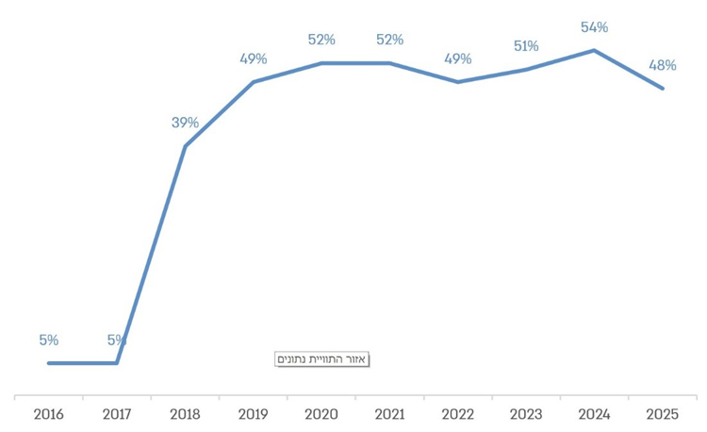
Based on data from the Ministry of Education, processed by the State Comptroller’s Office.
From Statements Made by the Educational Staff at One of the Secondary Schools Examined

"
"

“The process of granting accommodations creates difficulties for the school because it creates friction both with teachers and with parents. The friction between the school administration and teachers stems from the fact that teachers are required to assess the need for accommodations despite not having been trained in the subject, while most of the burden falls on a small number of teachers in text-heavy subjects (in 10th grade, only Bible studies and history are taught). Another source of friction is with parents of students who were not granted testing accommodations, whose accommodations do not correspond to the parents’ expectations, or whose accommodations, in the parents’ view, were not granted quickly enough…”

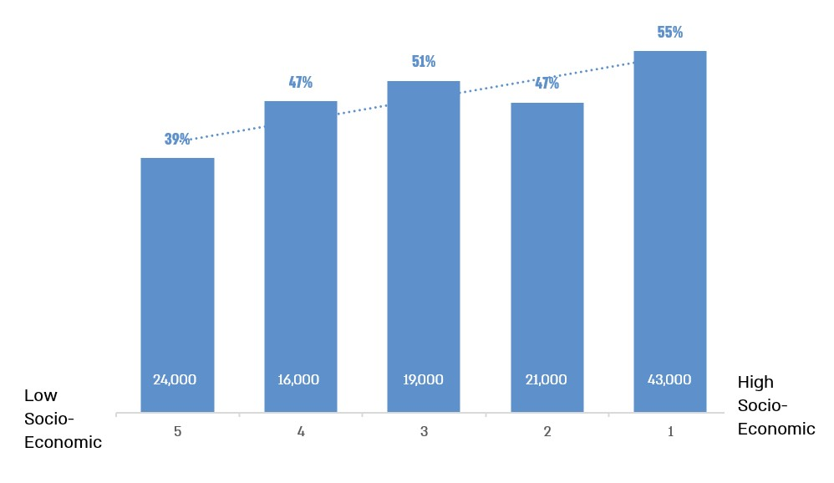
Percentage of Students Who Completed Their Studies in the 2024–2025 School Year and Were Eligible for Extended Time Approved by Their School, by Schools’ Socio-Economic Quintiles

According to data from the Ministry of Education, processed by the State Comptroller’s Office.
* The figures shown underneath each column represent the total number of students who completed their studies in the 2024–2025 school year, sat for at least one matriculation examination in each socio-economic quintile (rounded to the nearest thousand), and for whom data regarding their school’s socio-economic index were available (123,000 students. For 8,000 students, no data regarding their school’s socio-economic index were available).
The chart illustrates the variation in eligibility rates according to the socio-economic status of the schools attended by students, such that among students from the lowest socio-economic background (Socio-Economic Quintile 5), the percentage eligible for extended time is the lowest, and vice versa.

Summary
Eligibility for testing accommodations is intended to ensure the reduction of disparities and the removal of barriers stemming from students’ difficulties in demonstrating their knowledge in matriculation examinations. Extended time is the most common accommodation. Data from the Ministry of Education indicate that approximately 52% of students who completed their studies in the 2024–2025 school year and sat for at least one matriculation examination were eligible for it (approximately 68,500 students), and approximately 92% of them (approximately 63,000 students) received eligibility for this accommodation from the schools they attended on the basis of a medical, emotional or psychological condition, a learning disability, or an attention disorder.
The audit found variation in rates of eligibility for extended time among different student populations: in the 2024–2025 school year, the percentage of students eligible for extended time in the state and state-religious education systems (approximately 51%) was significantly higher than the percentage in the ultra-Orthodox Jewish sector (38%) and the non-Jewish sector (45% in the Arab sector and 40% in the Druze sector). The audit further found that, as a general rule, there is a direct relationship between socio-economic status, as measured by socio-economic quintiles, and the percentage of students eligible for extended time. In other words, among students from the highest socio-economic background, the percentage eligible for extended time is the highest, and vice versa. Variation was also identified among schools in the percentage of students approved for extended time, with approximately 15% of schools (133 out of 914) approving extended time for more than 90% of their students. It was further found that the likelihood of receiving extended time diminishes as the socio-economic status of the school decreases; it is higher in schools within the Arab, ultra-Orthodox Jewish, and state-religious sectors than in schools within the state sector; and it increases where students are examined in a greater number of mathematics study units. Regarding the effect of eligibility for extended time on matriculation examination scores, the audit found that it has a positive effect of approximately 2.5 points. It should be stressed that even the addition of a few points to an examination score may be significant in a student’s admission to highly sought-after university programs.
The foregoing indicates that, on the one hand, schools approve eligibility for extended time without the need for a professional assessment, while, on the other hand, such eligibility has a positive effect on students’ matriculation examination scores and directly affects the school’s overall matriculation score average. Accordingly, schools have an inherent interest in granting eligibility for extended time to their students, which also contributes to the school’s academic performance.
The audit further found that Ministry of Education districts failed to properly oversee schools with regard to the approval of extended time. In the absence of appropriate oversight, each of the schools examined operated according to its own approach, and some even acted contrary to established procedures. Under these circumstances, two students with identical characteristics studying at different schools may receive different decisions – one may be granted eligibility, while the other may not. The audit further found that despite the high percentage of students whose eligibility for extended time was approved by schools (48% of all examinees in the 2024–2025 school year), the Ministry had not in recent years conducted methodical staff work on the issue of extended time or examined the effectiveness of the policy governing eligibility for extended time among different groups of students.
It is recommended that the Ministry of Education revalidate the policy it has established regarding the granting of eligibility for extended time in matriculation examinations that schools are authorized to approve. This revalidation should be based on data analysis, mapping of barriers in the process, comparison with education systems in other countries, and a review of up-to-date research, in order to ensure that the conclusions provide an appropriate response to students’ needs and to the challenges faced by schools. It is recommended that the Ministry analyze the reasons for the high percentage of students eligible for extended time and examine the reasons for the variation among groups of eligible students according to relevant parameters, in order to identify barriers and difficulties that may undermine equality and educational fairness. In particular, it is recommended that the Ministry examine the high percentage of students eligible for extended time in the state and state-religious sectors relative to the national average, as well as the policy governing the granting of eligibility for extended time in the Arab and ultra-Orthodox Jewish sectors, where particularly large disparities among schools were identified. In addition, it is recommended that the Ministry examine the effectiveness of granting extended time according to the basis on which it was approved for the student, and that, based on the findings, an appropriate response be formulated at the school, district, and national levels.
It is further recommended that the Ministry of Education increase the involvement of its districts in overseeing the accommodations approved by schools, including, inter alia, identifying schools in which the percentage of students eligible for extended examination time is unusually high. It is also recommended that the Ministry provide guidance to schools on implementing the process for granting eligibility and consider introducing additional solutions for all students in order to reduce the need for extended time; for example, by developing intervention programs that teach relevant skills, including time management, reading fluency, and learning strategies.
In its response to the State Comptroller’s Office in February 2026, the Ministry of Education stated that it would thoroughly examine the findings of the report, conduct an in-depth review, and implement improvement and corrective processes based on the findings.

Unlike special education frameworks, which provide a dedicated educational setting for children with special needs who have difficulty integrating into mainstream education systems.
Translator's note: The difference between five mathematics study units and three mathematics study units lies in the scope of the material, the level of difficulty, and the opportunities they provide for admission to higher education and employment.
State Comptroller, Annual Report 63C (2013), Accommodations for Students with Learning Disabilities in Matriculation Examinations, p. 1133.

